**Spring Boot CRUD REST API JPA**

# Target Pembelajan

## Indikator

1. Mengetahui JPA
2. Mengetahui Entity
3. Mengetahui Repositori
4. Mengetahui Service/Interface
5. Mengetahui Controller

## Tools

1. JDK 1.8
2. Intellij IDEA

## Proses Alur

## Peserta diharapkan mengikuti setiap langkah pada dokumen ini.

# CRUD

CRUD adalah singkatan dari create, read, update, and delete.

merupakan fungsi-fungsi utama yang diimplementasikan dalam aplikasi database

Akronim CRUD mengidentifikasi semua fungsi utama yang melekat pada database relasional dan aplikasi yang digunakan untuk mengelolanya, termasuk Oracle Database, Microsoft SQL Server, MySQL, dan lainnya.

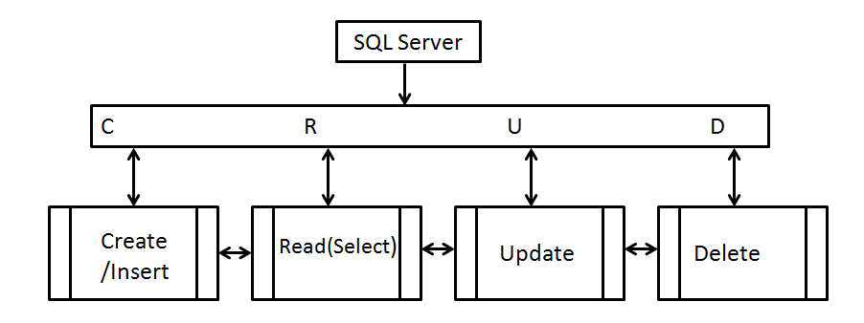

* Create

Fungsi CRUD yang pertama adalah create. Fungsi ini memungkinkanmu membuat record baru dalam database. Dalam aplikasi SQL, fungsi create sering disebut juga sebagai insert.

Kamu dapat membuat baris baru dan mengisinya dengan data yang sesuai dengan setiap atribut. Tetapi, hanya administrator yang dapat menambahkan atribut baru ke tabel itu sendiri.

* Read

Fungsi read hampir mirip dengan fungsi search. Fungsi ini memungkinkan kamu untuk mencari dan mengambil data tertentu dalam tabel dan membaca nilainya.

Kamu dapat menemukan record yang diinginkan menggunakan kata kunci,atau dengan memfilter data berdasarkan kriteria yang diinginkan.

* Update

Untuk memodifikasi record yang telah tersimpan di database, fungsi CRUD yang bisa kamu gunakan adalah fungsi update.

Namun, kamu perlu mengubah berbagai informasi terkait agar bisa memodifikasi record yang diinginkan secara utuh.

Record yang ada dalam database harus diubah dan semua nilai atribut diubah untuk mencerminkan karakteristik baru yang diinginkan.

* Delete

Ketika ada record atau data yang tidak lagi dibutuhkan dalam database, fungsi CRUD yang digunakan adalah fungsi delete. Fungsi ini dapat digunakan untuk menghapus data tersebut.

Beberapa aplikasi database relasional mungkin mengizinkan kamu untuk melakukan hard delete atau soft delete.

Hard delete akan secara menghapus  catatan dari database permanen.

Sementara, soft delete hanya akan memperbarui status baris untuk menunjukkan bahwa data telah dihapus meskipun data tersebut tetap ada dan utuh.

# Cara kerja REST API

Dan cara kerja dari **RESTful API** yaitu REST client akan Melakukan akses pada data/resource pada REST server dimana masing-masing resource. Atau data/resource tersebut akan dibedakan oleh sebuah global ID atau URIs (Universal Resource Identifiers).

 Resource tersebut direpresentasikan dalam bentuk format teks, JSON atau XML. Pada umumnya formatnya menggunakan JSON dan XML.

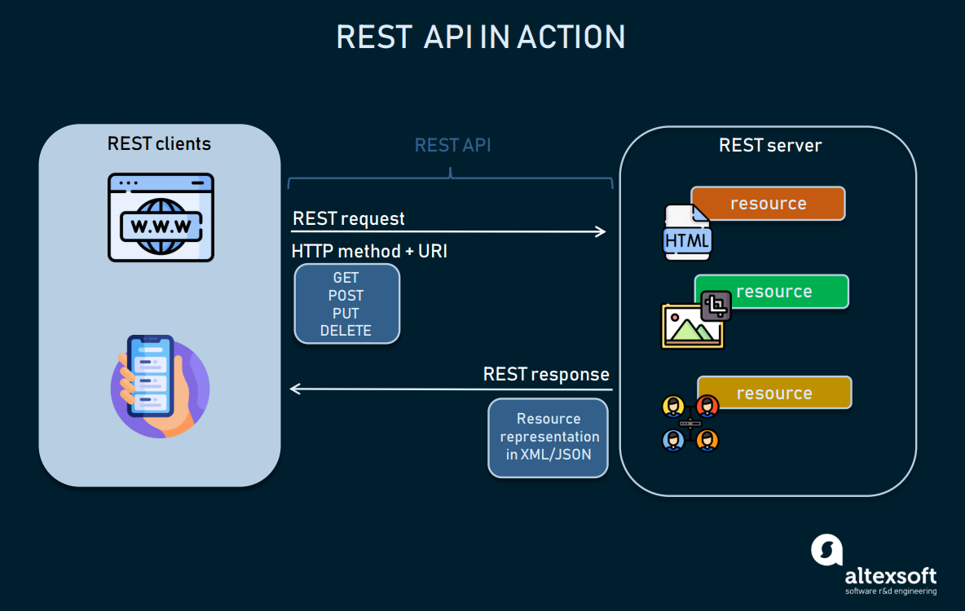

**Gambar Cara kerja REST API**

## Komponen dari HTTP Request

* **Verb, HTTP method** yang digunakan misalnya GET, POST, DELETE, PUT dll.
* *Uniform Resource Identifier***(URI)** untuk mengidentifikasikan lokasi resource pada server.
* **HTTP Version**, menunjukkan versi dari HTTP yang digunakan, contoh HTTP v1.1.
* **Request Header**, berisi metadata untuk HTTP Request. Contoh, type client/browser, format yang didukung oleh client, format dari body pesan, seting cache dll.
* **Request Body**, konten dari data.

## **Komponen** dari **HTTP Response**

* **Status/Response Code**, mengindikasikan status server terhadap resource yang direquest. misal : 404, artinya resource tidak ditemukan dan 200 response OK.
* **HTTP Version**, menunjukkan versi dari HTTP yang digunakan, contoh HTTP v1.1.
* **Response Header**, berisi metadata untuk HTTP Response. Contoh, type server, panjang content, tipe content, waktu response, dll
* **Response Body**, konten dari data yang diberikan.

# METHOD REST API

REST memiliki standarisasi dalam pemakaian, yaitu URL dan HTTP *method*. HTTP methoddigunakan untuk mengetahui kegunaan dari URL yang diakses, sehingga mempermudah dalam penulisan URL.

* GET, berfungsi untuk membaca data/resource dari REST server
* POST, berfungsi untuk membuat sebuah data/resource baru di REST server
* PUT, berfungsi untuk memperbaharui data/resource di REST server
* DELETE, berfungsi untuk menghapus data/resource dari REST serve
* OPTIONS, berfungsi untuk mendapatkan operasi yang disupport pada resource dari REST server.
* **PATCH**, digunakan untuk mengubah beberapa *field*dalam sebuah *record*

# STATUS CODE

* [200 OK](https://developer.mozilla.org/en-US/docs/Web/HTTP/Status/200) : The request has succeeded. The meaning of the success depends on the HTTP method:
* 400 Bad Request – klien mengirim permintaan yang tidak valid, seperti tidak memiliki request body atau parameter yang diperlukan
* 401 Unauthorized – klien gagal mengautentikasi dengan server : token failed
* 403 Forbidden – klien diautentikasi tetapi tidak memiliki izin untuk mengakses sumber daya yang diminta
* 404 Not Found – sumber daya yang diminta tidak ada
* 412 Precondition Failed – satu atau lebih kondisi di bidang header permintaan dievaluasi salah
* 500 Internal Server Error – kesalahan umum terjadi di server
* 503 Service Unavailable – layanan yang diminta tidak tersedia

Refer : https://developer.mozilla.org/en-US/docs/Web/HTTP/Status

# Kenapa harus menggunakan Rest?

Berikut beberapa hal yang membuat kenapa harus menggunakan Rest :  
- Rest menggunakan HTTP standar  
- Rest lebih mudah diterapkan  
- Rest Menggunakan bandwidth yang kecil  
- Rest memungkinkan banyak format data  
- Rest memiliki kinerja dan skalabilitas yang lebih baik

# Bahasa pemrograman apa saja yang dapat membuat Rest API?

Hampir semua bahasa pemrograman dapat membuat Rest, seperti:  
PHP - Laravel  
PHP - CI  
Node - Express  
Python - Flask  
GO - Gin  
GO - Echo  
Java - Spring dan lain lain

# Lombok

**@AllArgsConstructor** dan **@NoArgsConstructor** adalah anotasi yang berasal dari proyek Lombok, yang adalah perpustakaan Java yang digunakan untuk mengurangi boilerplate code dalam kode sumber Anda. Kedua anotasi ini memiliki kegunaan sebagai berikut:

1. **@AllArgsConstructor**:
   * **Kegunaan**: Anotasi **@AllArgsConstructor** digunakan untuk menghasilkan sebuah konstruktor yang menerima semua parameter dari kelas. Ini akan mengurangi boilerplate code yang biasanya diperlukan untuk menulis konstruktor dengan semua parameter.
   * **Contoh**: Misalnya, jika Anda memiliki kelas seperti ini:

**public class Person { private String name; private int age; }**

Dengan menggunakan **@AllArgsConstructor**, Anda dapat menghasilkan konstruktor seperti ini secara otomatis:

**public Person(String name, int age) { this.name = name; this.age = age; }**

1. **@NoArgsConstructor**:
   * **Kegunaan**: Anotasi **@NoArgsConstructor** digunakan untuk menghasilkan konstruktor tanpa argumen atau konstruktor default. Ini berguna ketika Anda ingin memiliki konstruktor default yang tidak menerima parameter.
   * **Contoh**: Misalnya, jika Anda memiliki kelas seperti ini:

public class Person { private String name; private int age; }

Dengan menggunakan **@NoArgsConstructor**, Anda dapat menghasilkan konstruktor tanpa argumen seperti ini secara otomatis:

public Person() { // Konstruktor tanpa argumen }

Kedua anotasi ini sangat membantu untuk mengurangi kerja berulang yang terkait dengan menulis konstruktor kelas, terutama saat Anda memiliki banyak atribut dalam kelas Anda. Mereka membuat kode Anda lebih bersih dan lebih mudah dibaca. Namun, pastikan Anda telah mengintegrasikan Lombok ke dalam proyek Anda agar anotasi-anotasi ini berfungsi dengan baik.

# Init Project Spirng Boot

## Buka link [**start.spring.io**](https://start.spring.io/)

Web tersebut akan terlihat seperti gambar berikut.

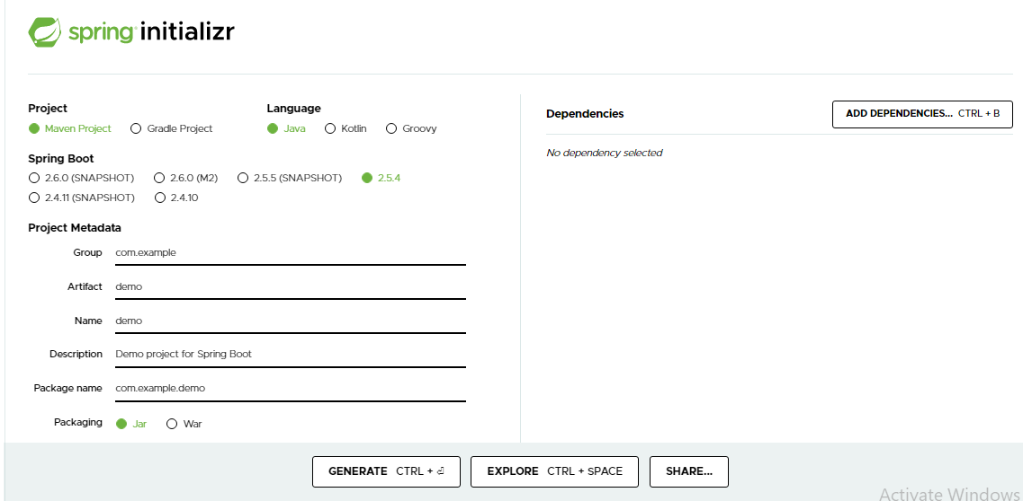

**Ikutin langkah berikut**

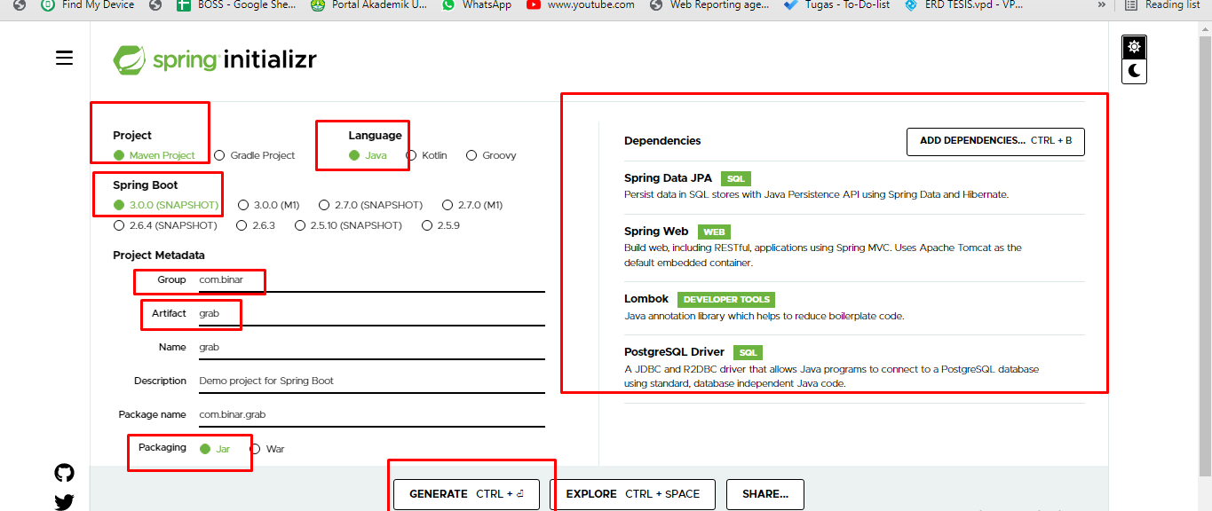

## Pilih Project

jenis project yang akan di buat.  
Biasanya Maven untuk project spring boot, sedangkan gradle untuk project android.  
Pilih Language -> bahasa yang akan digunakan. Untuk project Spring Boot kali ini, disarankan menggunakan bahasa Java.

## Spring Boot

versi dari Spring Boot yang akan di buat, untuk project kali ini disarankan menggunakan versi 2.2.4.

Project Metadata -> penamaan project, atau hierarki project yang akan di buat sedangkan artifact adalah nama project yang akan di buat.

## Dependencies

sejenis java build tools (Maven), yang kegunaannya adalah untuk menyesuaikan setiap kebutuhan IDE. Sebagai contoh ketika kita membuat sebuah kodingan di IDE tertentu, dan kita ingin membagi kodingan kita kepada teman, maka teman tersebut harus menyesuaikan jenis2 library/java build tools yang diperlukan. Dengan adanya Maven ini, mempermudah kita dalam me-refactor atau pun sekedar ingin menjalankan project orang lain di IDE kita, sehingga kita tidak perlu menyesuaikan versi secara manual, Maven tersebut, akan menyesuaikan secara otomatis.

Contoh Lib depedency Maven:

|  |
| --- |
| <! — <https://mvnrepository.com/artifact/org.projectlombok/lombok> → <dependency>  <groupId>org.projectlombok</groupId>  <artifactId>lombok</artifactId>  <version>1.18.12</version>  <scope>provided</scope> </dependency> |

Anda dapat menambahkan setiap maven anda di file pom.xml

Untuk menjalankan project dengan maven, anda harus memiliki maven terlebih dahulu.

Jika belum memiliki maven, anda bisa mendownloadnya dari halaman berikut, [Apache Maven Project](https://maven.apache.org/). Setelah berhasil di download, kemudian di ekstrak, setelah itu anda harus mendaftarkan direktori bin folder maven tersebut ke dalam environment variables.

Untuk project baru, anda tidak perlu menambahkan banyak maven. Anda di sarankan untuk menambahkan maven Spring Web, karena untuk maven yang lain, anda dapat menambahkannya setelah project berhasil di buat.

* Group id : nama package default anda
* Artifact : nama projek anda
* Version : versi projek anda
* Packaging : hasil build projek anda
* Name : nama projek anda, bisa disamakan dengan artifact
* Description : deskripsi projek anda
* Package Name : nama package default anda, bisa disamakan dengan group id
* Language : Bahasa yang digunakan
* Java Version : Versi java sdk yang anda punya

## Setelah semua selesai di isi sesuai dengan keperluan project, maka saatnya untuk membuat project baru. Anda dapat membuat project baru dengan menekan tombol Generate.

## Setelah menekan tombol tersebut, anda tinggal menunggu project anda selesai dibuat. Setelah download selesai, anda akan diberikan file dengan nama file yang anda set sebelumnya dengan extensi **.zip**

## Setelah berhasil di download, anda bisa meng-ekstrak file .zip tersebut.

## Setelah di extrack, maka akan ada file-file berikut di dalam folder dengan nama yang telah anda set sebelumnya.

# Praktek Spring Boot Hello Word

## Hello World

Tambahkan pada pom.xlm

|  |
| --- |
| <dependency>  <groupId>org.springframework.boot</groupId>  <artifactId>spring-boot-starter-web</artifactId> </dependency> |

Controller : buatlah class TestController pada package controller

|  |
| --- |
| @RestController @RequestMapping("/v1/praktek/") class Example {  @RequestMapping("/")  @ResponseBody  public String hello() {  return "Hello Spring Boot";  } } |

Output : http://localhost:8080/v1/praktek/

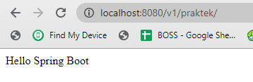

Ubah versi java di pom.xml

<properties>  
 <java.version>1.8</java.version>  
</properties>

## Run Spring boot

Application Runner adalah antarmuka yang digunakan untuk mengeksekusi kode setelah aplikasi Spring Boot dimulai.

Kode

|  |
| --- |
| @SpringBootApplication public class BinarApplication {   public static void main(String[] args) {  SpringApplication.*run*(BinarApplication.class, args);  } } |

## Application properties

File ini akan selalu dibaca oleh Spring Boot sebagai file konfigurasi default.

Terletak pada src/resources/application.properties

contoh

|  |
| --- |
| server.port = 9090  spring.application.name = nameApps |

Get app name in kode

Buatlah class controller :

|  |
| --- |
| @Value("${spring.application.name}") private String name;  @RequestMapping("/nameapp") @ResponseBody public String getNameApp() {  return name; }  Output : <http://localhost:9090/v1/praktek/nameapp>  Graphical user interface, text, application, chat or text message  Description automatically generated |

# Praktek Spring MVC Hello Word

## Pom

|  |
| --- |
| <!-- //web tymeleaf--> <dependency>  <groupId>org.springframework.boot</groupId>  <artifactId>spring-boot-starter-thymeleaf</artifactId>  <version>3.0.4</version> </dependency> |

## controller

|  |
| --- |
| package com.aplikasi.karyawan.ch4.mvc;  import org.springframework.stereotype.Controller; import org.springframework.ui.ModelMap; import org.springframework.web.bind.annotation.RequestMapping; import org.springframework.web.bind.annotation.RequestMethod;  @Controller @RequestMapping("/v1/mvc/") public class HelloControolerMVC {  @RequestMapping(value = "/hello_world", method = RequestMethod.*GET*)  public String printHelloWorld(ModelMap modelMap){   // add attribute to load modelMap  modelMap.addAttribute("message",  "Hello World and Welcome to Spring MVC!");   return "hello_world";  }  } |

## html

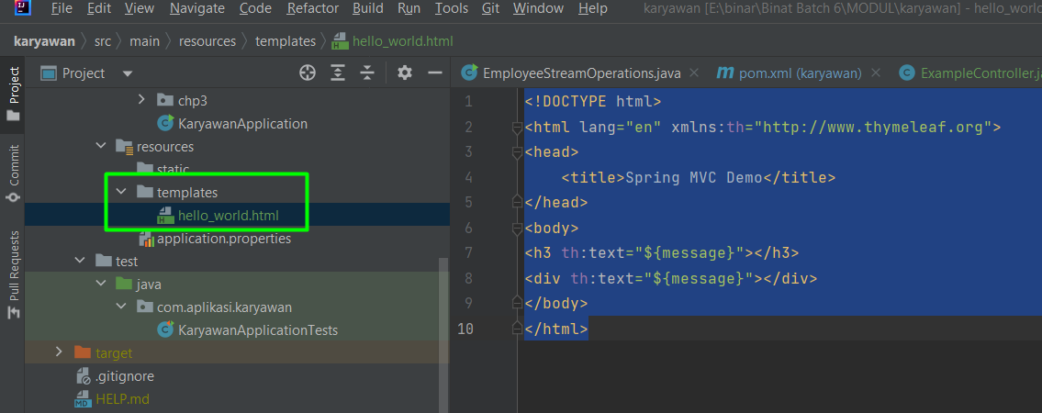

|  |
| --- |
| <!DOCTYPE html> <html lang="en" xmlns:th="http://www.thymeleaf.org"> <head>  <title>Spring MVC Demo</title> </head> <body> <h3 th:text="${message}"></h3> <div th:text="${message}"></div> </body> </html> |

## run

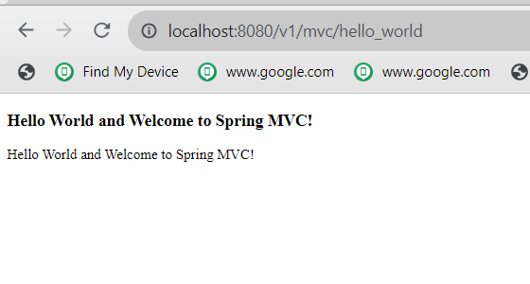

## Contoh 2

### controller

|  |
| --- |
| @RequestMapping(value = "/sample1", method = RequestMethod.*GET*) public String sample2(ModelMap modelMap){   // nama file FE  return "sample"; } |

### Html

|  |
| --- |
| <!DOCTYPE html> <html lang="en" xmlns:th="http://www.thymeleaf.org"> <head>  <meta charset="UTF-8">  <title>Profil Pengguna</title>  <style>  body {  font-family: Arial, sans-serif;  background-color: #f2f2f2;  margin: 0;  padding: 0;  }   .profile-container {  max-width: 800px;  margin: 0 auto;  background-color: #fff;  padding: 20px;  border: 1px solid #ccc;  border-radius: 5px;  box-shadow: 0 0 10px rgba(0, 0, 0, 0.2);  }   .profile-image {  width: 150px;  height: 150px;  border-radius: 50%;  margin: 0 auto;  display: block;  }   h1 {  text-align: center;  color: #333;  }   p {  text-align: center;  color: #666;  }   .btn-edit-profile {  display: block;  margin: 20px auto;  padding: 10px 20px;  background-color: #007bff;  color: #fff;  text-decoration: none;  border-radius: 5px;  text-align: center;  font-weight: bold;  }   .btn-edit-profile:hover {  background-color: #0056b3;  }  </style> </head> <body>  <div class="profile-container">  <img class="profile-image" src="profile-image.jpg" alt="Foto Profil">  <h1>Nama Pengguna</h1>  <p>Email: user@example.com</p>  <p>Alamat: Jl. Contoh No. 123</p>  <a class="btn-edit-profile" href="/edit-profile">Edit Profil</a>  </div> </body> </html> |

### Output

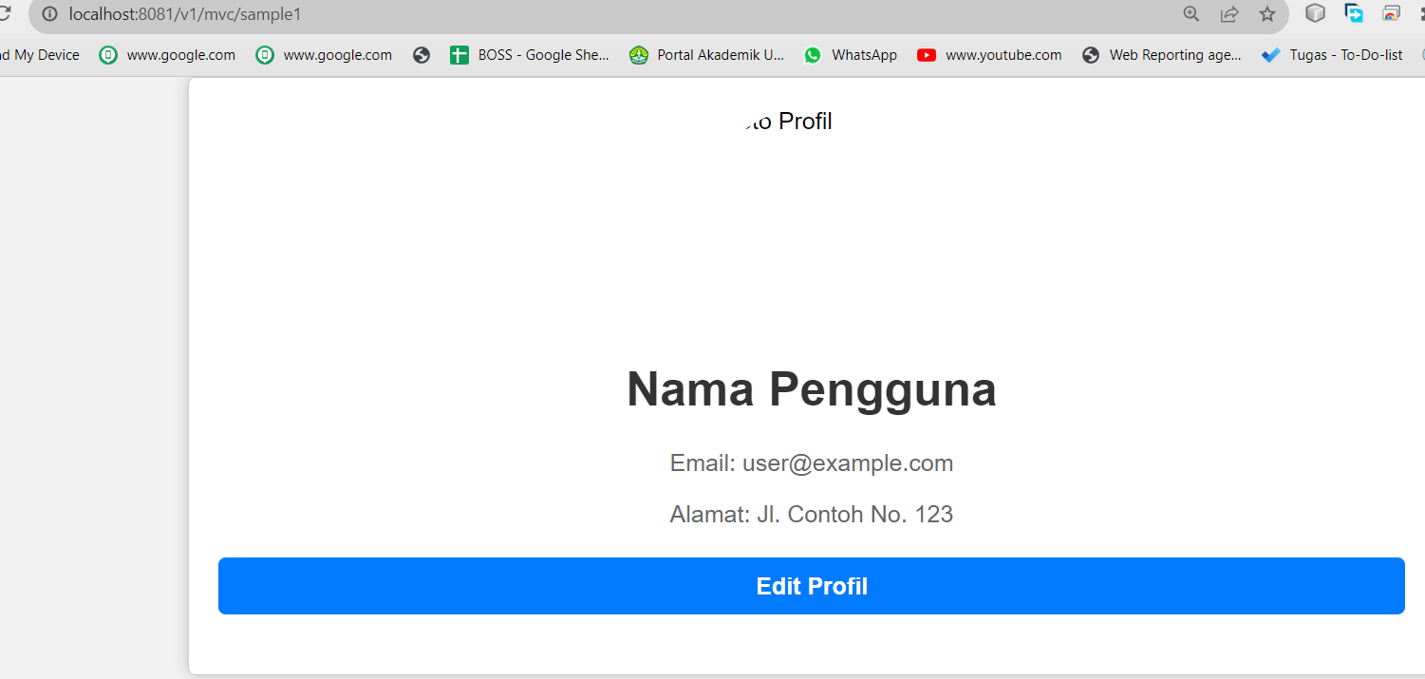

# Koneksi Ke database menggunakan spring boot dan postgresql

## Buat database di postgresql

|  |
| --- |
| **create** **database** binar6_karyawan; |

## Open application.properties dan tambahkan

|  |
| --- |
| spring.jpa.hibernate.ddl-auto=update spring.datasource.url=jdbc:postgresql://localhost:5432/tamara spring.datasource.username=postgres spring.datasource.password=password |

spring.jpa.hibernate.ddl-auto=update

* UPDATE : ketika update di field entity -> maka otomatis keupdate dari DB
* CREATE : menghapus semua data pada tabel : hati2 -> data kalian yang existing akan ilang
* CREATE-DROP : membuat ulang tabel2 kalian dan data existing akan terhapus

## Library di POM.xml Postgresql

|  |
| --- |
| <dependency>  <groupId>org.postgresql</groupId>  <artifactId>postgresql</artifactId>  <scope>runtime</scope> </dependency> |

## Tambahkan library JPA dan hibernite

|  |
| --- |
| <!-- db -->  <dependency>  <groupId>org.postgresql</groupId>  <artifactId>postgresql</artifactId>  <scope>runtime</scope>  </dependency>  <!-- hibernite dan JPA-->  <dependency>  <groupId>org.springframework.boot</groupId>  <artifactId>spring-boot-starter-data-jpa</artifactId>  </dependency> |

Jika eror : ilangin yang core .hibernitenya.

# Study Kasus: Konsep MVC with Spring

Ex:

Diketahui : data Barang : terdiri dari

|  |
| --- |
| private Long id; private String nama; private int stok; private String satuan; private Double harga; |

|  |  |
| --- | --- |
| get | /v1/view/barang/list |
| post | /v1/view/barang/add |
| put | /v1/view/barang/{barangid}/edit |
| delete | /v1/view/barang/{barangid}/deleted |
| Get by id | /v1/view/barang/{barangid} |
|  |  |
|  |  |

Jawab:

## Membuat Model

Barang

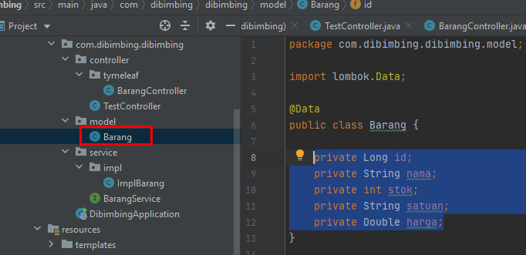

|  |
| --- |
| @Data public class Barang {   private Long id;  private String nama;  private int stok;  private String satuan;  private Double harga; } |

## Membuat View/Interface

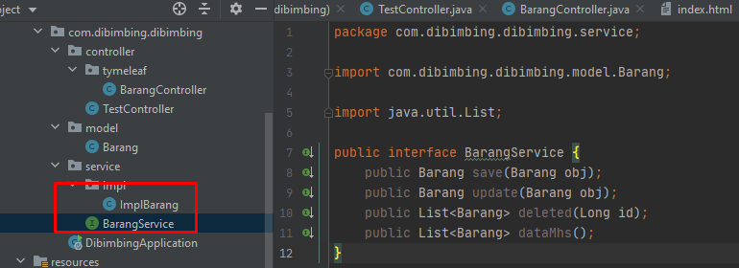

**Service**

|  |
| --- |
| import java.util.List;  public interface BarangService {  public Barang save(Barang obj);  public Barang update(Barang obj);  public List<Barang> deleted(Long id);  public List<Barang> dataMhs(); } |

**ImplMhs**

|  |
| --- |
| import java.util.ArrayList; import java.util.List;  @Service public class ImplBarang implements BarangService {  static List<Barang> *listMhs* = new ArrayList<>();  @Override  public Barang save(Barang obj) {  obj.setId(1L);  *listMhs*.add(obj);  return obj;  }   @Override  public Barang update(Barang obj) {  for(Barang data : *listMhs*){  if(obj.getId() == data.getId()){  Barang update = new Barang();  update.setNama(data.getNama());  update.setId(data.getId());  update.setSatuan(data.getSatuan());  update.setStok(data.getStok());  *listMhs*.remove(data);  *listMhs*.add(update);  return update;  }  }  return null;  }   @Override  public List<Barang> deleted(Long id) {  for(Barang data : *listMhs*){  if(id == data.getId()){  Barang update = new Barang();  update.setNama(data.getNama());  update.setId(data.getId());  update.setSatuan(data.getSatuan());  update.setStok(data.getStok());  *listMhs*.remove(data);   return *listMhs*;  }  }  return null;  }   @Override  public List<Barang> dataMhs(int row,int page) {   return *listMhs*;  }   @Override  public Barang findById(long obj) {  for(Barang data : *listMhs*){  if(obj == data.getId()){  return data;  }  }  return null;  } } |

## Add POM.xml

|  |
| --- |
| <!--//template engine tymeleaf-->  <dependency>  <groupId>org.springframework.boot</groupId>  <artifactId>spring-boot-starter-thymeleaf</artifactId>  </dependency> |

## Membuat Controller

**BarangController**

|  |
| --- |
| import org.springframework.beans.factory.annotation.Autowired; import org.springframework.stereotype.Controller; import org.springframework.ui.Model; import org.springframework.web.bind.annotation.*;  import java.util.List;   @Controller @RequestMapping("/v1/view/barang") public class BarangController {   @Autowired  public com.dibimbing.dibimbing.service.BarangService barangService;   private final int ROW_PER_PAGE = 5;   // Index Page  @GetMapping(value = {"/", "/index"})  public String index(Model model) {  model.addAttribute("title", "Title Saya");  return "index";  }    @GetMapping(value = "/list")  public String getBarang(Model model,  @RequestParam(value = "page", defaultValue = "1") int pageNumber) {  List<Barang> barangs = barangService.dataMhs(pageNumber, ROW_PER_PAGE);   long count = barangs== null ? 1 :barangs.size();  boolean hasPrev = pageNumber > 1;  boolean hasNext = (pageNumber * ROW_PER_PAGE) < count;  model.addAttribute("barangs", barangs);  model.addAttribute("hasPrev", hasPrev);  model.addAttribute("prev", pageNumber - 1);  model.addAttribute("hasNext", hasNext);  model.addAttribute("next", pageNumber + 1);  return "barang-list";  }   @GetMapping(value = {"/add"})  public String showAddBarang(Model model) {  Barang barang = new Barang();  model.addAttribute("add", true);  model.addAttribute("barang", barang);   return "barang-edit";  }   @PostMapping(value = "/add")  public String addBarang(Model model,  @ModelAttribute("barang") Barang barang) {  try {  System.*out*.println("nilai barnag barang=" + barang.getNama());  Barang newBarang = barangService.save(barang);  return "redirect:/v1/view/barang/" + String.*valueOf*(newBarang.getId());  } catch (Exception ex) {   String errorMessage = ex.getMessage();  model.addAttribute("errorMessage", errorMessage);  model.addAttribute("add", true);  return "barang-edit";  }  }   @GetMapping(value = {"/{barangId}/edit"})  public String showEditBarang(Model model, @PathVariable long barangId) {  Barang barang = null;  barang = barangService.findById(barangId);  model.addAttribute("add", false);  model.addAttribute("barang", barang);  return "barang-edit";  }   @PostMapping(value = {"/{barangId}/edit"})  public String updateBarang(Model model,  @PathVariable long barangId,  @ModelAttribute("barang") Barang barang) {  try {  barang.setId(barangId);  barangService.update(barang);  return "redirect:/v1/view/barang/" + String.*valueOf*(barang.getId());  } catch (Exception ex) {  // log exception first,  // then show error  String errorMessage = ex.getMessage();  model.addAttribute("errorMessage", errorMessage);   model.addAttribute("add", false);  return "barang-edit";  }  }   @GetMapping(value = "/{barangId}")  public String getBarangById(Model model, @PathVariable long barangId) {  Barang barang = null;  barang = barangService.findById(barangId);  model.addAttribute("barang", barang);  return "barang";  }   //delete  @GetMapping(value = {"/{barangId}/delete"})  public String showDeleteBarangById(  Model model, @PathVariable long barangId) {  Barang barang = null;  barang = barangService.findById(barangId);  model.addAttribute("allowDelete", true);  model.addAttribute("barang", barang);  return "barang";  }   @PostMapping(value = {"/{barangId}/delete"})  public String deleteBarangById(  Model model, @PathVariable long barangId) {  barangService.deleted(barangId);  return "redirect:/v1/view/barang/list";  } } |

## UI

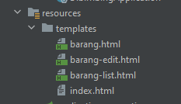

**Barang.html**

|  |
| --- |
| <!DOCTYPE HTML> <html xmlns:th="http://www.thymeleaf.org"> <head>  <meta charset="UTF-8" />  <title>View Barang</title>  <link rel="stylesheet" type="text/css" th:href="@{/css/style.css}"/> </head> <body> <h1>View Barang</h1> <a th:href="@{/v1/view/barang/list}">Back to Barang List</a> <br/><br/> <div th:if="${barang}">  <table border="0">  <tr>  <td>Name</td>  <td>:</td>  <td th:utext="${barang.nama}">...</td>  </tr>  <tr>  <td>Phone</td>  <td>:</td>  <td th:utext="${barang.stok}">...</td>  </tr>  <tr>  <td>Email</td>  <td>:</td>  <td th:utext="${barang.satuan}">...</td>  </tr>  <tr>  <td>Address</td>  <td>:</td>  <td th:utext="${barang.harga}">...</td>  </tr>  </table>  <br/><br/>  <div th:if="not ${allowDelete}">  <a th:href="@{/v1/view/barang/{barangId}/edit(barangId=${barang.id})}">Edit</a> |  <a th:href="@{/v1/view/barang/{barangId}/delete(barangId=${barang.id})}">Delete</a>  </div>  <form th:if="${allowDelete}" th:action="@{/v1/view/barang/{barangId}/delete(barangId=${barang.id})}" method="POST">  Delete this barang? <input type="submit" th:value="Yes" />  </form> </div> <div th:if="${errorMessage}" th:utext="${errorMessage}" class="error" /> </body> </html> |

**Barang-edit.html**

|  |
| --- |
| <!DOCTYPE HTML> <html xmlns:th="http://www.thymeleaf.org"> <head>  <meta charset="UTF-8" />  <title th:text="${add} ? 'Create a Barang' : 'Edit a Barang'" />  <link rel="stylesheet" type="text/css" th:href="@{/css/style.css}"/> </head> <body> <h1 th:text="${add} ? 'Create a Barang:' : 'Edit a Barang:'" /> <a th:href="@{/v1/view/barang/list}">Back to Barang List</a> <br/><br/> <form th:action="${add} ? @{/v1/view/barang/add} : @{/v1/view/barang/{barangId}/edit(barangId=${barang.id})}"  th:object="${barang}" method="POST">  <table border="0">  <tr>  <td>Nama</td>  <td>:</td>  <td><input type="text" th:field="*{nama}" /></td>  </tr>  <tr>  <td>Stok</td>  <td>:</td>  <td><input type="text" th:field="*{stok}" /></td>  </tr>  <tr>  <td>Satuan</td>  <td>:</td>  <td><input type="text" th:field="*{satuan}" /></td>  </tr>  <tr>  <td>Harga</td>  <td>:</td>  <td><input type="text" th:field="*{harga}"/></td>  </tr>  </table>  <input type="submit" th:value="${add} ? 'Create' : 'Update'" /> </form>  <br/> <!-- Check if errorMessage is not null and not empty --> <div th:if="${errorMessage}" th:utext="${errorMessage}" class="error" /> </body> </html> |

**Barang-list.html**

|  |
| --- |
| <!DOCTYPE HTML> <html xmlns:th="http://www.thymeleaf.org"> <head>  <meta charset="UTF-8" />  <title>Barang List</title>  <link rel="stylesheet" type="text/css" th:href="@{/css/style.css}"/> </head> <body> <h1>Barang List</h1>  <div>  <nobr>  <a th:href="@{/v1/view/barang/add}">Add Barang</a> |  <a th:href="@{/v1/view/barang/}">Back to Index</a>  </nobr> </div> <br/><br/> <div>  <table border="1">  <tr>  <th>Nama</th>  <th>Stok</th>  <th>Satuan</th>  <th>Harga</th>  </tr>  <tr th:each ="barang : ${barangs}">  <td><a th:href="@{/v1/view/barang/{barangId}(barangId=${barang.id})}" th:utext="${barang.nama}">...</a></td>  <td><a th:href="@{/v1/view/barang/{barangId}(barangId=${barang.id})}" th:utext="${barang.stok}">...</a></td>  <td th:utext="${barang.satuan}">...</td>  <td th:utext="${barang.harga}">...</td>  <td><a th:href="@{/v1/view/barang/{barangId}/edit(barangId=${barang.id})}">Edit</a></td>  </tr>  </table> </div> <br/><br/> <div>  <nobr>  <span th:if="${hasPrev}"><a th:href="@{/v1/view/barang/list?page={prev}(prev=${prev})}">Prev</a>&nbsp;&nbsp;&nbsp;</span>  <span th:if="${hasNext}"><a th:href="@{/v1/view/barang/list?page={next}(next=${next})}">Next</a></span>  </nobr> </div> </body> </html> |

**Index.html**

|  |
| --- |
| <!DOCTYPE HTML> <html xmlns:th="http://www.thymeleaf.org">  <head>  <meta charset="UTF-8" />  <title th:utext="${title}"/>  <link rel="stylesheet" type="text/css" th:href="@{/css/style.css}"/>  </head>  <body>  <h1 th:utext="${title}"/>  <a th:href="@{/v1/view/barang/list}">Barang List</a>  <br/><br/>  <div>Copyright 2021</div>  </body> </html> |

## Output

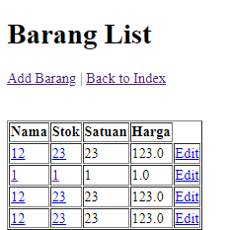

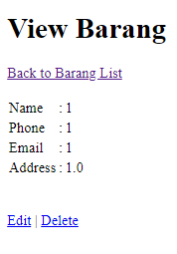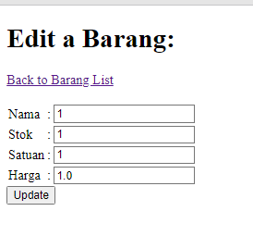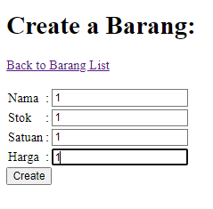

## Branch : https://github.com/rikialdi/dibimbing/tree/tymeleaf

# Spring IoC

## pengertian

Spring membantu pembuatan kontainer dalam menampung object-object yang memiliki ketergantungan pada object lain dalam melakukan transaksi. IoC berupa layer abstrak yang menampung object-object yang akan digunakan secara singleton (singleton adalah object yang dibuat sekali dan ditampung terus dalam memory selama aplikasi berjalan). Contoh object yang disimpan didalam IoC Container adalah SessionManager yang membuat koneksi dengan database. Contoh penggunaan objek SessionManager tersebut dalam IoC Container yaitu melakukan auto wire data injeksi object kedalam object yang akan melakukan transaksi dalam database.

Jika kita bayangkan container ini semacam wadah dari beans yang kita gunakan dalam aplikasi java kita yang akan menggunakan spring framework. **Beans disini** artinya merupakan sebuah object yang digunakan dalam aplikasi yang kita buat dan yang dimanaged oleh Spring IoC Container. Container ini tidak hanya menampung object-object tadi, tapi juga bertugas untuk menginstansiasi, mengkonfigurasi dan merangkai beans yang ada sesuai dengan konfigurasi yang kita gunakan.

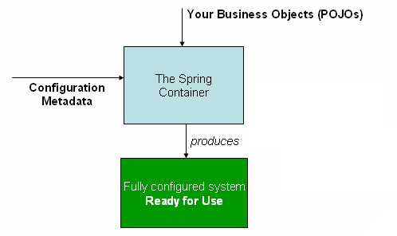

# DI : Depedency Injection

## Pengertian

Salah satu kemampuan utama dari spring adalah kemampuannya melakukan DI (*defendency injection*)*.*Semua aplikasi berbasis spring akan bergantung pada DI ini. Object-object dari aplikasi yang menggunakan spring akan berada pada **spring container** seperti gambar berikut. Object-object pada spring container yang terhubung satu sama lain oleh proses DI

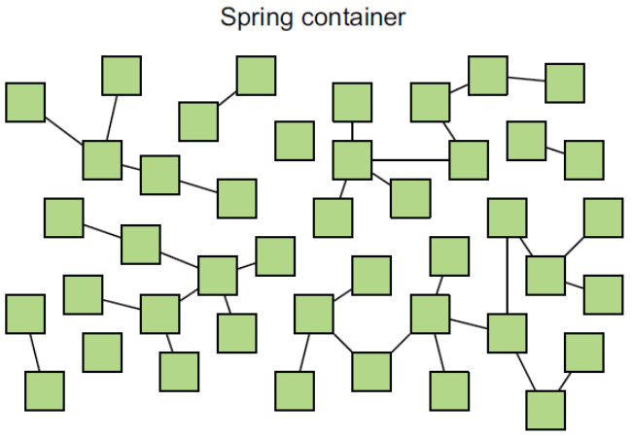

Core container spring terdiri dari beberapa sub komponent utama yang dapat dijelaskan sebagai berikut.

* **Spring Core**, modul ini akan menyediakan semua komponen utama termasuk didalamnya IoC (Inversion of Control) dan DI (Dependency Injection)
* **Spring Bean**, modul ini menyediakan servcie terhadap pembuatan object dari class-class java (instansiasi java bean). Class utama atau tepatnya interface adalah BeanFactory.
* **Spring Context,**modul ini menyediakan service yang ada di atas Core dan Bean sehingga object-object tesebut dapat lebih mudah diakses dari code java. Tentunya object-object ini telah kita konfigurasi terlebih dahulu.
* **Spring Expression Language (SpEL),**modul ini menyediakan service untuk dapat mengakses ke object java (graph) berupa xml atau anotasi.

Berikut adalah tugas utama dari spring container yang berhubungan dengan DI dan IOC.

* Creation atau pembentukan object (bean dan XML config)
* Hold dan maintenance object yang di simpan pada memory komputer
* Melukukan injection object ke object lain yang memerlukannya
* Melakukan destroy object-object yang sudah tidak digunakan

# Memahami Inversion Of Control Vs Dependency Injection Pada Spring Framework

## Inversion of Control

Misalkan, Terdapat sebuah class bernama Karyawan seperti berikut

|  |
| --- |
| public class Karyawan {      private int id;      private String name;      private String country;      //get set is omitted    } |

Biasanya, untuk membuat *object* dari class Karyawan, digunakan *sintaks* **new** seperti berikut

|  |
| --- |
| Karyawan karyawan = new Karyawan() |

*Nah*, **IoC** adalah teknik dalam *software engineering* yang  memindahkan tanggung jawab pembuatan dan pengelolaan object tidak lagi di *code* melainkan  di *framework* dan *Container*.

## **Lalu apa itu***Container***?**

Di dalam terminologi*software development* istilah *Container* digunakan untuk  menjelaskan komponen yang dapat menampung ( *contain* ) komponen – komponen lain di dalamnya. Misalnya **Apache Tomcat** adalah Web /  Container yang menampung servlet. Sedangkan **JBoss** disebut sebagai application server / container, yang juga merupakan   EJB Container.

*Container* bertugas membuat *object* dan mengkonfigurasi serta menghubungkan ke code yang memerlukan, juga mengelola keseluruhan daur hidup object – object tersebut

## **Spring** *Container*

Jika telah memahami apa itu **Container**, maka akan menjadi mudah mengerti apa itu **Spring Container**. **Spring Container** adalah komponen sentral dari Spring Framework yang berfungsi menampung semua komponen object (kemudian disebut, **spring bean)** dan menangani daur hidupnya secara keseluruhan.

Untuk mengenali masing – masing *beans* yang ada di dalam Container, **Spring** menggunakan konfigurasi metadata yang dapat direpresentasikan dalam format XML atau dalam bentuk anotasi java. Hal ini mirip dengan **Apache Tomcat** yang merupakan *servlet container*, juga membaca web.xml  untuk mengidentifikasi servlet mana yang akan dibentuk.

## **Dependency** *Injection*

adalah *design pattern*  di dalam*software engineering* modern yang  sangat penting untuk memudahkan sebuah program untuk dibuat unit test-nya. kebalikan dari  **DI** adalah  *hardcoded dependencies*.

***Dependency injection****adalah suatu cara dalam menyediakan object dengan membuatnya menjadi sebuah parameter di constructor ataupun di setter dari pada membuatnya langsung di classnya.*

Dalam banyak referensi juga disebutkan bahwa **DI** adalah salah satu implementasi dari **IoC**, atau bagaimana teknis dari konsep **IoC** diterapkan.

Misalkan terdapat class Perusahaan yang punya dependensi terhadap kelas Karyawan, jika digunakan*hardcoded dependency*maka ditulis sebagai berikut:

|  |
| --- |
| public class Perusahaan  {       private Karyawan karyawan = new Karyawan();    } |

dengan **DI** menjadi sebagai berikut

|  |
| --- |
| public class Perusahaan  {      private Karyawan karyawan;        public Perusahaan(Karyawan karyawan){          this.karyawan=karyawan;      }    } |

Mengelola **DI** dengan pendekatan “tradisional” akan membuat keseluruhan program semakin rumit. Dalam contoh ini, diperlukan *class* lain, untuk membuat object Karyawan dan menginjeksikannya ke kelas Perusahaan misalnya PerusahaanService

|  |
| --- |
| public class PerusahaanService {        private Perusahaan perusahaan;        public PerusahaanService() {            Karyawan karyawan =new Karyawan();          this.perusahaan = new Perusahaan(karyawan);      }    } |

*Code* tersebut menyebabkan kerumitan lain, karena  kini terdapat dependensi antara PerusahaanService dan Karyawan, sebuah hal yang tentu tidak diinginkan. Belum lagi, dependensi antara PerusahaanService dengan *object*Perusahaan

Namun ini bukan berarti *design pattern* tersebut gagal. **DI** adalah implementasi bagaimana  **IoC** diterapkan. Yang perlu dilakukan adalah memindahkan tanggungjawab (atau bahasa teknisnya, *inversion of Control*) injeksi dependensi dari yang semula dilakukan code menjadi dilakukan  oleh Framework.

## BEAN

**Bean dalam spring**adalah suatu object dari class java yang terbentuk sekali saat aplikasi spring di jalankan dan dicontrol sama Spring IoC Container. Jadi dengan kata lain Spring IoC Container ini yang membentuk, menyimpan dan menyediakan bean bagi yang membutuhkannya. Bean ini bisa kita sebut juga sebagai object ya, jadi kalo sudah terbentuk bean artinya kita tidak perlu lagi membuat object secara manual atau secara terus menerus, karena default bean ini modenya mode singleton (jika sudah terbentuk tdk membentuk lagi) dan akan terus hidup sepanjang aplikasi spring masih menyala.

https://medium.com/@satya.syahputra/mengenal-spring-dependency-injection-framework-bahasa-indonesia-3c3b9487a59e

scope

## **Depency Injection X Inversion of Control**

*Dengan menggunakan****IoC****,*Dependency*akan dikelola oleh*IoC Container *sehingga*IoC Container *– lah yang akan membuat*object*Karyawan dan menginjeksikan object tersebut ke  Perusahaan.*

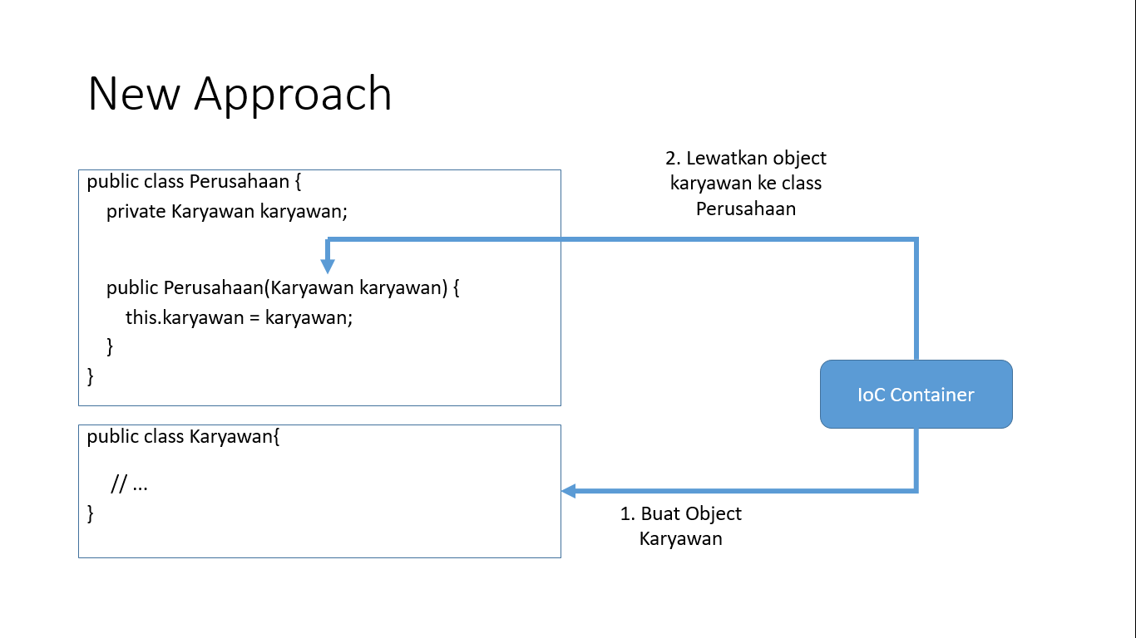

**Spring IoC Container** direpresentasikan oleh interface org.springframework.context.ApplicationContext yang bertanggungjawab membentuk *instance*, melakukan konfigurasi hingga merakit beans.

|  |
| --- |
| <?xml version="1.0" encoding="UTF-8"?>  <beans xmlns="<http://www.springframework.org/schema/beans>" xmlns:xsi="<http://www.w3.org/2001/XMLSchema-instance>" xmlns:context="<http://www.springframework.org/schema/context>" xsi:schemaLocation="<http://www.springframework.org/schema/beans> <http://www.springframework.org/schema/beans/spring-beans-4.3.xsd> <http://www.springframework.org/schema/context> <http://www.springframework.org/schema/context/spring-context-4.3.xsd>">       1. <bean id="karyawan" class="com.subrutin.belajarspring.domains.Karyawan"> 2. <property name="country" value="Indonesia" /> 3. <property name="id" value="1" /> 4. <property name="name" value="Bambang" /> 5. </bean> 6. <bean id="perusahaan" class="com.subrutin.belajarspring.domains.Perusahaan"> 7. <constructor-arg ref="karyawan" /> 8. </bean> 9. </beans> |

Pada baris 5-9, spring akan membuat object karyawan dengan nilai yang diatur pada tag property

Pada baris 10-12, Spring akan menyuntikkan (inject) object Karyawan ke kelas Perusahaanmelalui argumen pada Constructor.

## **Dependency Injection dan Beans**

http://imamfarisi.com/dependency-injection-dan-beans-di-spring-core/

# Praktek Kelas : Spring Boot

Spring Framework merupakan Dependency Injection Framework, mengapa demikian? Karena Spring Framework pada dasarnya di desain yang dimana komponennya loosely coupled dan modular sehingga tingkat ketergantungan antar komponen pada String tidaklah tinggi yang membuat kelas mudah untuk diubah dalam bentuk(kelas) lain. Hal tersebut dapat kita lihat dari banyaknya projek pada halaman resmi [Spring](https://spring.io/projects) serta penggunaan Bean pada Spring.

## **Bean (@Component, @Repository, @Service, @Controller dan @RestController)**

Bean ini merupakan instance pada suatu kelas yang kita buat, namun perlu menambahkan setidaknya anotasi **@Component** pada kelas atau turunannya **seperti @Repository, @Service, @Controller dan @RestControlle**r. Tapi kali ini hanya akan menggunakan anotasi @Component saja sebagai contoh.

// file **MusicImpl.java**  
@Component  
public class MusicImpl {  
 ....  
}// file **Music.java**  
public interface Music {  
 ....  
}// file **PopMusic.java**  
@Component  
public class PopMusic implements Music {  
 ....  
}

Pada kode diatas kelas MusicImpl &PopMusic akan dibuat bean pada Spring Application. Secara default setiap bean akan dibuat menjadi Singleton Pattern. Mengapa singleton? Karena dengan menggunakan singleton pattern memori yang digunakan untuk aplikasi menjadi lebih sedikit sehingga bisa menghemat banyak memori. Perlu diketahui Singleton yang dibuat oleh Spring Application berbeda dengan Gang of Four (GOF), yang mana singleton yang dibuat oleh spring hanya sebatas aplikasi spring saja sedangkan pada GOF dibuat pada JVM sehingga bila ada aplikasi lain tidak dapat membuat singleton yang sama.

## **Menentukan scope pada bean menggunakan @Scope**

Contoh menentukan sebuah bean akan dibuat menjadi Singleton atau Prototype :

// Contoh **Singleton**  
@Component  
@Scope(ConfigurableBeanFactory.SCOPE_SINGLETON)  
public class MusicImpl {  
 ....  
}// Contoh **Prototype**  
@Component  
@Scope(ConfigurableBeanFactory.SCOPE_PROTOTYPE)  
public class MusicImpl {  
 ....  
}

***Ingat! tanpa menambahkan anotasi @Scope, secara default scope yang akan digunakan adalah singleton****.*

## **Melakukan injeksi bean menggunakan @Autowired**

// file **MusicImpl.java**  
@Component  
public class MusicImpl {  
 **@Autowired**  
 private Music music;  
  
 public String playMusic() {  
 return music.returnMusic();  
 }  
}// file **Music.java**  
public interface Music {  
 String returnMusic();  
}// file **PopMusic.java**  
@Component  
public class PopMusic implements Music {  
 public String returnMusic() {  
 return "Play Pop Music";  
 }  
}

Dari kode diatas pada kelas MusicImpl terdapat properti Music, yang mana kelas MusicImpl tidak akan bisa terbentuk tanpa terbentuknya Music. Hal ini disebut dependency, yang mana **MusicImpl bergantung pada Music**. Kemudian pada kelas PopMusic merupakan turunan Music, yang mana kelas Music merupakan interface sehingga PopMusic implements Music. Dengan demikian PopMusic dapat digunakan pada properti Music di kelas MusicImpl.

Oke, kemudian pada properti Music terdapat anotasi @Autowired yang digunakan untuk menginjeksi bean Music (yaitu PopMusic). Secara otomatis properti music akan berisikan objek singleton dari PopMusic.

## **Menggunakan bean dengan mendefinisikan nama bean pada @Component.**

**Bagaimana bila menggunakan Music yang lain?** Oke mari lihat baris kode berikut :

// file **RockMusic.java**  
**@Component("rock")**  
public class RockMusic implements Music {  
 public String returnMusic() {  
 return "Play Rock Music";  
 }  
}

Pada anotasi @Component terdapat nilai “rock”, dengan nilai string yang diberikan seperti potongan kode di atas maka bean yang pada kelas RockMusic akan bernama “rock”. **Bagaimana cara menggunakannya?** cukup mudah, yaitu seperti berikut :

// file **MusicImpl.java**  
@Component  
public class MusicImpl {  
 @Autowired  
 private Music **rock**;  
  
 public String playMusic() {  
 return **rock**.returnMusic();  
 }  
}

Dengan menyesuaikan nama dari bean dan properti, secara otomatis bean yang terpasang pada properti pada contoh diatas merupakan kelas RockMusic. Selanjutnya pasti akan terlintas pertanyaan Apabila kita tidak memberikan nama pada komponen, apa nama default dari komponen? Nama default dari bean merupakan nama dengan **camel case**contoh untuk kelas **PopMusic** maka akan **menjadi popMusic**. Kemudian bagaimana caranya menggunakan PopMusic lagi? Cukup dengan **mengubah nama properti**yang kita gunakan menjadi popMusic.

## **Menggunakan bean dengan anotasi @Qualifier**

Apabila kurang nyaman dengan menggunakan nama properti sesuai dengan nama bean. Anotasi **@Qualifier** menjadi solusi terbaik. Dengan menambahkan anotasi **@Qualifier** pada properti seperti berikut :

// file **MusicImpl.java**  
@Component  
public class MusicImpl {  
 @Autowired  
 @Qualifier("rock")  
 private Music **music**;  
  
 public String playMusic() {  
 return **music**.returnMusic();  
 }  
}

## **Penggunaan anotasi @Primary**

Selain itu bisa juga dengan menggunakan anotasi @Primary pada salah satu dari bean, contoh :

// file **RockMusic.java**  
@Component **@Primary**  
public class RockMusic implements Music {  
 public String returnMusic() {  
 return "Play Rock Music";  
 }  
}

Dengan memberikan anotasi @Primary ini, penggunaan definisi nama tidak lagi diperhatikan. Karena secara otomatis anotasi @Autowired akan menggunakan bean yang memiliki anotasi @Primary. Hal ini akan memprioritas utamakan selalu sehingga penyesuaian nama properti dengan bean atau penggunaan @Qualifier tidak berfungsi.

# Intro Pom.xml

Berisi semua konfigurasi misalnya mendaftarkan library-library, configurasi version jdk, dll

# Kata Istilah : Spring Boot

## **Daftar Istilah Pada Spring**

| **Istilah** | **Deskripsi** |
| --- | --- |
| @Autowired | Anotasi yang digunakan untuk melakukan inject instance dari suatu bean ke objek yang memiliki dependency |
| @Configuration | Anotasi yang digunakan agar Spring container dapat membuat definisi bean dari suatu kelas dan menunjukkan bahwa suatu kelas mendeklarasikan satu atau lebih method @bean (kelas konfigurasi). (Best practice) Kelas yang mendefinisikan method main dapat menjadi kelas @Configuration utama. Tidak semua konfigurasi harus diletakkan dalam 1 kelas, anotasi @Import dapat digunakan untuk mengimport kelas @Configuration tambahan. Cara lain dapat menggunakan @ComponentScan untuk mencari secara otomatis kelas @Configuration. |
| @Component | Anotasi yang digunakan agar Spring container dapat membuat definisi bean dari suatu kelas |
| @ComponentScan | Anotasi yang digunakan untuk melakukan scan @Component, @Service, @Controller, @RestController, @Repository pada saat aplikasi mulai dijalankan, ketika @Component, @Service, @Controller, @RestController, @Repository ditemukan disinilah proses pembentukan bean terjadi yang nantinya akan digunakan untuk proses dependency injection |
| @Controller | Anotasi yang digunakan agar Spring container dapat membuat definisi bean dari suatu kelas dan menunjukkan kelas tersebut adalah kelas controller |
| @Repository | Anotasi yang digunakan agar Spring container dapat membuat definisi bean dari suatu kelas dan menunjukkan kelas tersebut adalah kelas repository |
| @RestController | Anotasi yang digunakan agar Spring container dapat membuat definisi bean dari suatu kelas dan menunjukkan kelas tersebut adalah kelas rest controller |
| @RequestMapping | Anotasi yang digunakan untuk melakukan mapping url dengan method |
| @Service | Anotasi yang digunakan agar Spring container dapat membuat definisi bean dari suatu kelas dan menunjukkan kelas tersebut adalah kelas service |
| @SpringBootApplication | Anotasi yang digunakan untuk menggantikan deklarasi @Configuration, @EnableAutoConfiguration dan @ComponentScan secara bersamaan dengan menggunakan atribut default dari masing-masing anotasi yang digantikan tadi. Untuk @ComponentScan atribut default untuk package yang discan adalah package yang ada pada kelas yang memiliki anotasi ini |
| @EnableAutoConfiguration | Anotasi yang digunakan agar Spring dapat melakukan konfigurasi secara otomatis berdasarkan dependency jar yang ditambahkan. (Best practice) Dalam satu projek Spring, anotasi @EnableAutoConfiguration hanya boleh digunakan satu kali dan biasanya ditambahkan hanya di kelas @Configuration utama. |
| Bean | Objek yang dibuat dan diatur oleh Spring IoC Container |
| Dispatcher Servlet atau Front Controller | Program yang digunakan untuk mengatur alur kerja pemrosesan request web pada Spring |
| IoC (Inverse of Control) atau Dependency Injection | Spring akan mengatur dependency suatu objek dengan membuat suatu instance atas dependency objek tersebut |
| Runtime | Waktu pada saat program mulai dijalankan pada komputer (tahap compile) |
| Servlet | Program kecil pada web server Java yang akan berjalan secara otomatis sebagai bentuk respon dari inputan user |

* **@Repository** merupakan penanda untuk setiap kelas yang memenuhi peran atau stereotip dari repositori (juga dikenal sebagai Data Access Object atau DAO).

Annotation │ Meaning │

├──────────────┼─────────────────────────────────────────────────────┤

│ @Component │ generic stereotype for any Spring-managed component │

│ @Repository │ stereotype for persistence layer │

│ @Service │ stereotype for service layer │

│ @Controller │ stereotype for presentation layer (spring-mvc)

1. @Controller-> Kelas yang dijelaskan dengan ini, dimaksudkan untuk menerima permintaan dari sisi klien. Permintaan pertama datang ke Servlet Dispatcher, dari mana ia mengirimkan permintaan ke pengontrol tertentu menggunakan nilai @RequestMappinganotasi.
2. @Service-> Kelas yang dijelaskan dengan ini, dimaksudkan untuk memanipulasi data, yang kami terima dari klien atau mengambil dari database. Semua manipulasi dengan data harus dilakukan di lapisan ini.
3. @Repository-> Kelas yang dijelaskan dengan ini, dimaksudkan untuk terhubung dengan database. Itu juga dapat dianggap sebagai lapisan DAO (Data Access Object). Lapisan ini harus dibatasi hanya untuk operasi CRUD (buat, ambil, perbarui, hapus). Jika diperlukan manipulasi, data harus dikirim dikirim kembali ke lapisan @Service.
4. @Componant : mandaftarkan kelas supaya dikenal oleh spring boot. bertindak sebagai anotasi @Bean di kelas konfigurasi, register bean dalam konteks musim semi. Juga merupakan induk untuk penjelasan @Service, @Repository, dan @Controller.

# CommandLineRunner

* **CommandLineRunner** adalah interface yang memiliki metode run().
* **Digunakan** untuk mengeksekusi beberapa kode tepat setelah spring boot application dimulai.
* **Contoh** Penggunaan untuk insert default data ke tabel database.

**Contoh :**

|  |
| --- |
| import org.slf4j.Logger; import org.slf4j.LoggerFactory; import org.springframework.boot.CommandLineRunner; import org.springframework.stereotype.Component;  import java.util.Date;  @Component public class MyRunner implements CommandLineRunner {   private static final Logger *logger* = LoggerFactory.*getLogger*(MyRunner.class);   @Override  public void run(String... args) throws Exception {  *logger*.info("{}", "Running ke" + new Date());  } } |

# Java Logging

## Apa itu logging?

Logging merupakan tools untuk membantu dalam memahami dan melakukan debugging behavior yang terjadi saat program berjalan.

Contoh:

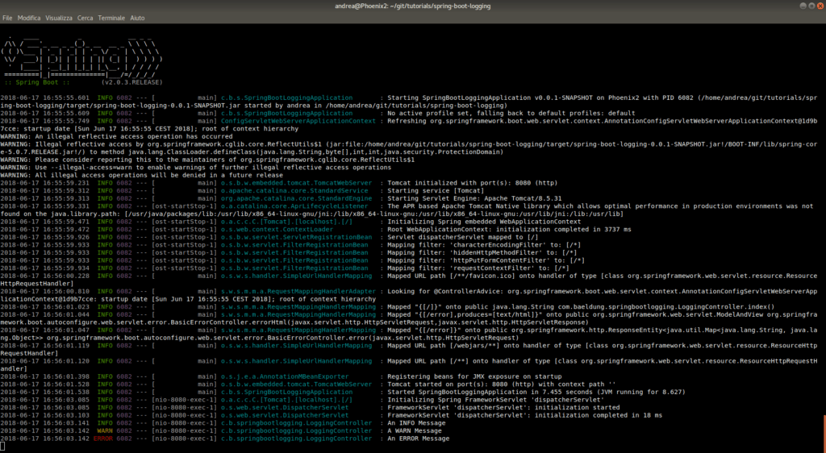 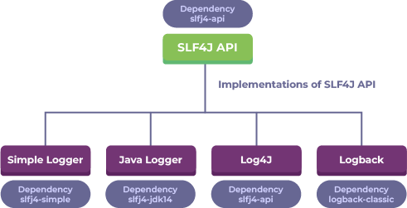

## Hirarki logging

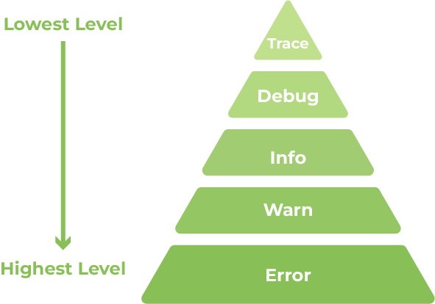

## Baca log logging

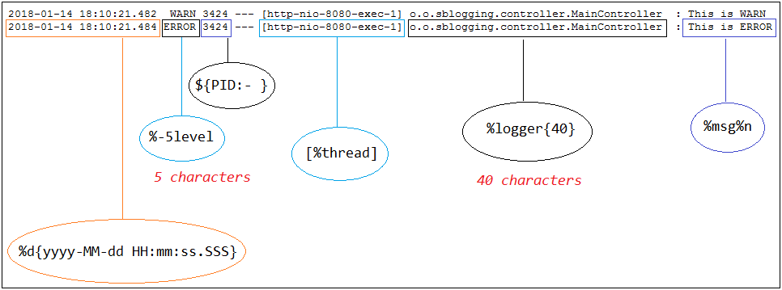

## Cara membuat logging

Pom.xml

|  |
| --- |
| <dependency>  <groupId>org.slf4j</groupId>  <artifactId>slf4j-api</artifactId>  <version>2.0.9</version> </dependency> <dependency>  <groupId>ch.qos.logback</groupId>  <artifactId>logback-core</artifactId>  <version>1.4.11</version> </dependency> <dependency>  <groupId>ch.qos.logback</groupId>  <artifactId>logback-classic</artifactId>  <version>1.4.11</version> </dependency> |

|  |
| --- |
| package com.binar5.apps.testing;  import com.binar5.apps.AppsApplication; import org.junit.Test; import org.slf4j.Logger; import org.slf4j.LoggerFactory; import org.springframework.boot.test.context.SpringBootTest;  @SpringBootTest public class TestingLogging {   private static Logger *logger* = LoggerFactory.*getLogger*(TestingLogging.class);   @Test  public void testLogging(){  *logger*.info("info logging level");  *logger*.error("eror logging level");  *logger*.warn("warning logging level");  *logger*.debug("debug logging level");  *logger*.trace("trace logging level");  } } |

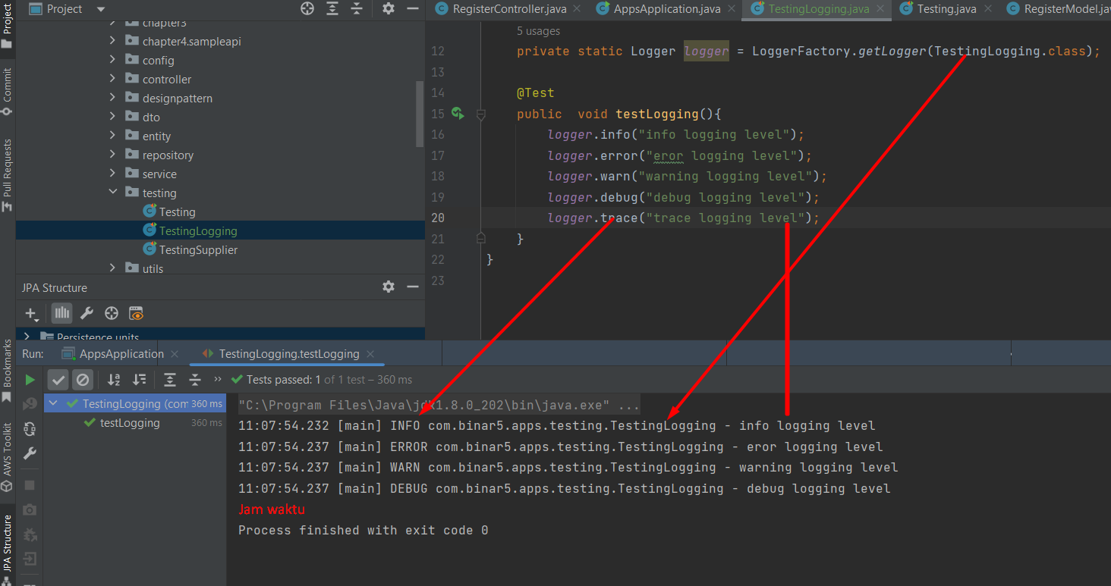

## Cara membuat output logging : File

### Struktur project

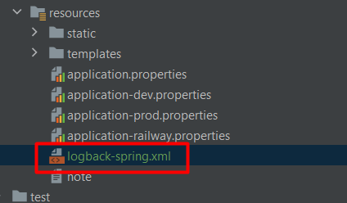

|  |
| --- |
| <?xml version="1.0" encoding="UTF-8"?> <configuration>  <property name="DIRECTORY" value="./logs" />  <appender name="STDOUT" class="ch.qos.logback.core.ConsoleAppender">  <encoder>  <pattern>[%d{yyyy-MM-dd HH:mm:ss.sss}][%-5p][%C][%t][%L]%m%n  </pattern>  </encoder>  </appender>  <timestamp key="dateFormat" datePattern="yyyy-MM-dd" />  <appender name="FILE"  class="ch.qos.logback.core.rolling.RollingFileAppender">  <file>${DIRECTORY}/application-${dateFormat}.log</file>   <rollingPolicy  class="ch.qos.logback.core.rolling.SizeAndTimeBasedRollingPolicy">  <!-- rollover daily -->  <fileNamePattern>${DIRECTORY}/%d{yyyy/MM/dd, aux}/logfile-%d{yyyy-MM-dd}.%i.log  </fileNamePattern>  <maxFileSize>50MB</maxFileSize>  </rollingPolicy>  <encoder>  <pattern>[%d{yyyy-MM-dd HH:mm:ss.sss}][%-5p][%C][%t][%L]%m%n  </pattern>  </encoder>  </appender>  <root level="info">  <appender-ref ref="FILE" />  <appender-ref ref="STDOUT" />  </root> </configuration> |
| Apa itu rollingPolicy? Ketika sudah mencapai maksimum size,, makan akan membuat file baru berdassarkan patter di rolllling policy |

### Directori file ada disini :

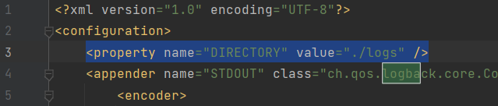

### Output:

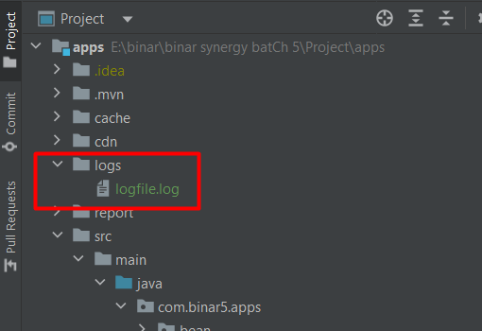

### Branch

<https://github.com/rikialdi/binar_batch_5/pull/new/241122-logging>

## memunculkan trace dand debug

tambahkan di application.properties untuk dapat menampilkan output file

|  |
| --- |
| *logging.level.root*=DEBUG *logging.level.com.aplikasi.karyawan.ch4*=TRACE |

|  |
| --- |
| Konfigurasi logging.level.root dalam sebuah sistem logging mengatur level logging untuk logger root, yang merupakan induk dari semua logger lainnya dalam hierarki logging.  logging.level.root diikuti oleh nilai level logging, yang menentukan jenis pesan apa yang akan direkam oleh logger root dan logger-loger di bawahnya. Level-level logging umumnya terdiri dari:   * TRACE: Pesan tingkat detail terendah. Digunakan untuk merekam detail-detail implementasi yang sangat mendalam. * DEBUG: Pesan tingkat detail rendah. Digunakan untuk merekam informasi yang berguna untuk debugging. * INFO: Pesan tingkat informasi. Digunakan untuk merekam informasi yang berguna untuk pemantauan dan pelaporan. * WARN: Pesan tingkat peringatan. Digunakan untuk merekam situasi yang mungkin menyebabkan masalah atau perlu diperhatikan. * ERROR: Pesan tingkat kesalahan. Digunakan untuk merekam situasi kesalahan yang tidak mematikan. * FATAL: Pesan tingkat fatal. Digunakan untuk merekam situasi kesalahan yang mematikan. * Contoh pengaturan logging.level.root adalah:   Copy code  logging.level.root=INFO  Artinya, sistem logging akan merekam semua pesan informasi (INFO) atau yang lebih tinggi dari itu (yaitu, WARN, ERROR, FATAL). Level-level logging di bawah INFO seperti DEBUG dan TRACE akan diabaikan. |

Maka outputnya

:

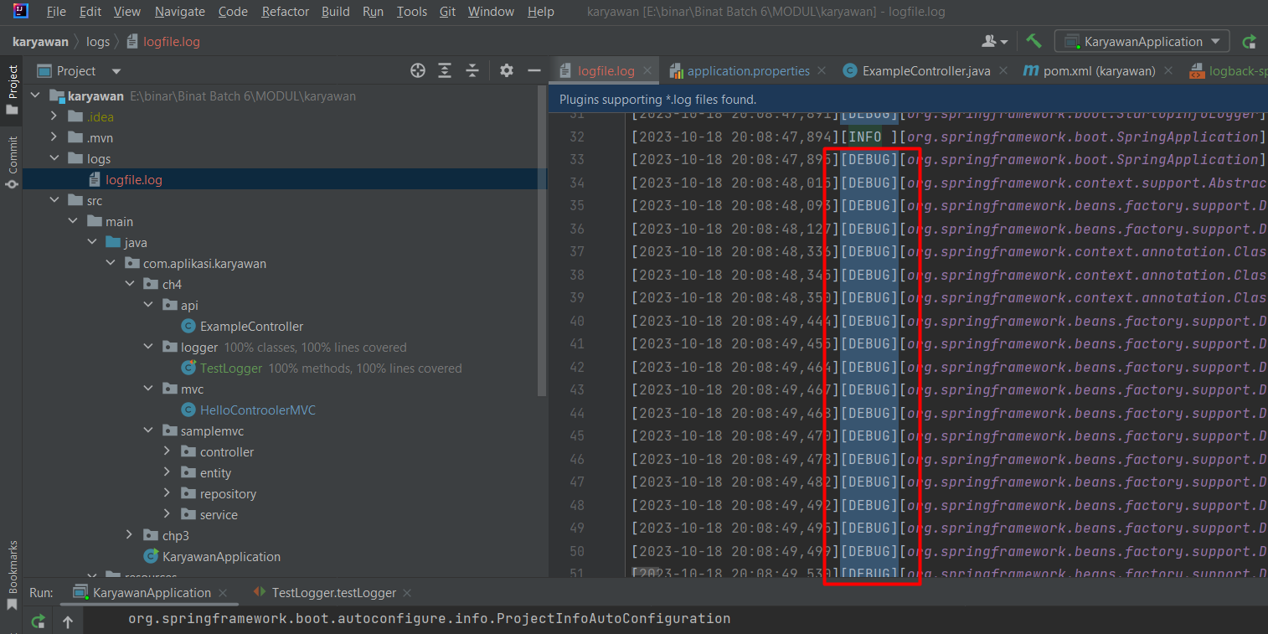

## Contoh Penerapan Pada API

|  |
| --- |
| // Inisialisasi logger private static final Logger *logger* = Logger.getLogger(MyApiClass.class.getName());  public void processRequest(Request request) {  // Contoh penggunaan logger  *logger*.info("Received request: " + request.toString());   try {  // Proses permintaan  // ...  } catch (Exception e) {  // Tangani kesalahan dan log  *logger*.error("Error processing request");  } } |

# JPA

JPA adalah sebuah spesifikasi atau standar, tentang bagaimana kita menyimpan sebuah objek di Java. JPA sendiri adalah singkatan dari Java Persistence API. *Persist* sendiri berarti: teguh; tahan lama; tidak berubah dalam kurun waktu tertentu. Umumnya objek di Java adalah data. Data biasanya disimpan agar dapat digunakan kembali (reusable). *Persistence* sendiri dimaksudkan agar objek Java yang pakai di aplikasi ini dapat disimpan sehingga tetap ada dan dapat digunakan kembali nantinya meskipun (misalnya) aplikasi yang memproduksi atau mengkonsumsi objek ini sudah mati atau tidak berjalan lagi.

Berbicara tentang JPA, biasanya tidak terlepas dari berbicara tentang database. JPA ada dalam package javax.persistence.*.

## Mengapa menggunakan JPA

Sebagai standar untuk mengimplementasikan:

* data mana yang akan disimpan dan,
* bagaimana cara kita menyimpan data tersebut.

## Keuntungan menggunakan JPA

Dengan menggunakan JPA, kita tidak perlu ribet memikirkan bagaimana data tersebut akan di-store ke database, cara menerjemahkan sebuah objek menjadi tabel di database ataupun cara kita mengambil 1 row data dari tabel dan diterjemahkan kembali menjadi sebuah objek yang dapat kita gunakan langsung di dalam aplikasi Java.

## ORM

Object Relational Mapping (ORM) sederhananya adalah framework yang mengimplementasi standar yang ditetapkan oleh JPA. ORM melakukan translasi dari sebuah objek Java ke dalam tabel database yang dimaksud. Jika JPA menetapkan bahwa, agar sebuah class Java dapat ditranslasi menjadi tabel, class tersebut harus dipasangi anotasi @Entity. Lalu tugas ORM adalah menerjemahkan class tersebut ke dalam tabel. ORM juga melakukan mapping field atau properti dari sebuah class menjadi kolom pada tabel di database. Sebuah properti firstName pada class Student akan menjadi kolom first_name pada tabe student di database, misalnya.

Framework ORM yang paling mature dan banyak digunakan untuk implementasi JPA adalah Hibernate.

## Langkah-langkah menggunakan JPA di Spring Boot

**Add depedencis Pom.xml**

|  |
| --- |
| <dependency>  <groupId>org.springframework.boot</groupId>  <artifactId>spring-boot-starter-data-jpa</artifactId> </dependency>  Tambahakn lib posgres  <dependency>  <groupId>org.postgresql</groupId>  <artifactId>postgresql</artifactId>  <scope>runtime</scope> </dependency> |

**Konfigurasi application properties**

|  |
| --- |
| spring.datasource.url=jdbc:postgresql://localhost:5433/db spring.datasource.username=postgres spring.datasource.password=12345 spring.datasource.hikari.maximum-pool-size=100 spring.datasource.initialization-mode=*always* spring.jpa.show-sql=true spring.jpa.hibernate.ddl-auto=update |

# Rest API : Studi kasus Barang

**Diketahui** :

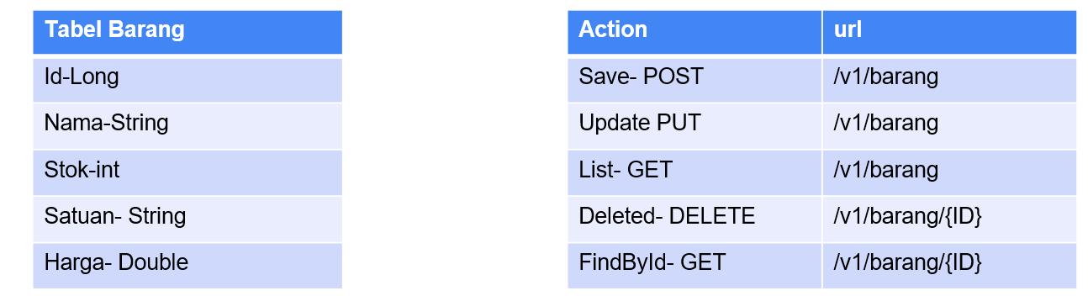

Atau employee

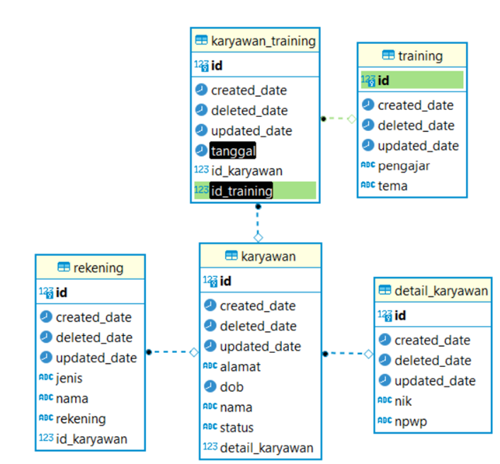

**Jawab**

## **Pom.xml**

|  |
| --- |
| <dependency>  <groupId>org.springframework.boot</groupId>  <artifactId>spring-boot-starter-data-jpa</artifactId> </dependency>  <!-- https://mvnrepository.com/artifact/org.hibernate/hibernate-core --> <dependency>  <groupId>org.hibernate</groupId>  <artifactId>hibernate-core</artifactId>  <version>5.6.5.Final</version> </dependency> <!--valdation--> <dependency>  <groupId>org.hibernate.validator</groupId>  <artifactId>hibernate-validator</artifactId>  <version>6.0.13.Final</version> </dependency> <dependency>  <groupId>javax.validation</groupId>  <artifactId>validation-api</artifactId>  <version>2.0.1.Final</version> </dependency> |
|  |

## Project strukture

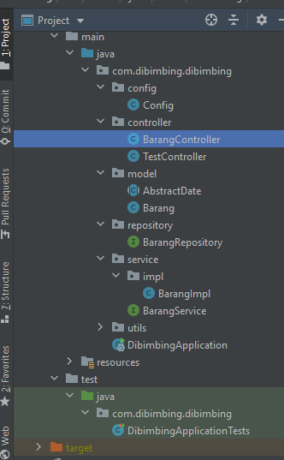

## JPA Date

Format yyyy-MM-DD

|  |
| --- |
| @Temporal(TemporalType.*DATE*) @JsonFormat(pattern = "yyyy-MM-dd") private Date dob;  Output |

## JPA Entity

Unutk foreing key dapat menggunakan ini

|  |
| --- |
| @ManyToOne(cascade = CascadeType.*ALL*) // FK dari tabel @JoinColumn(name = "id_karyawan") @PrimaryKeyJoinColumn private Employee karyawan; |

JPA Entity adalah sebuah class yang merepresentasikan table yang ada di database.

Contoh

|  |
| --- |
| @Entity @Table(name = "barang")  @Where(clause = "deleted_date is null") public class Barang implements Serializable {    @Id  @Column(name="id")  @GeneratedValue(strategy = GenerationType.*ENTITY*)  private Long id;   @Column(name = "nama", nullable = false, length = 45)  private String nama;   @Column(name = "stok", nullable = false, length = 11)  private int stok;   @Column(name = "satuan", nullable = false, length = 45)  private String satuan;   @Column(name = "harga", nullable = false, length = 11)  private Double harga;  } |

Atau dengan UUID

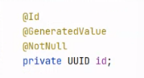

Secara otomatis, nama dari entity akan disesuaikan dengan nama class tersebut. Dengan menambahkan anotasi **@Entity**tersebut, artinya class **Tour** kita sudah di-mapping dengan table **tour**. Berikutnya, layaknya sebuah table, anotasi entity ini juga harus memiliki sebuah primary key yang ditandai dengan anotasi **@Id**. Jika kita ingin primary key yang kita miliki di-generate secara otomatis, maka kita bisa menggunakan anotasi **@GeneratedValue**. Anotasi **@GeneratedValue** ini memiliki 4 jenis strategi untuk generate primary key, yakni **AUTO, TABLE, SEQUENCE**dan**IDENTITY.**

Biasanya kita ingin men-generate primary key secara auto increment, maka kita bisa gunakan strategi **IDENTITY.** Selain itu kita juga bisa menggunakan anotasi **@Column** untuk class properti yang kita miliki agar lebih spesifik. Misalnya untuk sebuah description, kita ingin column tersebut bisa menampung 2000 character, maka kita dapat spesifikkan dengan cara :

|  |
| --- |
| @Column(name="description", length = 2000) public String description; |

## JPA REPOSITORI

JpaRepository adalah repository dari Java Peristence API yang dapat memudahkan kita sebagai developer membuat CRUD pada String Data. Dengan JpaRepository, kamu tidak perlu lagi membuat method insert() atau save() berkali kali pada repository. Karena JpaRepository memiliki method bawaan yang bisa kita gunakan pada semua interface repository, untuk memakai repository JpaRepository kita Cuma wajib membuat objek dari repository tersebut diikuti oleh anotasi @Autowired di atasnya.

|  |
| --- |
| @Repository public interface BarangRepository extends PagingAndSortingRepository<Barang, Long> {  @Query("select c from Barang c")// nama class  public Page<Barang> getAllData(Pageable pageable);   @Query("select c from Barang c WHERE c.id = :idbarang")  public Barang getbyID(@Param("idbarang") Long idbebas); } |

## Service / interface

**Interface adalah** blue print dari **class**. Isi method-nya kosong dan nanti akan diimplementasikan pada **class** lain.

|  |
| --- |
| public interface BarangService { public Map insert(Barang barang);  public Map update(Barang barang);  public Map delete(Long barang);  public Map getAll(int size, int page);  } |

**Service impl**

|  |
| --- |
| @Service public class BarangImpl implements BarangService {    @Autowired  public BarangRepository barangRepository;   public static final Logger *log* = LoggerFactory.*getLogger*(BarangImpl.class);    @Autowired  public TemplateResponse templateResponse;   @Override  public Map insert(Barang obj) {  try {  if (templateResponse.chekNull(obj.getNama())) {  return templateResponse.templateEror("Nama is Requiered");  }   if (templateResponse.chekNull(obj.getHarga())) {  return templateResponse.templateEror("Harga is requiered");  }  Barang barangSave = barangRepository.save(obj);  return templateResponse.templateSukses(barangSave);  } catch (Exception e) {  return templateResponse.templateEror(e);  }  }   @Override  public Map getAll(int size, int page) {  try {  Pageable show_data = PageRequest.*of*(page, size);  Page<Barang> list = barangRepository.getAllData(show_data);  return templateResponse.templateSukses(list);  } catch (Exception e) {  *log*.error("ada eror di method getAll:" + e);  return templateResponse.templateEror(e);  }  }    @Override  public Map update(Barang barangReq) {  try {   if (templateResponse.chekNull(barangReq.getId())) {  return templateResponse.templateEror("Id Barang is required");  }  Barang chekIdBarang = barangRepository.getbyID(barangReq.getId());  if (templateResponse.chekNull(chekIdBarang)) {  return templateResponse.templateEror("Id Barang Not found");  }   chekIdBarang.setNama(barangReq.getNama());  chekIdBarang.setHarga(barangReq.getHarga());  chekIdBarang.setStok(barangReq.getStok());  chekIdBarang.setSatuan(barangReq.getSatuan());  Barang dosave = barangRepository.save(chekIdBarang);   return templateResponse.templateSukses(dosave);  } catch (Exception e) {  return templateResponse.templateEror(e);  }   }   @Override  public Map delete(Long barang) {  try {  if (templateResponse.chekNull(barang)) {  return templateResponse.templateEror("Id Barang is required");  }   Barang chekIdBarang = barangRepository.getbyID(barang);  if (templateResponse.chekNull(chekIdBarang)) {  return templateResponse.templateEror("Id Barang Not found");  }   chekIdBarang.setDeleted_date(new Date());//  barangRepository.save(chekIdBarang);   return templateResponse.templateSukses("sukses deleted");   } catch (Exception e) {  return templateResponse.templateEror(e);  }  } } |

## Controller

**Controller** adalah **class** atau script yang bertanggung jawab merespon sebuah request. Ia bisa saja merespon dengan mengirimkan view, data JSON, data XML, atau bahkan tidak mengirimkan respon apapun

|  |
| --- |
| @RestController @RequestMapping("/v1/barang") public class BarangController {   @Autowired  public BarangService barangService;   Config config = new Config();   @Autowired  public BarangRepository barangRepository;   @Autowired  public TemplateResponse templateResponse;    @PostMapping("/save")  @ExceptionHandler(ConstraintViolationException.class)  public ResponseEntity<Map> save(@Valid @RequestBody Barang objModel) {  Map obj = barangService.insert(objModel);  return new ResponseEntity<Map>(obj, HttpStatus.*OK*);  }   @PutMapping("/update")  public ResponseEntity<Map> update(@RequestBody Barang objModel) {  Map map = barangService.update(objModel);  return new ResponseEntity<Map>(map, HttpStatus.*OK*);  }   @DeleteMapping("/delete/{id}")  public ResponseEntity<Map> delete(@PathVariable(value = "id") Long id) {  Map map = barangService.delete(id);  return new ResponseEntity<Map>(map, HttpStatus.*OK*);  }   @GetMapping("/list")  public ResponseEntity<Map> listByBama(  @RequestParam() Integer page,  @RequestParam() Integer size) {  Map list = barangService.getAll(size, page);  return new ResponseEntity<Map>(list, new HttpHeaders(), HttpStatus.*OK*);  } } |

## Config and Utils

**Config**

|  |
| --- |
| @Data public class Config {  String code = "status", message = "message";  public String code_notFound ="404";   public String codeRequired ="403";  public String isRequired =" is Required";   public String code_sukses = "200";  public String code_server = "500";  public String code_null = "1";  public String message_sukses = "sukses";   public String convertDateToString(Date date) {   DateFormat dateFormat = new SimpleDateFormat("yyyyMMddHHmmss");  String strDate = dateFormat.format(date);  return strDate;  } } |

**Utils**

|  |
| --- |
| @Component // IOC - Beans public class TemplateResponse {   public Map templateSukses(Object objek){  Map map = new HashMap();  map.put("data", objek);  map.put("message", "sukses");  map.put("status", "200");  return map;  }   public Map templateEror(Object objek){  Map map = new HashMap();  map.put("message", objek);  map.put("status", "404");  return map;  }  public Map notFound(Object objek){  Map map = new HashMap();  map.put("message", objek);  map.put("status", "404");  return map;  }    public boolean chekNull(Object obj){  if(obj == null){  return true;  }  return false;  } } |

## Output

**POST**

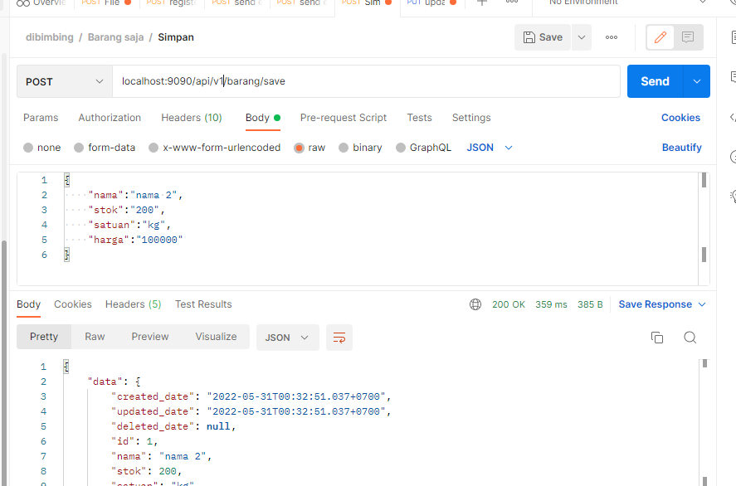

**PUT**

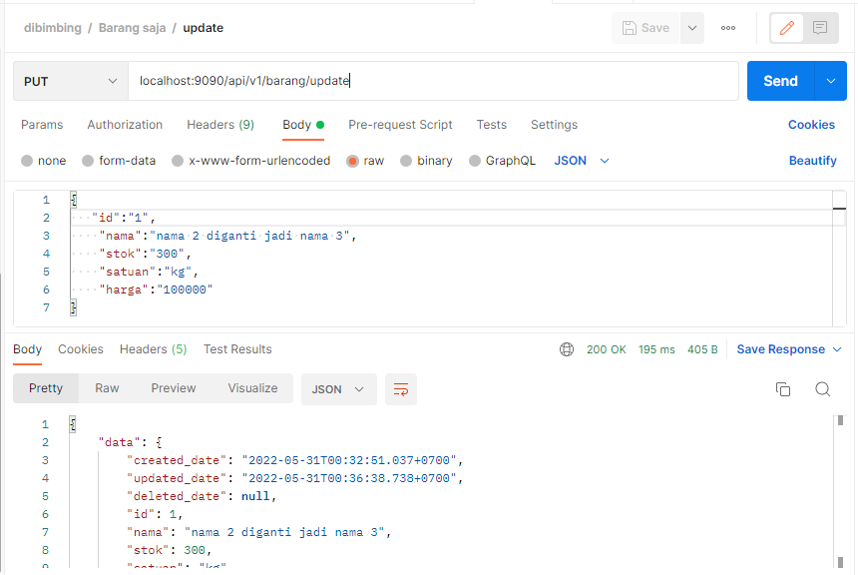

**LIST**

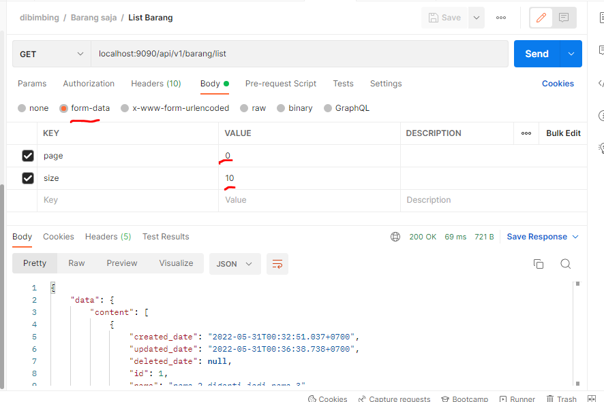

**DELETED**

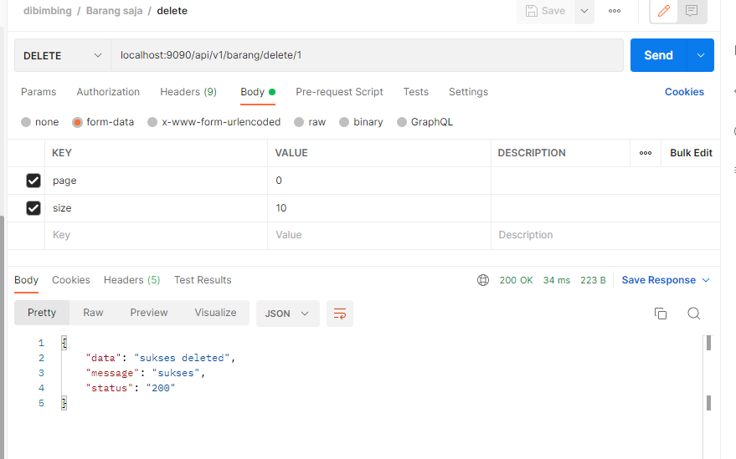

## Branch

<https://github.com/rikialdi/dibimbing/tree/rest-intro>

# Rest API : Studi Kasus Employee : CRUD API

## Query JPA

### ERD



|  |
| --- |
| Step –   1. Koneksi 2. Entity 3. Repository 4. Service – Sercive Implementasi 5. Controller 6. Output – Testing |

### Entity

|  |
| --- |
| package com.aplikasi.karyawan.entity;  import com.fasterxml.jackson.annotation.JsonFormat; import jakarta.persistence.*; import lombok.Data; import org.hibernate.annotations.Where; import org.springframework.boot.autoconfigure.domain.EntityScan; import org.springframework.format.annotation.DateTimeFormat;  import java.io.Serializable; import java.util.Date;  //@EntityScan @Data @Entity @Table(name = "employee") @Where(clause = "deleted_date is null") public class Employee extends AbstractDate implements Serializable {  @Id  @Column(name = "id")  @GeneratedValue(strategy = GenerationType.*IDENTITY*)  public Long id;   public String name;   @Column(name = "address", columnDefinition = "TEXT")  public String address;   // 2016-01-01  @Temporal(TemporalType.*DATE*)  @JsonFormat(pattern = "yyyy-MM-dd")  private Date dob;   public String status; } |

### Repository

|  |
| --- |
| package com.aplikasi.karyawan.repository;  import com.aplikasi.karyawan.entity.Employee; import org.springframework.data.jpa.repository.Query; import org.springframework.data.repository.PagingAndSortingRepository; import org.springframework.data.repository.query.Param; import org.springframework.stereotype.Repository;  @Repository public interface EmployeeRepository extends PagingAndSortingRepository<Employee,Long> {  //JPA Query  @Query(value = "select c from Employee c WHERE c.id = :idEmployee", nativeQuery = false)  public Employee getById(@Param("idEmployee") Long idEmployee);   //Native Query : menggunakan JPAQL  @Query(value = "select e from employee e where id = :idEmployee;",nativeQuery = true)  public Object getByIdNativeQuery(@Param("idEmployee") Long idEmployee);  } |

### Testing Junit JPA

|  |
| --- |
| package com.aplikasi.karyawan.testing;   import com.aplikasi.karyawan.entity.Employee; import com.aplikasi.karyawan.repository.EmployeeRepository; import org.junit.Before; import org.junit.Test; import org.junit.runner.RunWith; import org.springframework.beans.factory.annotation.Autowired; import org.springframework.boot.test.context.SpringBootTest; import org.springframework.test.context.junit4.SpringRunner;  @RunWith(SpringRunner.class) @SpringBootTest(webEnvironment = SpringBootTest.WebEnvironment.*RANDOM_PORT*) public class TestinJPA {   @Autowired  public EmployeeRepository employeeRepository;   @Before  public void abc(){  }  @Test  public void getIDJPAQL(){  Employee employee= employeeRepository.getById(1L);  System.*out*.println(employee.getId());  }   @Test  public void countEmployee(){  System.*out*.println("count="+employeeRepository.count());  } } |

## Relasi Entity (one to one, one to many, many to many)

Untuk foreign key dapat menggunakan ini

|  |
| --- |
| @ManyToOne(cascade = CascadeType.*ALL*) // FK dari tabel @JoinColumn(name = "id_karyawan") @PrimaryKeyJoinColumn private Employee karyawan; |

### Employee

|  |
| --- |
| package com.aplikasi.karyawan.entity;  import com.fasterxml.jackson.annotation.JsonFormat; import com.fasterxml.jackson.annotation.JsonIgnore; import jakarta.persistence.*; import lombok.Data; import org.hibernate.annotations.Where; import org.springframework.boot.autoconfigure.domain.EntityScan; import org.springframework.format.annotation.DateTimeFormat;  import java.io.Serializable; import java.util.Date; import java.util.List;  //@EntityScan @Data @Entity @Table(name = "employee") @Where(clause = "deleted_date is null") public class Employee extends AbstractDate implements Serializable {  @Id  @Column(name = "id")  @GeneratedValue(strategy = GenerationType.*IDENTITY*)  public Long id;   public String name;   @Column(name = "address", columnDefinition = "TEXT")  public String address;   // 2016-01-01  @Temporal(TemporalType.*DATE*)  @JsonFormat(pattern = "yyyy-MM-dd")  private Date dob;   public String status = "active";   @OneToOne(cascade = CascadeType.*ALL*,fetch = FetchType.*EAGER*)// ono to one  @JoinColumn(name = "id_detail_karyawan") //nama column  private DetailEmployee detailEmployee;    @JsonIgnore //: 100 rekening tampilin ke 100, ga ddisaranakan dengan banyak data  @OneToMany(mappedBy = "employee", fetch = FetchType.*LAZY*, cascade = CascadeType.*ALL*) // employee_id  private List<Rekening> rekenings;  /*  */  } |

### Detail employee

|  |
| --- |
| package com.aplikasi.karyawan.entity;  import lombok.Data; import org.hibernate.annotations.Where;  import jakarta.persistence.*; import java.io.Serializable; import java.util.Date;  @Data @Entity @Table(name = "karyawan_training") @Where(clause = "deleted_date is null") public class KaryawanTraining extends AbstractDate implements Serializable {  @Id  @GeneratedValue(strategy = GenerationType.IDENTITY)  @Column(name = "id")  private Long id;   @Column  private Date tanggal;   //relasi antar tabel ditandai adanya many to one  @ManyToOne(cascade = CascadeType.ALL)  @JoinColumn(name = "id_training")  private Training training;   @ManyToOne(cascade = CascadeType.ALL) // FK dari tabel  @JoinColumn(name = "id_karyawan")  private Employee karyawan; } |

### Rekening

|  |
| --- |
| package com.aplikasi.karyawan.entity;  import com.fasterxml.jackson.annotation.JsonIgnore; import lombok.Data; import org.hibernate.annotations.Where;  import jakarta.persistence.*; import java.io.Serializable; import java.util.List;  @Data @Entity @Table(name = "rekening") @Where(clause = "deleted_date is null") public class Rekening extends AbstractDate implements Serializable {  @Id  @GeneratedValue(strategy = GenerationType.*IDENTITY*)  @Column(name = "id")  private Long id;   @Column(name = "nama")  private String nama;   @Column(name = "jenis")  private String jenis;   @Column(length = 100)  private String rekening;  // @JsonIgnore  @ManyToOne  @JoinColumn(name = "id_karyawan")  private Employee employee;  } |

### Training

|  |
| --- |
| package com.aplikasi.karyawan.entity;  import lombok.Data; import org.hibernate.annotations.Where;  import jakarta.persistence.*; import java.io.Serializable;  @Data @Entity @Table(name = "training") @Where(clause = "deleted_date is null") public class Training extends AbstractDate implements Serializable {  @Id  @GeneratedValue(strategy = GenerationType.IDENTITY)  @Column(name = "id")  private Long id;   @Column(name = "pengajar")  private String pengajar;   @Column(name = "tema")  private String tema;  } |

### Karyawan training

|  |
| --- |
| package com.aplikasi.karyawan.entity;  import lombok.Data; import org.hibernate.annotations.Where;  import jakarta.persistence.*; import java.io.Serializable; import java.util.Date;  @Data @Entity @Table(name = "karyawan_training") @Where(clause = "deleted_date is null") public class KaryawanTraining extends AbstractDate implements Serializable {  @Id  @GeneratedValue(strategy = GenerationType.*IDENTITY*)  @Column(name = "id")  private Long id;   @Column  private Date tanggal;   //relasi antar tabel ditandai adanya many to one  @ManyToOne(cascade = CascadeType.*ALL*)  @JoinColumn(name = "id_training")  private Training training;   @ManyToOne(cascade = CascadeType.*ALL*) // FK dari tabel  @JoinColumn(name = "id_karyawan")  private Employee karyawan; } |

### Output ERD



## Repository

## Service – Service Implmentasi / logic

## Controller

# Studi Kasus : Relasi Spring Boot

## Case

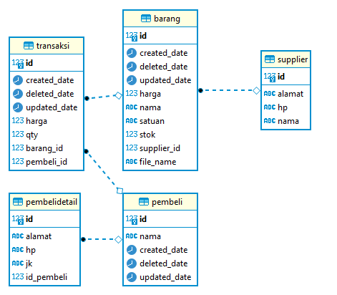

## Task

|  |  |  |
| --- | --- | --- |
| Supplier | save |  |
|  | update |  |
|  | List with Pagination |  |
|  | Soft Delete |  |
|  |  |  |
|  |  |  |
|  |  |  |
|  |  |  |

## Step 1- Create entitas

Entitas: membuat tabel secara otomatis

### Supplier

|  |
| --- |
| @Data @Entity @Table(name = "supplier") public class Supplier implements Serializable {  @Id  @Column(name="id")  @GeneratedValue(strategy = GenerationType.*IDENTITY*)  private Long id;   @Column(name = "nama", nullable = false, length = 45)  private String nama;   @Column(name = "hp", nullable = false, length = 15)  private String hp;   @Column(name = "alamat", columnDefinition="TEXT")  private String alamat;  } |

### Barang

|  |
| --- |
| // wajib @ManyToOne(targetEntity = Supplier.class, cascade = CascadeType.*ALL*) private Supplier supplier;//ok supplier_id  Pada gambar dibawah ini : menandakan relasi Many to One |

### Pembeli

|  |
| --- |
| @Data @Entity @Table(name = "pembeli") @Where(clause = "deleted_date is null") public class Pembeli extends AbstractDate implements Serializable {  @Id  @Column(name="id")  @GeneratedValue(strategy = GenerationType.*IDENTITY*)  private Long id;   @Column(name = "nama", nullable = false, length = 45)  private String nama;   //step 1 one to one  @OneToOne(mappedBy = "pembeli")  private PembeliDetail pembeliDetail; }  Pada gambar dibawah ini : menandakan relasi one to one ke detail Pembeli |

### Detail pembeli

|  |
| --- |
| import com.fasterxml.jackson.annotation.JsonIgnore; import lombok.Data;  import javax.persistence.*; import java.io.Serializable;  @Data @Entity @Table(name = "pembelidetail") public class PembeliDetail implements Serializable {  @Id  @Column(name="id")  @GeneratedValue(strategy = GenerationType.*IDENTITY*)  private Long id;   @Column(name = "hp", length = 15)  private String hp;   @Column(name = "jk", length = 15)  private String jk;   @Column(name = "alamat", columnDefinition="TEXT")  private String alamat;   // step one one : FK  @JsonIgnore  @OneToOne(cascade = CascadeType.*ALL*)  @JoinColumn(name = "id_pembeli", referencedColumnName = "id")  private Pembeli pembeli;  }  pada gambar dibawah ini: menandakan relasi one to one. Di kelas pembeli detail akan terbentuk FK |

### Transaksi

|  |
| --- |
| @Data @Entity @Table(name = "transaksi") @Where(clause = "deleted_date is null") public class Transaksi extends AbstractDate implements Serializable {  @Id  @Column(name="id")  @GeneratedValue(strategy = GenerationType.*IDENTITY*)  private Long id;   @ManyToOne  @JoinColumn(name = "barang_id")  Barang barang;   @ManyToOne  @JoinColumn(name = "pembeli_id")  Pembeli pembeli;   private Double harga;   private Integer qty;  }  Gambar dibawah ini merepresentasikan many to one. |

## Step 2- Create Repository

Repository : semua query yang berhubungan dengan tabel database akan ditulis disini.

Penulisanquery ada banyak cara: query native, query JPQL(Java Persistence Query Language)

**JPQL** adalah bahasa query JPA yang mirip dengan SQL. Bedanya, dalam JPQL kita menggunakan nama object dan property, bukan nama tabel dan kolom.

Contoh

Page<Barang> findByNamaAndAge(String nama, String amur, Pageable pageable);

**Native Query :** penulisan tabel dan column menyesuaikan dengan nama table pada database

Contoh

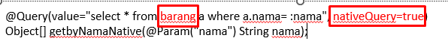

Silahkan refer ke materi : Spring Boot Custom Query.

### Supplier

|  |
| --- |
| @Repository public interface SupplierRepository extends PagingAndSortingRepository<Supplier, Long> {   @Query("select c from Supplier c WHERE c.id = :id")  public Supplier getbyID(@Param("id") Long id); } |

### Barang

|  |
| --- |
| @Repository public interface BarangRepository extends PagingAndSortingRepository<Barang, Long> {  @Query("select c from Barang c")// nama class  public Page<Barang> getAllData(Pageable pageable);   @Query("select c from Barang c WHERE c.id = :idbarang")  public Barang getbyID(@Param("idbarang") Long idbebas);   @Query("select c from Barang c where c.nama= :nama")  public Page<Barang> findByNama(String nama , Pageable pageable);    public Page<Barang> findByNamaLike(String nama , Pageable pageable);   public Barang findBySatuan(String satuan);   public Barang findBySatuanAndHarga(String satuan, int harga);   public Barang findBySatuanAndHargaOrNama(String satuan, int harga, String nama);   public Barang findBySatuanAndHargaOrNamaLike(String satuan, int harga, String nama);// "'%%'"   @Query("select c from Barang c where c.harga BETWEEN :priceMin and :priceMax")// nama class  Page<Barang> getDataByPrice( Double priceMin, Double priceMax, Pageable pageable);   @Query("select c from Barang c where c.harga BETWEEN :priceMin and :priceMax and c.nama like :nama")// nama class  Page<Barang> getDataByPriceAndNama( Double priceMin, Double priceMax,String nama, Pageable pageable);  } |

### Pembeli

|  |
| --- |
| @Repository public interface PembeliRepository extends  PagingAndSortingRepository<Pembeli, Long> {   @Query("select c from Pembeli c WHERE c.id = :id")  public Pembeli getbyID(@Param("id") Long id);   @Query("select c from Pembeli c ")// nama class  public Page<Pembeli> getAllData(Pageable pageable);   @Query("select c from Pembeli c where c.nama like :nama")// nama class  public Page<Pembeli> findByNama(String nama , Pageable pageable); } |

### Detail Pembeli

|  |
| --- |
| @Repository public interface PembeliDetailRepository extends  PagingAndSortingRepository<PembeliDetail, Long> {   @Query("select c from PembeliDetail c WHERE c.id = :id")  public PembeliDetail getbyID(@Param("id") Long id); } |

### Transaksi

|  |
| --- |
| @Repository //step 2 public interface TransaksiRepository extends  PagingAndSortingRepository<Transaksi, Long> {   @Query("select c from Transaksi c WHERE c.id = :id")  public Transaksi getbyID(@Param("id") Long id);   public Page<Transaksi> findByBarangNamaLike(String namaBarang , Pageable pageable);   public Page<Transaksi> findByPembeliNamaLike(String namaPembeli , Pageable pageable);   @Query("select c from Transaksi c")  public Page<Transaksi> getAllData(Pageable pageable); } |

## Step 3-Service

Interface ini mempresentasikan Method yang diperlukan.

Method ini akan call oleh controller.

### Supplier

### Barang

|  |
| --- |
| public interface BarangService {  public Map insert(Barang barang);   public Map update(Barang barang);   public Map delete(Long barang);   public Map getAll(int size, int page);   public Map findByNama(String nama, Integer page, Integer size);   Page<Barang> findByNamaLike(String nama, Pageable pageable);  public Map insert(Barang barang, Long idsupplier);  public Map update(Barang barang, Long idsupplier);  } |

### Pembeli and Detail Pembeli

|  |
| --- |
| public interface PembeliService {  /* relasi one- to one Pembeli dan DetailPembeli  1. simpan pembeli dan detail  post : /api/pembeli/simpan  2. update pembeli dan detail  put : /api/pembeli/update  3. list pembeli - filter by nama  get : /api/pembeli/list  4. delete sof pembeli -  delete : /api/pembeli/delete  */  public Map simpan(Pembeli obj);   public Map update(Pembeli obj);   // list : di controller   public Map delete(Long idPembeli); } |

### Transaksi

Membutuhkan Req :

{

“idPembeli”:1,

“idBarang”:1,

“harga”:1000,

“qty”:100  
}

Sehingga membutuhkan objek kelas baru untuk menampung request tersebut.

|  |
| --- |
| @Data public class TransaksiRequest {  public Long idBarang;  public Long idPembeli;  public Integer qty;  public Double harga;  public Long id;//id transaksi } |

|  |
| --- |
|  |
|  |

Transaksi Service

|  |
| --- |
| public interface TransaksiService {  /*  a. simpan transaksi  post : /api/transaksi  b. update transaksi  put : /api/transaksi  c. list transaksi : dalam satu API  - filter by nama barang  - filter by nama pembeli  - filter by tanggal pembelian barang  get : /api/transaksi  d. delete soft transaksi  delete : /api/transaksi  */   public Map simpan(TransaksiRequest obj);   public Map update(TransaksiRequest obj);   public Map delete(Long obj);   // list : controller } |

## Step 4- Service Implementasi

### Supplier

|  |
| --- |
| @Service public class SupplierImpl implements SupplierService {  //panggil repository :  /*  1. entity - OK  2. service -   3. service impl  4. repositpry  5. controller  */  @Autowired  public SupplierRepository supplierRepository;   @Autowired  TemplateResponse templateResponse;   @Override  public Map insert(Supplier obj) {  try {  if(templateResponse.chekNull(obj.getNama())){  return templateResponse.templateEror("Nama Tidak boleh null");  }   if(templateResponse.chekNull(obj.getAlamat())){  return templateResponse.templateEror("Alamat Tidak boleh null");  }  Supplier saveObj = supplierRepository.save(obj);  return templateResponse.templateSukses(saveObj);  }catch (Exception e){  return templateResponse.templateEror(e);  }  } } |

### Barang

|  |
| --- |
| @Service public class BarangImpl implements BarangService {    @Autowired  public BarangRepository barangRepository;   @Autowired  public SupplierRepository supplierRepository;   public static final Logger *log* = LoggerFactory.*getLogger*(BarangImpl.class);    @Autowired  public TemplateResponse templateResponse;   @Override  public Map insert(Barang obj) {  try {  if (templateResponse.chekNull(obj.getNama())) {  return templateResponse.templateEror("Nama is Requiered");  }   if (templateResponse.chekNull(obj.getHarga())) {  return templateResponse.templateEror("Harga is requiered");  }  Barang barangSave = barangRepository.save(obj);  return templateResponse.templateSukses(barangSave);  } catch (Exception e) {  return templateResponse.templateEror(e);  }  }   @Override  public Map getAll(int size, int page) {  try {  Pageable show_data = PageRequest.*of*(page, size);  Page<Barang> list = barangRepository.getAllData(show_data);  return templateResponse.templateSukses(list);  } catch (Exception e) {  *log*.error("ada eror di method getAll:" + e);  return templateResponse.templateEror(e);  }  }    @Override  public Map update(Barang barangReq) {  try {   if (templateResponse.chekNull(barangReq.getId())) {  return templateResponse.templateEror("Id Barang is required");  }  Barang chekIdBarang = barangRepository.getbyID(barangReq.getId());  if (templateResponse.chekNull(chekIdBarang)) {  return templateResponse.templateEror("Id Barang Not found");  }   chekIdBarang.setNama(barangReq.getNama());  chekIdBarang.setHarga(barangReq.getHarga());  chekIdBarang.setStok(barangReq.getStok());  chekIdBarang.setSatuan(barangReq.getSatuan());  Barang dosave = barangRepository.save(chekIdBarang);   return templateResponse.templateSukses(dosave);  } catch (Exception e) {  return templateResponse.templateEror(e);  }   }   @Override  public Map delete(Long barang) {  try {  if (templateResponse.chekNull(barang)) {  return templateResponse.templateEror("Id Barang is required");  }   Barang chekIdBarang = barangRepository.getbyID(barang);  if (templateResponse.chekNull(chekIdBarang)) {  return templateResponse.templateEror("Id Barang Not found");  }   chekIdBarang.setDeleted_date(new Date());//  barangRepository.save(chekIdBarang);   return templateResponse.templateSukses("sukses deleted");   } catch (Exception e) {  return templateResponse.templateEror(e);  }  }   @Override  public Map findByNama(String nama, Integer page, Integer size) {  try {  /*  1. buat query dulu where nama barang  */  Pageable show_data = PageRequest.*of*(page, size);  Page<Barang> list = barangRepository.findByNama(nama, show_data);  return templateResponse.templateSukses(list);  } catch (Exception e) {   *log*.error("eror disini findByNama : " + e);  //menampilkan responose  return templateResponse.templateEror(e);  }  }    @Override  public Page<Barang> findByNamaLike(String nama, Pageable pageable) {  try {  /*  1. buat query dulu where nama barang = like  */  //tidak pake kutip  //perhatikan tolowercasenya  Page<Barang> list = barangRepository.findByNamaLike("%" + nama + "%", pageable);  Contoh lah  // public Page<Barang> findByNamaLike(String nama , Pageable pageable);  return list;  } catch (Exception e) {  // manampilkan di terminal saja  *log*.error("ada eror di method findByNamaLike:" + e);  return null;  }  }   @Override  public Map insert(Barang obj, Long idsupplier) {  try {  if (templateResponse.chekNull(obj.getNama())) {  return templateResponse.templateEror("Nama is Requiered");  }   if (templateResponse.chekNull(obj.getHarga())) {  return templateResponse.templateEror("Harga is requiered");  }   if (templateResponse.chekNull(idsupplier)) {  return templateResponse.templateEror("Id Supplier is requiered");  }  Supplier chekId = supplierRepository.getbyID(idsupplier);  if (templateResponse.chekNull(chekId)) {  return templateResponse.templateEror("Id Supplier NOt found");  }  //do save  obj.setSupplier(chekId);  Barang barangSave = barangRepository.save(obj);  return templateResponse.templateSukses(barangSave);  } catch (Exception e) {  return templateResponse.templateEror(e);  }  }   @Override  public Map update(Barang barangReq, Long idsupplier) {  try { /* 1. chek id supplirt - takutnya suppliar tidak ada 2. chek id barang - apakah ada atau tidak di db 3. simpan ke database  */  if (templateResponse.chekNull(idsupplier)) {  return templateResponse.templateEror("Id Supplier is requiered");  } // 1. che id supplirt - =takutnyanya suppliar  Supplier chekId = supplierRepository.getbyID(idsupplier);  if (templateResponse.chekNull(chekId)) {  return templateResponse.templateEror("Id Supplier N0t found");  }  if (templateResponse.chekNull(barangReq.getId())) {  return templateResponse.templateEror("Id Barang is required");  } // 2. chek id barang - apakah ada atau ga  Barang chekIdBarang = barangRepository.getbyID(barangReq.getId());  if (templateResponse.chekNull(chekIdBarang)) {  return templateResponse.templateEror("Id Barang Not found");  } // 3. simpan database : update  chekIdBarang.setNama(barangReq.getNama());  chekIdBarang.setHarga(barangReq.getHarga());  chekIdBarang.setStok(barangReq.getStok());  chekIdBarang.setSatuan(barangReq.getSatuan());  Barang dosave = barangRepository.save(chekIdBarang);   return templateResponse.templateSukses(dosave);  } catch (Exception e) {  return templateResponse.templateEror(e);  }   } } |

### Pembeli dan Detail Pembeli

|  |
| --- |
| @Service public class PembeliImpl implements PembeliService {   public static final Logger *log* = LoggerFactory.*getLogger*(PembeliImpl.class);    @Autowired  public PembeliDetailRepository pembeliDetailRepository;   @Autowired  public PembeliRepository pembeliRepository;   @Autowired  public TemplateResponse templateResponse;   @Override  public Map simpan(Pembeli request) {  try {  /* {  "nama":"nama 2",  "pembeliDetail" :{  "hp":"",  "jk":"",  "alamat":""  } }  */  /*  1. validasi  2. chek detail  3. insert pembeli  4. insert pembeli detail  */ // 1. validasi  if (templateResponse.chekNull(request.getNama())) {  return templateResponse.templateEror("Nama is Requiered");  } // 2. chek detail  if (templateResponse.chekNull(request.getPembeliDetail())) {  return templateResponse.templateEror("Pembeli Detail is Requiered");  }  if (templateResponse.chekNull(request.getPembeliDetail().getHp())) {  return templateResponse.templateEror("Hp is Requiered");  } // 3. insert pembeli  Pembeli pembeliData = new Pembeli();  pembeliData.setNama(request.getNama());  Pembeli pembeli = pembeliRepository.save(pembeliData);  // 4. insert pembeli detail : set FK dari pembeli  PembeliDetail pembeliDetailData = new PembeliDetail();  pembeliDetailData.setHp(request.getPembeliDetail().getHp());  pembeliDetailData.setPembeli(pembeli);  pembeliDetailData.setAlamat(request.getPembeliDetail().getAlamat());  pembeliDetailData.setJk(request.getPembeliDetail().getJk());  PembeliDetail doUpdateDetailPembeli = pembeliDetailRepository.save(pembeliDetailData);   return templateResponse.templateSukses(pembeli);  } catch (Exception e) {  return templateResponse.templateEror(e);  }  }   @Override  public Map update(Pembeli request) {  try {  /* {  "id":"1",  "nama":"nama 2",  "pembeliDetail" :{  "id":"1",  "hp":"",  "jk":"",  "alamat":""  } }  */  /*  1. validasi  2. chek detail  3. update pembeli  4. update pembeli detail  */ // 1. validasi  if (templateResponse.chekNull(request.getNama())) {  return templateResponse.templateEror("Nama is Requiered");  } // 2. chek detail  if (templateResponse.chekNull(request.getPembeliDetail())) {  return templateResponse.templateEror("Pembeli Detail is Requiered");  }  if (templateResponse.chekNull(request.getPembeliDetail().getHp())) {  return templateResponse.templateEror("Hp is Requiered");  }  //chekl id pembeli  Pembeli pembeliUpdate = pembeliRepository.getbyID(request.getId());  if (templateResponse.chekNull(pembeliUpdate)) {  return templateResponse.templateEror("Pembeli tidak ada di database");  } // 3. update pembeli  pembeliUpdate.setNama(request.getNama());  pembeliUpdate.getPembeliDetail().setHp(request.getPembeliDetail().getHp());  pembeliUpdate.getPembeliDetail().setAlamat(request.getPembeliDetail().getAlamat());  pembeliUpdate.getPembeliDetail().setJk(request.getPembeliDetail().getJk()); // 4. do update ke database  Pembeli doUpdateDetailPembeli = pembeliRepository.save(pembeliUpdate);   return templateResponse.templateSukses(doUpdateDetailPembeli);  } catch (Exception e) {  return templateResponse.templateEror(e);  }  }   @Override  public Map delete(Long idPembeli) {  /*  soft delete , bukan delete permanent  1. chek id idPembeli  2. update , tanggal deleted saja  */  try {  if (templateResponse.chekNull(idPembeli)) {  return templateResponse.templateEror("Id Pembeli is required");  }  // 1. chek id idPembeli  Pembeli chekIdPembeli = pembeliRepository.getbyID(idPembeli);  if (templateResponse.chekNull(chekIdPembeli)) {  return templateResponse.templateEror("Id Pembeli Not found");  }  // 2. update , tanggal deleted saja  chekIdPembeli.setDeleted_date(new Date());//  pembeliRepository.save(chekIdPembeli);   return templateResponse.templateSukses("sukses deleted");   } catch (Exception e) {  return templateResponse.templateEror(e);  }  } } |

### Transaksi

|  |
| --- |
| @Service public class TransaksiImpl implements TransaksiService {   @Autowired  public TemplateResponse templateResponse;   @Autowired  public TransaksiRepository transaksiRepository;   @Autowired  public BarangRepository barangRepository;   @Autowired  public PembeliRepository pembeliRepository;  @Override  public Map simpan(TransaksiRequest request) {  try {    if(templateResponse.chekNull(request.getIdBarang())){  return templateResponse.templateEror("Id Barang Tidak boleh null");  }   if(templateResponse.chekNull(request.getIdPembeli())){  return templateResponse.templateEror("Id Pembeli Tidak boleh null");  }  Barang chekIdBarang = barangRepository.getbyID(request.getIdBarang());  if(templateResponse.chekNull(chekIdBarang)){  return templateResponse.templateEror("Id Barang Tidak ada di database");  }   Pembeli chekIdPembeli = pembeliRepository.getbyID(request.getIdPembeli());  if(templateResponse.chekNull(chekIdBarang)){  return templateResponse.templateEror("Id Pembeli Tidak ada di database");  }   //disimpan ke db: objek transaksi  Transaksi objSave = new Transaksi();  objSave.setBarang(chekIdBarang);  objSave.setPembeli(chekIdPembeli);  objSave.setHarga(chekIdBarang.getHarga());  objSave.setQty(request.getQty());  Transaksi doSave = transaksiRepository.save(objSave);  return templateResponse.templateSukses(doSave);  }catch (Exception e){  return templateResponse.templateEror(e);  }  }   @Override  public Map update(TransaksiRequest request) {  try {   if(templateResponse.chekNull(request.getIdBarang())){  return templateResponse.templateEror("Id Barang Tidak boleh null");  }   if(templateResponse.chekNull(request.getIdPembeli())){  return templateResponse.templateEror("Id Pembeli Tidak boleh null");  }  if(templateResponse.chekNull(request.getId())){  return templateResponse.templateEror("Id Transaksi Tidak boleh null");  }   Barang chekIdBarang = barangRepository.getbyID(request.getIdBarang());  if(templateResponse.chekNull(chekIdBarang)){  return templateResponse.templateEror("Id Barang Tidak ada di database");  }   Pembeli chekIdPembeli = pembeliRepository.getbyID(request.getIdPembeli());  if(templateResponse.chekNull(chekIdPembeli)){  return templateResponse.templateEror("Id Pembeli Tidak ada di database");  }   Transaksi chekIdTransaksi = transaksiRepository.getbyID(request.getId());  if(templateResponse.chekNull(chekIdBarang)){  return templateResponse.templateEror("Id Transaksi Tidak ada di database");  }  //update disini  chekIdTransaksi.setBarang(chekIdBarang);  chekIdTransaksi.setHarga(chekIdBarang.getHarga());  chekIdTransaksi.setQty(request.getQty());  Transaksi doSave = transaksiRepository.save(chekIdTransaksi);  return templateResponse.templateSukses(doSave);  }catch (Exception e){  return templateResponse.templateEror(e);  }  }   @Override  public Map delete(Long obj) {  /*  soft delete , bukan delete permanent  1. chek id barang  2. update , tanggal deleted saja  */  try {  if (templateResponse.chekNull(obj)) {  return templateResponse.templateEror("Id Transaksi is required");  }  // 1. chek id barang  Transaksi chekIdTransaksi = transaksiRepository.getbyID(obj);  if (templateResponse.chekNull(chekIdTransaksi)) {  return templateResponse.templateEror("Id Transksi Not found");  }  // 2. update , tanggal deleted saja  chekIdTransaksi.setDeleted_date(new Date());//  transaksiRepository.save(chekIdTransaksi);   return templateResponse.templateSukses("sukses deleted");   } catch (Exception e) {  return templateResponse.templateEror(e);  }  } } |

## Step 5- Controller

### Supplier

|  |
| --- |
| @RestController @RequestMapping("/v1/supplier") public class SupplierController {   @Autowired  public SupplierService supplierService;   @PostMapping("")  public ResponseEntity<Map> save(@RequestBody Supplier objModel) {  Map obj = supplierService.insert(objModel);  return new ResponseEntity<Map>(obj, HttpStatus.*OK*);  } } |

### Barang

|  |
| --- |
| @RestController @RequestMapping("/v1/barang") public class BarangController {    @Autowired  public BarangService barangService;   Config config = new Config();  @Autowired  public BarangRepository barangRepository;   @Autowired  public TemplateResponse templateResponse;   SimpleStringUtils simpleStringUtils = new SimpleStringUtils();   @PostMapping("/save/{idsupplier}")  @ExceptionHandler(ConstraintViolationException.class)  public ResponseEntity<Map> save(@PathVariable(value = "idsupplier") Long idsupplier,  @Valid @RequestBody Barang objModel) {  Map obj = barangService.insert(objModel, idsupplier);  return new ResponseEntity<Map>(obj, HttpStatus.*OK*);  }   @PutMapping("/update/{idsupplier}")  public ResponseEntity<Map> update(@PathVariable(value = "idsupplier") Long idsupplier,  @RequestBody Barang objModel ) {  Map map = barangService.update(objModel, idsupplier);  return new ResponseEntity<Map>(map, HttpStatus.*OK*);  }   @DeleteMapping("/delete/{id}")  public ResponseEntity<Map> delete(@PathVariable(value = "id") Long id) {  Map map = barangService.delete(id);  return new ResponseEntity<Map>(map, HttpStatus.*OK*);  }   @GetMapping("/list")  public ResponseEntity<Map> listByBama(  @RequestParam() Integer page,  @RequestParam() Integer size) {  Map list = barangService.getAll(size, page);  return new ResponseEntity<Map>(list, new HttpHeaders(), HttpStatus.*OK*);  }   /*  kita ingin call rest kita sendiri: barang  a. post localhost:8082/api/v1/binar/barang/save/{idsupplier}  b. put localhost:8082/api/v1/binar/barang/update/{idsupplier}  c. delete localhost:8082/api/v1/binar/barang/delete/{id}  d. get localhost:8082/api/v1/binar/barang/list   */   @GetMapping("list-barang")// by seller  public ResponseEntity<Map> listNotif(  @RequestParam() Integer page,  @RequestParam(required = true) Integer size,  @RequestParam(required = false) String nama,  @RequestParam(required = false) Double priceMin,  @RequestParam(required = false) Double priceMax,  @RequestParam(required = false) String orderby,  @RequestParam(required = false) String ordertype,  Principal principal) {  /*  1.principal : mendapatkan username berdasarkan token user yang akses di client  2. getShort : shoritng  */  Pageable show_data = simpleStringUtils.getShort(orderby, ordertype, page, size);  Page<Barang> list = null;    if (nama != null && priceMin !=null && priceMax != null ) {  list = barangRepository.getDataByPriceAndNama(priceMin,priceMax, "'%" + nama + "%'",show_data);  } else if ( priceMin !=null && priceMax != null ) {  list = barangRepository.getDataByPrice(priceMin,priceMax, show_data);  } else if (nama != null ) {  list = barangRepository.findByNamaLike("%" + nama + "%", show_data);  } else {  list = barangRepository.getAllData(show_data);  }  return new ResponseEntity<Map>(templateResponse.templateSukses(list), new HttpHeaders(), HttpStatus.*OK*);  } } |

Utils Class :digunakan untuk method yang digunakan secara global

|  |
| --- |
| public class SimpleStringUtils {  public static String randomString(int size) {  return *randomString*(size, false);  }   @SuppressWarnings("SpellCheckingInspection")  public static String randomString(int size, boolean numberOnly) {  String saltChars = "1234567890";  if (!numberOnly) {  saltChars += "ABCDEFGHIJKLMNOPQRSTUVWXYZabcdefghijklmnopqrstuvwxyz";  }  StringBuilder salt = new StringBuilder();  Random rnd = new Random();  while (salt.length() < size) {  int index = (int) (rnd.nextFloat() * saltChars.length());  salt.append(saltChars.charAt(index));  }   return salt.toString();  }   public Pageable getShort(String orderby, String ordertype, Integer page, Integer size) {  Pageable show_data;  if (orderby != null) {  if (ordertype != null) {  if (ordertype.equals("desc")) {  show_data = PageRequest.*of*(page, size, Sort.*by*(orderby).descending());  } else {  show_data = PageRequest.*of*(page, size, Sort.*by*(orderby).ascending());  }  } else {  show_data = PageRequest.*of*(page, size, Sort.*by*(orderby).descending());  }   } else {  show_data = PageRequest.*of*(page, size, Sort.*by*("id").descending());  }  return show_data;  }  } |

### Pembeli dan Detail Pembeli

|  |
| --- |
| @RestController @RequestMapping("/v1/pembeli") public class PembeliController {   @Autowired  public PembeliRepository pembeliRepository;   @Autowired  public PembeliService pembeliService;   @Autowired  public TemplateResponse templateResponse;   @PostMapping("/save")  public ResponseEntity<Map> save(@RequestBody Pembeli objModel) {  Map map = new HashMap();  Map obj = pembeliService.simpan(objModel);  return new ResponseEntity<Map>(obj, HttpStatus.*OK*);  }   @PutMapping("/update")  public ResponseEntity<Map> update(@RequestBody Pembeli objModel) {  Map obj = pembeliService.update(objModel);  return new ResponseEntity<Map>(obj, HttpStatus.*OK*);  }   @DeleteMapping("/delete/{id}")  public ResponseEntity<Map> delete(@PathVariable(value = "id") Long id) {  Map map = pembeliService.delete(id);  return new ResponseEntity<Map>(map, HttpStatus.*OK*);  }   @GetMapping("/list")  public ResponseEntity<Map> listByBama(  @RequestParam() Integer page,  @RequestParam() Integer size,  @RequestParam(required = false) String nama) {  Map map = new HashMap();  Page<Pembeli> list = null;  Pageable show_data = PageRequest.*of*(page, size, Sort.*by*("id").descending());//batasin roq   if (nama != null && !nama.isEmpty()) {  list = pembeliRepository.findByNama("%" + nama + "%", show_data);  } else {  list = pembeliRepository.getAllData(show_data);  }  return new ResponseEntity<Map>(templateResponse.templateSukses(list), new HttpHeaders(), HttpStatus.*OK*);  } } |

### Transaksi

|  |
| --- |
| @RestController @RequestMapping("/v1/transaksi") public class TransaksiController {   @Autowired  public TransaksiService transaksiService;   @Autowired  public TemplateResponse templateResponse;   @Autowired  public TransaksiRepository transaksiRepository;  @PostMapping("")  public ResponseEntity<Map> save( @RequestBody TransaksiRequest objModel) {  Map obj = transaksiService.simpan(objModel);  return new ResponseEntity<Map>(obj, HttpStatus.*OK*);  }   @PutMapping("")  public ResponseEntity<Map> update( @RequestBody TransaksiRequest objModel ) {  Map map = transaksiService.update(objModel);  return new ResponseEntity<Map>(map, HttpStatus.*OK*);  }   @DeleteMapping("/{id}")  public ResponseEntity<Map> delete(@PathVariable(value = "id") Long id) {  Map map = transaksiService.delete(id);  return new ResponseEntity<Map>(map, HttpStatus.*OK*);  }   @GetMapping("/list")  public ResponseEntity<Map> listByBama(  @RequestParam() Integer page,  @RequestParam() Integer size,  @RequestParam(required = false) String namaBarang,// ga mandatory : default mandatory  @RequestParam(required = false) String namPembeli) {  Map map = new HashMap();  Page<Transaksi> list = null;  Pageable show_data = PageRequest.*of*(page, size, Sort.*by*("id").descending());//batasin roq   if(namaBarang != null && !namaBarang.isEmpty()){  list = transaksiRepository.findByBarangNamaLike("%"+namaBarang+"%",show_data);  } if(namPembeli != null && !namPembeli.isEmpty()){  list = transaksiRepository.findByPembeliNamaLike("%"+namPembeli+"%",show_data);  } else{  list = transaksiRepository.getAllData(show_data);  }  return new ResponseEntity<Map>(templateResponse.templateSukses(list), new HttpHeaders(), HttpStatus.*OK*);  }  } |

## Step 6-Optional- Controller Select Query List Pagination banyak kondisi menjadi satu query

### RepoCostum

|  |
| --- |
| package com.binar5.apps.repository;  import com.binar5.apps.utils.RepositoryUtil; import com.binar5.apps.utils.Response; import org.apache.commons.lang3.StringUtils; import org.springframework.beans.factory.annotation.Autowired; import org.springframework.data.domain.Pageable; import org.springframework.stereotype.Repository;  import javax.persistence.EntityManager; import javax.persistence.PersistenceContext; import java.util.HashMap; import java.util.Map;  @Repository public class BarangRepoCostum {   @PersistenceContext  private EntityManager entityManager;  @Autowired  public RepositoryUtil repoUtil;   @Autowired  public Response response;  public Map<String, Object> findPageCostumColumn(Pageable page, Map<String, Object> request ) { // Map<String, Object> result = new HashMap<>();  String contextPath = "o";   String qlString = "select o from Barang o "  + "left join fetch o.supplier " // + "left join fetch o.status s " // + "left join fetch o.user u " // + " where s.code != 'deleted'";  + " where 1=1";   if (StringUtils.*isNotEmpty*(request.get("nama").toString())) {  String clauseName = " and o.nama like :nama ";  qlString += clauseName;   }   if (StringUtils.*isNotEmpty*(request.get("satuan").toString())) {  String clauseSatuan = " and o.satuan like :satuan ";  qlString += clauseSatuan;   }   if (StringUtils.*isNotEmpty*(request.get("supplier").toString())) {  Map namaSupplier = (Map) request.get("supplier");  if (StringUtils.*isNotEmpty*(namaSupplier.get("nama").toString())) {  String clauseNamaSupplier = " and o.supplier.nama like :namaSupplier ";  qlString += clauseNamaSupplier;  }  }  // qlString += " order by o.id desc";   javax.persistence.Query query = repoUtil.createQuery(entityManager, qlString, page, contextPath);    if (StringUtils.*isNotEmpty*(request.get("nama").toString())) {  String paramName = "%" + request.get("nama").toString().trim() + "%";  query.setParameter("nama", paramName);   }  if (StringUtils.*isNotEmpty*(request.get("satuan").toString())) {  String paramSatuan = "%" + request.get("satuan").toString().trim() + "%";  query.setParameter("satuan", paramSatuan);  }   if (StringUtils.*isNotEmpty*(request.get("supplier").toString())) {  Map namaSupplier = (Map) request.get("supplier");  if (StringUtils.*isNotEmpty*(namaSupplier.get("nama").toString())) {  String paramNamaSupplier = "%" + namaSupplier.get("nama").toString().trim() + "%";  query.setParameter("namaSupplier", paramNamaSupplier);  }   }   return response.sukses(query.getResultList());  }  } |

### Service Class

|  |
| --- |
| package com.binar5.apps.service;  import com.binar5.apps.repository.BarangRepoCostum; import org.springframework.beans.factory.annotation.Autowired; import org.springframework.data.domain.Pageable; import org.springframework.stereotype.Service;  import java.util.Map;  @Service public class BarangServiceCostumQuery {   @Autowired  public BarangRepoCostum barangRepoCostum;   public Map<String, Object> pageFindAreaByParam(Pageable page, Map<String, Object> request ) {  return barangRepoCostum.findPageCostumColumn(page, request);  } } |

### Controller barang

|  |
| --- |
| @Autowired public BarangServiceCostumQuery barangServiceCostumQuery;  @GetMapping("/list/costum") public ResponseEntity<?> findDataCosutum( @RequestBody Map<String, Object> request ) {  try {  if( StringUtils.*isEmpty*(request.get("page").toString()) ){  return new ResponseEntity<Map>(response.sukses("page wajib diisi"), HttpStatus.*BAD_REQUEST*);  }  if( StringUtils.*isEmpty*(request.get("size").toString()) ){  return new ResponseEntity<Map>(response.sukses("size wajib diisi"), HttpStatus.*BAD_REQUEST*);  }  Integer page = Integer.*valueOf*(request.get("page").toString());  Integer size = Integer.*valueOf*(request.get("size").toString());  Pageable show_data = simpleStringUtils.getShort(null, null, page, size);  Map<String, Object> findByParam = barangServiceCostumQuery.pageFindAreaByParam(show_data, request);  return ResponseEntity.*ok*(findByParam);  } catch (Exception e) {  logger.error("error get data {}", e);  }  return ResponseEntity.*noContent*().build(); } |

### Testing dan output

|  |
| --- |
| {      "nama": "",      "satuan": "",      "supplier": {          "nama": ""      },      "page":"3",      "size":"2"  } |

### Branch

171122-file-zip

https://gitlab.com/rikialdi/binar5-spring.git

## One to one ?

Pertama , kita membuat entitas untuk tabel pembeli dan detail pembeli. Kedua tabel ini akan berelasi one to one. Berikut kode programnya :

|  |
| --- |
| **Class Pembeli**  @Setter @Getter @Entity @Table(name = "pembeli") public class Pembeli implements Serializable {   @Id  @Column(name="id")  @GeneratedValue(strategy = GenerationType.*IDENTITY*)  private Long id;   @Column(name = "nama", nullable = false, length = 45)  private String nama;   @Column(name = "hp", length = 15)  private String hp;   @Column(name = "jk", length = 15)  private String jk;    @Column(name = "alamat", columnDefinition="TEXT")  private String alamat; }  **Class Pembelidetail**  @Getter @Entity @Table(name = "pembelidetail") public class PembeliDetail implements Serializable {  @Id  @Column(name="id")  @GeneratedValue(strategy = GenerationType.*IDENTITY*)  private Long id;   @Column(name = "status", nullable = false, length = 45)  private String status; }  **Dimana kode one to one berada ?**  **Tabel pembeli**  @OneToOne(mappedBy = "pembeli") private PembeliDetail pembeliDetail;  **Tabel Pembeli detail**  @OneToOne(cascade = CascadeType.*ALL*) @JoinColumn(name = "id_pembeli", referencedColumnName = "id") private Pembeli pembeli;  **Output** |

## One to many ?

**Antara Barang – Supplier**

**Tampa relasi**

|  |
| --- |
| **Class Supplier**  @Setter @Getter @Entity @Table(name = "supplier") public class Supplier implements Serializable {   @Id  @Column(name="id")  @GeneratedValue(strategy = GenerationType.*IDENTITY*)  private Long id;   @Column(name = "nama", nullable = false, length = 45)  private String nama;   @Column(name = "hp", nullable = false, length = 15)  private String hp;   @Column(name = "alamat", columnDefinition="TEXT")  private String alamat;  }  **Class Barang**  @Data @Entity @Table(name = "barang") @Where(clause = "deleted_date is null") public class Barang extends AbstractDate implements Serializable {   @Id  @Column(name="id")  @GeneratedValue(strategy = GenerationType.*IDENTITY*)  private Long id;  @Column(name = "nama", nullable = false, length = 45)  private String nama;   @Column(name = "stok", nullable = false, length = 11)  private int stok;   @Column(name = "satuan", nullable = false, length = 45)  private String satuan;   @Column(name = "harga",length = 11)  private int harga;   @JsonIgnore  @ManyToOne(targetEntity = Supplier.class, cascade = CascadeType.*ALL*)  private Supplier supplier;  } |

**Dengan relasi**

|  |
| --- |
| **Tambahkan pada kelas Supplier**  @JsonIgnore @OneToMany(mappedBy = "supplier", fetch = FetchType.*LAZY*, cascade = CascadeType.*ALL*) private List<Barang> barang;  **Tambahkan pada kelas barang**  @ManyToOne(targetEntity = Supplier.class, cascade = CascadeType.*ALL*) private Supplier supplier;//ok  **Tabel barang : id supplier** |

* @OneToMany dan @ManyToOne : mendefisikan sebuah relasi tabel yang bersifat one-to-many dan many-to-one
* @JoinColumn : menandakan bahwa atribut tersebut mempunyai relasi ke tabel yang nantikan akan menjadi parent key

## Many to many ?

**Antara Barang – transaksi – pembeli**

|  |
| --- |
| **Transaksi**  @Setter @Getter @Entity @Table(name = "transaksi") public class Transaksi extends AuditDate implements Serializable {  @Id  @Column(name="id")  @GeneratedValue(strategy = GenerationType.*AUTO*)  private Long id;   @ManyToOne  @JoinColumn(name = "barang_id")  Barang barang;   @ManyToOne  @JoinColumn(name = "pembeli_id")  Pembeli pembeli; }  **Tambahkan pada tabel barang**  @OneToMany(mappedBy = "barang") List<Transaksi> transaksi;  **Tambahkan pada tabel Pembeli**  @OneToMany(mappedBy = "pembeli") List<Transaksi> transaksi;  **Output** |

## Step 6- Testing REST API dengan Postman

### Tabel barang

* Insert

|  |
| --- |
| localhost:8080/v1/barang/save/{idsupp}  {      "nama":"nama1",      "stok":"10",      "satuan":"pcs",      "harga":"1000"  } |

* Update

|  |
| --- |
| localhost:8080/v1/barang/update/{idsupp}  {      "id":"1",      "nama":"nama2",      "stok":"10",      "satuan":"pcs",      "harga":"1000"  } |

* Delete: soft delete

|  |
| --- |
| localhost:8080/v1/barang/delete/{id} |

* List page : pagination : sorting

|  |
| --- |
| localhost:8080/v1/barang/listPage |

### Tabel Supplier : Latihan

* Insert

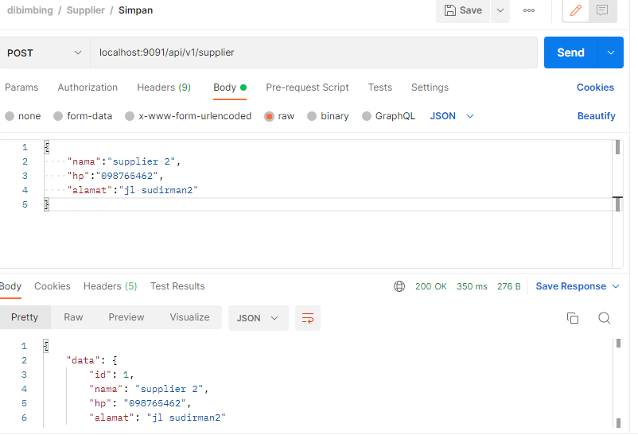

* Update
* Delete : soff delete
* List page

### Tabel pembeli/customer : Latihan

* Insert

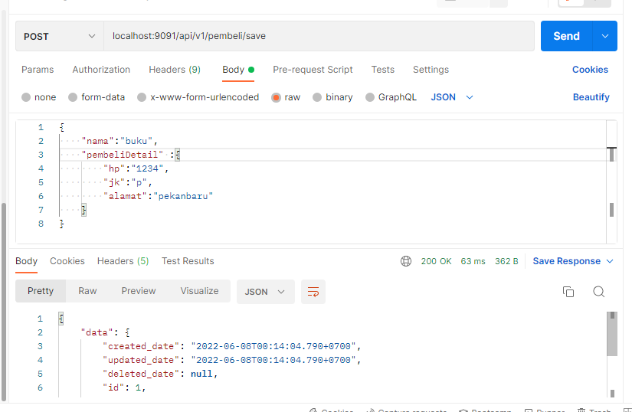

* Update
* Delete : soff delete
* List page

### Tabel transaksi : Latihan

* Insert

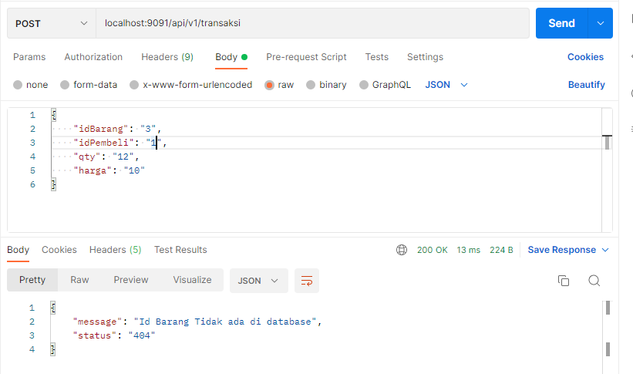

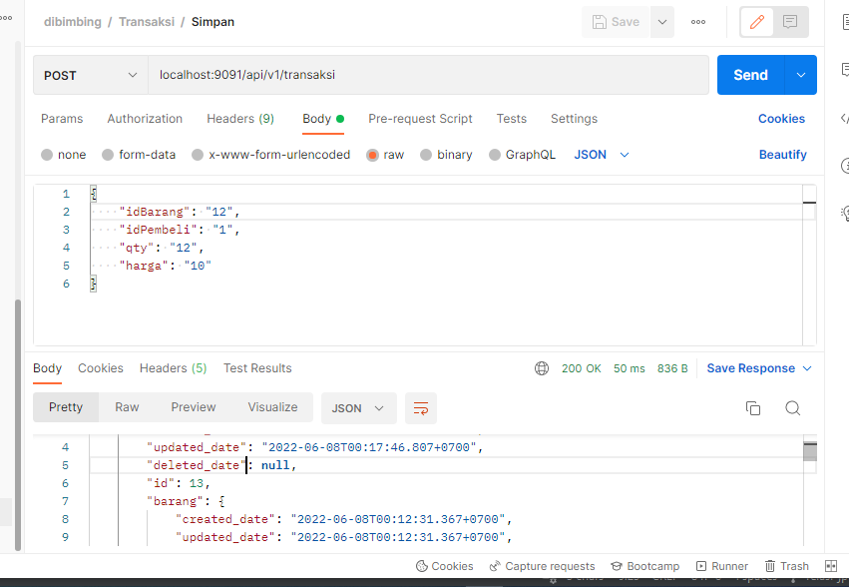

* Update
* List page

## Branch and Structure Project

https://github.com/rikialdi/dibimbing/pull/new/relasi-jpa

# Store Prosedure dan function di DBEver : bisa reder ke doc database

## Tabel karyawan

|  |
| --- |
| **CREATE** **TABLE** public.employee (  id bigserial **NOT** **NULL**,  created_date **timestamp**(6) **NOT** **NULL**,  deleted_date **timestamp**(6) **NULL**,  updated_date **timestamp**(6) **NOT** **NULL**,  address **text** **NULL**,  dob **date** **NULL**,  "name" **varchar**(255) **NULL**,  status **varchar**(255) **NULL**,  **CONSTRAINT** employee_pkey **PRIMARY** **KEY** (id)  );  **INSERT** **INTO** employee (created_date, updated_date, address, dob, "name", status)  **VALUES** (**now**(), **now**(), 'Alamat Karyawan 1', '1990-01-15', 'Karyawan 1', 'Active'),  (**now**(), **now**(), 'Alamat Karyawan 2', '1980-01-15', 'Karyawan 2', 'Active'),  (**now**(), **now**(), 'Alamat Karyawan 3', '1970-01-15', 'Karyawan 3', 'Active'),  (**now**(), **now**(), 'Alamat Karyawan 4', '1960-01-15', 'Karyawan 4', 'Active'),  (**now**(), **now**(), 'Alamat Karyawan 5', '1950-01-15', 'Karyawan 5', 'Active'); |

## Create function list employee

|  |
| --- |
| **CREATE** **OR** **REPLACE** **FUNCTION** public.getemployee6()  **RETURNS** **table** (resid **bigint**, resname **varchar**, resaddress **text**)  **LANGUAGE** plpgsql  **AS** **$function$**  **begin**  **RETURN** QUERY  **select** id **bigint**, **name** **varchar**, address **from** employee e;  **END**;  **$function$**  ;  Output  Select * from getemployee6(); |

## Store prosedure sample IN OUT

|  |
| --- |
| **CREATE** **OR** **REPLACE** **PROCEDURE** public.testsp(**IN** rqid **varchar**, **OUT** resid **varchar**)  **LANGUAGE** plpgsql  **AS** **$procedure$**  **BEGIN**  resid =rqid;  **END**;  **$procedure$**  ; |

Contoh 2 : IN OUT dan INOUT

|  |
| --- |
| **CREATE** **OR** **REPLACE** **PROCEDURE** public.testsp4(**IN** nama **varchar**, **out** resnama **varchar**, **inout** address **text**)  **LANGUAGE** plpgsql  **AS** **$function$**  **BEGIN**  resnama =nama;  **END**;  **$function$**  ;  Output |

## Function wit For

|  |
| --- |
| **CREATE** **OR** **REPLACE** **FUNCTION** public.listemployee(rqnama **character** **varying**)  **RETURNS** **TABLE**(resid **bigint**, resnama **character** **varying**)  **LANGUAGE** plpgsql  **AS** **$function$**  **DECLARE**  var_r record;  **BEGIN**  **FOR** var_r **IN**(**SELECT**  id,  **name**  **FROM** employee  **WHERE** **name** **ILIKE** rqNama)  **LOOP**  resid :=var_r.id ;  resnama :=var_r.**name**;  **RETURN** **NEXT**;  **END** **LOOP**;  **end** **$function$**  ; |

## Store prosedure insert karyawan

|  |
| --- |
| **CREATE** **OR** **REPLACE** **PROCEDURE** public.insert1(**inout** resid **bigint**,**inout** rqnama **character** **varying**)  **LANGUAGE** plpgsql  **AS** **$procedure$**  **begin**  **if** rqnama **is** **null** **Then**  **raise** **notice** 'nama kosong';  rqnama = 'nama wajib diisi';  **return**;  **else**  **raise** **notice** 'nama ada';  **end** **if**;  **INSERT** **into** public.employee  (id, created_date, updated_date, address, dob, "name", status)  **SELECT** **nextval**('employee_id_seq'),  **now**(),  **now**(),  'jakarta',  '1970-01-15',  rqnama,  'active'  **RETURNING** id **INTO** resid;  **commit**;  **END**;  **$procedure$**;  Output  Call insert1(null,’riki’); |

# Strore Prosedure dan function Call in spring boot studi kasus Employee.

## Arsitektur

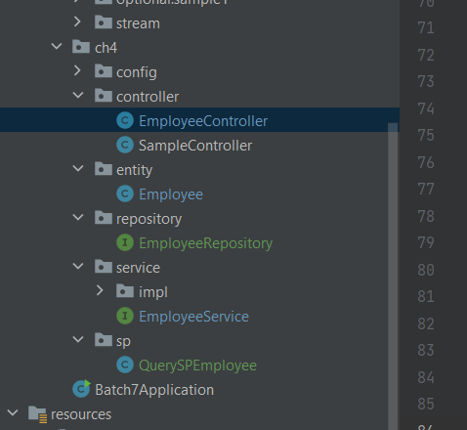

## Pom.xml

|  |
| --- |
| <dependency>  <groupId>org.hibernate.validator</groupId>  <artifactId>hibernate-validator</artifactId>  <version>6.0.13.Final</version> </dependency>  <dependency>  <groupId>org.springframework.boot</groupId>  <artifactId>spring-boot-test</artifactId> </dependency>  <dependency>  <groupId>org.springframework.boot</groupId>  <artifactId>spring-boot-starter-jdbc</artifactId> </dependency>  <dependency>  <groupId>org.springframework.boot</groupId>  <artifactId>spring-boot-starter-data-jpa</artifactId> </dependency>  <dependency>  <groupId>org.postgresql</groupId>  <artifactId>postgresql</artifactId>  <scope>runtime</scope> </dependency>  <dependency>  <groupId>org.springframework</groupId>  <artifactId>spring-test</artifactId> </dependency> |

## Create function dan prosedure di spring boot

|  |
| --- |
| package com.aplikasi.karyawan.ch4.sp;  import org.springframework.stereotype.Component;  @Component public class QuerySPEmployee {   public String getData ="CREATE OR REPLACE FUNCTION public.getemployee6()\n" +  " RETURNS TABLE(resid bigint, resname varchar, resaddress text)\n" +  " LANGUAGE plpgsql\n" +  "AS $function$\n" +  "\tbegin\n" +  "\tRETURN QUERY\n" +  " select id bigint, name varchar, address from employee e;\n" +  "\tEND;\n" +  "$function$\n" +  ";\n";   public String getDataEmployeeLikeName ="CREATE OR REPLACE FUNCTION public.listemployee2(rqnama varchar)\n" +  " RETURNS TABLE(resid bigint, resname varchar, resaddress varchar)\n" +  " LANGUAGE plpgsql\n" +  "AS $function$\n" +  " DECLARE \n" +  " var_r record;\n" +  " BEGIN\n" +  " FOR var_r IN(SELECT \n" +  " id,\n" +  " name,\n" +  " address \n" +  " FROM employee\n" +  " WHERE name ILIKE rqNama) \n" +  " LOOP\n" +  " resid :=var_r.id ;\n" +  " resname :=var_r.name;\n" +  " resaddress :=var_r.address;\n" +  " RETURN NEXT;\n" +  " END LOOP;\n" +  " end $function$\n" +  ";\n";  public String insertEmployee ="CREATE OR REPLACE PROCEDURE public.insert1(inout resid bigint,inout rqnama character varying)\n" +  " LANGUAGE plpgsql\n" +  " AS $procedure$\n" +  " begin\n" +  " if rqnama is null Then \n" +  " raise notice 'nama kosong';\n" +  " rqnama = 'nama wajib diisi';\n" +  " return;\n" +  " else \n" +  " raise notice 'nama ada';\n" +  " end if; \n" +  " INSERT into public.employee\n" +  " (id, created_date, updated_date, address, dob, \"name\", status) \n" +  " SELECT nextval('employee_id_seq'),\n" +  " now(),\n" +  " now(),\n" +  " 'jakarta',\n" +  " '1970-01-15',\n" +  " rqnama,\n" +  " 'active'\n" +  " RETURNING id INTO resid; \n" +  " commit;\n" +  " END;\n" +  " $procedure$;\n";  public String updateEmployee = "CREATE OR REPLACE PROCEDURE public.update_employee(INOUT resid bigint, INOUT rqnama varchar)\n" +  " LANGUAGE plpgsql\n" +  "AS $procedure$\n" +  " begin\n" +  " if rqnama is null Then \n" +  " raise notice 'nama kosong';\n" +  " rqnama = 'nama wajib diisi';\n" +  " return;\n" +  " else \n" +  " raise notice 'nama ada';\n" +  " end if; \n" +  " update employee\n" +  " set name=rqnama\n" +  " where id = resid;\n" +  " rqnama=rqnama;\n" + // " commit;\n" + -- Tidak perlu COMMIT di sini, biarkan aplikasi Anda yang mengelola transaksi.  " END;\n" +  " $procedure$\n" +  ";\n";   public String deletedEmployee ="CREATE OR REPLACE PROCEDURE public.deleted_employee1(INOUT resid bigint)\n" +  " LANGUAGE plpgsql\n" +  "AS $procedure$\n" +  " begin \n" +  " update employee\n" +  " set created_date =now()\n" +  " where id = resid;\n" + // " commit;\n" + -- Tidak perlu COMMIT di sini, biarkan aplikasi Anda yang mengelola transaksi.  " END;\n" +  " $procedure$\n" +  ";\n";  public String getByID = "CREATE OR REPLACE FUNCTION public.getemployeebyid(rqid bigint)\n" +  " RETURNS TABLE(resid bigint, resname character varying, resaddress text)\n" +  " LANGUAGE plpgsql\n" +  "AS $function$\n" +  "\tbegin\n" +  "\t\treturn QUERY\n" +  "\t\tselect id, name, address from employee where id =rqid;\n" +  "\tEND;\n" +  "$function$\n" +  ";\n";  } |

## Employee- Entity

|  |
| --- |
| package com.example.batch7.ch4.entity;  import lombok.Data;   import com.fasterxml.jackson.annotation.JsonFormat; import com.fasterxml.jackson.annotation.JsonIgnore; import jakarta.persistence.*; import lombok.Data; import org.hibernate.annotations.Where; import org.springframework.boot.autoconfigure.domain.EntityScan; import org.springframework.format.annotation.DateTimeFormat;  import java.io.Serializable; import java.util.Date; import java.util.List;  //@EntityScan @Data @Entity @Table(name = "employee") @Where(clause = "deleted_date is null") public class Employee implements Serializable {  @Id  @Column(name = "id")  @GeneratedValue(strategy = GenerationType.*IDENTITY*)  public Long id;   public String name;   @Column(name = "address", columnDefinition = "TEXT")  public String address;   // 2016-01-01  @Temporal(TemporalType.*DATE*)  @JsonFormat(pattern = "yyyy-MM-dd")  private Date dob;   public String status = "active";   } |

## Repository Employee

|  |
| --- |
| import com.example.batch7.ch4.entity.Employee; import org.springframework.data.jpa.repository.JpaRepository; import org.springframework.data.jpa.repository.JpaSpecificationExecutor; import org.springframework.data.jpa.repository.Query; import org.springframework.data.jpa.repository.query.Procedure; import org.springframework.data.repository.query.Param; import org.springframework.stereotype.Repository; import org.springframework.transaction.annotation.Transactional;  import java.util.List; import java.util.UUID;  @Repository //public interface EmployeeRepository extends PagingAndSortingRepository<Employee,Long> { public interface EmployeeRepository extends JpaRepository<Employee, Long>, JpaSpecificationExecutor<Employee> {  //Store prosedure  @Query(value = "select * from getemployee6()",nativeQuery = true)  public List<Object> getListSP();   @Procedure("insert1")  void saveEmployeeSP(@Param("resid") Long resid, @Param("rqnama") String rqnama);   @Procedure("update_employee")  void updateEmployeeSP(@Param("resid") Long resid,@Param("rqnama") String rqnama);   @Procedure("deleted_employee1")  void deleted_employee1(@Param("resid") Long resid);  @Procedure("getemployeebyid") Object getemployeebyid(@Param("rqid") Long rqid);  } |

## Service

## Employee Controller

|  |
| --- |
| package com.example.batch7.ch4.sp;   import com.example.batch7.ch4.service.EmployeeService; import org.springframework.beans.factory.annotation.Autowired; import org.springframework.http.HttpHeaders; import org.springframework.http.HttpStatus; import org.springframework.http.ResponseEntity; import org.springframework.web.bind.annotation.*;  import javax.sql.DataSource; import java.util.HashMap; import java.util.List; import java.util.Map;  @RestController @RequestMapping("/v1/employee/sp") public class EmployeeControllerSP {  @Autowired  public EmployeeService employeeService;   @Autowired  private DataSource dataSource;  @Autowired  public EmployeeRepository employeeRepository;   @GetMapping(value = {"", "/"})  public ResponseEntity<Map> getById() {  Map map = new HashMap();  map.put("list",employeeRepository.getListSP());  return new ResponseEntity<Map>(map, HttpStatus.*OK*);  } } |

## Testing dan Create function dan prosedure

|  |
| --- |
| package com.aplikasi.karyawan.ch4.sp;    import com.aplikasi.karyawan.entity.Employee; import com.aplikasi.karyawan.repository.EmployeeRepository; import org.junit.Before; import org.junit.Test; import org.junit.runner.RunWith; import org.springframework.beans.factory.annotation.Autowired; import org.springframework.boot.test.context.SpringBootTest; import org.springframework.jdbc.core.JdbcTemplate; import org.springframework.jdbc.core.namedparam.MapSqlParameterSource; import org.springframework.jdbc.core.namedparam.SqlParameterSource; import org.springframework.jdbc.core.simple.SimpleJdbcCall; import org.springframework.test.context.junit4.SpringRunner;  import javax.sql.DataSource; import java.io.IOException; import java.util.ArrayList; import java.util.HashMap; import java.util.List; import java.util.Map;  @RunWith(SpringRunner.class) @SpringBootTest(webEnvironment = SpringBootTest.WebEnvironment.*RANDOM_PORT*) public class TestingSp {  @Autowired  private DataSource dataSource;  @Autowired  public EmployeeRepository employeeRepository;   @Autowired  private JdbcTemplate jdbcTemplate;   @Autowired  public QuerySPEmployee querySPEmployee;  @Before  public void init() {  try {  jdbcTemplate.execute(querySPEmployee.getData);  jdbcTemplate.execute(querySPEmployee.getDataEmployeeLikeName);  jdbcTemplate.execute(querySPEmployee.insertEmployee);  jdbcTemplate.execute(querySPEmployee.updateEmployee);  jdbcTemplate.execute(querySPEmployee.deletedEmployee);  } finally { // session.close();  }  }   @Test  public void listSP(){  List<Object> obj = employeeRepository.getListSP();  System.*out*.println(obj);  }  @Test public void getIDSP(){  Object obj = employeeRepository.getemployeebyid(6L);  System.*out*.println(obj); }  @Test  public void getIdSp(){  Object obj = employeeRepository.getemployeebyid(6L);  System.*out*.println(obj);  }   @Test  public void saveSp(){  employeeRepository.saveEmployeeSP(null, "spring boot1");  }   @Test  public void udpateSP(){  employeeRepository.updateEmployeeSP(6L, "spring boot1");  }  @Test  public void deletedSp(){  employeeRepository.deleted_employee1(8L);  }  } |

Noted: jika terjadi eror, import library, dengan cara klik kanan dan pilih add library

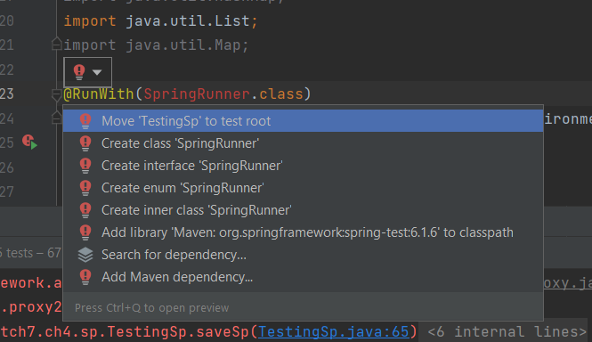

Jika eror

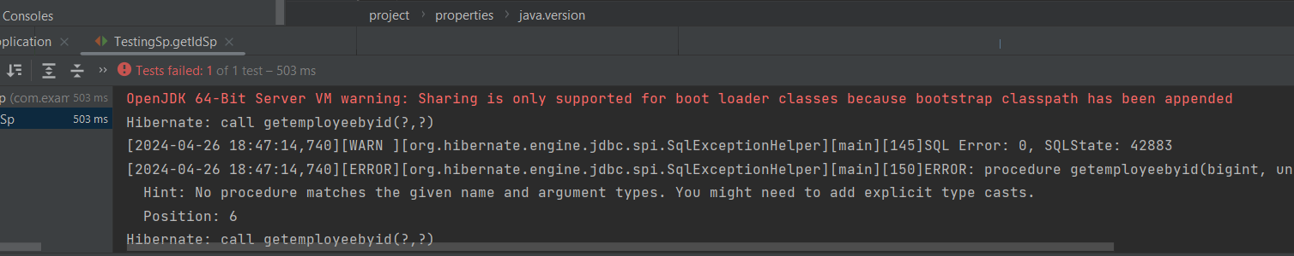

## Output setelah run testing junit

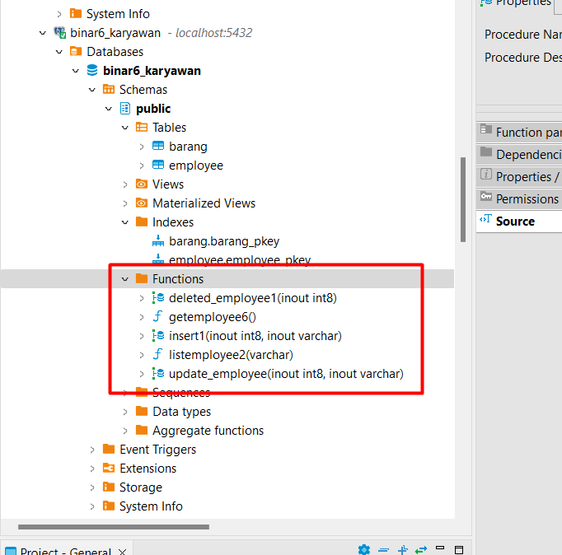

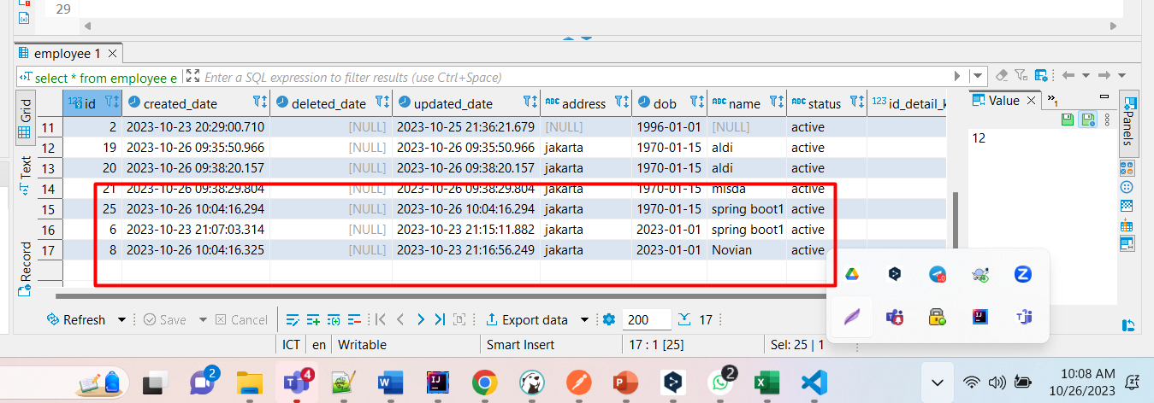

## Controller

|  |
| --- |
| package com.aplikasi.karyawan.controller;  import com.aplikasi.karyawan.entity.Employee; import com.aplikasi.karyawan.repository.EmployeeRepository; import com.aplikasi.karyawan.service.EmployeeService; import com.aplikasi.karyawan.utils.SimpleStringUtils; import com.aplikasi.karyawan.utils.TemplateResponse; import org.springframework.beans.factory.annotation.Autowired; import org.springframework.data.domain.Page; import org.springframework.data.domain.Pageable; import org.springframework.http.HttpHeaders; import org.springframework.http.HttpStatus; import org.springframework.http.ResponseEntity; import org.springframework.web.bind.annotation.*;  import java.util.HashMap; import java.util.Map;  @RestController @RequestMapping("/v1/employee/sp") public class EmployeeControllerSP {  @Autowired  public EmployeeService employeeService;   SimpleStringUtils simpleStringUtils = new SimpleStringUtils();   @Autowired  public EmployeeRepository employeeRepository;   @GetMapping(value = {"", "/"})  public ResponseEntity<Map> getById() {  Map map = new HashMap();  map.put("list",employeeRepository.getListSP());  return new ResponseEntity<Map>(map, HttpStatus.*OK*);  }    } |

## List

http://localhost:8081/api/v1/employee/sp

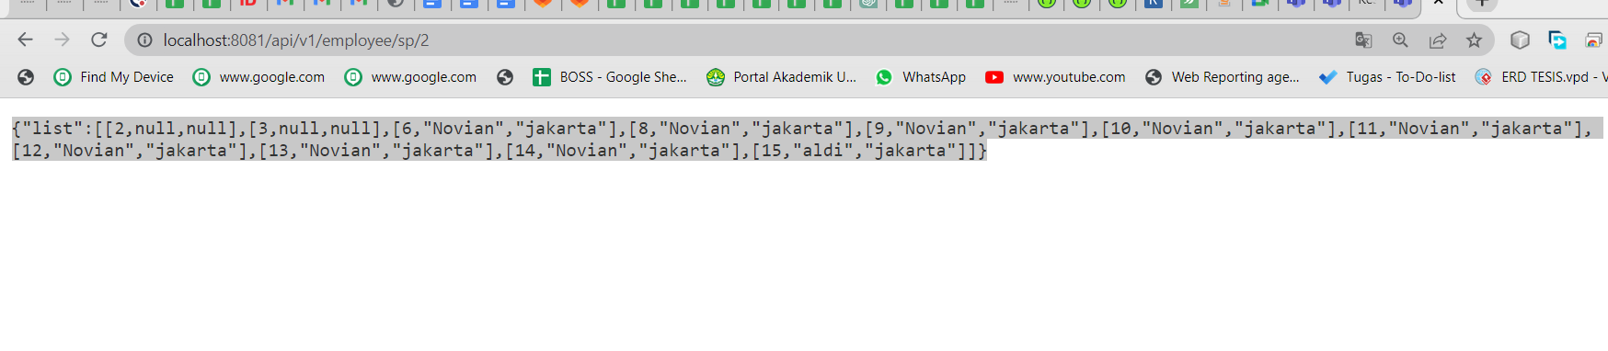

## Branch

ch4-sesi6-call-sp-spring-boot

<https://gitlab.com/rikialdi/batch6.git>

# Store Prodesure Rest API Studi Kasus Barang

Praktek CRUD studi kasus Tabel karyawan dengan menggunakan store prosedure dan function.

## Studi Kasus



## Strukture Project

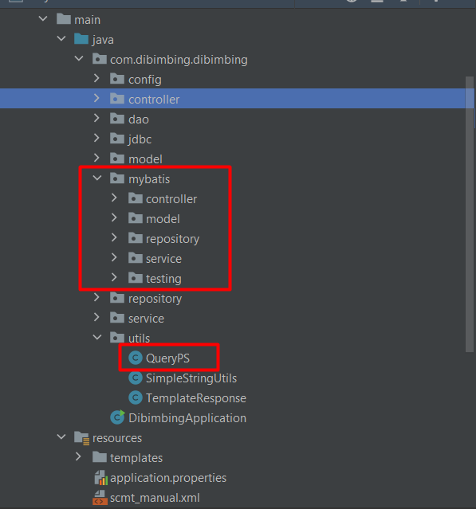

## Pom.xml

|  |
| --- |
| <!-- JDBC-->  <dependency>  <groupId>org.springframework.boot</groupId>  <artifactId>spring-boot-starter-jdbc</artifactId>  </dependency>   <dependency>  <groupId>org.mybatis.spring.boot</groupId>  <artifactId>mybatis-spring-boot-starter</artifactId>  <version>2.2.2</version>  </dependency> |

## Define Store Prosedure dan function

Class QueryPS : berisi semua prosedure dan function, bertujuan generate ke database lewat aplikasi.

|  |
| --- |
| package com.dibimbing.dibimbing.utils;  import org.springframework.stereotype.Component;  @Component public class QueryPS {  public String getByIDSP = "CREATE OR REPLACE FUNCTION public.getbyidfunction(rqid integer)\n" +  " RETURNS TABLE(resid bigint, resnama character varying, ressatuan character varying, resstok integer, resharga double precision)\n" +  " LANGUAGE plpgsql\n" +  "AS $function$\n" +  "BEGIN\n" +  " RETURN QUERY\n" +  " select e.id, e.nama, e.satuan,e.stok,e.harga\n" +  " FROM public.barang AS e\n" +  " WHERE id = rqId;\n" +  "END;\n" +  "$function$\n" +  ";\n";   public String testSP = "CREATE OR REPLACE PROCEDURE public.testsp(IN rqid character varying, OUT resid character varying)\n" +  " LANGUAGE plpgsql\n" +  "AS $procedure$\n" +  "\tBEGIN\n" +  " resid =rqid;\n" +  "\tEND;\n" +  "$procedure$\n" +  ";\n";   public String getBarang1 = "CREATE OR REPLACE FUNCTION public.getbarang1(rqnama character varying)\n" +  " RETURNS TABLE(resid integer, resnama character varying, resstok character varying, resharga integer, ressatuan character varying)\n" +  " LANGUAGE plpgsql\n" +  "AS $function$\n" +  "DECLARE \n" +  " var_r record;\n" +  "BEGIN\n" +  " FOR var_r IN(SELECT \n" +  " id,\n" +  " nama,\n" +  " stok,\n" +  " harga,\n" +  " satuan\n" +  " FROM barang\n" +  " WHERE nama ILIKE rqNama) \n" +  " LOOP\n" +  " resid := var_r.id ; \n" +  " resnama := var_r.nama ; \n" +  " resstok := var_r.stok ; \n" +  " resharga := var_r.harga ; \n" +  " ressatuan := var_r.satuan ; \n" +  " RETURN NEXT;\n" +  " END LOOP;\n" +  "END; $function$\n" +  ";\n";   public String updatebarang ="CREATE OR REPLACE PROCEDURE public.updatebarang(IN rqharga double precision, IN rqnama character varying, IN rqsatuan character varying, IN rqstok integer, INOUT resid integer)\n" +  " LANGUAGE plpgsql\n" +  "AS $procedure$\n" +  "\tbegin\n" +  "\t\n" +  "\t\tIf not Exists(select id from barang b where id = resid) Then \n" +  "\t\t raise notice 'id tidak ada';\n" +  "\t\t return;\n" +  "\t\telse \n" +  "\t\t raise notice 'id ada';\n" +  "\t\tend if;\n" +  "\t\t\n" +  "\t\t\n" +  "\tupdate public.barang\n" +  " set harga = rqharga, nama = rqnama, satuan = rqsatuan, stok = rqstok\n" +  " where id = resid returning id into resid; \n" +  " commit;\n" +  "\tEND;\n" +  "$procedure$\n" +  ";\n";   public String deletebarang= "CREATE OR REPLACE PROCEDURE public.deletebarang(IN rqid integer)\n" +  " LANGUAGE plpgsql\n" +  "AS $procedure$\n" +  "\tbegin\t\n" +  "\tdelete from barang where id = rqid;\n" +  " commit;\n" +  "\tEND;\n" +  "$procedure$\n" +  ";\n";   public String updatebarangoutwitheror = "CREATE OR REPLACE PROCEDURE public.updatebarangoutwitheror(IN rqharga double precision, IN rqnama character varying, IN rqsatuan character varying, IN rqstok integer, INOUT resid integer, INOUT resharga double precision, INOUT resnama character varying, INOUT ressatuan character varying, INOUT resstok integer, INOUT reserordesc character varying, INOUT reserorcode integer)\n" +  " LANGUAGE plpgsql\n" +  "AS $procedure$\n" +  "\tbegin\n" +  "\t\tIf not Exists(select id from barang b where id = resid) Then \n" +  "\t\t raise notice 'id tidak ada';\n" +  "\t\t reserordesc = 'id tidak ditemukan';\n" +  "\t\t reserorcode = '404';\n" +  "\t\t return;\n" +  "\t\telse \n" +  "\t\t raise notice 'id ada';\n" +  "\t\tend if;\n" +  "\t\n" +  "\tupdate public.barang\n" +  " set harga = rqharga, nama = rqnama, satuan = rqsatuan, stok = rqstok\n" +  " where id = resid returning id into resid; \n" +  " resharga = rqharga;\n" +  " resnama =rqnama;\n" +  " ressatuan =rqsatuan;\n" +  " resstok =rqstok;\n" +  " \n" +  " reserordesc = 'sukses';\n" +  "\treserorcode = '200';\n" +  " commit;\n" +  "\tEND;\n" +  "$procedure$\n" +  ";\n";   public String testLong = "CREATE OR REPLACE PROCEDURE public.testsplong(IN rqid bigint, INOUT resid bigint)\n" +  " LANGUAGE plpgsql\n" +  "AS $procedure$\n" +  "\tBEGIN\n" +  " resid =rqid;\n" +  "\tEND;\n" +  "$procedure$\n" +  ";\n";   public String testDouble = "CREATE OR REPLACE PROCEDURE public.testspdouble(IN rqid DOUBLE PRECISION, INOUT resid DOUBLE PRECISION)\n" +  " LANGUAGE plpgsql\n" +  "AS $procedure$\n" +  "\tBEGIN\n" +  " resid =rqid;\n" +  "\tEND;\n" +  "$procedure$\n" +  ";\n";   public String testInteger = "CREATE OR REPLACE PROCEDURE public.testspInteger(IN rqid integer, INOUT resid integer)\n" +  " LANGUAGE plpgsql\n" +  "AS $procedure$\n" +  "\tBEGIN\n" +  " resid =rqid;\n" +  "\tEND;\n" +  "$procedure$\n" +  ";\n";   public String save ="CREATE OR REPLACE PROCEDURE public.savebarangoutwitheror(IN rqharga double precision, IN rqnama character varying, IN rqsatuan character varying, IN rqstok integer, INOUT resid integer, INOUT resharga double precision, INOUT resnama character varying, INOUT ressatuan character varying, INOUT resstok integer, INOUT reserordesc character varying, INOUT reserorcode integer)\n" +  " LANGUAGE plpgsql\n" +  "AS $procedure$\n" +  "\tbegin\n" +  "\t\tif rqnama is null Then \n" +  "\t\t raise notice 'nama kosong';\n" +  "\t\t reserordesc = 'nama wajib diisi';\n" +  "\t\t reserorcode = 404;\n" +  "\t\t return;\n" +  "\t\telse \n" +  "\t\t raise notice 'nama ada';\n" +  "\t\tend if; \n" +  "\t\n" +  " INSERT into public.barang\n" +  " (id,harga,nama,satuan,stok,created_date,updated_date) \n" +  " SELECT nextval('barang_id_seq'),\n" +  " rqharga,\n" +  " rqnama,\n" +  " rqsatuan,\n" +  " rqstok,\n" +  " NOW(),NOW()\n" +  " RETURNING id INTO resid;\n" +  " resharga = rqharga;\n" +  " resnama =rqnama;\n" +  " ressatuan =rqsatuan;\n" +  " resstok =rqstok;\n" +  " \n" +  " reserordesc = 'sukses';\n" +  "\treserorcode = 200;\n" +  " commit;\n" +  "\tEND;\n" +  "$procedure$\n" +  ";\n"; } |

## Model

|  |
| --- |
| import lombok.Data;  @Data public class BarangMybatis {  Long resid ;  String resnama;  String ressatuan;  Double resharga;  Integer resstok;  String reserordesc;  Integer reserorcode; } |

## Repository

Berisi semua query ke database.

|  |
| --- |
| package com.dibimbing.dibimbing.mybatis.repository;  import com.dibimbing.dibimbing.mybatis.model.BarangMyBatisMapper; import com.dibimbing.dibimbing.mybatis.model.BarangMybatis; import org.apache.ibatis.annotations.*; import org.apache.ibatis.mapping.StatementType;  import java.util.List; import java.util.Map;  @Mapper//https://github.com/mybatis/spring-boot-starter public interface BarangRepoMybatis {  @Select("SELECT resid, resharga, resnama, ressatuan, resstok FROM getByIDFunction(#{rqid});")  BarangMybatis selectBlog(int rqid);   @Select("select resid,resharga, resnama, ressatuan,resstok from public.getBarang1(#{rqnama});")  List<BarangMybatis> selectList(String rqnama);   @Insert("call savebarang(#{rqharga,mode=IN},#{rqnama,mode=IN},#{rqsatuan,mode=IN},#{rqstok,mode=IN},#{resid,mode=INOUT})")  void insertProcedure(Double rqharga, String rqnama, String rqsatuan, int rqstok, int resid);   @Update("call updatebarang(#{rqharga,mode=IN},#{rqnama,mode=IN},#{rqsatuan,mode=IN},#{rqstok,mode=IN},#{resid,mode=INOUT})")  void updateProcedure(Double rqharga, String rqnama, String rqsatuan, int rqstok, int resid);   @Update(value = "call updatebarangoutwitheror(#{rqharga,mode=IN}," +  "#{rqnama,mode=IN}," +  "#{rqsatuan,mode=IN}," +  "#{rqstok,mode=IN}," +  "#{resid,mode=INOUT}," +  "#{resharga,mode=INOUT}," +  "#{resnama,mode=INOUT}," +  "#{ressatuan,mode=INOUT}," +  "#{resstok,mode=INOUT}," +  "#{reserordesc,mode=INOUT}," +  "#{reserorcode,mode=INOUT})")  void updatebarangoutwitheror(Double rqharga,  String rqnama,  String rqsatuan,  int rqstok,  int resid,  Double resharga,  String resnama,  String ressatuan,  Integer resstok,  String reserordesc,  Integer reserorcode);   @Update(value = "call updatebarangoutwitheror(#{rqharga,mode=IN,jdbcType=NUMERIC}," +  "#{rqnama,mode=IN,jdbcType=VARCHAR}," +  "#{rqsatuan,mode=IN,jdbcType=VARCHAR}," +  "#{rqstok,mode=IN,jdbcType=INTEGER}," +  "#{resid,mode=INOUT,jdbcType=INTEGER}," +  "#{resharga,mode=INOUT,jdbcType=DOUBLE}," +  "#{resnama,mode=INOUT,jdbcType=VARCHAR}," +  "#{ressatuan,mode=INOUT,jdbcType=VARCHAR}," +  "#{resstok,mode=INOUT,jdbcType=INTEGER}," +  "#{reserordesc,mode=INOUT,jdbcType=VARCHAR}," +  "#{reserorcode,mode=INOUT,jdbcType=INTEGER})")  @Options(statementType = StatementType.*CALLABLE*)  void updatebarangoutwitheror2(Map<String,Object> map);   @Update(value = "call savebarangoutwitheror(#{rqharga,mode=IN,jdbcType=NUMERIC}," +  "#{rqnama,mode=IN,jdbcType=VARCHAR}," +  "#{rqsatuan,mode=IN,jdbcType=VARCHAR}," +  "#{rqstok,mode=IN,jdbcType=INTEGER}," +  "#{resid,mode=INOUT,jdbcType=INTEGER}," +  "#{resharga,mode=INOUT,jdbcType=DOUBLE}," +  "#{resnama,mode=INOUT,jdbcType=VARCHAR}," +  "#{ressatuan,mode=INOUT,jdbcType=VARCHAR}," +  "#{resstok,mode=INOUT,jdbcType=INTEGER}," +  "#{reserordesc,mode=INOUT,jdbcType=VARCHAR}," +  "#{reserorcode,mode=INOUT,jdbcType=INTEGER})")  @Options(statementType = StatementType.*CALLABLE*)  void savebarangoutwitheror(Map<String,Object> map);   @Update(value = "call testsp(#{rqid,mode=IN,jdbcType=VARCHAR}," +  "#{resid,mode=OUT,jdbcType=VARCHAR})")  @Options(statementType = StatementType.*CALLABLE*)  void test(Map<String,Object> map);   @Update(value = "call testsplong(#{rqid,mode=IN,jdbcType=BIGINT}," +  "#{resid,mode=INOUT,jdbcType=BIGINT})")  @Options(statementType = StatementType.*CALLABLE*)  void testLONG(Map<String,Object> map);   @Update(value = "call testspdouble(#{rqid,mode=IN,jdbcType=DOUBLE}," +  "#{resid,mode=INOUT,jdbcType=DOUBLE})")  @Options(statementType = StatementType.*CALLABLE*)  void testDOUBLE(Map<String,Object> map);   @Update(value = "call testspInteger(#{rqid,mode=IN,jdbcType=INTEGER}," +  "#{resid,mode=INOUT,jdbcType=INTEGER})")  @Options(statementType = StatementType.*CALLABLE*)  void testINTEGER(Map<String,Object> map);  @Update("call deletebarang(#{rqid,mode=IN})")  void deleteProcedure(int resid);  } |

## Service/Interface

Berisi semua method yaang digunakan untuk di CALL pada controller.

|  |
| --- |
| package com.dibimbing.dibimbing.mybatis.service;  import com.dibimbing.dibimbing.model.Barang; import com.dibimbing.dibimbing.mybatis.model.BarangMybatis; import org.apache.ibatis.annotations.Insert; import org.apache.ibatis.annotations.Mapper; import org.apache.ibatis.annotations.Select; import org.apache.ibatis.annotations.Update; import org.springframework.stereotype.Service;  import java.util.List; import java.util.Map;   public interface BarangServiceMybatis {   BarangMybatis selectBlog(int rqid);   List<BarangMybatis> selectList(String rqnama);   void insertProcedure(Double rqharga, String rqnama, String rqsatuan, int rqstok, int resid);   void updateProcedure(Double rqharga, String rqnama, String rqsatuan, int rqstok, int resid);   void deleteProcedure(int resid);   Map updatebarangoutwitheror(Double rqharga, String rqnama, String rqsatuan, int rqstok, int resid);   Map savebarangoutwitheror(Double rqharga, String rqnama, String rqsatuan, int rqstok, Integer resid);   // use xml  public Map updateProcedureXML(BarangMybatis item);  List<BarangMybatis> listBarangXML(BarangMybatis item);  BarangMybatis getByIdBarangXML(Integer id);   public Map testPS(BarangMybatis item);   } |

## Implementasi Service/Interface

Berisi Logic dari Kodingan.

|  |
| --- |
| package com.dibimbing.dibimbing.mybatis.service.impl;  import com.dibimbing.dibimbing.model.Barang; import com.dibimbing.dibimbing.mybatis.model.BarangMyBatisMapper; import com.dibimbing.dibimbing.mybatis.model.BarangMybatis; import com.dibimbing.dibimbing.mybatis.repository.BarangRepoMybatis; import com.dibimbing.dibimbing.mybatis.repository.BarangRepoMybatisXML; import com.dibimbing.dibimbing.mybatis.service.BarangServiceMybatis; import com.dibimbing.dibimbing.utils.QueryPS; import com.dibimbing.dibimbing.utils.TemplateResponse; import org.springframework.beans.factory.annotation.Autowired; import org.springframework.jdbc.core.JdbcTemplate; import org.springframework.stereotype.Service;  import java.util.HashMap; import java.util.List; import java.util.Map;  @Service public class BarangServiceImplMybatis implements BarangServiceMybatis {   @Autowired  BarangRepoMybatis barangRepoMybatis;  @Autowired  public TemplateResponse templateResponse;  @Autowired  private JdbcTemplate jdbcTemplate;  @Autowired  QueryPS queryPS;  @Autowired  public BarangRepoMybatisXML barangRepoMybatisXML;  @Override  public BarangMybatis selectBlog(int rqid) {  return barangRepoMybatis.selectBlog(rqid);  }   @Override  public List<BarangMybatis> selectList(String rqnama) {  return barangRepoMybatis.selectList(rqnama);  }   @Override  public void insertProcedure(Double rqharga, String rqnama, String rqsatuan, int rqstok, int resid) {  barangRepoMybatis.insertProcedure( rqharga, rqnama, rqsatuan, rqstok, resid);  }   @Override  public void updateProcedure(Double rqharga, String rqnama, String rqsatuan, int rqstok, int resid) {  barangRepoMybatis.updateProcedure( rqharga, rqnama, rqsatuan, rqstok, resid);   }   @Override  public void deleteProcedure(int resid) {  barangRepoMybatis.deleteProcedure( resid);  }   @Override  public Map updatebarangoutwitheror(Double rqharga, String rqnama, String rqsatuan, int rqstok, int resid) { // barangRepoMybatis.updatebarangoutwitheror( rqharga, rqnama, rqsatuan, rqstok, resid, // 1.0,"","",1,"",1);  Map<String , Object> map = new HashMap<>();  map.put("rqharga",rqharga);  map.put("rqnama",rqnama);  map.put("rqsatuan",rqsatuan);  map.put("rqstok",rqstok);  map.put("resid",resid);  map.put("resharga",null);  map.put("resnama", null);  map.put("ressatuan",null);  map.put("resstok",null);  map.put("reserordesc",null);  map.put("reserorcode",null); // penting dibaca type data mybatis https://mybatis.org/mybatis-3/apidocs/reference/org/apache/ibatis/type/JdbcType.html  barangRepoMybatis.updatebarangoutwitheror2(map);  System.out.println("resid="+(Integer) map.get("resid"));  System.out.println("resharga="+(Double) map.get("resharga"));  System.out.println("resnama="+(String) map.get("resnama"));  System.out.println("ressatuan="+(String) map.get("ressatuan"));  System.out.println("resstok="+(Integer) map.get("resstok"));  System.out.println("reserordesc="+(String) map.get("reserordesc"));  System.out.println("reserorcode="+(Integer) map.get("reserorcode"));    Barang objBarang = new Barang();  objBarang.setId(Long.parseLong(String.valueOf((Integer) map.get("resid"))));  objBarang.setSatuan((String) map.get("ressatuan"));  objBarang.setStok((Integer) map.get("resstok"));  objBarang.setHarga((Double) map.get("resharga"));  objBarang.setNama((String) map.get("resnama"));   return templateResponse.templateSukses(objBarang,(String) map.get("reserordesc"), String.valueOf((Integer) map.get("reserorcode")));   }   @Override  public Map savebarangoutwitheror(Double rqharga, String rqnama, String rqsatuan, int rqstok, Integer resid) {  jdbcTemplate.execute(queryPS.save);   Map<String , Object> map = new HashMap<>();  map.put("rqharga",rqharga);  map.put("rqnama",rqnama);  map.put("rqsatuan",rqsatuan);  map.put("rqstok",rqstok);  map.put("resid",(resid == null ? 0: resid));  map.put("resharga",null);  map.put("resnama", null);  map.put("ressatuan",null);  map.put("resstok",null);  map.put("reserordesc",null);  map.put("reserorcode",null); // penting dibaca type data mybatis https://mybatis.org/mybatis-3/apidocs/reference/org/apache/ibatis/type/JdbcType.html  barangRepoMybatis.savebarangoutwitheror(map);  System.out.println("resid="+(Integer) map.get("resid"));  System.out.println("resharga="+(Double) map.get("resharga"));  System.out.println("resnama="+(String) map.get("resnama"));  System.out.println("ressatuan="+(String) map.get("ressatuan"));  System.out.println("resstok="+(Integer) map.get("resstok"));  System.out.println("reserordesc="+(String) map.get("reserordesc"));  System.out.println("reserorcode="+(Integer) map.get("reserorcode"));    Barang objBarang = new Barang();  objBarang.setId(Long.parseLong(String.valueOf((Integer) map.get("resid"))));  objBarang.setSatuan((String) map.get("ressatuan"));  objBarang.setStok((Integer) map.get("resstok"));  objBarang.setHarga((Double) map.get("resharga"));  objBarang.setNama((String) map.get("resnama"));  return templateResponse.templateSukses(objBarang,(String) map.get("reserordesc"), String.valueOf((Integer) map.get("reserorcode")));   }   @Override  public Map updateProcedureXML(BarangMybatis item) {  Map map = new HashMap();  map.put("rqharga", item.getResharga());  map.put("rqnama", item.getResnama());  map.put("rqsatuan", item.getRessatuan());  map.put("rqstok",item.getResstok());  map.put("resid", item.getResid());  showLog(map, "Insert Header");  return barangRepoMybatisXML.updatebarang(map);  }   @Override  public List<BarangMybatis> listBarangXML(BarangMybatis item) {  Map map = new HashMap<>();  map.put("rqnama", "%"+item.getResnama()+"%");  showLog(map, "Insert Header");  return barangRepoMybatisXML.listDataXML(map);  }   @Override  public BarangMybatis getByIdBarangXML(Integer id) {  Map map = new HashMap<>();  map.put("rqid", id);  showLog(map, " Header");  return barangRepoMybatisXML.getByIdBarangXML(map);  }   @Override  public Map testPS(BarangMybatis item) {  Map map = new HashMap();  map.put("rqid", "3343");  map.put("resid",null);  showLog(map, " Header");  return barangRepoMybatisXML.testps(map);  }    public void showLog(Map<String, Object> map, String title) {  System.*out*.println("Process : " + title);  for (Map.Entry<String, Object> entry : map.entrySet()) {  String key = entry.getKey();  Object value = entry.getValue();  System.out.println(key + " : " + value);  }  System.out.println("========================");  }  } |

## Controller- Rest API

Merupakan controller untuk rest api, berisi request dan response api. Controller akan memangiil service/interface method.

|  |
| --- |
| package com.dibimbing.dibimbing.mybatis.controller;   import com.dibimbing.dibimbing.config.Config; import com.dibimbing.dibimbing.model.Barang; import com.dibimbing.dibimbing.mybatis.model.BarangMybatis; import com.dibimbing.dibimbing.mybatis.service.BarangServiceMybatis; import com.dibimbing.dibimbing.repository.BarangRepository; import com.dibimbing.dibimbing.service.BarangService; import com.dibimbing.dibimbing.utils.SimpleStringUtils; import com.dibimbing.dibimbing.utils.TemplateResponse; import org.springframework.beans.factory.annotation.Autowired; import org.springframework.data.domain.Page; import org.springframework.data.domain.Pageable; import org.springframework.http.HttpHeaders; import org.springframework.http.HttpStatus; import org.springframework.http.ResponseEntity; import org.springframework.web.bind.annotation.*;  import javax.validation.ConstraintViolationException; import javax.validation.Valid; import java.security.Principal; import java.util.ArrayList; import java.util.List; import java.util.Map; import com.dibimbing.dibimbing.mybatis.service.BarangServiceMybatis; @RestController @RequestMapping("/v1/sp/barang") public class BarangControllerMybatis {    @Autowired  public BarangServiceMybatis barangServiceMybatis;   Config config = new Config();   @Autowired  public TemplateResponse templateResponse;   SimpleStringUtils simpleStringUtils = new SimpleStringUtils();   @PostMapping("/save")  public ResponseEntity<Map> dave(@RequestBody Barang objModel) {  Map map = barangServiceMybatis.savebarangoutwitheror(objModel.getHarga(),  objModel.getNama(),  objModel.getSatuan(),  objModel.getStok(),  Integer.parseInt(objModel.getId().toString()));  return new ResponseEntity<Map>(map, HttpStatus.OK);  }   @PutMapping("/update")  public ResponseEntity<Map> update(@RequestBody Barang objModel) {  Map map = barangServiceMybatis.updatebarangoutwitheror(objModel.getHarga(),  objModel.getNama(),  objModel.getSatuan(),  objModel.getStok(),  Integer.parseInt(objModel.getId().toString()));  return new ResponseEntity<Map>(map, HttpStatus.OK);  }  // @DeleteMapping("/delete/{id}") // public ResponseEntity<Map> delete(@PathVariable(value = "id") Long id) { // Map map = barangService.delete(id); // return new ResponseEntity<Map>(map, HttpStatus.OK); // }   @GetMapping("/list")  public ResponseEntity<Map> listByBama(  @RequestParam(required = false) String nama) {  List<BarangMybatis> list = barangServiceMybatis.selectList("%"+nama+"%");  return new ResponseEntity<Map>(templateResponse.templateSukses(templateResponse.conversiToBarang(list)), new HttpHeaders(), HttpStatus.OK);  }   @GetMapping("/{id}")  public ResponseEntity<Map> delete(@PathVariable(value = "id") Integer id) {  BarangMybatis obj = barangServiceMybatis.selectBlog(id);  return new ResponseEntity<Map>(templateResponse.templateSukses(templateResponse.conversiToBarang(obj)), HttpStatus.OK);  }   } |

## Testing with RestTemplate

Testing rest api, bisa menggunakan postman atau JUNIT. Untuk testing rest api saat ini menggunakan JUNIT.

|  |
| --- |
| package com.dibimbing.dibimbing.mybatis.testing;  import org.junit.Test; import org.junit.runner.RunWith; import org.springframework.beans.factory.annotation.Autowired; import org.springframework.boot.test.context.SpringBootTest; import org.springframework.boot.test.web.client.TestRestTemplate; import org.springframework.http.*; import org.springframework.test.context.junit4.SpringRunner;  import static org.junit.Assert.assertEquals;   @RunWith(SpringRunner.class) @SpringBootTest(webEnvironment = SpringBootTest.WebEnvironment.RANDOM_PORT) public class BarangJunitRestTemplateMybatis {   @Autowired  private TestRestTemplate restTemplate;   @Test  public void listSukses() {  HttpHeaders headers = new HttpHeaders();  headers.set("Accept", "*/*");  headers.set("Content-Type", "application/json");    ResponseEntity<String> exchange = restTemplate.exchange("http://localhost:9090/api/v1/sp/barang/list?nama=bar", HttpMethod.GET, null, String.class);  System.out.println("response =" + exchange.getBody());  assertEquals(HttpStatus.OK, exchange.getStatusCode());  }   @Test  public void getIdSukses() {  HttpHeaders headers = new HttpHeaders();  headers.set("Accept", "*/*");  headers.set("Content-Type", "application/json");  Integer id = 3;  ResponseEntity<String> exchange = restTemplate.exchange("http://localhost:9090/api/v1/sp/barang/"+id, HttpMethod.GET, null, String.class);  System.out.println("response =" + exchange.getBody());  assertEquals(HttpStatus.OK, exchange.getStatusCode());  }   @Test  public void saveSukses() {  HttpHeaders headers = new HttpHeaders();  headers.set("Accept", "*/*");  headers.set("Content-Type", "application/json");  String bodyTesting = "{\n" +  " \"id\":\"0\",\n" +  " \"nama\":\"barang baru\",\n" +  " \"stok\":\"1\",\n" +  " \"satuan\":\"pcs\",\n" +  " \"harga\":\"123\"\n" +  "}";  HttpEntity<String> entity = new HttpEntity<String>(bodyTesting, headers);  System.out.println("bodyTesting =" + bodyTesting);  ResponseEntity<String> exchange = restTemplate.exchange("http://localhost:9090/api/v1/sp/barang/save", HttpMethod.POST, entity, String.class);  System.out.println("response =" + exchange.getBody());  assertEquals(HttpStatus.OK, exchange.getStatusCode());   }   @Test  public void updateSukses() {  HttpHeaders headers = new HttpHeaders();  headers.set("Accept", "*/*");  headers.set("Content-Type", "application/json");  String bodyTesting = "{\n" +  " \"id\":\"8\",\n" +  " \"nama\":\"pulpen update\",\n" +  " \"stok\":\"1\",\n" +  " \"satuan\":\"pcs\",\n" +  " \"harga\":\"123\"\n" +  "}";  HttpEntity<String> entity = new HttpEntity<String>(bodyTesting, headers);   ResponseEntity<String> exchange = restTemplate.exchange("http://localhost:9090/api/v1/sp/barang/update", HttpMethod.PUT, entity, String.class);   assertEquals(HttpStatus.OK, exchange.getStatusCode());  System.out.println("response =" + exchange.getBody());  }  } |

## Output

Output Testing Rest API menggunakan RestTemplate.

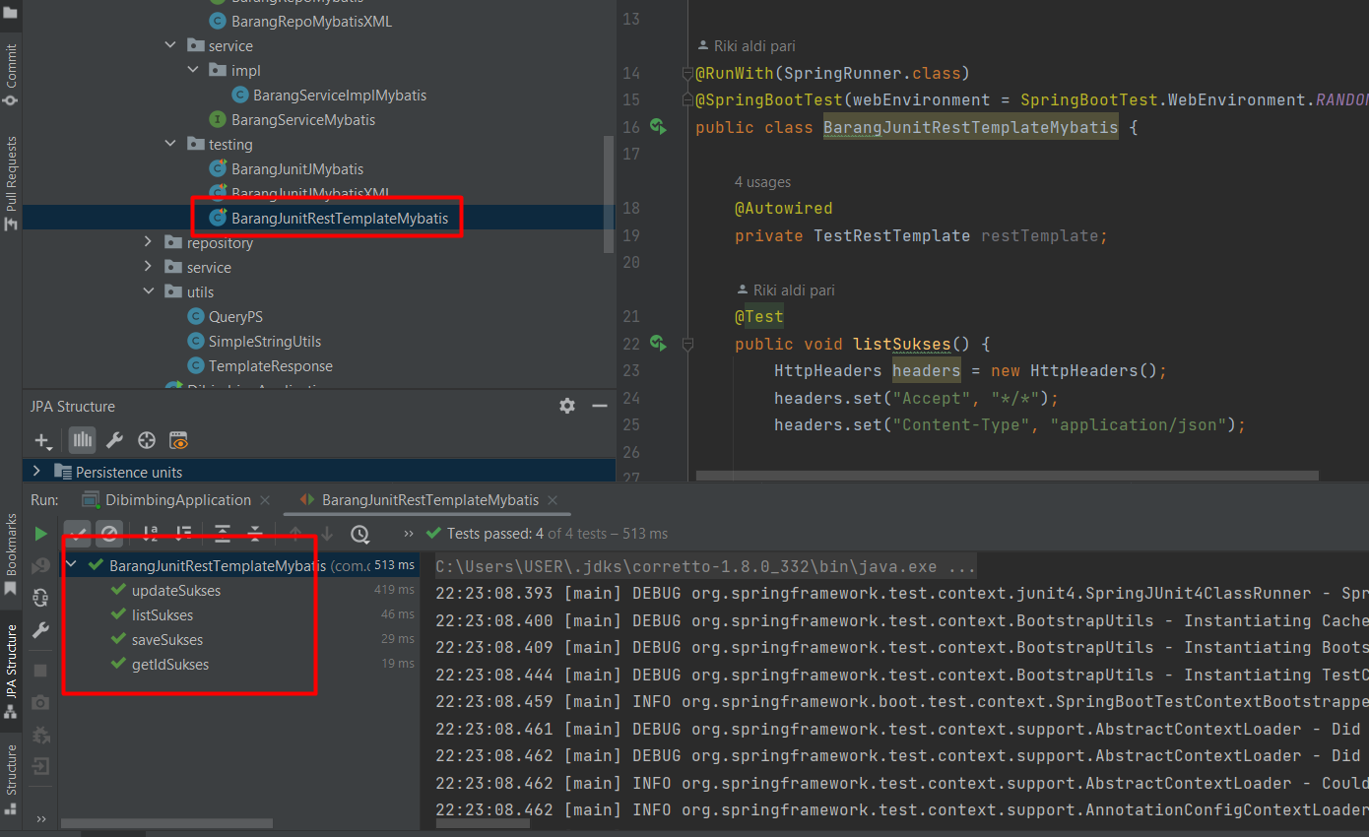

## Branch

URL : <https://github.com/rikialdi/dibimbing/tree/rest-jdbc/src/main/java/com/dibimbing/dibimbing/jdbc>

# JDBC -CRUD Praktek

Studi Kasus CRUD Barang.

## POM.xml

|  |
| --- |
| <!-- JDBC-->  <dependency>  <groupId>org.springframework.boot</groupId>  <artifactId>spring-boot-starter-jdbc</artifactId>  </dependency> |

## Model

|  |
| --- |
| package com.dibimbing.dibimbing.jdbc.model;  import lombok.Data;  @Data public class BarangJdbc {   Long id ;  String nama;  String satuan;  Double harga;  Integer stok; } |

Mapper

|  |
| --- |
| package com.dibimbing.dibimbing.jdbc.model;  import org.springframework.jdbc.core.RowMapper;  import java.sql.ResultSet; import java.sql.SQLException;  public class BarangMapper implements RowMapper<BarangJdbc> {   @Override  public BarangJdbc mapRow(ResultSet rs, int rowNum) throws SQLException {   BarangJdbc barang = new BarangJdbc();  barang.setId(rs.getLong("id"));  barang.setNama(rs.getString("nama"));  barang.setSatuan(rs.getString("satuan"));  barang.setStok(rs.getInt("stok"));  barang.setHarga(rs.getDouble("harga")); // barang.setCreatedDate(rs.getTimestamp("created_date").toLocalDateTime());   return barang;   } } |

## Repository

|  |
| --- |
| package com.dibimbing.dibimbing.jdbc.repository;  import com.dibimbing.dibimbing.jdbc.model.BarangJdbc; import com.dibimbing.dibimbing.jdbc.model.BarangMapper; import com.dibimbing.dibimbing.model.Barang; import org.springframework.beans.factory.annotation.Autowired; import org.springframework.jdbc.core.BeanPropertyRowMapper; import org.springframework.jdbc.core.JdbcTemplate; import org.springframework.stereotype.Repository;  import java.math.BigDecimal; import java.sql.Timestamp; import java.time.LocalDateTime; import java.util.ArrayList; import java.util.List; import java.util.Map;  @Repository public class BarangRepoJdbc {  @Autowired  private JdbcTemplate jdbcTemplate;   public int save(Barang barang) {  return jdbcTemplate.update(  "insert into barang (created_date,updated_date,harga,nama,satuan,stok)\n" +  " values (?, ?, ?, ?, ?, ?)",  LocalDateTime.*now*(), LocalDateTime.*now*(), barang.getHarga(),barang.getNama(),barang.getSatuan(),barang.getStok());  }   public int update(Barang barang) {  return jdbcTemplate.update(  "update barang set harga =?, nama=?, satuan=?, stok=? where id =?",  barang.getHarga(), barang.getNama(), barang.getSatuan(),barang.getStok(),barang.getId());  }   public List<BarangJdbc> findAll() {   String sql = "SELECT * FROM barang";   List<BarangJdbc> objbarang = new ArrayList<>();   List<Map<String, Object>> rows = jdbcTemplate.queryForList(sql);   for (Map row : rows) {  BarangJdbc obj = new BarangJdbc();  obj.setId(((Long) row.get("id")).longValue());  obj.setNama((String) row.get("nama"));  obj.setSatuan((String) row.get("satuan"));  obj.setStok(((Integer) row.get("stok")));  obj.setHarga(((Double) row.get("harga"))); // obj.setCreatedDate(((Timestamp) row.get("CREATED_DATE")).toLocalDateTime());  objbarang.add(obj);  }   return objbarang;  }   public List<BarangJdbc> findAll2() {   String sql = "SELECT * FROM barang";   List<BarangJdbc> customers = jdbcTemplate.query(  sql,  new BarangMapper());   return customers;  }   public List<BarangJdbc> findAll3() {  String sql = "SELECT id,nama,harga,satuan,stok FROM barang";  List<BarangJdbc> obj = jdbcTemplate.query(  sql,  new BeanPropertyRowMapper(BarangJdbc.class));  return obj;  }   public BarangJdbc findByBarangId(Long id) {   String sql = "SELECT * FROM barang WHERE ID =?";   return jdbcTemplate.queryForObject(sql, new Object[]{id}, new BarangMapper());   }   public BarangJdbc findByBarangId2(Long id) {   String sql = "SELECT * FROM barang WHERE ID =?";   return (BarangJdbc) jdbcTemplate.queryForObject(sql, new Object[]{id}, new BeanPropertyRowMapper(BarangJdbc.class));   }   public int delete(Long id) {  return jdbcTemplate.update(  "delete from barang where id =?",  id);  } } |

## Service

|  |
| --- |
|  |

## Testing Junit

|  |
| --- |
| package com.dibimbing.dibimbing.jdbc.testing;  import com.dibimbing.dibimbing.jdbc.model.BarangJdbc; import com.dibimbing.dibimbing.jdbc.repository.BarangRepoJdbc; import com.dibimbing.dibimbing.model.Barang; import com.dibimbing.dibimbing.repository.BarangRepository; import com.dibimbing.dibimbing.service.BarangService; import org.junit.Test; import org.junit.runner.RunWith; import org.springframework.beans.factory.annotation.Autowired; import org.springframework.boot.test.context.SpringBootTest; import org.springframework.boot.test.web.client.TestRestTemplate; import org.springframework.test.context.junit4.SpringRunner;  import java.util.List; import java.util.Map;  import static org.junit.Assert.*assertEquals*;   @RunWith(SpringRunner.class) @SpringBootTest(webEnvironment = SpringBootTest.WebEnvironment.*RANDOM_PORT*) public class BarangJunitJdbc {   @Autowired  BarangRepoJdbc barangRepoJdbc;   @Test  public void save() {  Barang obj = new Barang();  obj.setHarga(1235.0);  obj.setNama("barang 4");  obj.setStok(789);  obj.setSatuan("pcs");  int chek = barangRepoJdbc.save(obj);  System.*out*.println("Value:"+chek);  }   @Test  public void update() {  Barang obj = new Barang();  obj.setHarga(1235.0);  obj.setNama("barang 4");  obj.setStok(789);  obj.setSatuan("pcs");  obj.setId(15L);  int chek = barangRepoJdbc.update(obj);  System.*out*.println("Value:"+chek);  }   @Test  public void findAll1() {  List<BarangJdbc> obk =barangRepoJdbc.findAll();  for(BarangJdbc o : obk){  System.*out*.println("id:"+o.getId());  System.*out*.println("nama :"+o.getNama());  System.*out*.println("=======");  }  }   @Test  public void findAll2() {  List<BarangJdbc> obk =barangRepoJdbc.findAll2();  for(BarangJdbc o : obk){  System.*out*.println("id:"+o.getId());  System.*out*.println("nama :"+o.getNama());  System.*out*.println("=======");  }  }   @Test  public void findAll3() {  List<BarangJdbc> obk =barangRepoJdbc.findAll3();  for(BarangJdbc o : obk){  System.*out*.println("id:"+o.getId());  System.*out*.println("nama :"+o.getNama());  System.*out*.println("=======");  }  }   @Test  public void findById1() {  BarangJdbc obj =barangRepoJdbc.findByBarangId(15L);  System.*out*.println("id:"+obj.getId());  System.*out*.println("nama :"+obj.getNama());  System.*out*.println("=======");  }   @Test  public void findById2() {  BarangJdbc obj =barangRepoJdbc.findByBarangId2(15L);  System.*out*.println("id:"+obj.getId());  System.*out*.println("nama :"+obj.getNama());  System.*out*.println("=======");  }   @Test  public void delete() {  int chek = barangRepoJdbc.delete(15L);  System.*out*.println("Value:"+chek);  } } |

## OUTPUT

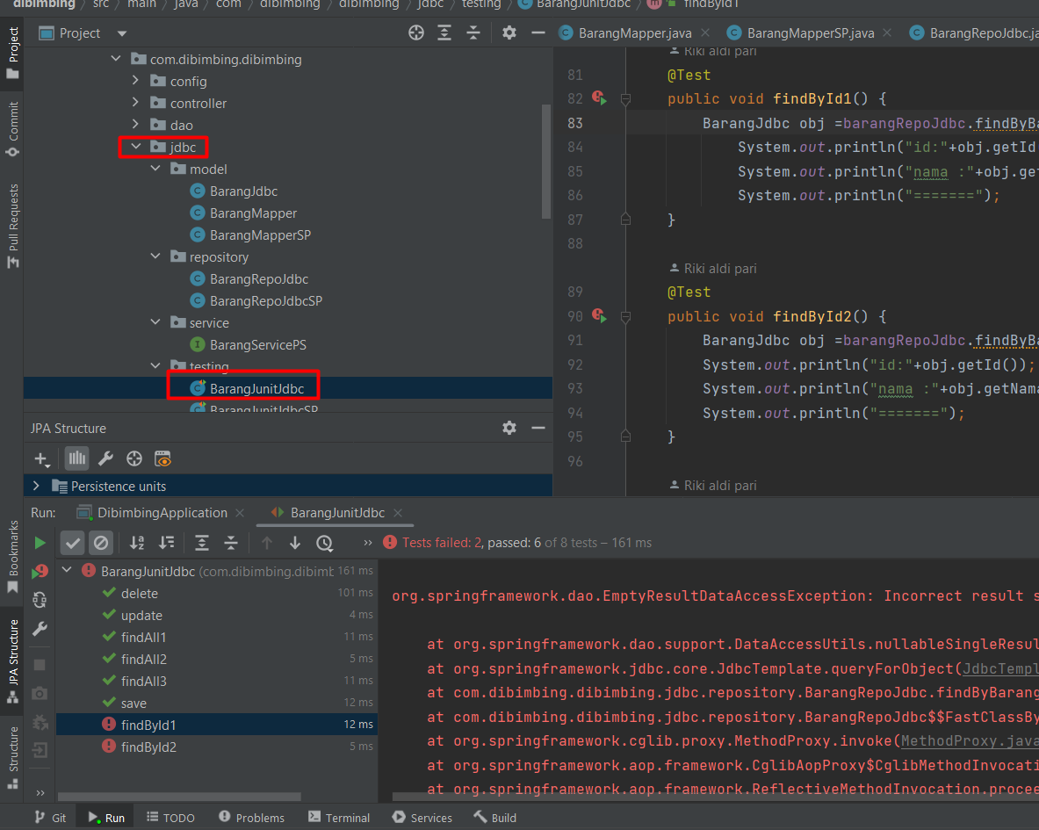

## Branch

URL : <https://github.com/rikialdi/dibimbing/tree/rest-jdbc/src/main/java/com/dibimbing/dibimbing/jdbc>

# MyBatis CRUD-file.xml

Studi kasus CRUD barang.

## File xml.

File ini digunakan untuk mapping query. Termasuk Store Prosedure.

|  |
| --- |
|  |

## Application.properties

|  |
| --- |
| mybatis.type-aliases-package=com.dibimbing.dibimbing.mybatis.testing mybatis.type-handlers-package=com.dibimbing.dibimbing.mybatis.testing #mybatis.configuration.map-underscore-to-camel-case=true mybatis.configuration.default-fetch-size=100 mybatis.configuration.default-statement-timeout=30 #mybatis configuration mybatis.mapper-locations=classpath:scmt_manual.xml |

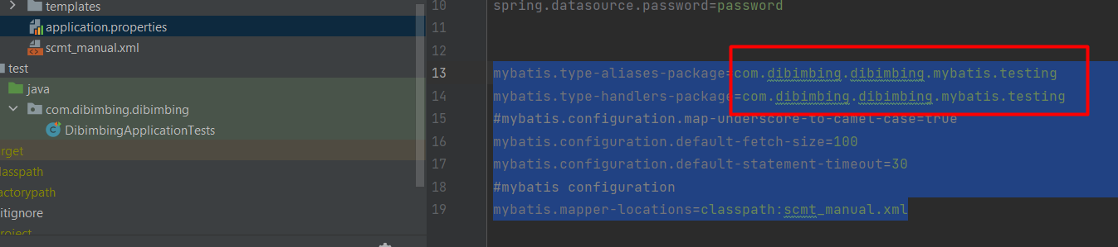

Package diatas menentukan dimana lokasi class repository berada

## Model

|  |
| --- |
| package com.dibimbing.dibimbing.mybatis.model;  import lombok.Data;  @Data public class BarangMybatis {  Long resid ;  String resnama;  String ressatuan;  Double resharga;  Integer resstok;  String reserordesc;  Integer reserorcode; } |

## Repository

|  |
| --- |
| package com.dibimbing.dibimbing.mybatis.repository;  import com.dibimbing.dibimbing.mybatis.model.BarangMybatis; import org.apache.ibatis.annotations.Insert; import org.apache.ibatis.annotations.Mapper; import org.apache.ibatis.annotations.Select; import org.apache.ibatis.annotations.Update; import org.apache.ibatis.session.SqlSession; import org.apache.ibatis.session.SqlSessionFactory; import org.springframework.beans.factory.annotation.Autowired; import org.springframework.stereotype.Component;  import java.util.List; import java.util.Map; @Component public class BarangRepoMybatisXML {  @Autowired  public SqlSessionFactory sqlSessionFactory;   public Map<String, Object> updatebarang(Map<String, Object> map) {  SqlSession session = sqlSessionFactory.openSession();  try {  session.update("scmt_manual.updatebarangxml", map);  session.commit();  return map;  } finally {  session.close();  }  }   public Map<String, Object> testps(Map<String, Object> map) {  SqlSession session = sqlSessionFactory.openSession();  try {  session.insert("scmt_manual.testsptyu", map);  session.commit();  return map;  } finally {  session.close();  }  }   public List<BarangMybatis> listDataXML(Map map) {  SqlSession session = sqlSessionFactory.openSession();  try {  List<BarangMybatis> list = session.selectList("scmt_manual.getListManual", map);  return list;  } finally {  session.close();  }  }   public BarangMybatis getByIdBarangXML(Map map) {  SqlSession session = sqlSessionFactory.openSession();  try {  BarangMybatis list = session.selectOne("scmt_manual.getById", map);  return list;  } finally {  session.close();  }  }  } |

## Service

|  |
| --- |
| package com.dibimbing.dibimbing.mybatis.service;  import com.dibimbing.dibimbing.model.Barang; import com.dibimbing.dibimbing.mybatis.model.BarangMybatis; import org.apache.ibatis.annotations.Insert; import org.apache.ibatis.annotations.Mapper; import org.apache.ibatis.annotations.Select; import org.apache.ibatis.annotations.Update; import org.springframework.stereotype.Service;  import java.util.List; import java.util.Map;   public interface BarangServiceMybatis {   BarangMybatis selectBlog(int rqid);   List<BarangMybatis> selectList(String rqnama);   void insertProcedure(Double rqharga, String rqnama, String rqsatuan, int rqstok, int resid);   void updateProcedure(Double rqharga, String rqnama, String rqsatuan, int rqstok, int resid);   void deleteProcedure(int resid);   Map updatebarangoutwitheror(Double rqharga, String rqnama, String rqsatuan, int rqstok, int resid);   Map savebarangoutwitheror(Double rqharga, String rqnama, String rqsatuan, int rqstok, Integer resid);   // use xml  public Map updateProcedureXML(BarangMybatis item);  List<BarangMybatis> listBarangXML(BarangMybatis item);  BarangMybatis getByIdBarangXML(Integer id);   public Map testPS(BarangMybatis item);   } |

## Service Implementation

|  |
| --- |
| package com.dibimbing.dibimbing.mybatis.service.impl;  import com.dibimbing.dibimbing.model.Barang; import com.dibimbing.dibimbing.mybatis.model.BarangMyBatisMapper; import com.dibimbing.dibimbing.mybatis.model.BarangMybatis; import com.dibimbing.dibimbing.mybatis.repository.BarangRepoMybatis; import com.dibimbing.dibimbing.mybatis.repository.BarangRepoMybatisXML; import com.dibimbing.dibimbing.mybatis.service.BarangServiceMybatis; import com.dibimbing.dibimbing.utils.QueryPS; import com.dibimbing.dibimbing.utils.TemplateResponse; import org.springframework.beans.factory.annotation.Autowired; import org.springframework.jdbc.core.JdbcTemplate; import org.springframework.stereotype.Service;  import java.util.HashMap; import java.util.List; import java.util.Map;  @Service public class BarangServiceImplMybatis implements BarangServiceMybatis {   @Autowired  BarangRepoMybatis barangRepoMybatis;  @Autowired  public TemplateResponse templateResponse;  @Autowired  private JdbcTemplate jdbcTemplate;  @Autowired  QueryPS queryPS;  @Autowired  public BarangRepoMybatisXML barangRepoMybatisXML;  @Override  public BarangMybatis selectBlog(int rqid) {  return barangRepoMybatis.selectBlog(rqid);  }   @Override  public List<BarangMybatis> selectList(String rqnama) {  return barangRepoMybatis.selectList(rqnama);  }   @Override  public void insertProcedure(Double rqharga, String rqnama, String rqsatuan, int rqstok, int resid) {  barangRepoMybatis.insertProcedure( rqharga, rqnama, rqsatuan, rqstok, resid);  }   @Override  public void updateProcedure(Double rqharga, String rqnama, String rqsatuan, int rqstok, int resid) {  barangRepoMybatis.updateProcedure( rqharga, rqnama, rqsatuan, rqstok, resid);   }   @Override  public void deleteProcedure(int resid) {  barangRepoMybatis.deleteProcedure( resid);  }   @Override  public Map updatebarangoutwitheror(Double rqharga, String rqnama, String rqsatuan, int rqstok, int resid) { // barangRepoMybatis.updatebarangoutwitheror( rqharga, rqnama, rqsatuan, rqstok, resid, // 1.0,"","",1,"",1);  Map<String , Object> map = new HashMap<>();  map.put("rqharga",rqharga);  map.put("rqnama",rqnama);  map.put("rqsatuan",rqsatuan);  map.put("rqstok",rqstok);  map.put("resid",resid);  map.put("resharga",null);  map.put("resnama", null);  map.put("ressatuan",null);  map.put("resstok",null);  map.put("reserordesc",null);  map.put("reserorcode",null); // penting dibaca type data mybatis https://mybatis.org/mybatis-3/apidocs/reference/org/apache/ibatis/type/JdbcType.html  barangRepoMybatis.updatebarangoutwitheror2(map);  System.*out*.println("resid="+(Integer) map.get("resid"));  System.*out*.println("resharga="+(Double) map.get("resharga"));  System.*out*.println("resnama="+(String) map.get("resnama"));  System.*out*.println("ressatuan="+(String) map.get("ressatuan"));  System.*out*.println("resstok="+(Integer) map.get("resstok"));  System.*out*.println("reserordesc="+(String) map.get("reserordesc"));  System.*out*.println("reserorcode="+(Integer) map.get("reserorcode"));    Barang objBarang = new Barang();  objBarang.setId(Long.*parseLong*(String.*valueOf*((Integer) map.get("resid"))));  objBarang.setSatuan((String) map.get("ressatuan"));  objBarang.setStok((Integer) map.get("resstok"));  objBarang.setHarga((Double) map.get("resharga"));  objBarang.setNama((String) map.get("resnama"));   return templateResponse.templateSukses(objBarang,(String) map.get("reserordesc"), String.*valueOf*((Integer) map.get("reserorcode")));   }   @Override  public Map savebarangoutwitheror(Double rqharga, String rqnama, String rqsatuan, int rqstok, Integer resid) {  jdbcTemplate.execute(queryPS.save);   Map<String , Object> map = new HashMap<>();  map.put("rqharga",rqharga);  map.put("rqnama",rqnama);  map.put("rqsatuan",rqsatuan);  map.put("rqstok",rqstok);  map.put("resid",(resid == null ? 0: resid));  map.put("resharga",null);  map.put("resnama", null);  map.put("ressatuan",null);  map.put("resstok",null);  map.put("reserordesc",null);  map.put("reserorcode",null); // penting dibaca type data mybatis https://mybatis.org/mybatis-3/apidocs/reference/org/apache/ibatis/type/JdbcType.html  barangRepoMybatis.savebarangoutwitheror(map);  System.*out*.println("resid="+(Integer) map.get("resid"));  System.*out*.println("resharga="+(Double) map.get("resharga"));  System.*out*.println("resnama="+(String) map.get("resnama"));  System.*out*.println("ressatuan="+(String) map.get("ressatuan"));  System.*out*.println("resstok="+(Integer) map.get("resstok"));  System.*out*.println("reserordesc="+(String) map.get("reserordesc"));  System.*out*.println("reserorcode="+(Integer) map.get("reserorcode"));    Barang objBarang = new Barang();  objBarang.setId(Long.*parseLong*(String.*valueOf*((Integer) map.get("resid"))));  objBarang.setSatuan((String) map.get("ressatuan"));  objBarang.setStok((Integer) map.get("resstok"));  objBarang.setHarga((Double) map.get("resharga"));  objBarang.setNama((String) map.get("resnama"));  return templateResponse.templateSukses(objBarang,(String) map.get("reserordesc"), String.*valueOf*((Integer) map.get("reserorcode")));   }   @Override  public Map updateProcedureXML(BarangMybatis item) {  Map map = new HashMap();  map.put("rqharga", item.getResharga());  map.put("rqnama", item.getResnama());  map.put("rqsatuan", item.getRessatuan());  map.put("rqstok",item.getResstok());  map.put("resid", item.getResid());  showLog(map, "Insert Header");  return barangRepoMybatisXML.updatebarang(map);  }   @Override  public List<BarangMybatis> listBarangXML(BarangMybatis item) {  Map map = new HashMap<>();  map.put("rqnama", "%"+item.getResnama()+"%");  showLog(map, "Insert Header");  return barangRepoMybatisXML.listDataXML(map);  }   @Override  public BarangMybatis getByIdBarangXML(Integer id) {  Map map = new HashMap<>();  map.put("rqid", id);  showLog(map, " Header");  return barangRepoMybatisXML.getByIdBarangXML(map);  }   @Override  public Map testPS(BarangMybatis item) {  Map map = new HashMap();  map.put("rqid", "3343");  map.put("resid",null);  showLog(map, " Header");  return barangRepoMybatisXML.testps(map);  }    public void showLog(Map<String, Object> map, String title) {  System.*out*.println("Process : " + title);  for (Map.Entry<String, Object> entry : map.entrySet()) {  String key = entry.getKey();  Object value = entry.getValue();  System.*out*.println(key + " : " + value);  }  System.*out*.println("========================");  }  } |

## Tetsting – JUNIT

|  |
| --- |
| package com.dibimbing.dibimbing.mybatis.testing;  import com.dibimbing.dibimbing.mybatis.model.BarangMybatis; import com.dibimbing.dibimbing.mybatis.service.BarangServiceMybatis; import com.dibimbing.dibimbing.utils.QueryPS; import org.apache.ibatis.annotations.Options; import org.apache.ibatis.annotations.Select; import org.apache.ibatis.mapping.StatementType; import org.apache.ibatis.session.SqlSession; import org.apache.ibatis.session.SqlSessionFactory; import org.junit.Test; import org.junit.runner.RunWith; import org.springframework.beans.factory.annotation.Autowired; import org.springframework.boot.test.context.SpringBootTest; import org.springframework.jdbc.core.JdbcTemplate; import org.springframework.test.context.junit4.SpringRunner;  import javax.sql.DataSource; import java.io.IOException; import java.util.HashMap; import java.util.List; import java.util.Map;   @RunWith(SpringRunner.class) @SpringBootTest(webEnvironment = SpringBootTest.WebEnvironment.*RANDOM_PORT*) public class BarangJunitJMybatisXML {   @Autowired  BarangServiceMybatis barangServiceMybatis;   @Autowired  private JdbcTemplate jdbcTemplate;  @Autowired  private DataSource dataSource;  @Autowired  QueryPS queryPS;   @Autowired  private SqlSessionFactory sqlSessionFactory;   @Test  public void suksesDataList() throws IOException {   BarangMybatis obj = new BarangMybatis();  obj.setResnama("");  List<BarangMybatis> list = barangServiceMybatis.listBarangXML(obj);  for (BarangMybatis data : list) {  System.*out*.println("data 90= ============== ");  System.*out*.println("id=" + data.getResid());  System.*out*.println("nama=" + data.getResnama());  System.*out*.println("satuan=" + data.getRessatuan());  System.*out*.println("harga=" + data.getResharga());  System.*out*.println("stok=" + data.getResstok());  }   }   @Test  public void suksesDataByID() throws IOException {  BarangMybatis data = barangServiceMybatis.getByIdBarangXML(3);   System.*out*.println("data 90= ============== ");  System.*out*.println("id=" + data.getResid());  System.*out*.println("nama=" + data.getResnama());  System.*out*.println("satuan=" + data.getRessatuan());  System.*out*.println("harga=" + data.getResharga());  System.*out*.println("stok=" + data.getResstok());  }   @Test  public void updateProcedureXML() throws IOException {   try {  BarangMybatis obj = new BarangMybatis();  obj.setResid(3L);  obj.setRessatuan("pcs");  obj.setResstok(123);  obj.setResnama("aplikasi");  obj.setResharga(123.4);  Map out = barangServiceMybatis.updateProcedureXML(obj);  String resid = out.get("resid").toString();  System.*out*.println(resid);  } finally {   }  }   @Test  public void testps() throws IOException { // BarangMybatis obj = new BarangMybatis(); // Map out = barangServiceMybatis.testPS(obj); // String resid = out.get("resid").toString(); // System.out.println(resid);    }    } |

## OUTPUT

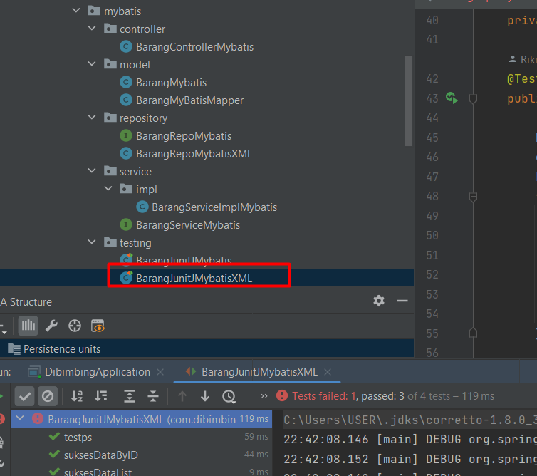

## Branch

https://github.com/rikialdi/dibimbing/tree/rest-jdbc/src/main/java/com/dibimbing/dibimbing/mybatis

# Spring MVC + Store Prosedure +Tymeleaf

Pembahasan saat ini akan membahas tentang impelementasi Spring MVC + Store Prosedure CRUD.

Spring MVC + Tymeleaf + Store Prosedure

Step by Step

## Model + Repositroy + Service + Pom.xml

Sudah dibahas pada CRUD Store Prosedure

## Controller Spring MVC

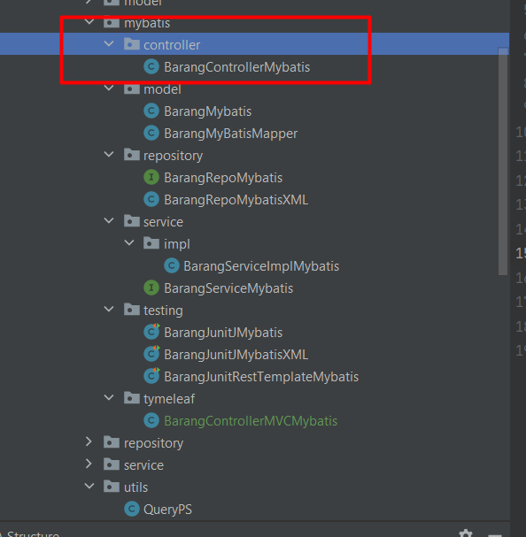

|  |
| --- |
| package com.dibimbing.dibimbing.mybatis.controller;   import com.dibimbing.dibimbing.config.Config; import com.dibimbing.dibimbing.model.Barang; import com.dibimbing.dibimbing.mybatis.model.BarangMybatis; import com.dibimbing.dibimbing.mybatis.service.BarangServiceMybatis; import com.dibimbing.dibimbing.repository.BarangRepository; import com.dibimbing.dibimbing.service.BarangService; import com.dibimbing.dibimbing.utils.SimpleStringUtils; import com.dibimbing.dibimbing.utils.TemplateResponse; import org.springframework.beans.factory.annotation.Autowired; import org.springframework.data.domain.Page; import org.springframework.data.domain.Pageable; import org.springframework.http.HttpHeaders; import org.springframework.http.HttpStatus; import org.springframework.http.ResponseEntity; import org.springframework.web.bind.annotation.*;  import javax.validation.ConstraintViolationException; import javax.validation.Valid; import java.security.Principal; import java.util.ArrayList; import java.util.List; import java.util.Map; import com.dibimbing.dibimbing.mybatis.service.BarangServiceMybatis; @RestController @RequestMapping("/v1/sp/barang") public class BarangControllerMybatis {    @Autowired  public BarangServiceMybatis barangServiceMybatis;   Config config = new Config();   @Autowired  public TemplateResponse templateResponse;   SimpleStringUtils simpleStringUtils = new SimpleStringUtils();   @PostMapping("/save")  public ResponseEntity<Map> dave(@RequestBody Barang objModel) {  Map map = barangServiceMybatis.savebarangoutwitheror(objModel.getHarga(),  objModel.getNama(),  objModel.getSatuan(),  objModel.getStok(),  Integer.*parseInt*(objModel.getId().toString()));  return new ResponseEntity<Map>(map, HttpStatus.*OK*);  }   @PutMapping("/update")  public ResponseEntity<Map> update(@RequestBody Barang objModel) {  Map map = barangServiceMybatis.updatebarangoutwitheror(objModel.getHarga(),  objModel.getNama(),  objModel.getSatuan(),  objModel.getStok(),  Integer.*parseInt*(objModel.getId().toString()));  return new ResponseEntity<Map>(map, HttpStatus.*OK*);  }  // @DeleteMapping("/delete/{id}") // public ResponseEntity<Map> delete(@PathVariable(value = "id") Long id) { // Map map = barangService.delete(id); // return new ResponseEntity<Map>(map, HttpStatus.OK); // }   @GetMapping("/list")  public ResponseEntity<Map> listByBama(  @RequestParam(required = false) String nama) {  List<BarangMybatis> list = barangServiceMybatis.selectList("%"+nama+"%");  return new ResponseEntity<Map>(templateResponse.templateSukses(templateResponse.conversiToBarang(list)), new HttpHeaders(), HttpStatus.*OK*);  }   @GetMapping("/{id}")  public ResponseEntity<Map> delete(@PathVariable(value = "id") Integer id) {  BarangMybatis obj = barangServiceMybatis.selectBlog(id);  return new ResponseEntity<Map>(templateResponse.templateSukses(templateResponse.conversiToBarang(obj)), HttpStatus.*OK*);  }   } |

## Template Tymeleaf

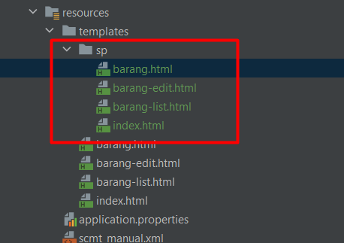

### Index

|  |
| --- |
| <!DOCTYPE HTML> <html xmlns:th="http://www.thymeleaf.org">  <head>  <meta charset="UTF-8" />  <title th:utext="${title}"/>  <link rel="stylesheet" type="text/css" th:href="@{/css/style.css}"/>  </head>  <body>  <h1 th:utext="${title}"/>  <a th:href="@{/v1/view/sp/barang/list}">Barang List SP</a>  <br/><br/>  <div>Copyright 2021</div>  </body> </html> |

### Barang

|  |
| --- |
| <!DOCTYPE HTML> <html xmlns:th="http://www.thymeleaf.org"> <head>  <meta charset="UTF-8" />  <title>View Barang SP</title>  <link rel="stylesheet" type="text/css" th:href="@{/css/style.css}"/> </head> <body> <h1>View Barang</h1> <a th:href="@{/v1/view/sp/barang/list}">Back to Barang List</a> <br/><br/> <div th:if="${barang}">  <table border="0">  <tr>  <td>Name</td>  <td>:</td>  <td th:utext="${barang.nama}">...</td>  </tr>  <tr>  <td>Phone</td>  <td>:</td>  <td th:utext="${barang.stok}">...</td>  </tr>  <tr>  <td>Email</td>  <td>:</td>  <td th:utext="${barang.satuan}">...</td>  </tr>  <tr>  <td>Address</td>  <td>:</td>  <td th:utext="${barang.harga}">...</td>  </tr>  </table>  <br/><br/>  <div th:if="not ${allowDelete}">  <a th:href="@{/v1/view/sp/barang/{barangId}/edit(barangId=${barang.id})}">Edit</a> |  <a th:href="@{/v1/view/sp/barang/{barangId}/delete(barangId=${barang.id})}">Delete</a>  </div>  <form th:if="${allowDelete}" th:action="@{/v1/view/sp/barang/{barangId}/delete(barangId=${barang.id})}" method="POST">  Delete this barang? <input type="submit" th:value="Yes" />  </form> </div> <div th:if="${errorMessage}" th:utext="${errorMessage}" class="error" /> </body> </html> |

### Barang-edit

|  |
| --- |
| <!DOCTYPE HTML> <html xmlns:th="http://www.thymeleaf.org"> <head>  <meta charset="UTF-8" />  <title th:text="${add} ? 'Create a Barang' : 'Edit a Barang'" />  <link rel="stylesheet" type="text/css" th:href="@{/css/style.css}"/> </head> <body> <h1 th:text="${add} ? 'Create a Barang:' : 'Edit a Barang:'" /> <a th:href="@{/v1/view/sp/barang/list}">Back to Barang List</a> <br/><br/> <form th:action="${add} ? @{/v1/view/sp/barang/add} : @{/v1/view/sp/barang/{barangId}/edit(barangId=${barang.id})}"  th:object="${barang}" method="POST">  <table border="0">  <tr>  <td>Nama</td>  <td>:</td>  <td><input type="text" th:field="*{nama}" /></td>  </tr>  <tr>  <td>Stok</td>  <td>:</td>  <td><input type="text" th:field="*{stok}" /></td>  </tr>  <tr>  <td>Satuan</td>  <td>:</td>  <td><input type="text" th:field="*{satuan}" /></td>  </tr>  <tr>  <td>Harga</td>  <td>:</td>  <td><input type="text" th:field="*{harga}"/></td>  </tr>  </table>  <input type="submit" th:value="${add} ? 'Create' : 'Update'" /> </form>  <br/> <!-- Check if errorMessage is not null and not empty --> <div th:if="${errorMessage}" th:utext="${errorMessage}" class="error" /> </body> </html> |

### Barang-list

|  |
| --- |
| <!DOCTYPE HTML> <html xmlns:th="http://www.thymeleaf.org"> <head>  <meta charset="UTF-8" />  <title>Barang List SP</title>  <link rel="stylesheet" type="text/css" th:href="@{/css/style.css}"/> </head> <body> <h1>Barang List SP</h1>  <div>  <nobr>  <a th:href="@{/v1/view/sp/barang/add}">Add Barang</a> |  <a th:href="@{/v1/view/sp/barang/}">Back to Index</a>  </nobr> </div> <br/><br/> <div>  <table border="1">  <tr>  <th>Nama</th>  <th>Stok</th>  <th>Satuan</th>  <th>Harga</th>  </tr>  <tr th:each ="barang : ${barangs}">  <td><a th:href="@{/v1/view/barang/{barangId}(barangId=${barang.id})}" th:utext="${barang.nama}">...</a></td>  <td><a th:href="@{/v1/view/barang/{barangId}(barangId=${barang.id})}" th:utext="${barang.stok}">...</a></td>  <td th:utext="${barang.satuan}">...</td>  <td th:utext="${barang.harga}">...</td>  <td><a th:href="@{/v1/view/barang/{barangId}/edit(barangId=${barang.id})}">Edit</a></td>  </tr>  </table> </div> <br/><br/> <div>  <nobr>  <span th:if="${hasPrev}"><a th:href="@{/v1/view/barang/list?page={prev}(prev=${prev})}">Prev</a>&nbsp;&nbsp;&nbsp;</span>  <span th:if="${hasNext}"><a th:href="@{/v1/view/barang/list?page={next}(next=${next})}">Next</a></span>  </nobr> </div> </body> </html> |

## Output

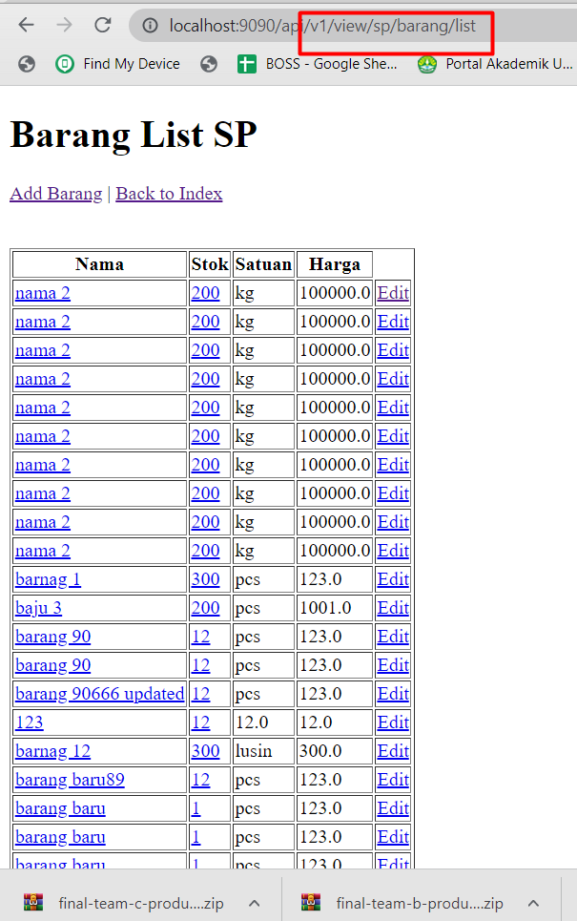

## Branch

https://github.com/rikialdi/dibimbing/tree/rest-jdbc/src/main/java/com/dibimbing/dibimbing/mybatis

# Design Pattern

**Design pattern** ini mirip kayak class, yaitu suatu blueprint.

Bedanya, kalau class ibarat blueprint atau acuan buat bikin object, kalau design pattern ibaratnya **blueprint atau template buat bikin program**.

## Jenis design pattern

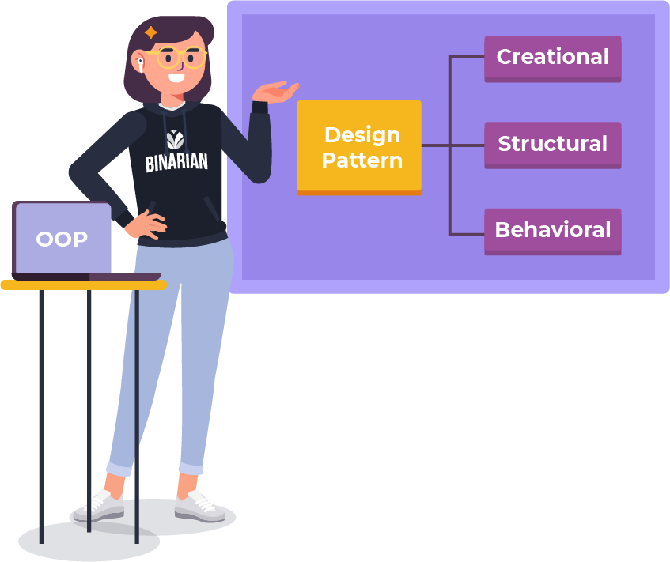

## Tujuan

Dengan menerapkan design pattern, **kode yang kita bikin bakal lebih terstruktur dan lebih gampang buat dipahami sama orang lain**.

Selain itu, kita juga jadi lebih gampang buat mengelompokkan kode-kode yang kita buat.

## Creational Pattern

Creational Pattern adalah solusi yang berkaitan dengan pembuatan object. Dengan creational pattern, kita bisa **me-manage penggunaan object.**

Maka dari itu kita perlu belajar tentang managing object melalui Creational Pattern, yang diturunkan lagi jadi tiga pattern, yaitu **singleton, factory, dan pool pattern.**

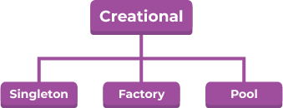

### Singleton Pattern

Yaitu pattern yang bisa **memanggil satu object di dalam suatu aplikasi.** Pokoknya inget aja kata single.

Contoh penerapan : membuat beans saat aplikasi pertama kali di running

|  |
| --- |
| @Configuration public class SingleCreateBeans {   @Bean  public SingleCreateBeans singleBean(){  System.*out*.println("create beans signleton: penerapan pada koneksi");  return new SingleCreateBeans();  } } |

Lakukan testing

|  |
| --- |
| import com.binar5.apps.bean.KaryawanBean; import org.junit.Test; import org.springframework.boot.test.context.SpringBootTest; import org.springframework.context.ApplicationContext; import org.springframework.context.annotation.AnnotationConfigApplicationContext;  @SpringBootTest public class Testing {   @Test  public void testSingleton(){  ApplicationContext applicationContext = new AnnotationConfigApplicationContext(SingleCreateBeans.class);   } }  output: |

### Factory Pattern

Yaitu pattern yang cukup sering dipakai.

Factory pattern bisa **bikin berbagai macam object dari satu sumber**.

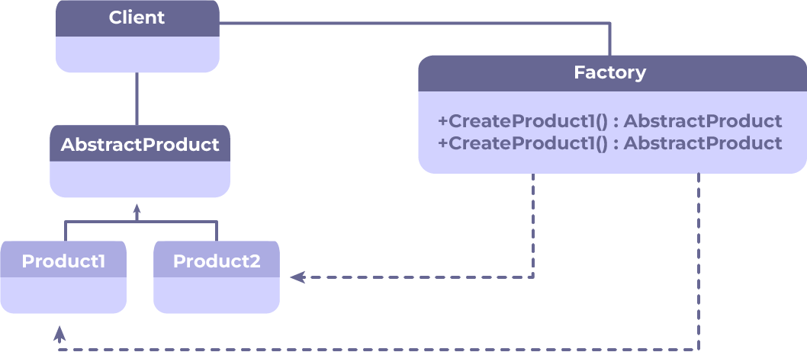

**Penerapan contoh :**

Misalnya ada suatu class service yang dipakai buat melakukan generate document xlsx, pdf dan csv.

Pas mau memproses file tersebut, semuanya udah mengimplement interface yang sama dengan method generate(). Tapi, implementasi atau cara buat men-generate masing-masing tipe document tersebut ternyata beda-beda. Jadi masing-masing tipe document bakal punya class-nya masing-masing.

Oleh karena itu, pada class service tersebut harus menentukan object apa yang harus dikembalikan.

**Contoh :**

**Ingin melakkukan CRUD: metdhod yang digunakan sama, namun memiliki behavior/kode program yang berbeda.**

Penerapan pada tabel barang dan supplier

* Strukture project

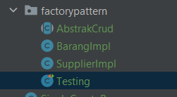

* AbsrakCrud class

|  |
| --- |
| import java.util.Map;  public abstract class AbstrakCrud {  public abstract Map save(Object req);  public abstract Map update(Object req);  public abstract Map delete(Object req);  public abstract Map list(Object req); } |

* BarangImpl

|  |
| --- |
| import java.util.HashMap; import java.util.Map;  @Service public class BarangImpl extends AbstrakCrud {   @Override  public Map save(Object req) {  return sukses("BarangImpl sukses save");  }   @Override  public Map update(Object req) {  return sukses("BarangImpl sukses update");  }   @Override  public Map delete(Object req) {  return sukses("BarangImpl sukses deleted");  }   @Override  public Map list(Object req) {  return sukses("BarangImpl sukses list");  }   public Map sukses(Object obj){  Map map = new HashMap();  map.put("data", obj);  map.put("code", 200);  map.put("status", "sukses");  return map;  } |

* SupplierImpl

|  |
| --- |
| package com.binar5.apps.designpattern.creational.factorypattern;  import org.springframework.beans.factory.annotation.Autowired; import org.springframework.stereotype.Service;  import java.util.HashMap; import java.util.Map; @Service public class SupplierImpl extends AbstrakCrud {    @Override  public Map save(Object req) {  return sukses("SupplierImpl sukses save");  }   @Override  public Map update(Object req) {  return sukses("SupplierImpl sukses update");  }   @Override  public Map delete(Object req) {  return sukses("SupplierImpl sukses deleted");  }   @Override  public Map list(Object req) {  return sukses("SupplierImpl sukses list");  }   public Map sukses(Object obj){  Map map = new HashMap();  map.put("data", obj);  map.put("code", 200);  map.put("status", "sukses");  return map;  } } |

* Testing

|  |
| --- |
| package com.binar5.apps.designpattern.creational.factorypattern;  import org.junit.Test; import org.springframework.boot.test.context.SpringBootTest;  @SpringBootTest public class Testing {   @Test  public void testBarangImpl(){  AbstrakCrud abs = new BarangImpl();  System.*out*.println(abs.save(""));  System.*out*.println(abs.update(""));  }   @Test  public void testSuppImpl(){  AbstrakCrud abs = new SupplierImpl();  System.*out*.println(abs.save(""));  System.*out*.println(abs.update(""));  } } |

* Output

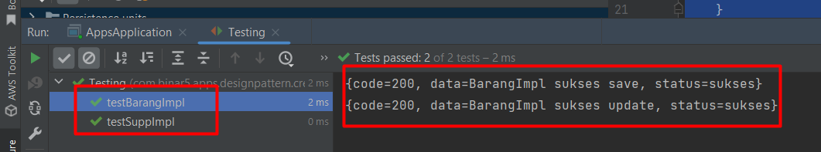

### Pool Pattern

Atau disebut juga object pool pattern merupakan **versi singleton pattern yang lebih kompleks.**

Dengan object ini bukan cuma satu aja yang di-instance sob, tapi object yang dibuat sesuai dengan kebutuhan.

Contoh penggunaannya adalah pada SpringDataJPA yang pakai [Hikari Connection Pool](http://www.masterspringboot.com/data-access/jpa-applications/hikari-connection-pool-with-spring-boot-made-simple/). Dengan menggunakan pool ini, kita bisa menyesuaikan berapa thread yang aktif pada kondisi idle, dan thread maksimum yang bisa diproses oleh pool.

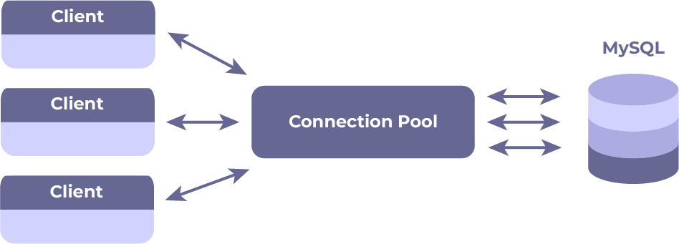

Contoh implementasi : <https://java-design-patterns.com/patterns/object-pool/>

## Structural pattern

Structural pattern merupakan **pattern yang mengatur gimana class-class berinteraksi**.

### tujuan

Kalau pakai pattern yang udah ada, kita bisa gampang banget buat melihat gimana sebuah class dikumpulkan dan membentuk sebuah struktur yang besar.

### Jenis

* Adapter pattern
* Bridge pattern
* Composite Pattern
* Decorator pattern
* Flyweight pattern
* Proxy pattern
* Facade pattern

### Façade Pattern

Facade pattern merupakan solusi untuk menampilkan **code yang complex** dan membaginya jadi beberapa bagian.

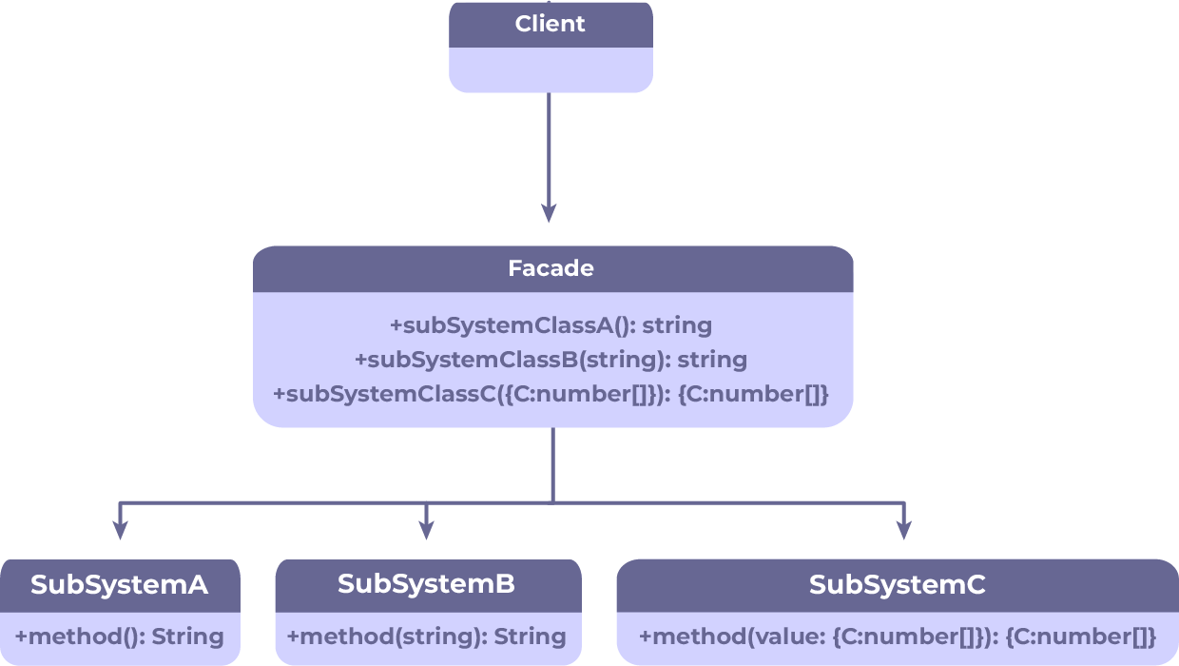

**Kenapa sih seluruh business logic nggak dijadikan satu class aja?**

Soalnya gini, kalau dijadikan satu class aja, maka **class yang isinya seluruh business logic bakal jadi kompleks banget**. Bahkan bisa jadi sulit buat dibaca dan dipahami.

Oleh karena itu class-class tersebut harus dikelompokkan jadi class-class yang lebih kecil supaya mudah dipahami. Dan sebaiknya class-class kecil tersebut punya interface yang berisi method utama.

### Contoh

Penerapan pada transaksi penjualan barang :

1. Ada service create order
2. Ada service chek stok
3. Ada service pembayaran.

Ketiga service diatas, akan digabungkan menjadi 1 class yang sama.  
gambaran seperti ini:

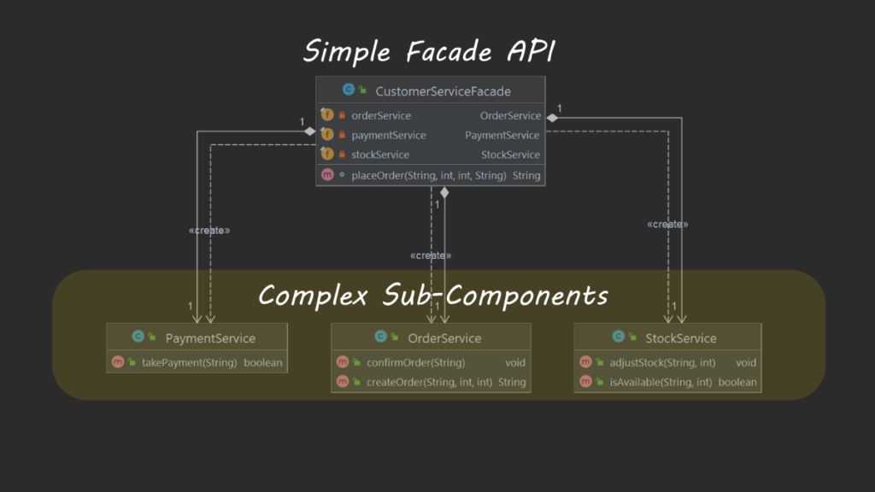

Struktur project:

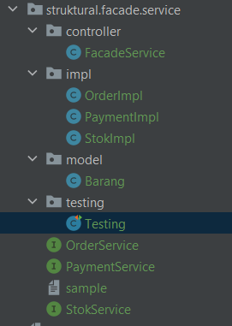

### Barang

|  |
| --- |
| package com.binar5.apps.designpattern.struktural.facade.service.model;  import lombok.Data;  @Data public class Barang {  private Long id;  private String nama;  private int stok;  private Double harga; } |

### OrderService

|  |
| --- |
| package com.binar5.apps.designpattern.struktural.facade.service;  import com.binar5.apps.designpattern.struktural.facade.service.model.Barang;  import java.util.Map;  public interface OrderService {  public Map orderBarangTotal(Barang request, Long qtyOrder); } |

### PaymentService

|  |
| --- |
| package com.binar5.apps.designpattern.struktural.facade.service;  import com.binar5.apps.designpattern.struktural.facade.service.model.Barang;  import java.util.Map;  public interface PaymentService {  public Map payment(Barang request, Long qty); } |

### StokService

|  |
| --- |
| package com.binar5.apps.designpattern.struktural.facade.service;  import com.binar5.apps.designpattern.struktural.facade.service.model.Barang; import com.sun.org.apache.xpath.internal.operations.Bool;  import java.util.Map;  public interface StokService {  public Map add(Barang request);  public Boolean chekStok(Barang request, Long qtyOrder); } |

### OrderImpl

|  |
| --- |
| package com.binar5.apps.designpattern.struktural.facade.service.impl;  import com.binar5.apps.designpattern.struktural.facade.service.OrderService; import com.binar5.apps.designpattern.struktural.facade.service.StokService; import com.binar5.apps.designpattern.struktural.facade.service.model.Barang; import org.springframework.stereotype.Service;  import java.util.HashMap; import java.util.Map; @Service public class OrderImpl implements OrderService {   public Map sukses(Object obj){  Map map = new HashMap();  map.put("data", obj);  map.put("code", 200);  map.put("status", "sukses");  return map;  }   @Override  public Map orderBarangTotal(Barang request,Long qtyOrder) {  return sukses(request.getHarga() * qtyOrder);  } } |

### PaymentImpl

|  |
| --- |
| package com.binar5.apps.designpattern.struktural.facade.service.impl;  import com.binar5.apps.designpattern.struktural.facade.service.OrderService; import com.binar5.apps.designpattern.struktural.facade.service.PaymentService; import com.binar5.apps.designpattern.struktural.facade.service.model.Barang; import org.springframework.stereotype.Service;  import java.util.HashMap; import java.util.Map;  @Service public class PaymentImpl implements PaymentService {   public Map sukses(Object obj){  Map map = new HashMap();  map.put("data", obj);  map.put("code", 200);  map.put("status", "sukses");  return map;  }   @Override  public Map payment(Barang request, Long qty) {  return sukses("Pembayaran berhasil");  } } |

### StokImpl

|  |
| --- |
| package com.binar5.apps.designpattern.struktural.facade.service.impl;  import com.binar5.apps.designpattern.struktural.facade.service.StokService; import com.binar5.apps.designpattern.struktural.facade.service.model.Barang; import com.sun.org.apache.xpath.internal.operations.Bool; import org.springframework.stereotype.Service;  import java.util.HashMap; import java.util.Map; @Service public class StokImpl implements StokService {   @Override  public Map add(Barang request) {  return sukses(request);  }   @Override  public Boolean chekStok(Barang request,Long qtyOrder) {  if(qtyOrder<=request.getHarga()){  return true;  }  return false;  }  public Map sukses(Object obj){  Map map = new HashMap();  map.put("data", obj);  map.put("code", 200);  map.put("status", "sukses");  return map;  } } |

### FacadeService

|  |
| --- |
| package com.binar5.apps.designpattern.struktural.facade.service.controller;  import com.binar5.apps.designpattern.struktural.facade.service.OrderService; import com.binar5.apps.designpattern.struktural.facade.service.PaymentService; import com.binar5.apps.designpattern.struktural.facade.service.StokService; import com.binar5.apps.designpattern.struktural.facade.service.model.Barang; import com.sun.org.apache.xpath.internal.operations.Bool; import org.springframework.beans.factory.annotation.Autowired; import org.springframework.stereotype.Component; import org.springframework.web.bind.annotation.PutMapping;  import java.util.Map;  @Component public class FacadeService {  @Autowired  public OrderService orderService;  @Autowired  public StokService stokService;  @Autowired  public PaymentService paymentService;   public Map totalHarga() {  /*  step 1 : add produk  step 2 : chek stok produk sebelum dipesan  step 3 : order produk  step 4 : total harga  */ // step 1 : add produk  Barang barang = new Barang();  barang.setId(1L);  barang.setHarga(100000.0);  barang.setStok(10);  Map addBarang = stokService.add(barang);  System.*out*.println("step 1 addBarang=" + addBarang); // step 2 : chek stok produk sebelum dipesan  Boolean chekStok = stokService.chekStok(barang, 5L);  System.*out*.println("step 2 chekStok=" + chekStok); // step 3 : order produk  Map order = orderService.orderBarangTotal(barang, 5L);  System.*out*.println("step 3 order=" + order); // step 4 : total harga  Map payment = paymentService.payment(barang, 5L);  System.*out*.println("step 4 payment=" + payment);   return payment;  }  } |

### Testing

|  |
| --- |
| package com.binar5.apps.designpattern.struktural.facade.service.testing;  import com.binar5.apps.designpattern.struktural.facade.service.controller.FacadeService; import org.junit.Test; import org.junit.runner.RunWith; import org.springframework.beans.factory.annotation.Autowired; import org.springframework.boot.test.context.SpringBootTest; import org.springframework.test.context.junit4.SpringRunner;  @RunWith(SpringRunner.class) @SpringBootTest(webEnvironment = SpringBootTest.WebEnvironment.*RANDOM_PORT*) public class Testing {   @Autowired  public FacadeService facadeService;   @Test  public void testing() {  facadeService.totalHarga();  } } |

### Output

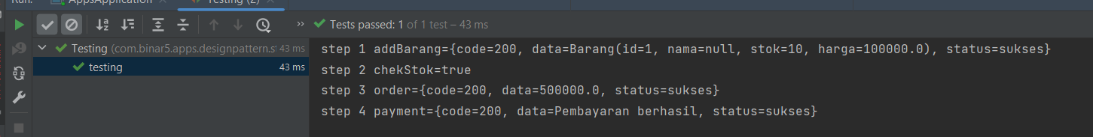

## Behavioral Pattern

Behavioral Pattern merupakan pattern yang isinya **gimana sebuah object berinteraksi dan berperilaku di dalam sebuah system**

### Jenis :

Behavioral Pattern yang cukup sering dipakai itu yang di bawah ini nih, gengs:

* **Command pattern**
* **Interpreter pattern**
* **Chain of Responsibility pattern**
* **Strategy pattern**
* **Memento pattern**
* **Observer pattern**

Di subtopic ini, kita bakal bahas **Strategy Pattern**.

### Tujuan

Hmm. Gini, gini. Strategy Pattern adalah **pattern untuk mengelompokkan algoritma**.

Strategy pattern ini agak mirip sama pattern yang kita bahas di awal. Tapi yang ditekankan di strategy pattern bukan tentang pembuatan objectnya, melainkan pengelompokkan algoritma yang jadi penekanannya.

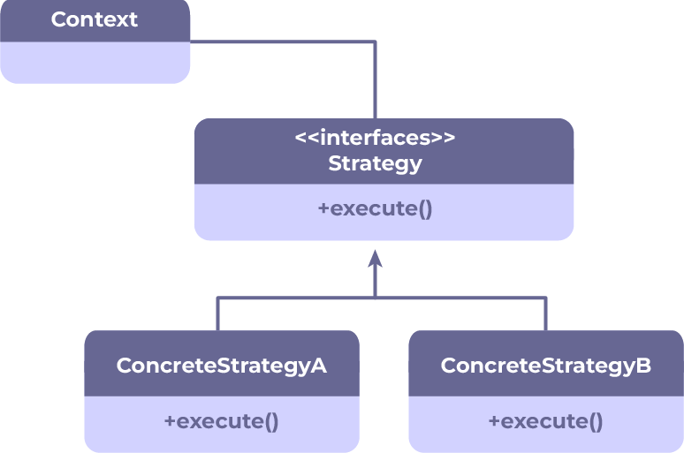

**Goal** :

Selama pattern-pattern tersebut **secara tepat digunakan**, maka nantinya bakal membentuk suatu coding practice yang baik.

### Contoh:

Refer : <https://www.jetbrains.com/help/idea/replace-conditional-logic-with-strategy-pattern.html>

Contoh kode program yang akan di tuliskan praktek kode yang lebih baik :

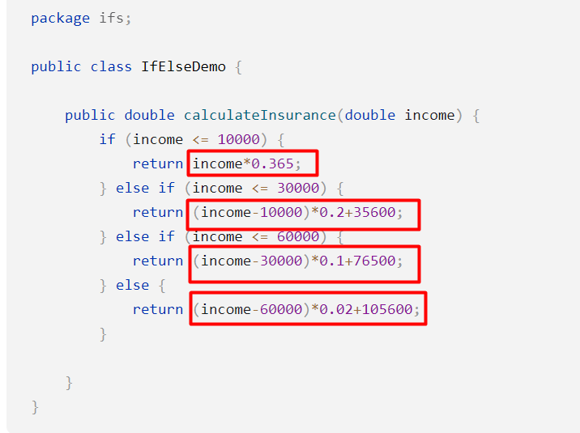

|  |
| --- |
| package com.binar5.apps.designpattern.behavioral;  public class ManualHitung {  public static void main(String[] args) {  *calculateInsurance*(100000.0);  }   public static double calculateInsurance(double income) {  if (income <= 10000) {  return income*0.365;  } else if (income <= 30000) {  return (income-10000)*0.2+35600;  } else if (income <= 60000) {  return (income-30000)*0.1+76500;  } else {  return (income-60000)*0.02+105600;  }  } } |

Analisa :

|  |  |  |  |  |
| --- | --- | --- | --- | --- |
| icnome | pengurangan | weight | bonus | **Aggapan** |
| <= 10000 | 0 | 0.365 | 0 | **LOW** |
| <= 30000 | -10000 | 0.2 | 35600 | **MEDIUM** |
| <= 60000 | -30000 | 0.1 | 76500 | **HIGH** |
| else | -60000 | 0.02 | 105600 | **VERY HIGH** |
|  |  |  |  |  |

### Solusi

Struktur project;

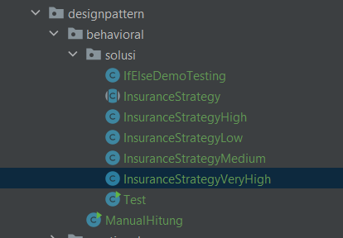

1. InsuranceStrategy

|  |
| --- |
| package com.binar5.apps.designpattern.behavioral.solusi;  public abstract class InsuranceStrategy {  public double calculateInsuranceVeryHigh(double income) {  return (income - getAdjustment()) * getWeight() + getConstant();  }   public abstract int getConstant();   public abstract double getWeight();   public abstract int getAdjustment(); } |

1. InsuranceStrategyHigh

|  |
| --- |
| package com.binar5.apps.designpattern.behavioral.solusi;  public class InsuranceStrategyHigh extends InsuranceStrategy {  @Override  public int getConstant() {  return 35600;  }   @Override  public double getWeight() {  return 0.2;  }   @Override  public int getAdjustment() {  return 10000;  } } |

1. InsuranceStrategyLow

|  |
| --- |
| package com.binar5.apps.designpattern.behavioral.solusi;  public class InsuranceStrategyLow extends InsuranceStrategy {  @Override  public int getConstant() {  return 35600;  }   @Override  public double getWeight() {  return 0.2;  }   @Override  public int getAdjustment() {  return 10000;  } } |

1. InsuranceStrategyMedium

|  |
| --- |
| package com.binar5.apps.designpattern.behavioral.solusi;  public class InsuranceStrategyMedium extends InsuranceStrategy {  @Override  public int getConstant() {  return 35600;  }   @Override  public double getWeight() {  return 0.2;  }   @Override  public int getAdjustment() {  return 10000;  } } |

1. InsuranceStrategyVeryHigh

|  |
| --- |
| package com.binar5.apps.designpattern.behavioral.solusi;  public class InsuranceStrategyVeryHigh extends InsuranceStrategy {  @Override  public int getConstant() {  return 35600;  }   @Override  public double getWeight() {  return 0.2;  }   @Override  public int getAdjustment() {  return 10000;  } } |

1. Testing

|  |
| --- |
| package com.binar5.apps.designpattern.behavioral.solusi;  public class IfElseDemoTesting {  private InsuranceStrategy strategy;   public double calculateInsurance(double income) {    if (income <= 10000) {  strategy = new InsuranceStrategyLow();  return strategy.calculateInsuranceVeryHigh(income);  } else if (income <= 30000) {  strategy = new InsuranceStrategyMedium();  return strategy.calculateInsuranceVeryHigh(income);  } else if (income <= 60000) {  strategy = new InsuranceStrategyHigh();  return strategy.calculateInsuranceVeryHigh(income);  } else {  strategy = new InsuranceStrategyVeryHigh();  return strategy.calculateInsuranceVeryHigh(income);  }   }  } |

1. Output

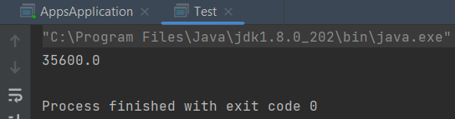

## Branch

101122-design-pattern

Gitlab : https://gitlab.com/rikialdi/binar5-spring

# Swagger

## Version Spring <3 :Mengetahui cara implementasi Swagger ke Spring boot

<https://gitlab.com/binarxgrab_mainbootcamp/backend_java/boilerplate_bej.git>

branch 14032022-swagger

### POM. Xml

|  |
| --- |
| <!-- swagger-->  <dependency>  <groupId>org.springdoc</groupId>  <artifactId>springdoc-openapi-ui</artifactId>  <version>1.6.6</version>  </dependency>  <dependency>  <!-- Automated JSON API documentation for API's built with Spring -->  <!-- <groupId>io.springfox</groupId>  <artifactId>springfox-swagger2</artifactId>  <version>2.9.2</version>  </dependency>  <dependency>-->  <!-- Generate beautiful documentation from a Swagger-compliant API. -->  <groupId>io.springfox</groupId>  <artifactId>springfox-swagger-ui</artifactId>  <version>3.0.0</version>  </dependency> |

### Main application

|  |
| --- |
| @OpenAPIDefinition  Contoh  @SpringBootApplication @OpenAPIDefinition //@EnableSwagger2 public class BinarApplication {  public static void main(String[] args) {  SpringApplication.*run*(BinarApplication.class, args);  } } |

### Application properties

|  |
| --- |
| #untuk swagger spring.mvc.pathmatch.matching-strategy=ant_path_matcher |

### Allow khusus spring security

|  |
| --- |
| "/swagger-ui/**","/swagger-ui.html","/v3/api-docs/**", |

### Testing : run app

Akses : <http://localhost:8080/api/swagger-ui/index.html>

Tampilan

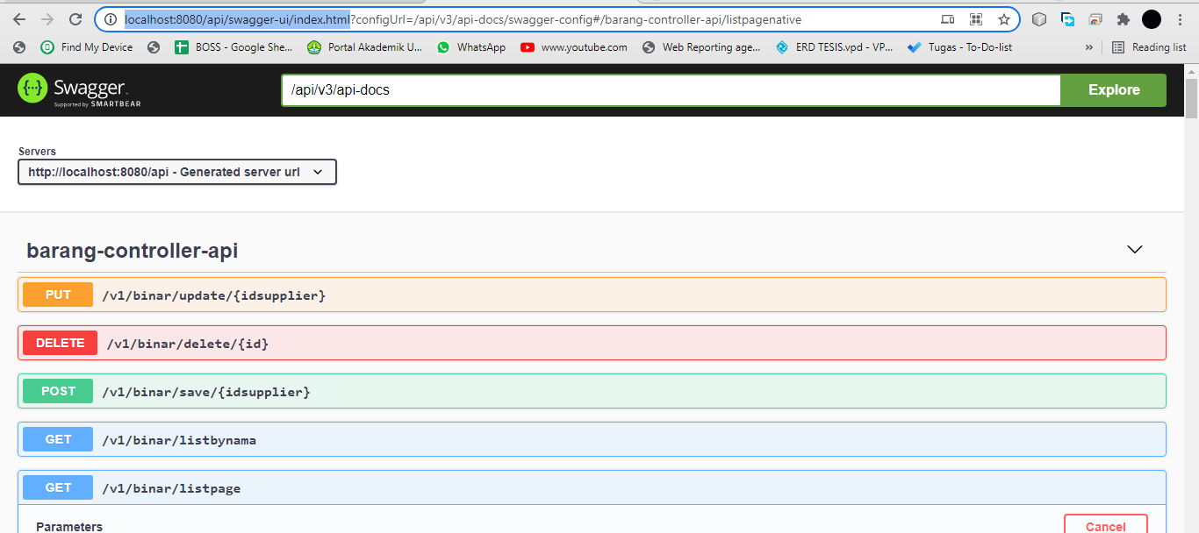

### Menyembunyikan.Hide Request Mapping URL API

Tambahkan @Hidden saja pada controoler seperti gambar dibawha ini

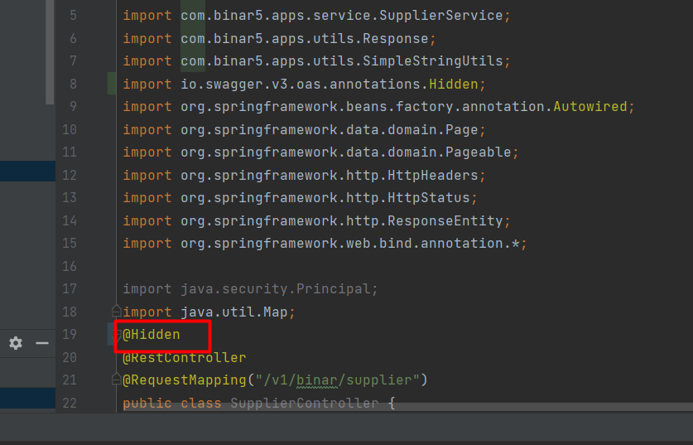

Add pom.xml

|  |
| --- |
| <dependency>  <groupId>io.springfox</groupId>  <artifactId>springfox-swagger2</artifactId>  <version>3.0.0</version> </dependency> <dependency> |

Tambahkan pada app main spring boot

|  |
| --- |
| @EnableSwagger2  Dan  //menampilkan bardasarkan path tertentu saja swagger @Bean public Docket api(){  return new Docket(DocumentationType.*SWAGGER_2*)  .select()  .apis(RequestHandlerSelectors.*basePackage*("com.binar5.apps"))  .paths(PathSelectors.*ant*("/api/v1/binar/supplier/**"))  .build(); } |

## Untuk Version Spring >3

### Referensi

|  |
| --- |
| https://www.baeldung.com/spring-rest-openapi-documentation |

### Pom xml

|  |
| --- |
|  |
| <dependency>  <groupId>org.springdoc</groupId>  <artifactId>springdoc-openapi-starter-webmvc-ui</artifactId>  <version>2.2.0</version> </dependency> |

### Application main

|  |
| --- |
| @OpenAPIDefinition |

### Open path

|  |
| --- |
| http://localhost:8080/v3/api-docs |

Output

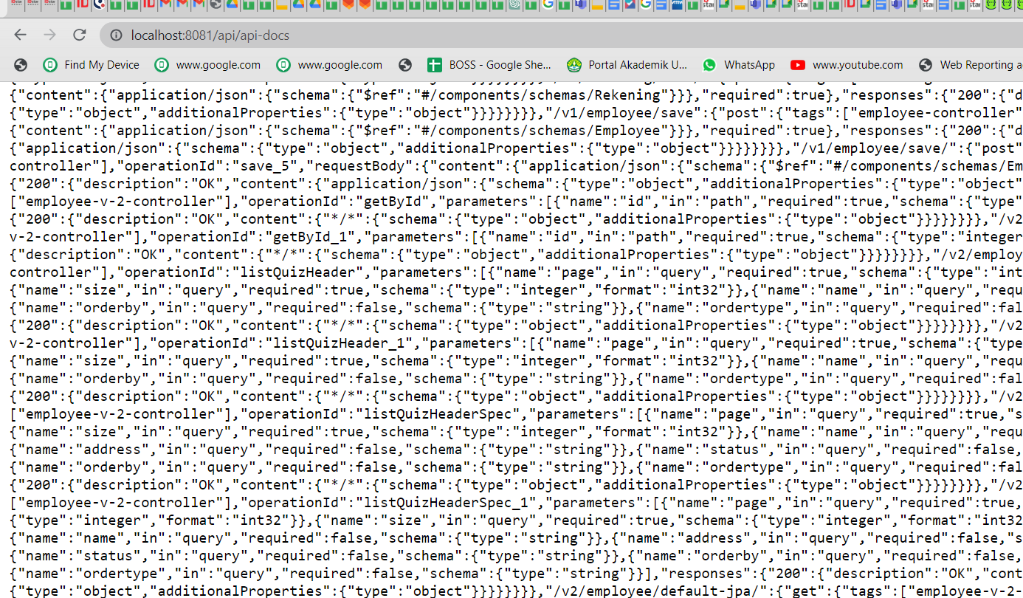

### Application properties

|  |
| --- |
| #Swagger springdoc.api-docs.path=/api-docs |

### Untuk download yaml

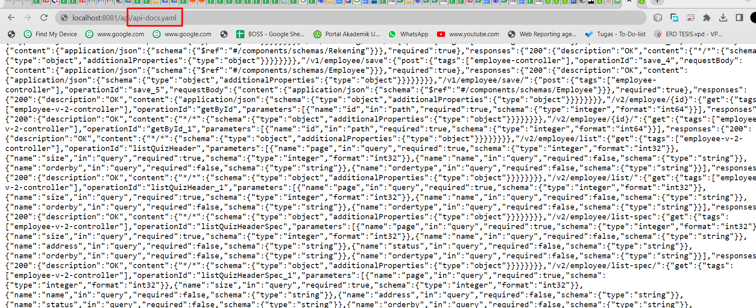

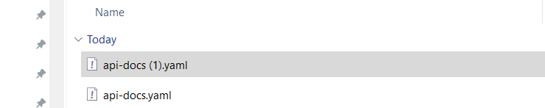

### Akses dan testing

<http://localhost:8081/api/swagger-ui/index.html>

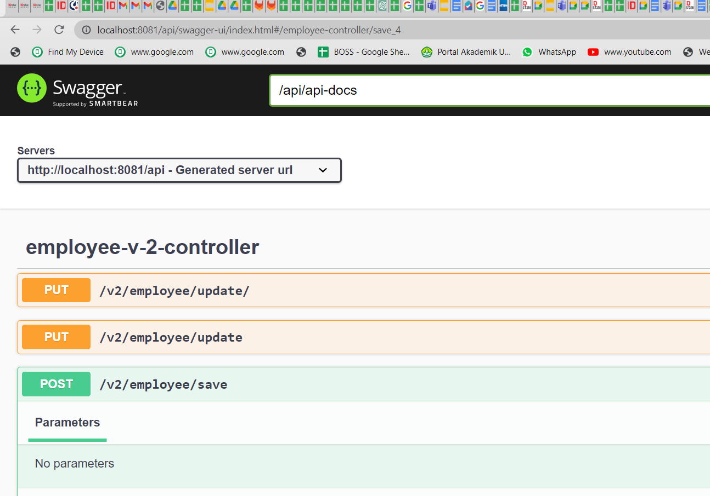

## Testing REST API di Swagger

### Studi kasus barang

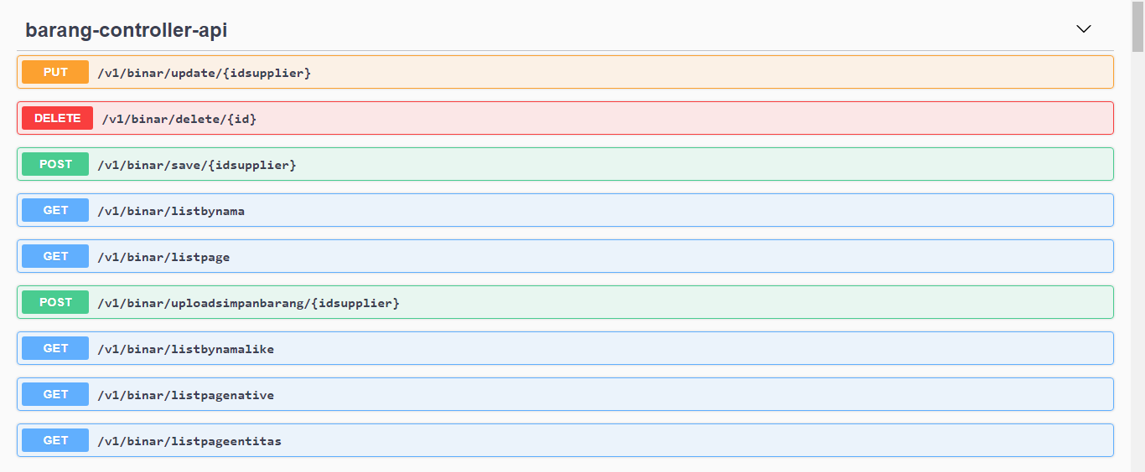

### POST

Pilih try out

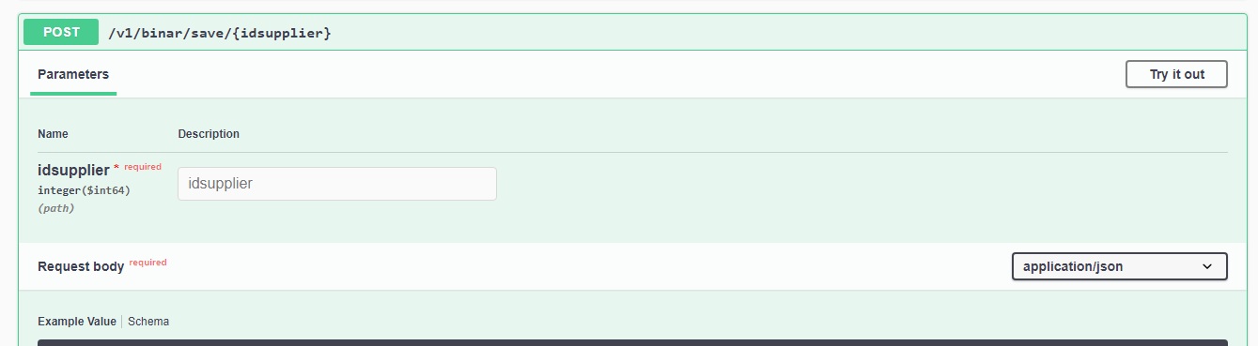

Isi request

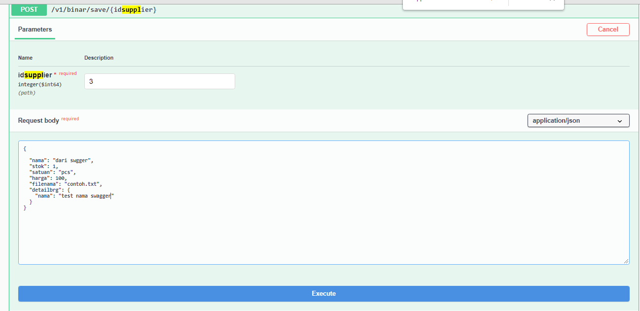

Kemudian pilih execute

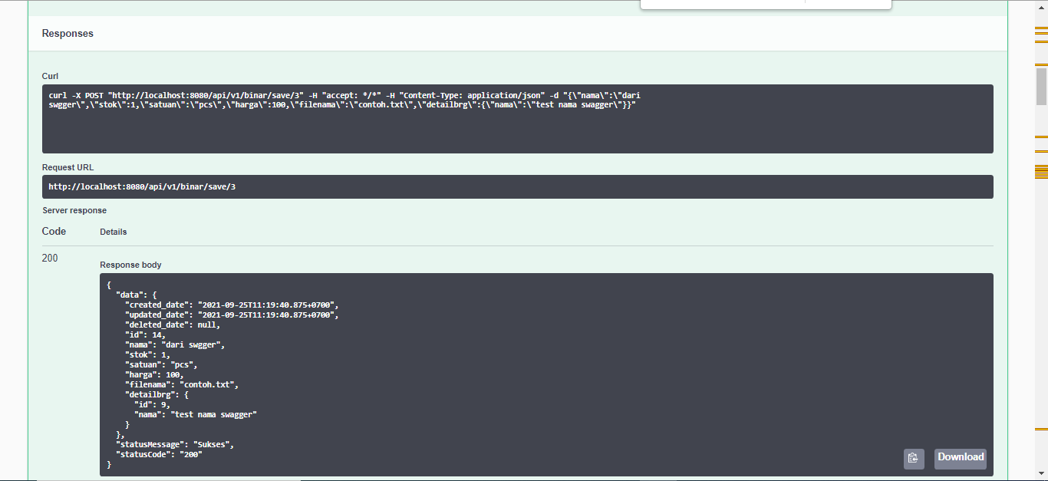

Bisa donload pojok kanan baah

### GET

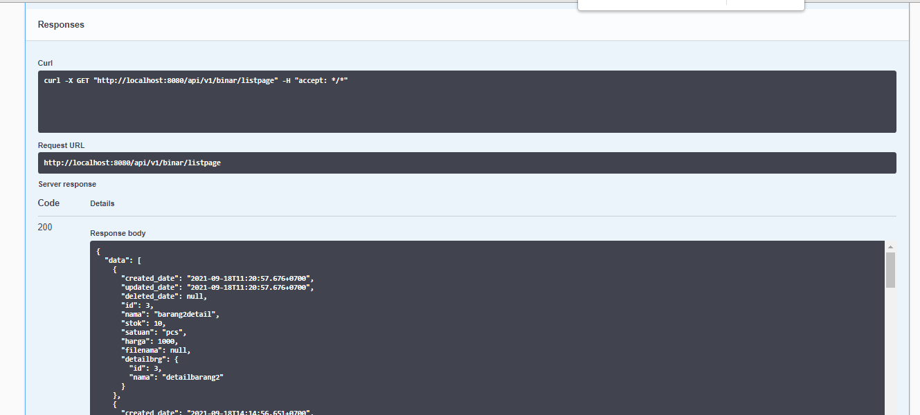

### PUT

Sama : silahkan di coba

### DELETE

Sama : silahkan di coba

## Membuat API DOC di swagger Studi Kasus Barang

### Study kasus barang

Sample output yang akan dibuat open api dengan swagger:

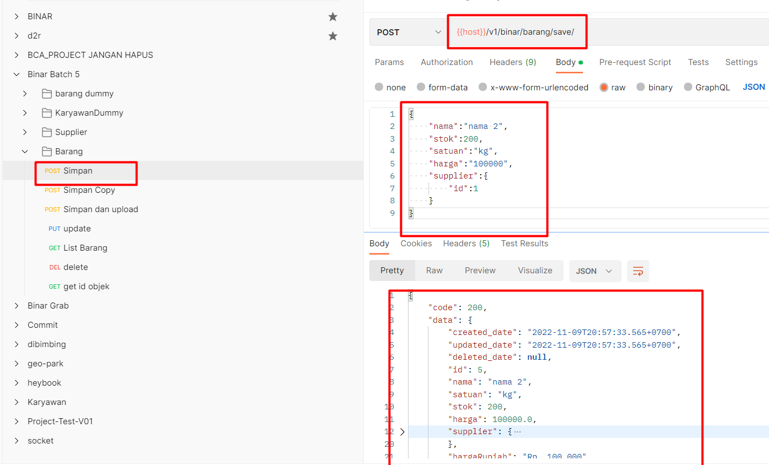

### step 1 :register

Silahkan akses

<https://app.swaggerhub.com/>

### tampilan utama

Create api baru

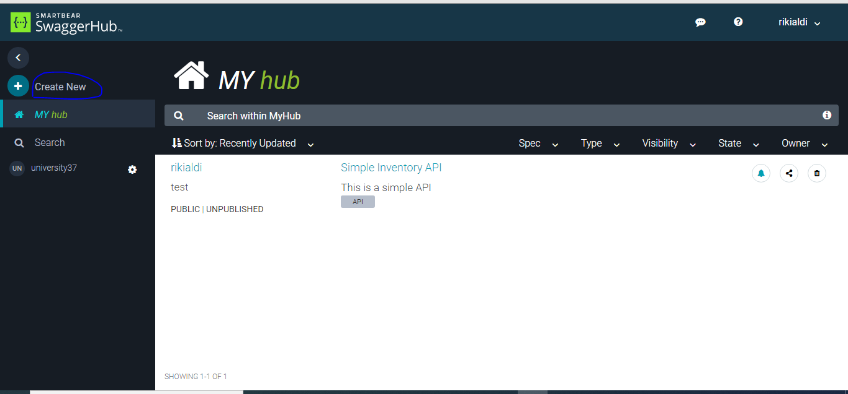

### Create api baru

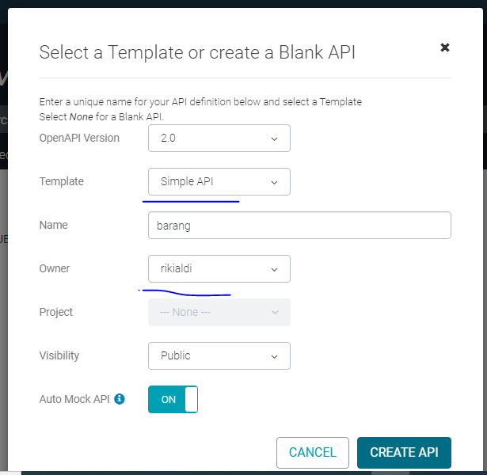

### Tampilan setalah create api

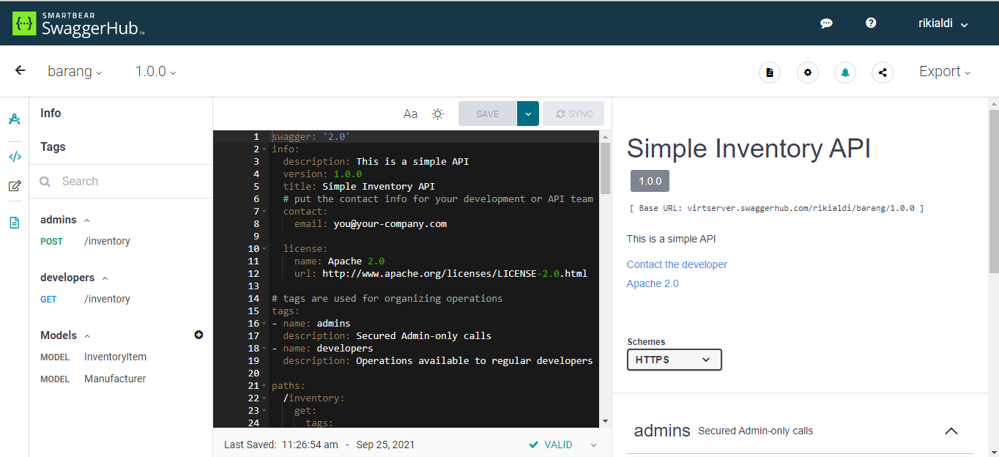

### Kerangka Swagger

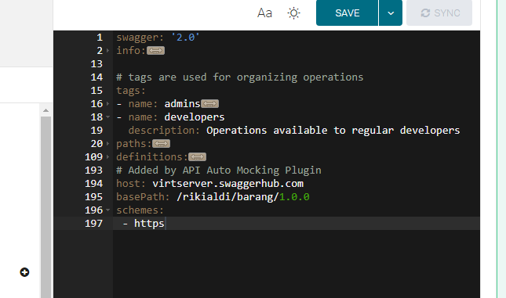

Path : method post, get,put, delete

Definition : membuat model: request, response

### create model

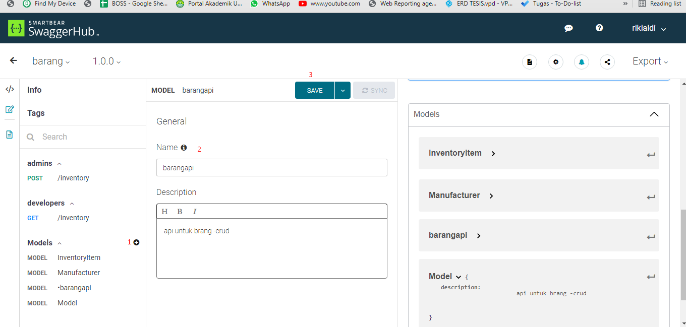

### Menambahkan field pada model di definition

Digunakan sebagai request barang

**Nama, stok, satuan , harga**

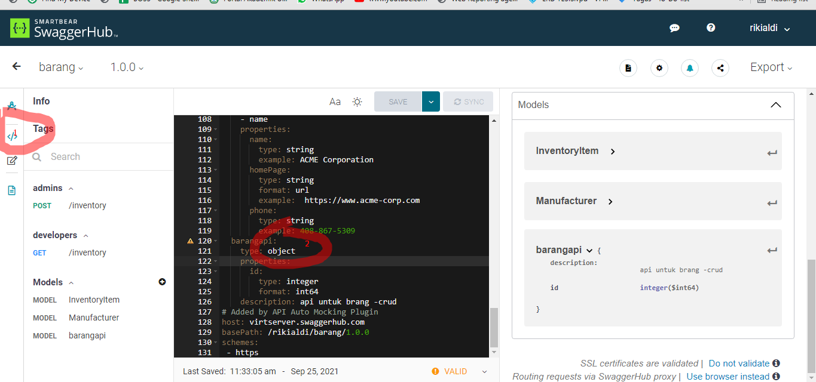

Tampilan :

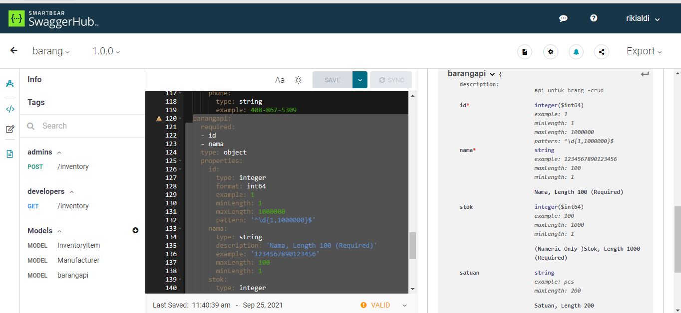

Code :

|  |
| --- |
| barangapi:  required:  - id  - nama  type: object  properties:  id:  type: integer  format: int64  example: 1  minLength: 1  maxLength: 1000000  pattern: '^\d{1,1000000}$'  nama:  type: string  description: 'Nama, Length 100 (Required)'  example: '1234567890123456'  maxLength: 100  minLength: 1  stok:  type: integer  format: int64  description: '(Numeric Only )Stok, Length 1000'  example: '100'  maxLength: 1000  pattern: '^\d{0,1000000}$'  satuan:  type: string  description: 'Satuan, Length 200'  example: 'pcs'  maxLength: 200  harga:  type: integer  format: int64  description: 'Harga, Length 15'  example: 10000  maxLength: 15  description: api untuk brang -crud |

### POST

Tambahkan pada /paths / barang / post:

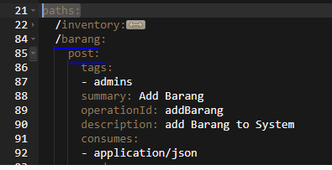

Code path

|  |
| --- |
| post:  tags:  - admins  summary: Add Barang  operationId: addBarang  description: add Barang to System  consumes:  - application/json  produces:  - application/json  parameters:  - in: body  name: barangmodel  description: Barang add  schema:  $ref: '#/definitions/barangmodel'  responses:  201:  description: Barang created  schema:  $ref: '#/definitions/ResponseSuccessBarang'  400:  description: invalid input, object invalid  409:  description: an existing barang already exists |

Menambahkan model ResponseSuccessBarang di definition

|  |
| --- |
| ResponseSuccessBarang:  type: object  description: Detail for response  additionalProperties: false  properties:  statusCode:  type: string  description: '(Required) Status code, Length 40'  example: '0'  statusDesc:  type: string  description: >-  sukses, Length 100  example: SUCCESS  data:  $ref: '#/definitions/barangmodel'  description: response |

Menambahkan model barangmodel'di definition

|  |
| --- |
| barangmodel:  required:  - nama  type: object  properties:  nama:  type: string  description: 'Nama, Length 100 (Required)'  example: '1234567890123456'  maxLength: 100  minLength: 1  stok:  type: integer  format: int64  description: '(Numeric Only )Stok, Length 1000'  example: '100'  maxLength: 1000  pattern: '^\d{0,1000000}$'  satuan:  type: string  description: 'Satuan, Length 200'  example: 'pcs'  maxLength: 200  harga:  type: integer  format: int64  description: 'Harga, Length 15'  example: 10000  maxLength: 15  description: api untuk brang -crud |

Tampilan output post

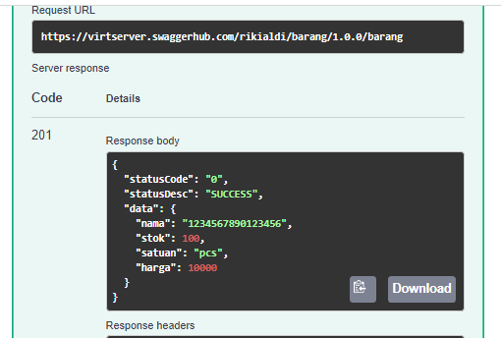

Testing

Pilih try out

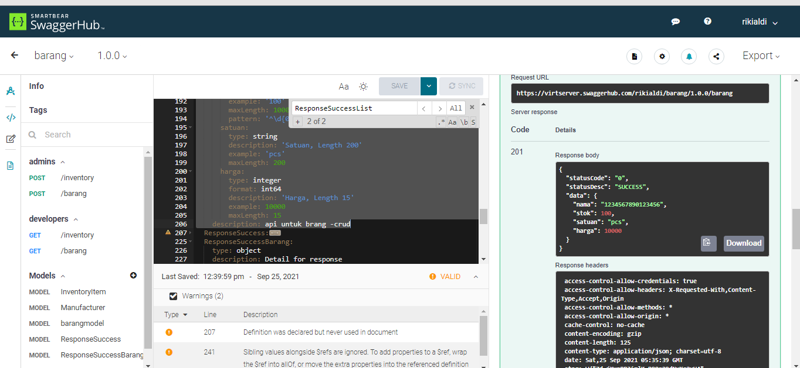

### GET

Tambahkan pada /paths / barang / get:

|  |
| --- |
| /barang:  get:  tags:  - developers  summary: searches Barang  operationId: searchBarang  description: |  By passing in the appropriate options, you can search for  available Barang in the system  produces:  - application/json  parameters:  - in: query  name: size  description: banyak row return  type: integer  format: int32  minimum: 0  - in: query  name: page  description: page return number  type: integer  format: int32  minimum: 0  maximum: 50  responses:  200:  description: search results matching criteria  schema:  $ref: '#/definitions/ResponseSuccessBarangList'  400:  description: bad input parameter |

Menambahkan model ResponseSuccessBarangList di definition

|  |
| --- |
| ResponseSuccessBarangList:  type: object  description: Detail for response  additionalProperties: false  properties:  statusCode:  type: string  description: '(Required) Status code, Length 40'  example: '0'  statusDesc:  type: string  description: >-  sukses, Length 100  example: SUCCESS  data:  type: array  items:  $ref: '#/definitions/barangmodel'  description: response |

Response

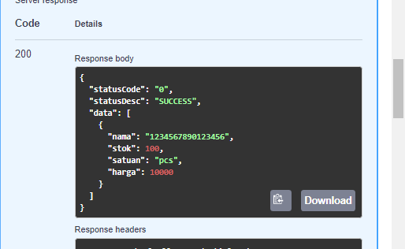

Testing

Pilih try out

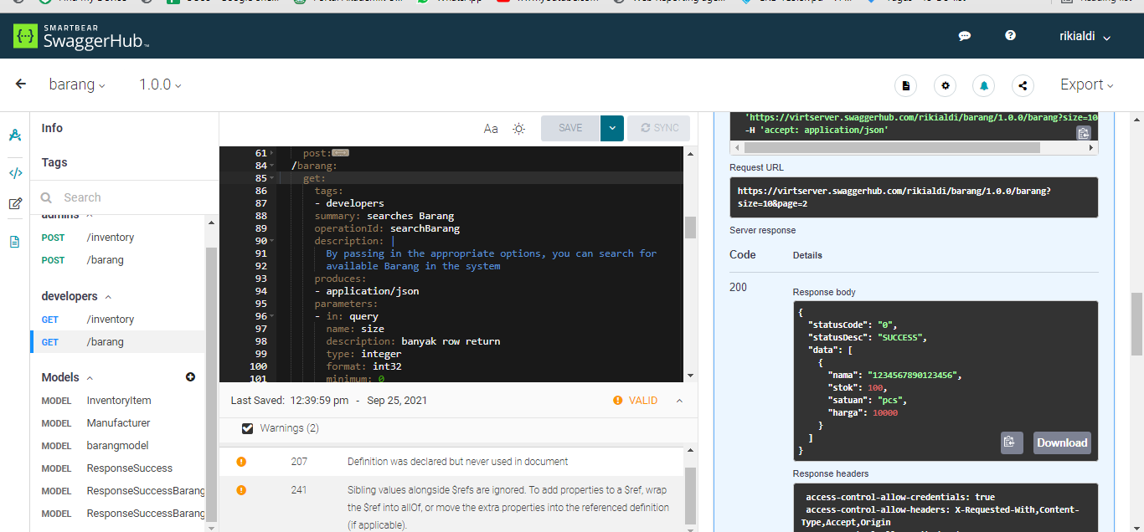

### PUT

### DELETE

### Code all Versi swagger 2.0

|  |
| --- |
| swagger: '2.0'  info:  description: This is a simple API  version: 1.0.0  title: Simple Barang API  # put the contact info for your development or API team  contact:  email: you@your-company.com  license:  name: Apache 2.0  url: http://www.apache.org/licenses/LICENSE-2.0.html  # tags are used for organizing operations  tags:  - name: barang  description: Secured Admin-only calls  - name: supplier  description: Secured supplier-only calls  - name: developers  description: Operations available to regular developers  paths:  /supplier:  post:  tags:  - supplier  summary: Add supplier  operationId: addSupplier  description: add supplier to System  consumes:  - application/json  produces:  - application/json  parameters:  - in: body  name: supplierModel  description: supplier add  schema:  $ref: '#/definitions/supplierModel'  responses:  201:  description: Supplier created  schema:  $ref: '#/definitions/ResponseSuccessSupplier'  400:  description: invalid input, object invalid  409:  description: an existing supplier already exists  /barang:  get:  tags:  - developers  summary: searches Barang  operationId: searchBarang  description: |  By passing in the appropriate options, you can search for  available Barang in the system  produces:  - application/json  parameters:  - in: query  name: size  description: banyak row return  type: integer  format: int32  minimum: 0  - in: query  name: page  description: page return number  type: integer  format: int32  minimum: 0  maximum: 50  responses:  200:  description: search results matching criteria  schema:  $ref: '#/definitions/ResponseSuccessBarangList'  400:  description: bad input parameter  post:  tags:  - barang  summary: Add Barang  operationId: addBarang  description: add Barang to System  consumes:  - application/json  produces:  - application/json  parameters:  - in: body  name: barangmodel  description: Barang add  schema:  $ref: '#/definitions/barangmodel'  responses:  201:  description: Barang created  schema:  $ref: '#/definitions/ResponseSuccessBarang'  400:  description: invalid input, object invalid  409:  description: an existing barang already exists  put:  tags:  - barang  summary: update Barang  operationId: updateBarang  description: update Barang to System  consumes:  - application/json  produces:  - application/json  parameters:  - in: body  name: barangmodel  description: Barang update  schema:  $ref: '#/definitions/barangmodelForUpdate'  responses:  201:  description: Barang created  schema:  $ref: '#/definitions/ResponseSuccessBarang'  400:  description: invalid input, object invalid  409:  description: an existing barang already exists  delete:  tags:  - barang  summary: delete Barang  operationId: deleteBarang  description: delete Barang to System  consumes:  - application/json  produces:  - application/json  parameters:  - in: body  name: barangmodel  description: Barang delete  schema:  $ref: '#/definitions/barangmodelForUpdate'  responses:  201:  description: Barang created  schema:  $ref: '#/definitions/ResponseSuccessBarang'  400:  description: invalid input, object invalid  409:  description: an existing barang already exists  definitions:  supplierModel:  required:  - nama  - id  type: object  properties:  id:  type: integer  description: 'id, Length 122353453453453543'  example: '1'  maxLength: 122353453453453543  minLength: 1  nama:  type: string  description: 'Nama, Length 100 (Required)'  example: '1234567890123456'  maxLength: 100  minLength: 1  hp:  type: integer  format: int64  description: '(Numeric Only )hp, Length 1000'  example: '100'  maxLength: 1000  pattern: '^\d{0,1000000}$'  alamat:  type: string  description: 'alamat, Length 200'  example: 'pcs'  maxLength: 200  description: api untuk brang -crud  ResponseSuccessSupplier:  type: object  description: Detail for response  additionalProperties: false  properties:  statusCode:  type: string  description: '(Required) Status code, Length 40'  example: '0'  statusDesc:  type: string  description: >-  sukses, Length 100  example: SUCCESS  data:  $ref: '#/definitions/supplierModel'  description: response  barangmodel:  required:  - nama  type: object  properties:  nama:  type: string  description: 'Nama, Length 100 (Required)'  example: '1234567890123456'  maxLength: 100  minLength: 1  stok:  type: integer  format: int64  description: '(Numeric Only )Stok, Length 1000'  example: '100'  maxLength: 1000  pattern: '^\d{0,1000000}$'  satuan:  type: string  description: 'Satuan, Length 200'  example: 'pcs'  maxLength: 200  harga:  type: integer  format: int64  description: 'Harga, Length 15'  example: 10000  maxLength: 15  description: api untuk brang -crud  barangmodelForUpdate:  required:  - nama  type: object  properties:  id:  type: integer  description: 'Id, Length 100000000000000 (Required)'  example: '1234567890123456'  maxLength: 100000000000000  minLength: 1  nama:  type: string  description: 'Nama, Length 100 (Required)'  example: '1234567890123456'  maxLength: 100  minLength: 1  stok:  type: integer  format: int64  description: '(Numeric Only )Stok, Length 1000'  example: '100'  maxLength: 1000  pattern: '^\d{0,1000000}$'  satuan:  type: string  description: 'Satuan, Length 200'  example: 'pcs'  maxLength: 200  harga:  type: integer  format: int64  description: 'Harga, Length 15'  example: 10000  maxLength: 15  description: api untuk brang -crud  ResponseSuccess:  type: object  description: Detail for response  additionalProperties: false  properties:  statusCode:  type: string  description: '(Required) Status code, Length 40'  example: '0'  subStatusCode:  type: string  description: 'Sub status code, Length 40'  example: '00'  statusDesc:  type: string  description: >-  sukses, Length 100  example: SUCCESS  ResponseSuccessBarang:  type: object  description: Detail for response  additionalProperties: false  properties:  statusCode:  type: string  description: '(Required) Status code, Length 40'  example: '0'  statusDesc:  type: string  description: >-  sukses, Length 100  example: SUCCESS  data:  $ref: '#/definitions/barangmodelForUpdate'  description: response  ResponseSuccessBarangList:  type: object  description: Detail for response  additionalProperties: false  properties:  statusCode:  type: string  description: '(Required) Status code, Length 40'  example: '0'  statusDesc:  type: string  description: >-  sukses, Length 100  example: SUCCESS  data:  type: array  items:  $ref: '#/definitions/barangmodelForUpdate'  description: response  # Added by API Auto Mocking Plugin  host: virtserver.swaggerhub.com  # basePath: /rikialdi/barang/1.0.0  schemes:  - https  # Added by API Auto Mocking Plugin  # basePath: /university37/binar_batch_5/1.0.0  # Added by API Auto Mocking Plugin  basePath: /university37/Binar_batch_5_v_swagger_2.0/1.0.0 |

## Membuat API DOC di swagger Studi Kasus Karyawan

### Studi kasus Employee

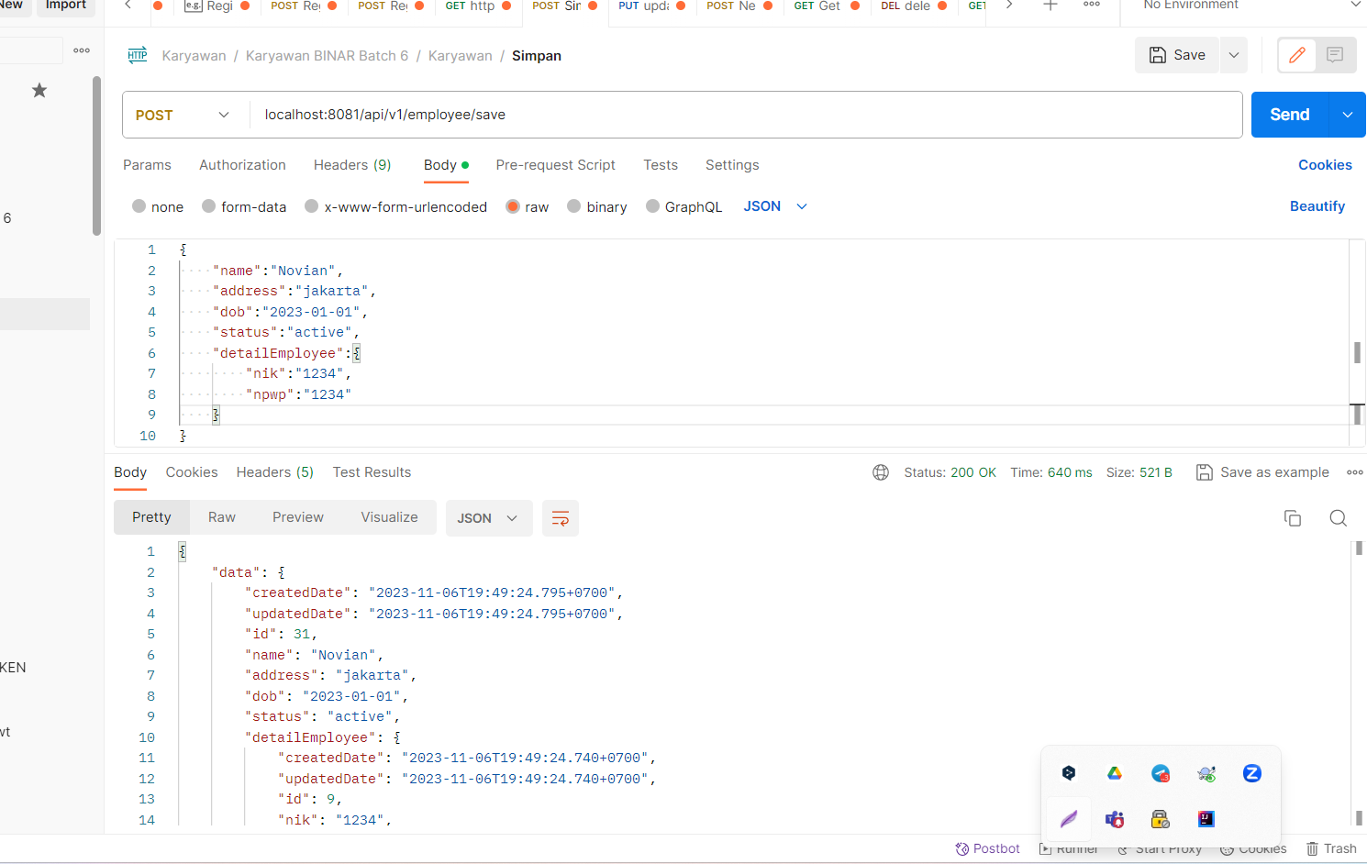

|  |
| --- |
| POST  URL :  localhost:8081/api/v1/employee/save  Req  {      "name":"Novian",      "address":"jakarta",      "dob":"2023-01-01",      "status":"active",      "detailEmployee":{          "nik":"1234",          "npwp":"1234"      }  }  Res  {      "data": {          "createdDate": "2023-11-06T19:49:24.795+0700",          "updatedDate": "2023-11-06T19:49:24.795+0700",          "id": 31,          "name": "Novian",          "address": "jakarta",          "dob": "2023-01-01",          "status": "active",          "detailEmployee": {              "createdDate": "2023-11-06T19:49:24.740+0700",              "updatedDate": "2023-11-06T19:49:24.740+0700",              "id": 9,              "nik": "1234",              "npwp": "1234"          }      },      "message": "Success",      "status": 200  } |

### Sample swagger V3.0.3

|  |
| --- |
| openapi: 3.0.3  info:  title: Swagger Petstore - OpenAPI 3.0  description: |-  This is a sample Pet Store Server based on the OpenAPI 3.0 specification. You can find out more about  Swagger at [https://swagger.io](https://swagger.io). In the third iteration of the pet store, we've switched to the design first approach!  You can now help us improve the API whether it's by making changes to the definition itself or to the code.  That way, with time, we can improve the API in general, and expose some of the new features in OAS3.  _If you're looking for the Swagger 2.0/OAS 2.0 version of Petstore, then click [here](https://editor.swagger.io/?url=https://petstore.swagger.io/v2/swagger.yaml). Alternatively, you can load via the `Edit > Load Petstore OAS 2.0` menu option!_    Some useful links:  - [The Pet Store repository](https://github.com/swagger-api/swagger-petstore)  - [The source API definition for the Pet Store](https://github.com/swagger-api/swagger-petstore/blob/master/src/main/resources/openapi.yaml)  termsOfService: http://swagger.io/terms/  contact:  email: apiteam@swagger.io  license:  name: Apache 2.0  url: http://www.apache.org/licenses/LICENSE-2.0.html  version: 1.0.11  externalDocs:  description: Find out more about Swagger  url: http://swagger.io  servers:  - url: https://petstore3.swagger.io/api/v3  tags:  - name: pet  description: Everything about your Pets  externalDocs:  description: Find out more  url: http://swagger.io  - name: store  description: Access to Petstore orders  externalDocs:  description: Find out more about our store  url: http://swagger.io  - name: user  description: Operations about user  paths:  /pet:  put:  tags:  - pet  summary: Update an existing pet  description: Update an existing pet by Id  operationId: updatePet  requestBody:  description: Update an existent pet in the store  content:  application/json:  schema:  $ref: '#/components/schemas/Pet'  application/xml:  schema:  $ref: '#/components/schemas/Pet'  application/x-www-form-urlencoded:  schema:  $ref: '#/components/schemas/Pet'  required: true  responses:  '200':  description: Successful operation  content:  application/json:  schema:  $ref: '#/components/schemas/Pet'  application/xml:  schema:  $ref: '#/components/schemas/Pet'  '400':  description: Invalid ID supplied  '404':  description: Pet not found  '405':  description: Validation exception  security:  - petstore_auth:  - write:pets  - read:pets  post:  tags:  - pet  summary: Add a new pet to the store  description: Add a new pet to the store  operationId: addPet  requestBody:  description: Create a new pet in the store  content:  application/json:  schema:  $ref: '#/components/schemas/Pet'  application/xml:  schema:  $ref: '#/components/schemas/Pet'  application/x-www-form-urlencoded:  schema:  $ref: '#/components/schemas/Pet'  required: true  responses:  '200':  description: Successful operation  content:  application/json:  schema:  $ref: '#/components/schemas/Pet'  application/xml:  schema:  $ref: '#/components/schemas/Pet'  '405':  description: Invalid input  security:  - petstore_auth:  - write:pets  - read:pets  /pet/findByStatus:  get:  tags:  - pet  summary: Finds Pets by status  description: Multiple status values can be provided with comma separated strings  operationId: findPetsByStatus  parameters:  - name: status  in: query  description: Status values that need to be considered for filter  required: false  explode: true  schema:  type: string  default: available  enum:  - available  - pending  - sold  responses:  '200':  description: successful operation  content:  application/json:  schema:  type: array  items:  $ref: '#/components/schemas/Pet'  application/xml:  schema:  type: array  items:  $ref: '#/components/schemas/Pet'  '400':  description: Invalid status value  security:  - petstore_auth:  - write:pets  - read:pets  /pet/findByTags:  get:  tags:  - pet  summary: Finds Pets by tags  description: Multiple tags can be provided with comma separated strings. Use tag1, tag2, tag3 for testing.  operationId: findPetsByTags  parameters:  - name: tags  in: query  description: Tags to filter by  required: false  explode: true  schema:  type: array  items:  type: string  responses:  '200':  description: successful operation  content:  application/json:  schema:  type: array  items:  $ref: '#/components/schemas/Pet'  application/xml:  schema:  type: array  items:  $ref: '#/components/schemas/Pet'  '400':  description: Invalid tag value  security:  - petstore_auth:  - write:pets  - read:pets  /pet/{petId}:  get:  tags:  - pet  summary: Find pet by ID  description: Returns a single pet  operationId: getPetById  parameters:  - name: petId  in: path  description: ID of pet to return  required: true  schema:  type: integer  format: int64  responses:  '200':  description: successful operation  content:  application/json:  schema:  $ref: '#/components/schemas/Pet'  application/xml:  schema:  $ref: '#/components/schemas/Pet'  '400':  description: Invalid ID supplied  '404':  description: Pet not found  security:  - api_key: []  - petstore_auth:  - write:pets  - read:pets  post:  tags:  - pet  summary: Updates a pet in the store with form data  description: ''  operationId: updatePetWithForm  parameters:  - name: petId  in: path  description: ID of pet that needs to be updated  required: true  schema:  type: integer  format: int64  - name: name  in: query  description: Name of pet that needs to be updated  schema:  type: string  - name: status  in: query  description: Status of pet that needs to be updated  schema:  type: string  responses:  '405':  description: Invalid input  security:  - petstore_auth:  - write:pets  - read:pets  delete:  tags:  - pet  summary: Deletes a pet  description: delete a pet  operationId: deletePet  parameters:  - name: api_key  in: header  description: ''  required: false  schema:  type: string  - name: petId  in: path  description: Pet id to delete  required: true  schema:  type: integer  format: int64  responses:  '400':  description: Invalid pet value  security:  - petstore_auth:  - write:pets  - read:pets  /pet/{petId}/uploadImage:  post:  tags:  - pet  summary: uploads an image  description: ''  operationId: uploadFile  parameters:  - name: petId  in: path  description: ID of pet to update  required: true  schema:  type: integer  format: int64  - name: additionalMetadata  in: query  description: Additional Metadata  required: false  schema:  type: string  requestBody:  content:  application/octet-stream:  schema:  type: string  format: binary  responses:  '200':  description: successful operation  content:  application/json:  schema:  $ref: '#/components/schemas/ApiResponse'  security:  - petstore_auth:  - write:pets  - read:pets  /store/inventory:  get:  tags:  - store  summary: Returns pet inventories by status  description: Returns a map of status codes to quantities  operationId: getInventory  responses:  '200':  description: successful operation  content:  application/json:  schema:  type: object  additionalProperties:  type: integer  format: int32  security:  - api_key: []  /store/order:  post:  tags:  - store  summary: Place an order for a pet  description: Place a new order in the store  operationId: placeOrder  requestBody:  content:  application/json:  schema:  $ref: '#/components/schemas/Order'  application/xml:  schema:  $ref: '#/components/schemas/Order'  application/x-www-form-urlencoded:  schema:  $ref: '#/components/schemas/Order'  responses:  '200':  description: successful operation  content:  application/json:  schema:  $ref: '#/components/schemas/Order'  '405':  description: Invalid input  /store/order/{orderId}:  get:  tags:  - store  summary: Find purchase order by ID  description: For valid response try integer IDs with value <= 5 or > 10. Other values will generate exceptions.  operationId: getOrderById  parameters:  - name: orderId  in: path  description: ID of order that needs to be fetched  required: true  schema:  type: integer  format: int64  responses:  '200':  description: successful operation  content:  application/json:  schema:  $ref: '#/components/schemas/Order'  application/xml:  schema:  $ref: '#/components/schemas/Order'  '400':  description: Invalid ID supplied  '404':  description: Order not found  delete:  tags:  - store  summary: Delete purchase order by ID  description: For valid response try integer IDs with value < 1000. Anything above 1000 or nonintegers will generate API errors  operationId: deleteOrder  parameters:  - name: orderId  in: path  description: ID of the order that needs to be deleted  required: true  schema:  type: integer  format: int64  responses:  '400':  description: Invalid ID supplied  '404':  description: Order not found  /user:  post:  tags:  - user  summary: Create user  description: This can only be done by the logged in user.  operationId: createUser  requestBody:  description: Created user object  content:  application/json:  schema:  $ref: '#/components/schemas/User'  application/xml:  schema:  $ref: '#/components/schemas/User'  application/x-www-form-urlencoded:  schema:  $ref: '#/components/schemas/User'  responses:  default:  description: successful operation  content:  application/json:  schema:  $ref: '#/components/schemas/User'  application/xml:  schema:  $ref: '#/components/schemas/User'  /user/createWithList:  post:  tags:  - user  summary: Creates list of users with given input array  description: Creates list of users with given input array  operationId: createUsersWithListInput  requestBody:  content:  application/json:  schema:  type: array  items:  $ref: '#/components/schemas/User'  responses:  '200':  description: Successful operation  content:  application/json:  schema:  $ref: '#/components/schemas/User'  application/xml:  schema:  $ref: '#/components/schemas/User'  default:  description: successful operation  /user/login:  get:  tags:  - user  summary: Logs user into the system  description: ''  operationId: loginUser  parameters:  - name: username  in: query  description: The user name for login  required: false  schema:  type: string  - name: password  in: query  description: The password for login in clear text  required: false  schema:  type: string  responses:  '200':  description: successful operation  headers:  X-Rate-Limit:  description: calls per hour allowed by the user  schema:  type: integer  format: int32  X-Expires-After:  description: date in UTC when token expires  schema:  type: string  format: date-time  content:  application/xml:  schema:  type: string  application/json:  schema:  type: string  '400':  description: Invalid username/password supplied  /user/logout:  get:  tags:  - user  summary: Logs out current logged in user session  description: ''  operationId: logoutUser  parameters: []  responses:  default:  description: successful operation  /user/{username}:  get:  tags:  - user  summary: Get user by user name  description: ''  operationId: getUserByName  parameters:  - name: username  in: path  description: 'The name that needs to be fetched. Use user1 for testing. '  required: true  schema:  type: string  responses:  '200':  description: successful operation  content:  application/json:  schema:  $ref: '#/components/schemas/User'  application/xml:  schema:  $ref: '#/components/schemas/User'  '400':  description: Invalid username supplied  '404':  description: User not found  put:  tags:  - user  summary: Update user  description: This can only be done by the logged in user.  operationId: updateUser  parameters:  - name: username  in: path  description: name that need to be deleted  required: true  schema:  type: string  requestBody:  description: Update an existent user in the store  content:  application/json:  schema:  $ref: '#/components/schemas/User'  application/xml:  schema:  $ref: '#/components/schemas/User'  application/x-www-form-urlencoded:  schema:  $ref: '#/components/schemas/User'  responses:  default:  description: successful operation  delete:  tags:  - user  summary: Delete user  description: This can only be done by the logged in user.  operationId: deleteUser  parameters:  - name: username  in: path  description: The name that needs to be deleted  required: true  schema:  type: string  responses:  '400':  description: Invalid username supplied  '404':  description: User not found  components:  schemas:  Order:  type: object  properties:  id:  type: integer  format: int64  example: 10  petId:  type: integer  format: int64  example: 198772  quantity:  type: integer  format: int32  example: 7  shipDate:  type: string  format: date-time  status:  type: string  description: Order Status  example: approved  enum:  - placed  - approved  - delivered  complete:  type: boolean  xml:  name: order  Customer:  type: object  properties:  id:  type: integer  format: int64  example: 100000  username:  type: string  example: fehguy  address:  type: array  xml:  name: addresses  wrapped: true  items:  $ref: '#/components/schemas/Address'  xml:  name: customer  Address:  type: object  properties:  street:  type: string  example: 437 Lytton  city:  type: string  example: Palo Alto  state:  type: string  example: CA  zip:  type: string  example: '94301'  xml:  name: address  Category:  type: object  properties:  id:  type: integer  format: int64  example: 1  name:  type: string  example: Dogs  xml:  name: category  User:  type: object  properties:  id:  type: integer  format: int64  example: 10  username:  type: string  example: theUser  firstName:  type: string  example: John  lastName:  type: string  example: James  email:  type: string  example: john@email.com  password:  type: string  example: '12345'  phone:  type: string  example: '12345'  userStatus:  type: integer  description: User Status  format: int32  example: 1  xml:  name: user  Tag:  type: object  properties:  id:  type: integer  format: int64  name:  type: string  xml:  name: tag  Pet:  required:  - name  - photoUrls  type: object  properties:  id:  type: integer  format: int64  example: 10  name:  type: string  example: doggie  category:  $ref: '#/components/schemas/Category'  photoUrls:  type: array  xml:  wrapped: true  items:  type: string  xml:  name: photoUrl  tags:  type: array  xml:  wrapped: true  items:  $ref: '#/components/schemas/Tag'  status:  type: string  description: pet status in the store  enum:  - available  - pending  - sold  xml:  name: pet  ApiResponse:  type: object  properties:  code:  type: integer  format: int32  type:  type: string  message:  type: string  xml:  name: '##default'  requestBodies:  Pet:  description: Pet object that needs to be added to the store  content:  application/json:  schema:  $ref: '#/components/schemas/Pet'  application/xml:  schema:  $ref: '#/components/schemas/Pet'  UserArray:  description: List of user object  content:  application/json:  schema:  type: array  items:  $ref: '#/components/schemas/User'  securitySchemes:  petstore_auth:  type: oauth2  flows:  implicit:  authorizationUrl: https://petstore3.swagger.io/oauth/authorize  scopes:  write:pets: modify pets in your account  read:pets: read your pets  api_key:  type: apiKey  name: api_key  in: header |

### Membuat Objek Employee

|  |
| --- |
| Berikut code full nya  openapi: 3.0.3  info:  title: Swagger Petstore - OpenAPI 3.0  description: |-  This is a sample Pet Store Server based on the OpenAPI 3.0 specification. You can find out more about  Swagger at [https://swagger.io](https://swagger.io). In the third iteration of the pet store, we've switched to the design first approach!  You can now help us improve the API whether it's by making changes to the definition itself or to the code.  That way, with time, we can improve the API in general, and expose some of the new features in OAS3.  _If you're looking for the Swagger 2.0/OAS 2.0 version of Petstore, then click [here](https://editor.swagger.io/?url=https://petstore.swagger.io/v2/swagger.yaml). Alternatively, you can load via the `Edit > Load Petstore OAS 2.0` menu option!_    Some useful links:  - [The Pet Store repository](https://github.com/swagger-api/swagger-petstore)  - [The source API definition for the Pet Store](https://github.com/swagger-api/swagger-petstore/blob/master/src/main/resources/openapi.yaml)  termsOfService: http://swagger.io/terms/  contact:  email: apiteam@swagger.io  license:  name: Apache 2.0  url: http://www.apache.org/licenses/LICENSE-2.0.html  version: 1.0.11  externalDocs:  description: Find out more about Swagger  url: http://swagger.io  servers:  - url: https://petstore3.swagger.io/api/v3  tags:  - name: pet  description: Everything about your Pets  externalDocs:  description: Find out more  url: http://swagger.io  - name: store  description: Access to Petstore orders  externalDocs:  description: Find out more about our store  url: http://swagger.io  - name: user  description: Operations about user  paths:  /pet:  put:  tags:  - pet  summary: Update an existing pet  description: Update an existing pet by Id  operationId: updatePet  requestBody:  description: Update an existent pet in the store  content:  application/json:  schema:  $ref: '#/components/schemas/Pet'  application/xml:  schema:  $ref: '#/components/schemas/Pet'  application/x-www-form-urlencoded:  schema:  $ref: '#/components/schemas/Pet'  required: true  responses:  '200':  description: Successful operation  content:  application/json:  schema:  $ref: '#/components/schemas/Pet'  application/xml:  schema:  $ref: '#/components/schemas/Pet'  '400':  description: Invalid ID supplied  '404':  description: Pet not found  '405':  description: Validation exception  security:  - petstore_auth:  - write:pets  - read:pets  post:  tags:  - pet  summary: Add a new pet to the store  description: Add a new pet to the store  operationId: addPet  requestBody:  description: Create a new pet in the store  content:  application/json:  schema:  $ref: '#/components/schemas/Pet'  application/xml:  schema:  $ref: '#/components/schemas/Pet'  application/x-www-form-urlencoded:  schema:  $ref: '#/components/schemas/Pet'  required: true  responses:  '200':  description: Successful operation  content:  application/json:  schema:  $ref: '#/components/schemas/Pet'  application/xml:  schema:  $ref: '#/components/schemas/Pet'  '405':  description: Invalid input  security:  - petstore_auth:  - write:pets  - read:pets  /pet/findByStatus:  get:  tags:  - pet  summary: Finds Pets by status  description: Multiple status values can be provided with comma separated strings  operationId: findPetsByStatus  parameters:  - name: status  in: query  description: Status values that need to be considered for filter  required: false  explode: true  schema:  type: string  default: available  enum:  - available  - pending  - sold  responses:  '200':  description: successful operation  content:  application/json:  schema:  type: array  items:  $ref: '#/components/schemas/Pet'  application/xml:  schema:  type: array  items:  $ref: '#/components/schemas/Pet'  '400':  description: Invalid status value  security:  - petstore_auth:  - write:pets  - read:pets  /pet/findByTags:  get:  tags:  - pet  summary: Finds Pets by tags  description: Multiple tags can be provided with comma separated strings. Use tag1, tag2, tag3 for testing.  operationId: findPetsByTags  parameters:  - name: tags  in: query  description: Tags to filter by  required: false  explode: true  schema:  type: array  items:  type: string  responses:  '200':  description: successful operation  content:  application/json:  schema:  type: array  items:  $ref: '#/components/schemas/Pet'  application/xml:  schema:  type: array  items:  $ref: '#/components/schemas/Pet'  '400':  description: Invalid tag value  security:  - petstore_auth:  - write:pets  - read:pets  /pet/{petId}:  get:  tags:  - pet  summary: Find pet by ID  description: Returns a single pet  operationId: getPetById  parameters:  - name: petId  in: path  description: ID of pet to return  required: true  schema:  type: integer  format: int64  responses:  '200':  description: successful operation  content:  application/json:  schema:  $ref: '#/components/schemas/Pet'  application/xml:  schema:  $ref: '#/components/schemas/Pet'  '400':  description: Invalid ID supplied  '404':  description: Pet not found  security:  - api_key: []  - petstore_auth:  - write:pets  - read:pets  post:  tags:  - pet  summary: Updates a pet in the store with form data  description: ''  operationId: updatePetWithForm  parameters:  - name: petId  in: path  description: ID of pet that needs to be updated  required: true  schema:  type: integer  format: int64  - name: name  in: query  description: Name of pet that needs to be updated  schema:  type: string  - name: status  in: query  description: Status of pet that needs to be updated  schema:  type: string  responses:  '405':  description: Invalid input  security:  - petstore_auth:  - write:pets  - read:pets  delete:  tags:  - pet  summary: Deletes a pet  description: delete a pet  operationId: deletePet  parameters:  - name: api_key  in: header  description: ''  required: false  schema:  type: string  - name: petId  in: path  description: Pet id to delete  required: true  schema:  type: integer  format: int64  responses:  '400':  description: Invalid pet value  security:  - petstore_auth:  - write:pets  - read:pets  /pet/{petId}/uploadImage:  post:  tags:  - pet  summary: uploads an image  description: ''  operationId: uploadFile  parameters:  - name: petId  in: path  description: ID of pet to update  required: true  schema:  type: integer  format: int64  - name: additionalMetadata  in: query  description: Additional Metadata  required: false  schema:  type: string  requestBody:  content:  application/octet-stream:  schema:  type: string  format: binary  responses:  '200':  description: successful operation  content:  application/json:  schema:  $ref: '#/components/schemas/ApiResponse'  security:  - petstore_auth:  - write:pets  - read:pets  /store/inventory:  get:  tags:  - store  summary: Returns pet inventories by status  description: Returns a map of status codes to quantities  operationId: getInventory  responses:  '200':  description: successful operation  content:  application/json:  schema:  type: object  additionalProperties:  type: integer  format: int32  security:  - api_key: []  /store/order:  post:  tags:  - store  summary: Place an order for a pet  description: Place a new order in the store  operationId: placeOrder  requestBody:  content:  application/json:  schema:  $ref: '#/components/schemas/Order'  application/xml:  schema:  $ref: '#/components/schemas/Order'  application/x-www-form-urlencoded:  schema:  $ref: '#/components/schemas/Order'  responses:  '200':  description: successful operation  content:  application/json:  schema:  $ref: '#/components/schemas/Order'  '405':  description: Invalid input  /store/order/{orderId}:  get:  tags:  - store  summary: Find purchase order by ID  description: For valid response try integer IDs with value <= 5 or > 10. Other values will generate exceptions.  operationId: getOrderById  parameters:  - name: orderId  in: path  description: ID of order that needs to be fetched  required: true  schema:  type: integer  format: int64  responses:  '200':  description: successful operation  content:  application/json:  schema:  $ref: '#/components/schemas/Order'  application/xml:  schema:  $ref: '#/components/schemas/Order'  '400':  description: Invalid ID supplied  '404':  description: Order not found  delete:  tags:  - store  summary: Delete purchase order by ID  description: For valid response try integer IDs with value < 1000. Anything above 1000 or nonintegers will generate API errors  operationId: deleteOrder  parameters:  - name: orderId  in: path  description: ID of the order that needs to be deleted  required: true  schema:  type: integer  format: int64  responses:  '400':  description: Invalid ID supplied  '404':  description: Order not found  /user:  post:  tags:  - user  summary: Create user  description: This can only be done by the logged in user.  operationId: createUser  requestBody:  description: Created user object  content:  application/json:  schema:  $ref: '#/components/schemas/User'  application/xml:  schema:  $ref: '#/components/schemas/User'  application/x-www-form-urlencoded:  schema:  $ref: '#/components/schemas/User'  responses:  default:  description: successful operation  content:  application/json:  schema:  $ref: '#/components/schemas/User'  application/xml:  schema:  $ref: '#/components/schemas/User'  /user/createWithList:  post:  tags:  - user  summary: Creates list of users with given input array  description: Creates list of users with given input array  operationId: createUsersWithListInput  requestBody:  content:  application/json:  schema:  type: array  items:  $ref: '#/components/schemas/User'  responses:  '200':  description: Successful operation  content:  application/json:  schema:  $ref: '#/components/schemas/User'  application/xml:  schema:  $ref: '#/components/schemas/User'  default:  description: successful operation  /user/login:  get:  tags:  - user  summary: Logs user into the system  description: ''  operationId: loginUser  parameters:  - name: username  in: query  description: The user name for login  required: false  schema:  type: string  - name: password  in: query  description: The password for login in clear text  required: false  schema:  type: string  responses:  '200':  description: successful operation  headers:  X-Rate-Limit:  description: calls per hour allowed by the user  schema:  type: integer  format: int32  X-Expires-After:  description: date in UTC when token expires  schema:  type: string  format: date-time  content:  application/xml:  schema:  type: string  application/json:  schema:  type: string  '400':  description: Invalid username/password supplied  /user/logout:  get:  tags:  - user  summary: Logs out current logged in user session  description: ''  operationId: logoutUser  parameters: []  responses:  default:  description: successful operation  /user/{username}:  get:  tags:  - user  summary: Get user by user name  description: ''  operationId: getUserByName  parameters:  - name: username  in: path  description: 'The name that needs to be fetched. Use user1 for testing. '  required: true  schema:  type: string  responses:  '200':  description: successful operation  content:  application/json:  schema:  $ref: '#/components/schemas/User'  application/xml:  schema:  $ref: '#/components/schemas/User'  '400':  description: Invalid username supplied  '404':  description: User not found  put:  tags:  - user  summary: Update user  description: This can only be done by the logged in user.  operationId: updateUser  parameters:  - name: username  in: path  description: name that need to be deleted  required: true  schema:  type: string  requestBody:  description: Update an existent user in the store  content:  application/json:  schema:  $ref: '#/components/schemas/User'  application/xml:  schema:  $ref: '#/components/schemas/User'  application/x-www-form-urlencoded:  schema:  $ref: '#/components/schemas/User'  responses:  default:  description: successful operation  delete:  tags:  - user  summary: Delete user  description: This can only be done by the logged in user.  operationId: deleteUser  parameters:  - name: username  in: path  description: The name that needs to be deleted  required: true  schema:  type: string  responses:  '400':  description: Invalid username supplied  '404':  description: User not found  components:  schemas:  Order:  type: object  properties:  id:  type: integer  format: int64  example: 10  petId:  type: integer  format: int64  example: 198772  quantity:  type: integer  format: int32  example: 7  shipDate:  type: string  format: date-time  status:  type: string  description: Order Status  example: approved  enum:  - placed  - approved  - delivered  complete:  type: boolean  xml:  name: order  Customer:  type: object  properties:  id:  type: integer  format: int64  example: 100000  username:  type: string  example: fehguy  address:  type: array  xml:  name: addresses  wrapped: true  items:  $ref: '#/components/schemas/Address'  xml:  name: customer  Address:  type: object  properties:  street:  type: string  example: 437 Lytton  city:  type: string  example: Palo Alto  state:  type: string  example: CA  zip:  type: string  example: '94301'  xml:  name: address  Category:  type: object  properties:  id:  type: integer  format: int64  example: 1  name:  type: string  example: Dogs  xml:  name: category  User:  type: object  properties:  id:  type: integer  format: int64  example: 10  username:  type: string  example: theUser  firstName:  type: string  example: John  lastName:  type: string  example: James  email:  type: string  example: john@email.com  password:  type: string  example: '12345'  phone:  type: string  example: '12345'  userStatus:  type: integer  description: User Status  format: int32  example: 1  xml:  name: user  Tag:  type: object  properties:  id:  type: integer  format: int64  name:  type: string  xml:  name: tag  Pet:  required:  - name  - photoUrls  - hp  type: object  properties:  id:  type: integer  format: int64  example: 10  name:  type: string  example: doggie  hp:  type: integer  format: int64  example: 10  pattern: ^\d{1,19}$  maxLength: 19  minLength: 1  category:  $ref: '#/components/schemas/Category'  photoUrls:  type: array  xml:  wrapped: true  items:  type: string  xml:  name: photoUrl  tags:  type: array  xml:  wrapped: true  items:  $ref: '#/components/schemas/Tag'  status:  type: string  description: pet status in the store  enum:  - available  - pending  - sold  xml:  name: pet  Employee:  required:  - name  type: object  properties:  id:  type: integer  format: int64  example: 10  name:  type: string  example: Jhon  maxLength: 19  minLength: 1  address:  type: string  example: Jhon  dob:  type: string  description: Dob Format YYYY-MM-DD, Length 10,  example: 2023-10-10  pattern: ^$|\d{4}\-(0[1-9]|1[012])\-(0[1-9]|[12][0-9]|3[01])$  status:  type: string  description: Status Employee  enum:  - active  - inactive  detailEmployee:  $ref: '#/components/schemas/DetailEmployee'  xml:  name: employee  DetailEmployee:  required:  - nik  type: object  properties:  id:  type: integer  format: int64  example: 10  nik:  type: string  example: 12345123  maxLength: 19  minLength: 1  npwp:  type: string  example: 12345123  xml:  name: detailEmployee  ApiResponse:  type: object  properties:  code:  type: integer  format: int32  type:  type: string  message:  type: string  xml:  name: '##default'  requestBodies:  Pet:  description: Pet object that needs to be added to the store  content:  application/json:  schema:  $ref: '#/components/schemas/Pet'  application/xml:  schema:  $ref: '#/components/schemas/Pet'  UserArray:  description: List of user object  content:  application/json:  schema:  type: array  items:  $ref: '#/components/schemas/User'  securitySchemes:  petstore_auth:  type: oauth2  flows:  implicit:  authorizationUrl: https://petstore3.swagger.io/oauth/authorize  scopes:  write:pets: modify pets in your account  read:pets: read your pets  api_key:  type: apiKey  name: api_key  in: header |

### Membuat API POST /v1/employee/save

Ditambahkan didalam path

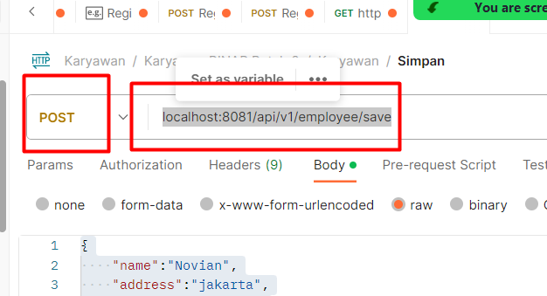

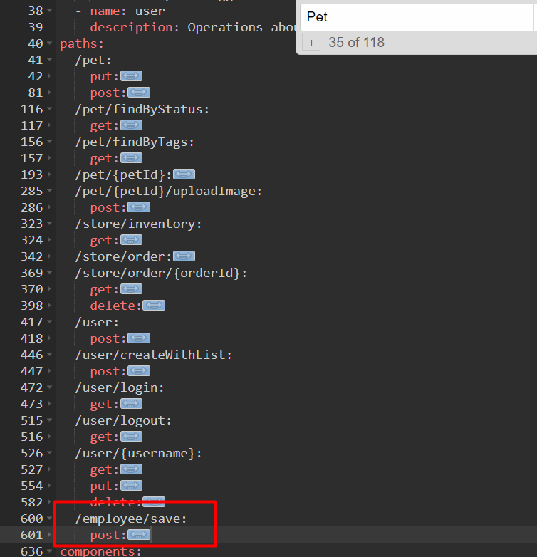

Req

|  |
| --- |
|  |

Res

|  |
| --- |
|  |

Full code

|  |
| --- |
| openapi: 3.0.3  info:  title: Swagger Petstore - OpenAPI 3.0  description: |-  This is a sample Pet Store Server based on the OpenAPI 3.0 specification. You can find out more about  Swagger at [https://swagger.io](https://swagger.io). In the third iteration of the pet store, we've switched to the design first approach!  You can now help us improve the API whether it's by making changes to the definition itself or to the code.  That way, with time, we can improve the API in general, and expose some of the new features in OAS3.  _If you're looking for the Swagger 2.0/OAS 2.0 version of Petstore, then click [here](https://editor.swagger.io/?url=https://petstore.swagger.io/v2/swagger.yaml). Alternatively, you can load via the `Edit > Load Petstore OAS 2.0` menu option!_    Some useful links:  - [The Pet Store repository](https://github.com/swagger-api/swagger-petstore)  - [The source API definition for the Pet Store](https://github.com/swagger-api/swagger-petstore/blob/master/src/main/resources/openapi.yaml)  termsOfService: http://swagger.io/terms/  contact:  email: apiteam@swagger.io  license:  name: Apache 2.0  url: http://www.apache.org/licenses/LICENSE-2.0.html  version: 1.0.11  externalDocs:  description: Find out more about Swagger  url: http://swagger.io  servers:  - url: https://petstore3.swagger.io/api/v3  tags:  - name: pet  description: Everything about your Pets  externalDocs:  description: Find out more  url: http://swagger.io  - name: store  description: Access to Petstore orders  externalDocs:  description: Find out more about our store  url: http://swagger.io  - name: user  description: Operations about user  paths:  /pet:  put:  tags:  - pet  summary: Update an existing pet  description: Update an existing pet by Id  operationId: updatePet  requestBody:  description: Update an existent pet in the store  content:  application/json:  schema:  $ref: '#/components/schemas/Pet'  application/xml:  schema:  $ref: '#/components/schemas/Pet'  application/x-www-form-urlencoded:  schema:  $ref: '#/components/schemas/Pet'  required: true  responses:  '200':  description: Successful operation  content:  application/json:  schema:  $ref: '#/components/schemas/Pet'  application/xml:  schema:  $ref: '#/components/schemas/Pet'  '400':  description: Invalid ID supplied  '404':  description: Pet not found  '405':  description: Validation exception  security:  - petstore_auth:  - write:pets  - read:pets  post:  tags:  - pet  summary: Add a new pet to the store  description: Add a new pet to the store  operationId: addPet  requestBody:  description: Create a new pet in the store  content:  application/json:  schema:  $ref: '#/components/schemas/Pet'  application/xml:  schema:  $ref: '#/components/schemas/Pet'  application/x-www-form-urlencoded:  schema:  $ref: '#/components/schemas/Pet'  required: true  responses:  '200':  description: Successful operation  content:  application/json:  schema:  $ref: '#/components/schemas/Pet'  application/xml:  schema:  $ref: '#/components/schemas/Pet'  '405':  description: Invalid input  security:  - petstore_auth:  - write:pets  - read:pets  /pet/findByStatus:  get:  tags:  - pet  summary: Finds Pets by status  description: Multiple status values can be provided with comma separated strings  operationId: findPetsByStatus  parameters:  - name: status  in: query  description: Status values that need to be considered for filter  required: false  explode: true  schema:  type: string  default: available  enum:  - available  - pending  - sold  responses:  '200':  description: successful operation  content:  application/json:  schema:  type: array  items:  $ref: '#/components/schemas/Pet'  application/xml:  schema:  type: array  items:  $ref: '#/components/schemas/Pet'  '400':  description: Invalid status value  security:  - petstore_auth:  - write:pets  - read:pets  /pet/findByTags:  get:  tags:  - pet  summary: Finds Pets by tags  description: Multiple tags can be provided with comma separated strings. Use tag1, tag2, tag3 for testing.  operationId: findPetsByTags  parameters:  - name: tags  in: query  description: Tags to filter by  required: false  explode: true  schema:  type: array  items:  type: string  responses:  '200':  description: successful operation  content:  application/json:  schema:  type: array  items:  $ref: '#/components/schemas/Pet'  application/xml:  schema:  type: array  items:  $ref: '#/components/schemas/Pet'  '400':  description: Invalid tag value  security:  - petstore_auth:  - write:pets  - read:pets  /pet/{petId}:  get:  tags:  - pet  summary: Find pet by ID  description: Returns a single pet  operationId: getPetById  parameters:  - name: petId  in: path  description: ID of pet to return  required: true  schema:  type: integer  format: int64  responses:  '200':  description: successful operation  content:  application/json:  schema:  $ref: '#/components/schemas/Pet'  application/xml:  schema:  $ref: '#/components/schemas/Pet'  '400':  description: Invalid ID supplied  '404':  description: Pet not found  security:  - api_key: []  - petstore_auth:  - write:pets  - read:pets  post:  tags:  - pet  summary: Updates a pet in the store with form data  description: ''  operationId: updatePetWithForm  parameters:  - name: petId  in: path  description: ID of pet that needs to be updated  required: true  schema:  type: integer  format: int64  - name: name  in: query  description: Name of pet that needs to be updated  schema:  type: string  - name: status  in: query  description: Status of pet that needs to be updated  schema:  type: string  responses:  '405':  description: Invalid input  security:  - petstore_auth:  - write:pets  - read:pets  delete:  tags:  - pet  summary: Deletes a pet  description: delete a pet  operationId: deletePet  parameters:  - name: api_key  in: header  description: ''  required: false  schema:  type: string  - name: petId  in: path  description: Pet id to delete  required: true  schema:  type: integer  format: int64  responses:  '400':  description: Invalid pet value  security:  - petstore_auth:  - write:pets  - read:pets  /pet/{petId}/uploadImage:  post:  tags:  - pet  summary: uploads an image  description: ''  operationId: uploadFile  parameters:  - name: petId  in: path  description: ID of pet to update  required: true  schema:  type: integer  format: int64  - name: additionalMetadata  in: query  description: Additional Metadata  required: false  schema:  type: string  requestBody:  content:  application/octet-stream:  schema:  type: string  format: binary  responses:  '200':  description: successful operation  content:  application/json:  schema:  $ref: '#/components/schemas/ApiResponse'  security:  - petstore_auth:  - write:pets  - read:pets  /store/inventory:  get:  tags:  - store  summary: Returns pet inventories by status  description: Returns a map of status codes to quantities  operationId: getInventory  responses:  '200':  description: successful operation  content:  application/json:  schema:  type: object  additionalProperties:  type: integer  format: int32  security:  - api_key: []  /store/order:  post:  tags:  - store  summary: Place an order for a pet  description: Place a new order in the store  operationId: placeOrder  requestBody:  content:  application/json:  schema:  $ref: '#/components/schemas/Order'  application/xml:  schema:  $ref: '#/components/schemas/Order'  application/x-www-form-urlencoded:  schema:  $ref: '#/components/schemas/Order'  responses:  '200':  description: successful operation  content:  application/json:  schema:  $ref: '#/components/schemas/Order'  '405':  description: Invalid input  /store/order/{orderId}:  get:  tags:  - store  summary: Find purchase order by ID  description: For valid response try integer IDs with value <= 5 or > 10. Other values will generate exceptions.  operationId: getOrderById  parameters:  - name: orderId  in: path  description: ID of order that needs to be fetched  required: true  schema:  type: integer  format: int64  responses:  '200':  description: successful operation  content:  application/json:  schema:  $ref: '#/components/schemas/Order'  application/xml:  schema:  $ref: '#/components/schemas/Order'  '400':  description: Invalid ID supplied  '404':  description: Order not found  delete:  tags:  - store  summary: Delete purchase order by ID  description: For valid response try integer IDs with value < 1000. Anything above 1000 or nonintegers will generate API errors  operationId: deleteOrder  parameters:  - name: orderId  in: path  description: ID of the order that needs to be deleted  required: true  schema:  type: integer  format: int64  responses:  '400':  description: Invalid ID supplied  '404':  description: Order not found  /user:  post:  tags:  - user  summary: Create user  description: This can only be done by the logged in user.  operationId: createUser  requestBody:  description: Created user object  content:  application/json:  schema:  $ref: '#/components/schemas/User'  application/xml:  schema:  $ref: '#/components/schemas/User'  application/x-www-form-urlencoded:  schema:  $ref: '#/components/schemas/User'  responses:  default:  description: successful operation  content:  application/json:  schema:  $ref: '#/components/schemas/User'  application/xml:  schema:  $ref: '#/components/schemas/User'  /user/createWithList:  post:  tags:  - user  summary: Creates list of users with given input array  description: Creates list of users with given input array  operationId: createUsersWithListInput  requestBody:  content:  application/json:  schema:  type: array  items:  $ref: '#/components/schemas/User'  responses:  '200':  description: Successful operation  content:  application/json:  schema:  $ref: '#/components/schemas/User'  application/xml:  schema:  $ref: '#/components/schemas/User'  default:  description: successful operation  /user/login:  get:  tags:  - user  summary: Logs user into the system  description: ''  operationId: loginUser  parameters:  - name: username  in: query  description: The user name for login  required: false  schema:  type: string  - name: password  in: query  description: The password for login in clear text  required: false  schema:  type: string  responses:  '200':  description: successful operation  headers:  X-Rate-Limit:  description: calls per hour allowed by the user  schema:  type: integer  format: int32  X-Expires-After:  description: date in UTC when token expires  schema:  type: string  format: date-time  content:  application/xml:  schema:  type: string  application/json:  schema:  type: string  '400':  description: Invalid username/password supplied  /user/logout:  get:  tags:  - user  summary: Logs out current logged in user session  description: ''  operationId: logoutUser  parameters: []  responses:  default:  description: successful operation  /user/{username}:  get:  tags:  - user  summary: Get user by user name  description: ''  operationId: getUserByName  parameters:  - name: username  in: path  description: 'The name that needs to be fetched. Use user1 for testing. '  required: true  schema:  type: string  responses:  '200':  description: successful operation  content:  application/json:  schema:  $ref: '#/components/schemas/User'  application/xml:  schema:  $ref: '#/components/schemas/User'  '400':  description: Invalid username supplied  '404':  description: User not found  put:  tags:  - user  summary: Update user  description: This can only be done by the logged in user.  operationId: updateUser  parameters:  - name: username  in: path  description: name that need to be deleted  required: true  schema:  type: string  requestBody:  description: Update an existent user in the store  content:  application/json:  schema:  $ref: '#/components/schemas/User'  application/xml:  schema:  $ref: '#/components/schemas/User'  application/x-www-form-urlencoded:  schema:  $ref: '#/components/schemas/User'  responses:  default:  description: successful operation  delete:  tags:  - user  summary: Delete user  description: This can only be done by the logged in user.  operationId: deleteUser  parameters:  - name: username  in: path  description: The name that needs to be deleted  required: true  schema:  type: string  responses:  '400':  description: Invalid username supplied  '404':  description: User not found  /employee/save:  post:  tags:  - employee  summary: Add a new employee  description: Add a new employee  operationId: addEmployee  requestBody:  description: Create a new employee  content:  application/json:  schema:  $ref: '#/components/schemas/Employee'  application/x-www-form-urlencoded:  schema:  $ref: '#/components/schemas/Employee'  required: true  responses:  '200':  description: Successful operation  content:  application/json:  schema:  $ref: '#/components/schemas/ResponseEmployee'  application/xml:  schema:  $ref: '#/components/schemas/ResponseEmployee'  '405':  content:  application/json:  schema:  $ref: '#/components/schemas/ResponseEmployeeFailed'  description: Invalid input  security:  - petstore_auth:  - write:pets  - read:pets  components:  schemas:  Order:  type: object  properties:  id:  type: integer  format: int64  example: 10  petId:  type: integer  format: int64  example: 198772  quantity:  type: integer  format: int32  example: 7  shipDate:  type: string  format: date-time  status:  type: string  description: Order Status  example: approved  enum:  - placed  - approved  - delivered  complete:  type: boolean  xml:  name: order  Customer:  type: object  properties:  id:  type: integer  format: int64  example: 100000  username:  type: string  example: fehguy  address:  type: array  xml:  name: addresses  wrapped: true  items:  $ref: '#/components/schemas/Address'  xml:  name: customer  Address:  type: object  properties:  street:  type: string  example: 437 Lytton  city:  type: string  example: Palo Alto  state:  type: string  example: CA  zip:  type: string  example: '94301'  xml:  name: address  Category:  type: object  properties:  id:  type: integer  format: int64  example: 1  name:  type: string  example: Dogs  xml:  name: category  User:  type: object  properties:  id:  type: integer  format: int64  example: 10  username:  type: string  example: theUser  firstName:  type: string  example: John  lastName:  type: string  example: James  email:  type: string  example: john@email.com  password:  type: string  example: '12345'  phone:  type: string  example: '12345'  userStatus:  type: integer  description: User Status  format: int32  example: 1  xml:  name: user  Tag:  type: object  properties:  id:  type: integer  format: int64  name:  type: string  xml:  name: tag  Pet:  required:  - name  - photoUrls  - hp  type: object  properties:  id:  type: integer  format: int64  example: 10  name:  type: string  example: doggie  hp:  type: integer  format: int64  example: 10  pattern: ^\d{1,19}$  maxLength: 19  minLength: 1  category:  $ref: '#/components/schemas/Category'  photoUrls:  type: array  xml:  wrapped: true  items:  type: string  xml:  name: photoUrl  tags:  type: array  xml:  wrapped: true  items:  $ref: '#/components/schemas/Tag'  status:  type: string  description: pet status in the store  enum:  - available  - pending  - sold  xml:  name: pet  Employee:  required:  - name  type: object  properties:  id:  type: integer  format: int64  example: 10  name:  type: string  example: Jhon  maxLength: 19  minLength: 1  address:  type: string  example: Jhon  dob:  type: string  description: Dob Format YYYY-MM-DD, Length 10,  example: 2023-10-10  pattern: ^$|\d{4}\-(0[1-9]|1[012])\-(0[1-9]|[12][0-9]|3[01])$  status:  type: string  description: Status Employee  enum:  - active  - inactive  detailEmployee:  $ref: '#/components/schemas/DetailEmployee'  xml:  name: employee  DetailEmployee:  required:  - nik  type: object  properties:  id:  type: integer  format: int64  example: 10  nik:  type: string  example: 12345123  maxLength: 19  minLength: 1  npwp:  type: string  example: 12345123  xml:  name: detailEmployee  ResponseEmployee:  type: object  properties:  status:  type: integer  example: 200  message:  type: string  example: Success  data:  $ref: '#/components/schemas/Employee'  xml:  name: responseEmployee  ResponseEmployeeFailed:  type: object  properties:  status:  type: integer  example: 404  message:  type: string  example: Failed  xml:  name: responseEmployee  ApiResponse:  type: object  properties:  code:  type: integer  format: int32  type:  type: string  message:  type: string  xml:  name: '##default'  requestBodies:  Pet:  description: Pet object that needs to be added to the store  content:  application/json:  schema:  $ref: '#/components/schemas/Pet'  application/xml:  schema:  $ref: '#/components/schemas/Pet'  UserArray:  description: List of user object  content:  application/json:  schema:  type: array  items:  $ref: '#/components/schemas/User'  securitySchemes:  petstore_auth:  type: oauth2  flows:  implicit:  authorizationUrl: https://petstore3.swagger.io/oauth/authorize  scopes:  write:pets: modify pets in your account  read:pets: read your pets  api_key:  type: apiKey  name: api_key  in: header |

### PR : tambahkan, get id, put, list, delete

# Pattern Regex

<https://regexr.com/>

WebFlux – Video Streaming

Referensi : <https://github.com/vinsguru/vinsguru-blog-code-samples/tree/master/webflux/webflux-video-streaming>

Ref web : <https://www.vinsguru.com/spring-webflux-video-streaming/>

## Output

Dapat memutar video

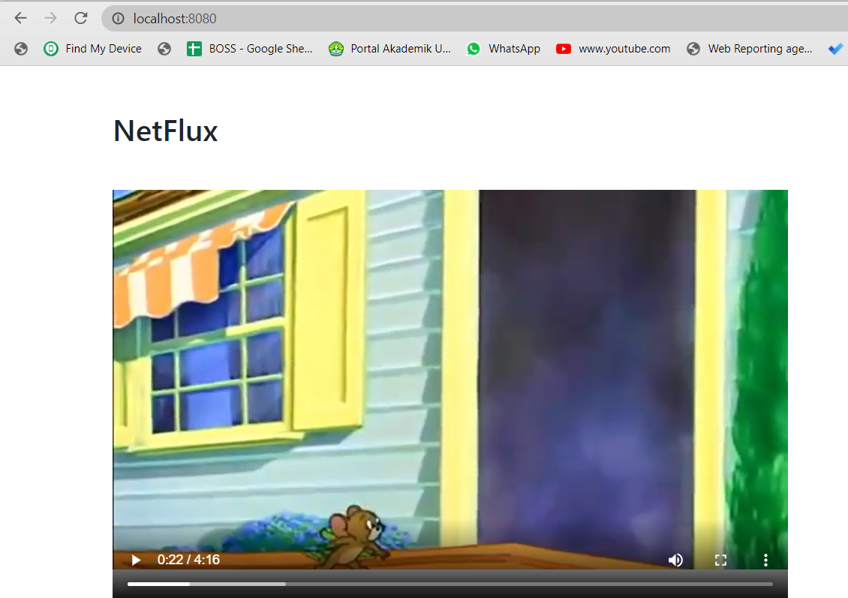

## Struktur project

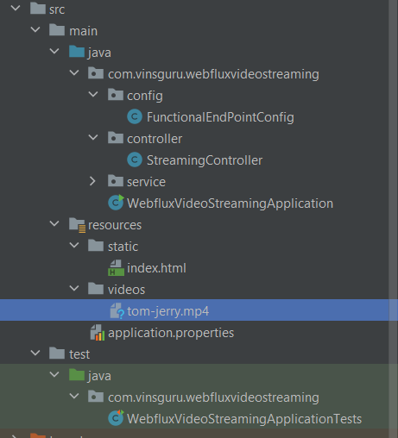

## Branch local

E:\binar\binar synergy batCh 5\Project\WebFlux\vinsguru-blog-code-samples-master\webflux\webflux-video-streaming

# Jasper Report with Spring Boot

## Download

<https://sourceforge.net/projects/jasperstudio/files/latest/download>

## sample project

E:\binar\binar synergy batCh 5\Project\jasper report

url : <https://websparrow.org/spring/spring-boot-jasper-report-example#google_vignette>

## memanggil jasper report dengan spring boot

### pom.xml

|  |
| --- |
| <!-- jasper-->  <dependency>  <groupId>net.sf.jasperreports</groupId>  <artifactId>jasperreports</artifactId>  <version>6.4.0</version>  </dependency>  <!-- Spring JDBC Support --> <dependency>  <groupId>org.springframework</groupId>  <artifactId>spring-jdbc</artifactId>  <version>5.3.23</version> </dependency> |

### Struktur project

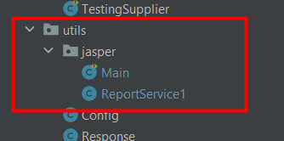

### Class ReportService1

|  |
| --- |
| package com.binar5.apps.utils.jasper;   import net.sf.jasperreports.engine.*; import net.sf.jasperreports.engine.export.JRXlsExporterParameter; import net.sf.jasperreports.engine.export.ooxml.JRDocxExporter; import net.sf.jasperreports.engine.export.ooxml.JRXlsxExporter; import net.sf.jasperreports.export.SimpleExporterInput; import net.sf.jasperreports.export.SimpleOutputStreamExporterOutput; import org.springframework.beans.factory.annotation.Autowired; import org.springframework.http.HttpHeaders; import org.springframework.http.HttpStatus; import org.springframework.http.ResponseEntity; import org.springframework.jdbc.core.JdbcTemplate; import org.springframework.stereotype.Service;  import javax.sql.DataSource; import java.io.ByteArrayOutputStream; import java.io.File; import java.io.FileOutputStream; import java.io.OutputStream; import java.sql.Connection; import java.sql.SQLException; import java.util.Map;  @Service public class ReportService1 {   @Autowired  JdbcTemplate jdbcTemplate;   @Autowired  DataSource dataSource;   public byte[] generate_pdf(Map<String, Object> parameters, String reportName) throws SQLException {  try {  JasperReport report = JasperCompileManager.*compileReport*(reportName);  System.*out*.println("reportreport="+reportName);  JasperPrint jasperPrint = JasperFillManager  .*fillReport* (report,  parameters,  jdbcTemplate.getDataSource().getConnection()); // JasperPrint jasperPrint = JasperFillManager // .fillReport // (reportName, // parameters, // dataSource.getConnection());  JasperExportManager.*exportReportToPdfFile*(jasperPrint, "./cdn/out.pdf");  byte[] result = JasperExportManager.*exportReportToPdf*(jasperPrint) ;  return result;   } catch (Exception e) {  e.printStackTrace();  return null;  }finally {  //close koneksi  jdbcTemplate.getDataSource().getConnection().close();  }  }   public byte[] generateDocx(Map<String, Object> parameters, String reportName) throws SQLException {  try {  JasperReport report = JasperCompileManager.*compileReport*(reportName);  System.*out*.println("reportreport="+reportName);  JasperPrint jasperPrint = JasperFillManager  .*fillReport* (report,  parameters,  jdbcTemplate.getDataSource().getConnection()); // JasperExportManager.exportReportToPdfFile(jasperPrint, "./cdn/out.pdf");  JRDocxExporter exporter = new JRDocxExporter();  exporter.setExporterInput(new SimpleExporterInput(jasperPrint));  File exportReportFile = new File("./cdn/out.docx");  exporter.setExporterOutput(new SimpleOutputStreamExporterOutput(exportReportFile));  exporter.exportReport();  byte[] result = JasperExportManager.*exportReportToPdf*(jasperPrint) ;  return result;   } catch (Exception e) {  e.printStackTrace();  return null;  }finally {  //close koneksi  jdbcTemplate.getDataSource().getConnection().close();  }  }    public byte[] generateHtml(Map<String, Object> parameters, String reportName) {  try {  JasperReport report = JasperCompileManager.*compileReport*(reportName);   JasperPrint jasperPrint = JasperFillManager.*fillReport*(report, parameters,jdbcTemplate.getDataSource().getConnection());  //perbedaan hanya disini  JasperExportManager.*exportReportToHtmlFile*(jasperPrint, "./cdn/out.html");  byte[] result = JasperExportManager.*exportReportToPdf*(jasperPrint) ;  return result;  } catch (Exception e) {  e.printStackTrace();  return null;  }  }   public ResponseEntity generate_excel(Map<String, Object> parameters, String reportName) throws SQLException {  Connection connection = null;  byte[] data = new byte[0];  HttpHeaders httpHeaders = new HttpHeaders();  try {  connection = dataSource.getConnection();  httpHeaders.set( HttpHeaders.*CONTENT_DISPOSITION*, "attachment; filename=" + reportName + ".xlsx" );   JasperReport report = JasperCompileManager.*compileReport*(reportName);   // Fill the report  JasperPrint jasperPrint = JasperFillManager.*fillReport*(report, parameters,jdbcTemplate.getDataSource().getConnection());   JRXlsxExporter exporter = new JRXlsxExporter();   ByteArrayOutputStream byteArrayOutputStream=new ByteArrayOutputStream();  exporter.setParameter(JRExporterParameter.*JASPER_PRINT*, jasperPrint);  exporter.setParameter(JRExporterParameter.*OUTPUT_STREAM*, byteArrayOutputStream);  exporter.setParameter(JRXlsExporterParameter.*IS_ONE_PAGE_PER_SHEET*, Boolean.*TRUE*);  exporter.setParameter(JRXlsExporterParameter.*IS_WHITE_PAGE_BACKGROUND*, Boolean.*FALSE*);  exporter.setParameter(JRXlsExporterParameter.*IS_REMOVE_EMPTY_SPACE_BETWEEN_ROWS*, Boolean.*TRUE*);  exporter.exportReport();  data = byteArrayOutputStream.toByteArray();  OutputStream out = new FileOutputStream("./cdn/out.xlsx");  out.write(data);  out.close();  } catch (Exception e) {  e.printStackTrace();  return null;  } finally {  if(connection != null) {  connection.close();  connection = null;  }  }  return new ResponseEntity(data, httpHeaders, HttpStatus.*OK* );  }   public ResponseEntity generateCSV(Map<String, Object> parameters, String reportName) throws SQLException {  Connection connection = null;  byte[] data = new byte[0];  HttpHeaders httpHeaders = new HttpHeaders();  try {  connection = dataSource.getConnection();  httpHeaders.set( HttpHeaders.*CONTENT_DISPOSITION*, "attachment; filename=" + reportName + ".csv" );   JasperReport report = JasperCompileManager.*compileReport*(reportName);   // Fill the report  JasperPrint jasperPrint = JasperFillManager.*fillReport*(report, parameters,jdbcTemplate.getDataSource().getConnection());   JRXlsxExporter exporter = new JRXlsxExporter();   ByteArrayOutputStream byteArrayOutputStream=new ByteArrayOutputStream();  exporter.setParameter(JRExporterParameter.*JASPER_PRINT*, jasperPrint);  exporter.setParameter(JRExporterParameter.*OUTPUT_STREAM*, byteArrayOutputStream);  exporter.setParameter(JRXlsExporterParameter.*IS_ONE_PAGE_PER_SHEET*, Boolean.*TRUE*);  exporter.setParameter(JRXlsExporterParameter.*IS_WHITE_PAGE_BACKGROUND*, Boolean.*FALSE*);  exporter.setParameter(JRXlsExporterParameter.*IS_REMOVE_EMPTY_SPACE_BETWEEN_ROWS*, Boolean.*TRUE*);  exporter.exportReport();  data = byteArrayOutputStream.toByteArray();  OutputStream out = new FileOutputStream("./cdn/out.csv");  out.write(data);  out.close();  } catch (Exception e) {  e.printStackTrace();  return null;  } finally {  if(connection != null) {  connection.close();  connection = null;  }  }  return new ResponseEntity(data, httpHeaders, HttpStatus.*OK* );  }      } |

### Testing

|  |
| --- |
| package com.binar5.apps.utils.jasper;   import net.sf.jasperreports.engine.JRException; import org.junit.Test; import org.junit.runner.RunWith; import org.springframework.beans.factory.annotation.Autowired; import org.springframework.boot.test.context.SpringBootTest; import org.springframework.context.annotation.AnnotationConfigApplicationContext; import org.springframework.test.context.junit4.SpringRunner;  import java.sql.SQLException; import java.util.HashMap; import java.util.Map; @RunWith(SpringRunner.class) @SpringBootTest(webEnvironment = SpringBootTest.WebEnvironment.*RANDOM_PORT*) public class Main {  @Autowired  public ReportService1 reportService1;   @Test  public void tets() throws SQLException {  Map<String, Object> parameters33 = new HashMap<>();  parameters33.put("logo", "C:\\Users\\USER\\Downloads\\hard-01.jpg");  parameters33.put("idSupplier", 1L);  parameters33.put("pathReport", "C:\\Users\\USER\\JaspersoftWorkspace\\binar\\"); // String pathUrl = "E:\\binar\\binar synergy batCh 5\\Project\\apps\\report\\baranglist.jrxml"; // String pathUrl = "E:\\binar\\binar synergy batCh 5\\Project\\apps\\report\\Supplier2.jrxml";  String pathUrl = "E:\\binar\\binar synergy batCh 5\\Project\\apps\\report\\Supplier_include_barang.jrxml";//bisa dengan gambar, namun tidak bisa load sub report  reportService1.generate_pdf(parameters33,pathUrl);  reportService1.generateHtml(parameters33,pathUrl);  reportService1.generate_excel(parameters33,pathUrl);  reportService1.generateCSV(parameters33,pathUrl);  reportService1.generateDocx(parameters33,pathUrl);  } } |

### Output file

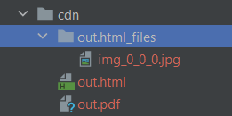

### Branch github

**151122-jasper-report**

[**https://gitlab.com/rikialdi/binar5-spring.git**](https://gitlab.com/rikialdi/binar5-spring.git)

## Mengabungkan banyak report menjadi 1 file

### Main testing

|  |
| --- |
| @Test  public void gabungManyReportPDF() throws SQLException {  Map<String, Object> parameters33 = new HashMap<>();  parameters33.put("logo", "C:\\Users\\USER\\Downloads\\hard-01.jpg");  parameters33.put("idSupplier", 1L);  parameters33.put("pathReport", "C:\\Users\\USER\\JaspersoftWorkspace\\binar\\"); // String pathUrl = "E:\\binar\\binar synergy batCh 5\\Project\\apps\\report\\baranglist.jrxml"; // String pathUrl = "E:\\binar\\binar synergy batCh 5\\Project\\apps\\report\\Supplier2.jrxml";  String pathUrl = "E:\\binar\\binar synergy batCh 5\\Project\\apps\\report\\Supplier_include_barang.jrxml";//bisa dengan gambar, namun tidak bisa load sub report  reportService1.exportMerge5PDF(pathUrl,parameters33);  } |

### Service

|  |
| --- |
| public void exportMerge5PDF(String jrxmlOutputTemplate1, Map parameters1){  try {  JasperDesign design1 = JRXmlLoader.*load*(jrxmlOutputTemplate1);  JasperReport report1 = JasperCompileManager.*compileReport*(design1);   JasperPrint print1 = JasperFillManager.*fillReport*(report1, parameters1, jdbcTemplate.getDataSource().getConnection());   JasperDesign design2 = JRXmlLoader.*load*(jrxmlOutputTemplate1);  JasperReport report2 = JasperCompileManager.*compileReport*(design2);  // JasperPrint print2 = JasperFillManager.fillReport(report2, parameters1, new JREmptyDataSource());  JasperPrint print2 = JasperFillManager.*fillReport*(report2, parameters1, jdbcTemplate.getDataSource().getConnection());   JasperDesign design3 = JRXmlLoader.*load*(jrxmlOutputTemplate1);  JasperReport report3 = JasperCompileManager.*compileReport*(design3);   JasperPrint print3 = JasperFillManager.*fillReport*(report3, parameters1, jdbcTemplate.getDataSource().getConnection());   JasperDesign design4 = JRXmlLoader.*load*(jrxmlOutputTemplate1);  JasperReport report4 = JasperCompileManager.*compileReport*(design4);   JasperPrint print4 = JasperFillManager.*fillReport*(report4, parameters1, jdbcTemplate.getDataSource().getConnection());   JasperDesign design5 = JRXmlLoader.*load*(jrxmlOutputTemplate1);  JasperReport report5 = JasperCompileManager.*compileReport*(design5);   JasperPrint print5 = JasperFillManager.*fillReport*(report5, parameters1, jdbcTemplate.getDataSource().getConnection());   List<JasperPrint> jasperPrintList = new ArrayList<JasperPrint>();  jasperPrintList.add(print1);  jasperPrintList.add(print2);  jasperPrintList.add(print3);  jasperPrintList.add(print4);  jasperPrintList.add(print5);  // generateReportList(print1,print2,print3, print4,pdfOutput);  generateReportListfleksibel(jasperPrintList, "./cdn/allpdf.pdf"); // JasperExportManager.exportReportToPdfFile(print, pdfOutput);  } catch (JRException e) {  *logger*.error("error jasper report {}", e);  } catch (Exception e) {  *logger*.error("error other jasper report {}", e);  }   }    public void generateReportListfleksibel(List<JasperPrint> jasperPrintList, String pdfOutput) {  //throw the JasperPrint Objects in a list   try {   ByteArrayOutputStream baos = new ByteArrayOutputStream();  JRPdfExporter exporter = new JRPdfExporter();  //Add the list as a Parameter  exporter.setParameter(JRExporterParameter.*JASPER_PRINT_LIST*, jasperPrintList);  //this will make a bookmark in the exported PDF for each of the reports  exporter.setParameter(JRPdfExporterParameter.*IS_CREATING_BATCH_MODE_BOOKMARKS*, Boolean.*TRUE*);  exporter.setParameter(JRPdfExporterParameter.*FORCE_LINEBREAK_POLICY*, Boolean.*TRUE*);  exporter.setParameter(JRExporterParameter.*OUTPUT_STREAM*, new FileOutputStream(pdfOutput)); // exporter.setParameter(JRPdfExporterParameter.INPUT_FILE_NAME, pdfOutput);   exporter.exportReport();  } catch (JRException e) {  // *TODO Auto-generated catch block* e.printStackTrace();  } catch (FileNotFoundException e) {  // *TODO Auto-generated catch block* e.printStackTrace();  }   } |

### Output

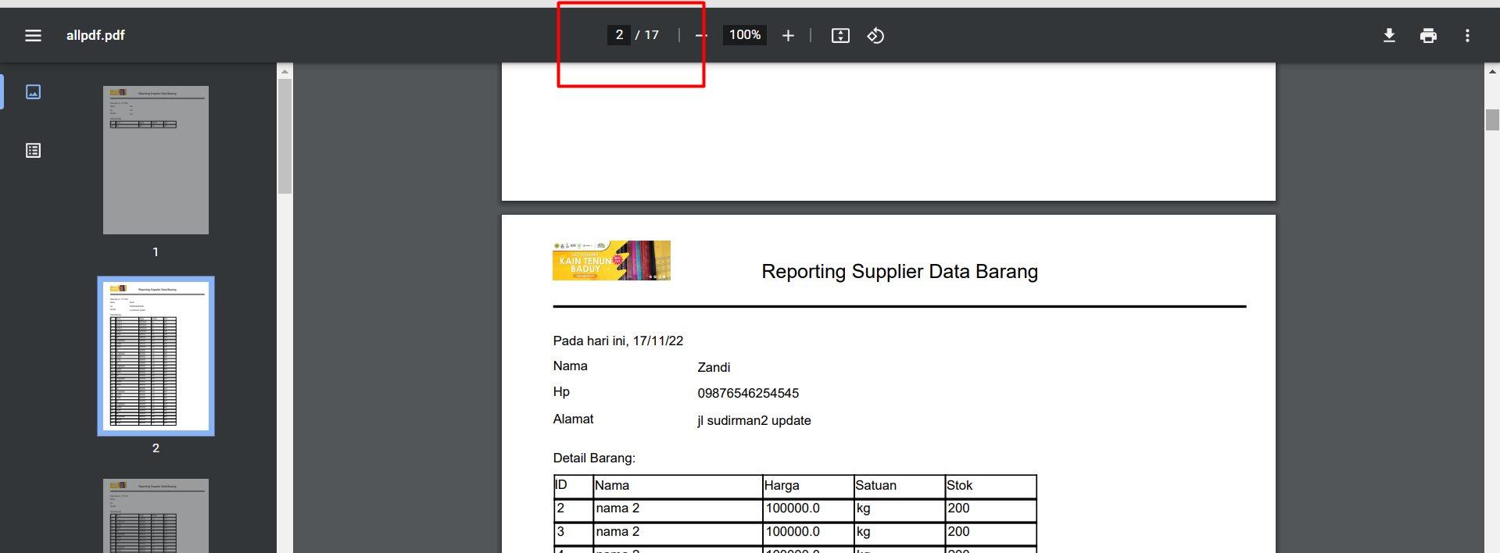

Halaman menjadi lebih banyak, karena mengabungkan beberapa reporting

### Branch

[**https://gitlab.com/rikialdi/binar5-spring.git**](https://gitlab.com/rikialdi/binar5-spring.git)

171122-file-zip

# Jasper Report Design

## Create project

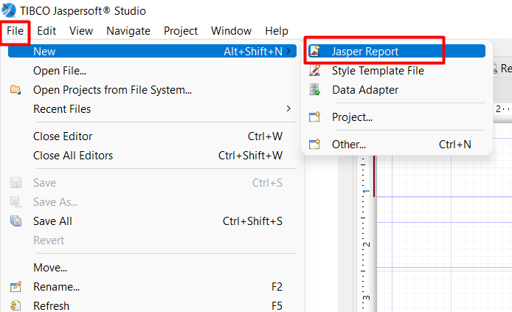

## Tampilan file

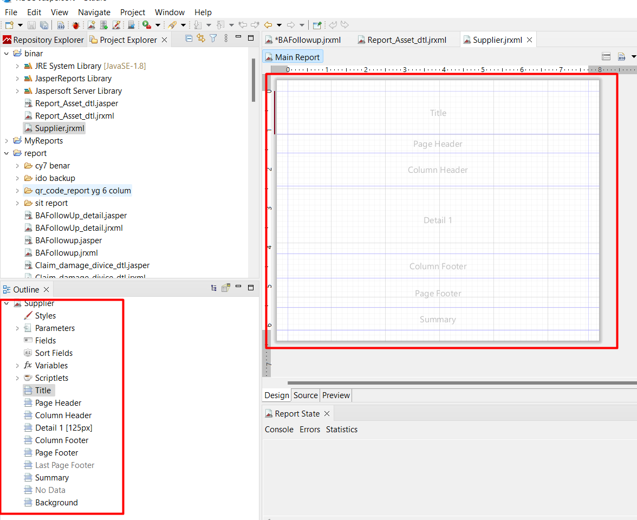

## Palete

Komponen pada jasper report

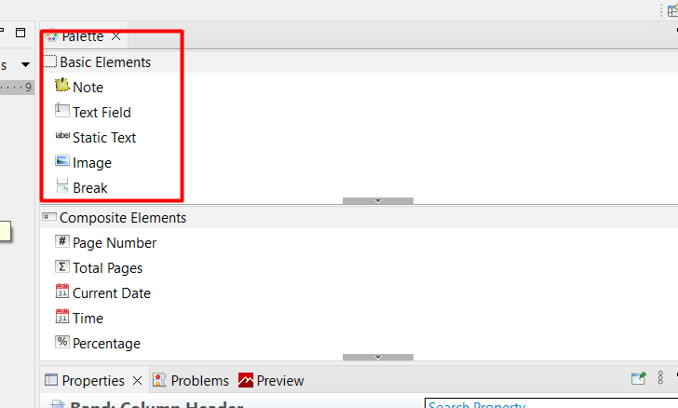

## Parameter, field dan variabel

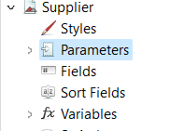

Parameter : membuat parameter bertujuan dapat menampung value dari luar. Misal request id

Field : field select kolumn pada database

Variabel : dapat membuat variabel untuk keperluan jasper report, misal no urut.

## Studi kasus

Menampilkan data supplier beserta detail barang yang dimiliki.

## Step 1 : membuat report supplier

Buatlah dengan nama : Supplier.jrxml

### Menambahkan image

Tambahkan di column header

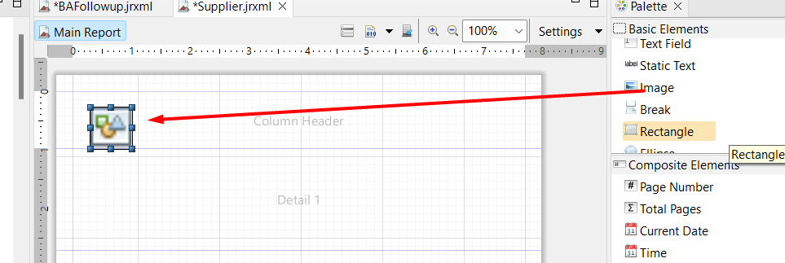

### Tambahkan parameter “logo” di properties

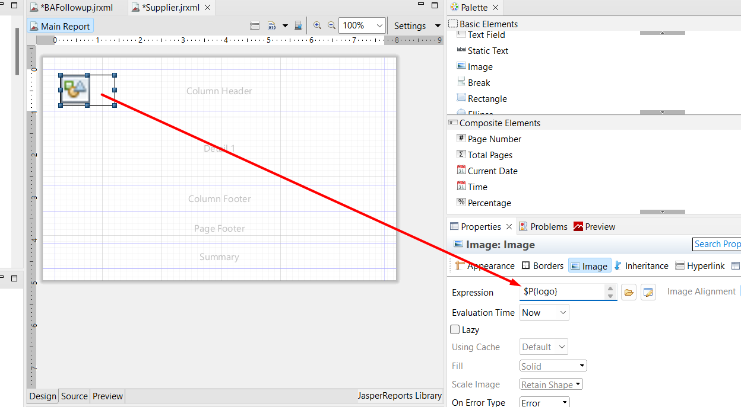

### Buatlah parameter “logo”

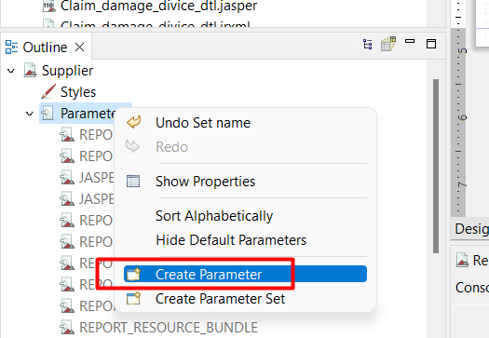

### Tambahkan Header

Pilih dengan static text

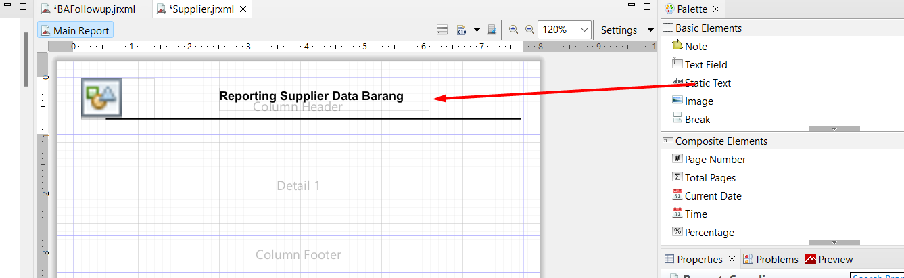

### Hasil akhir column header

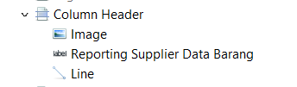

### Menambahkan koneksi ke database

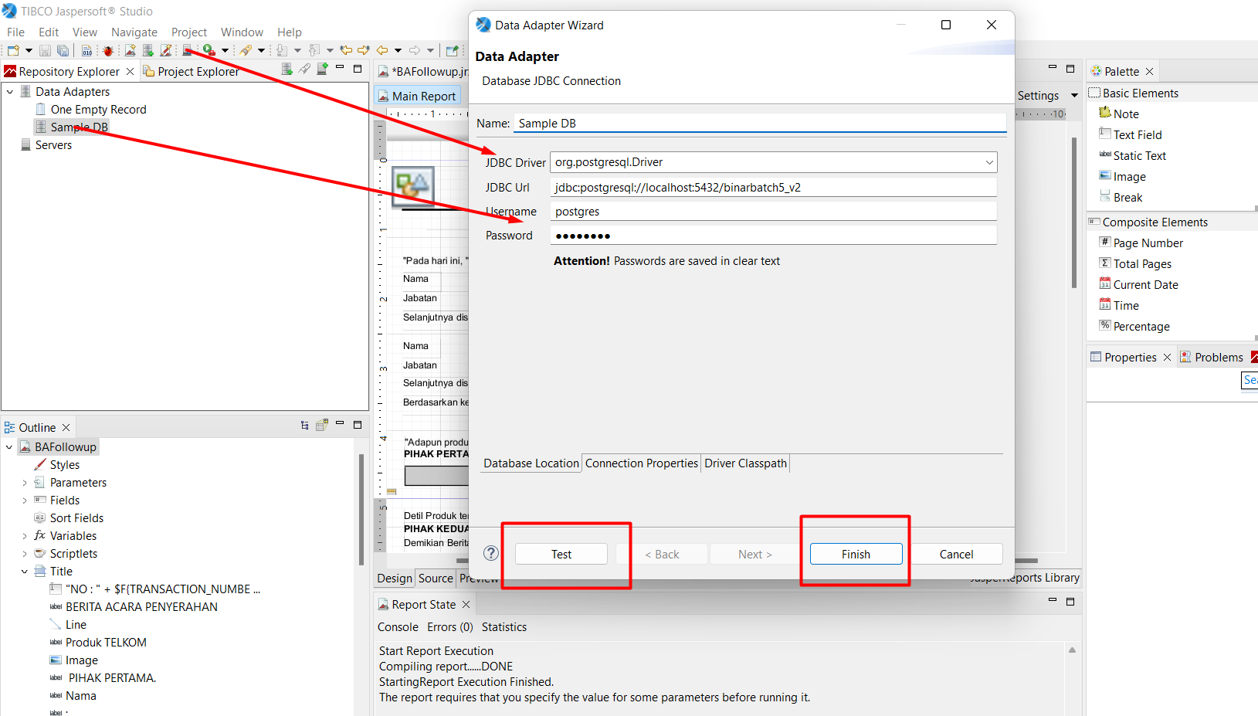

### Manambhakan query

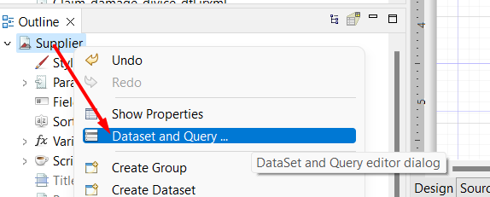

Buatlah query dengan parameter idsupplier

Pilih db dan ketikkan query kemudian klik read field

Maka akan muncul field kolumn di bawah nya.

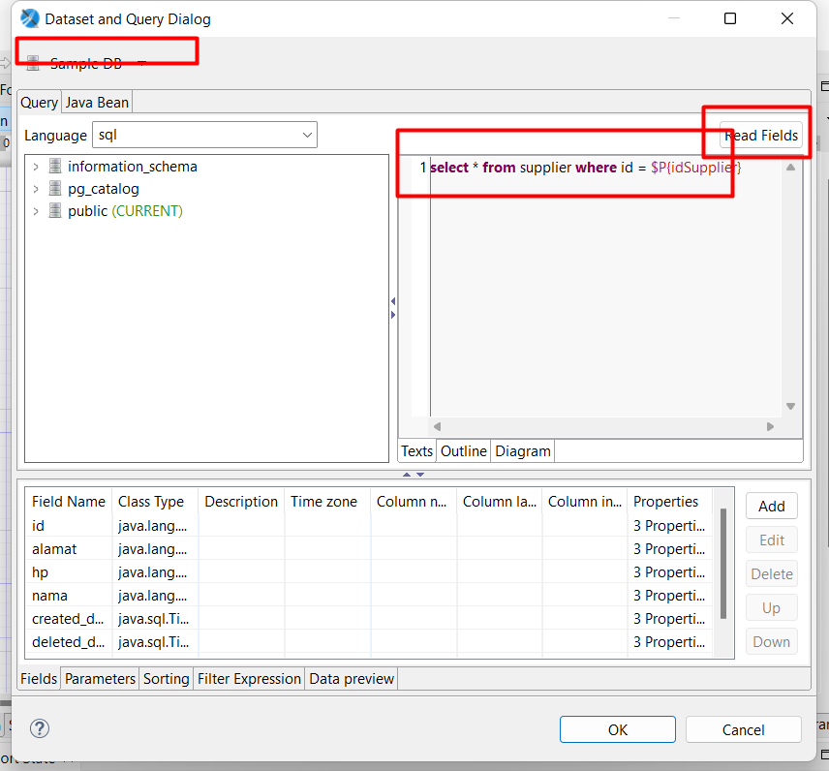

Buatlah parameter “idSupplier”

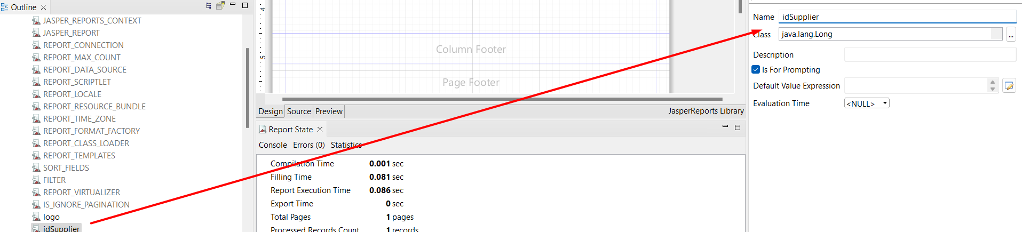

### Menambahkan design kolum tabel supplier

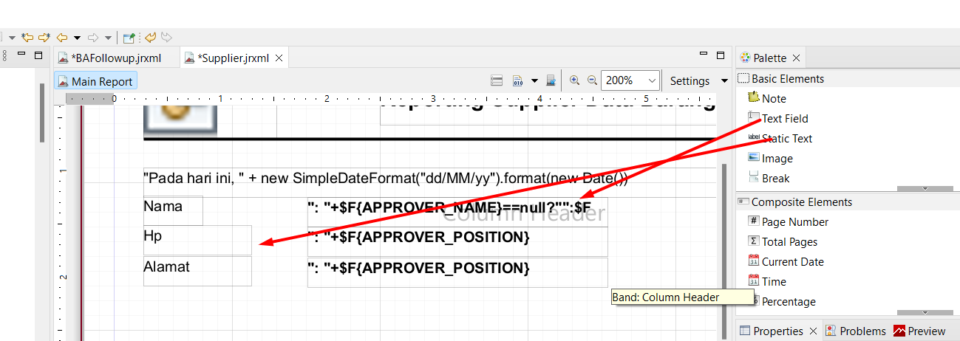

Edit texkfield sesuai kolumn database

Contoh column hp

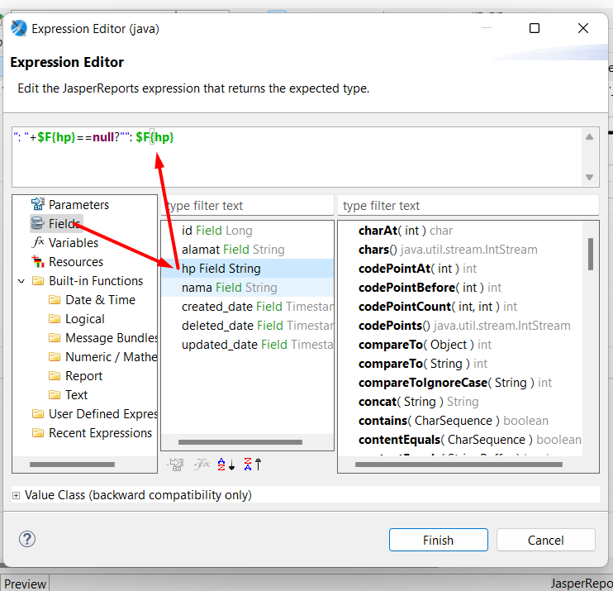

### Tampilan akhir

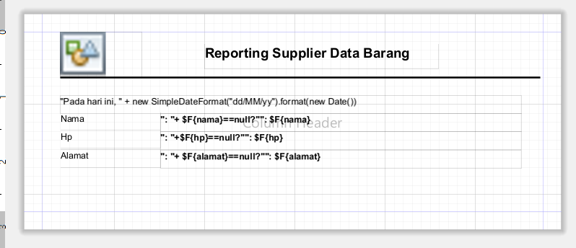

### Output akhir

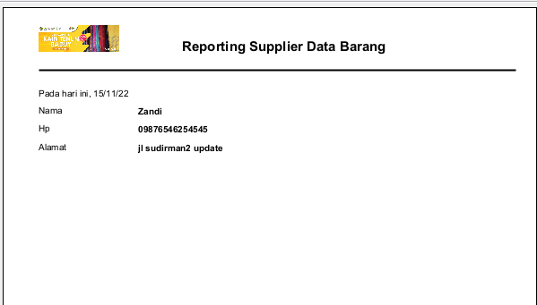

## Membuat Desing Jasper Report Barang List

### Create new report “baranglist.jrxml”

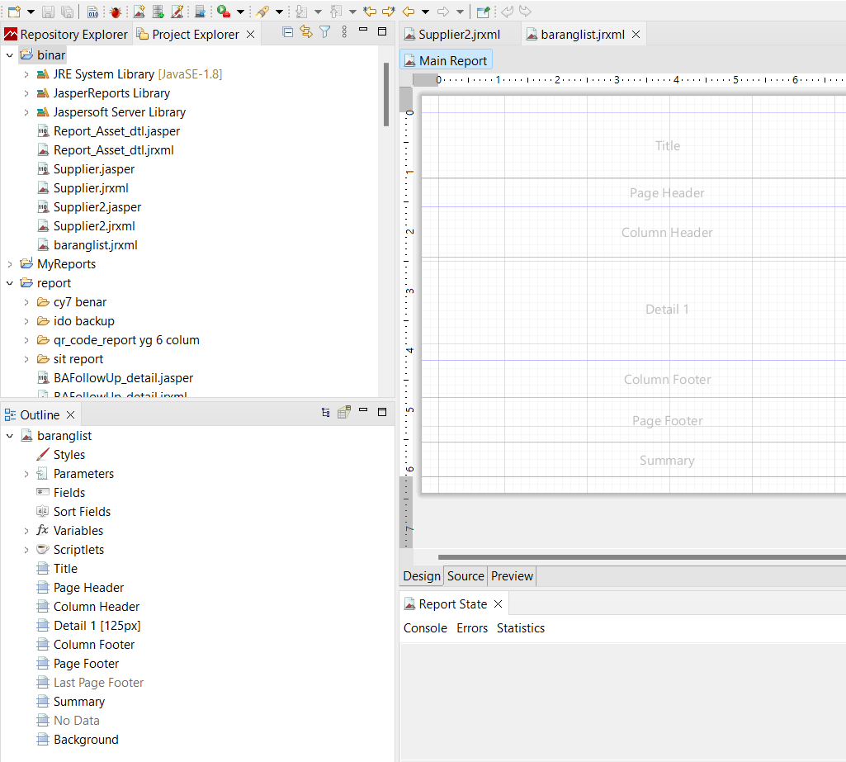

### Hapus semua tag, sisakan detail dan column header

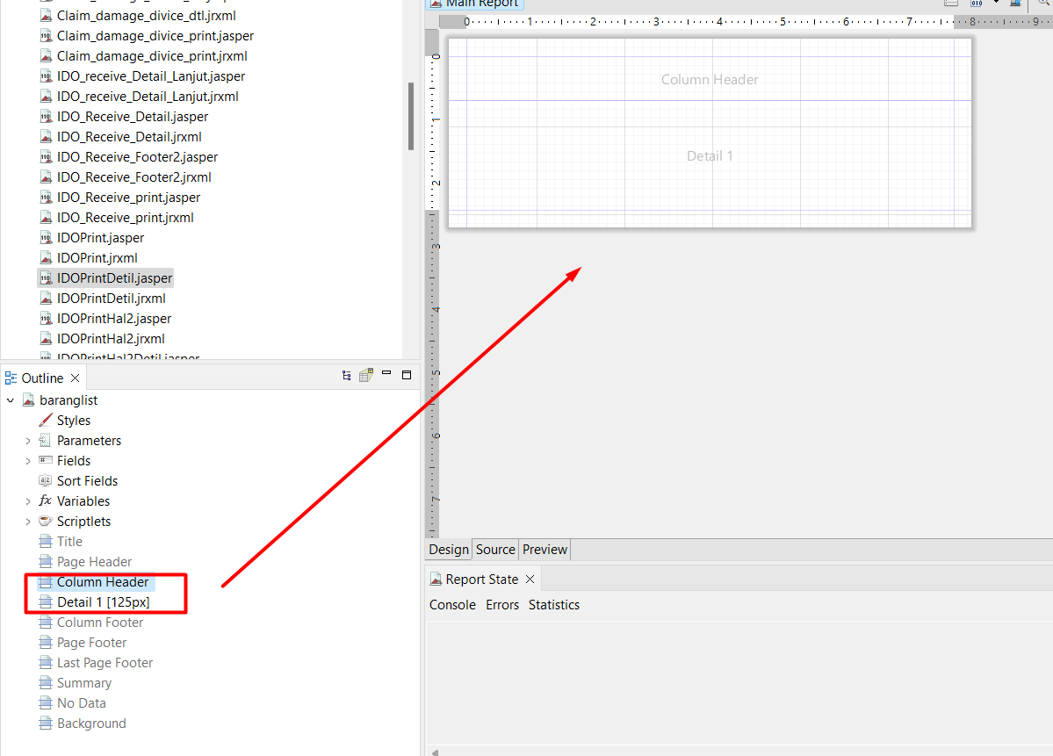

### Membuat query select barang by supplier

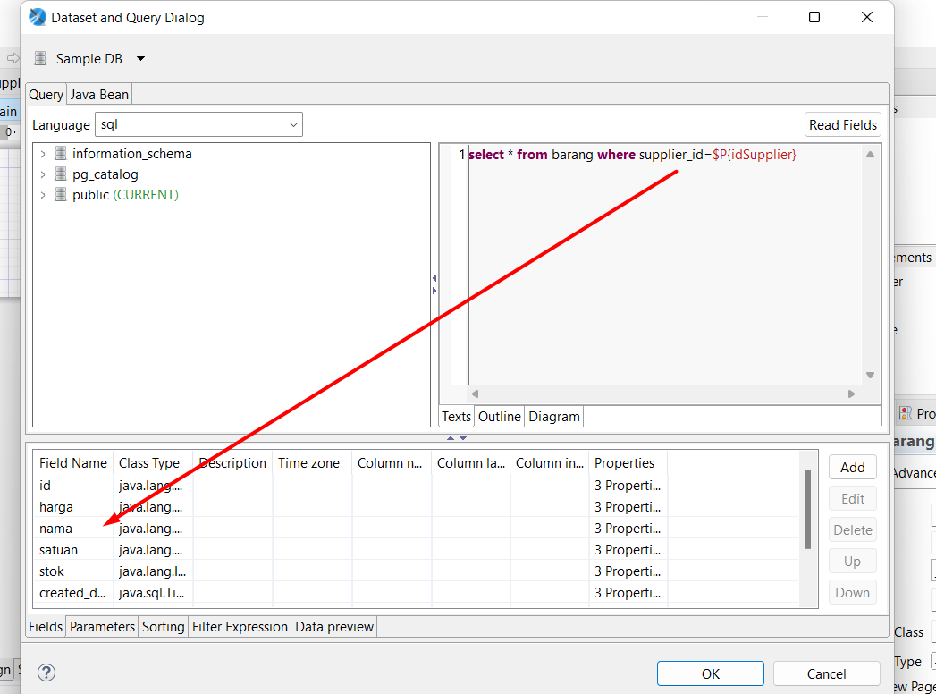

### Membuat parameter “idSupplier”

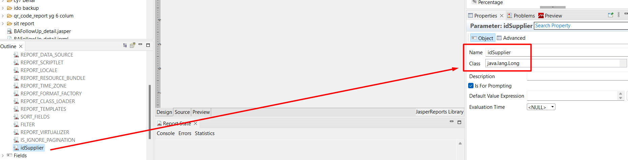

### Tambahkan static text dan textfield

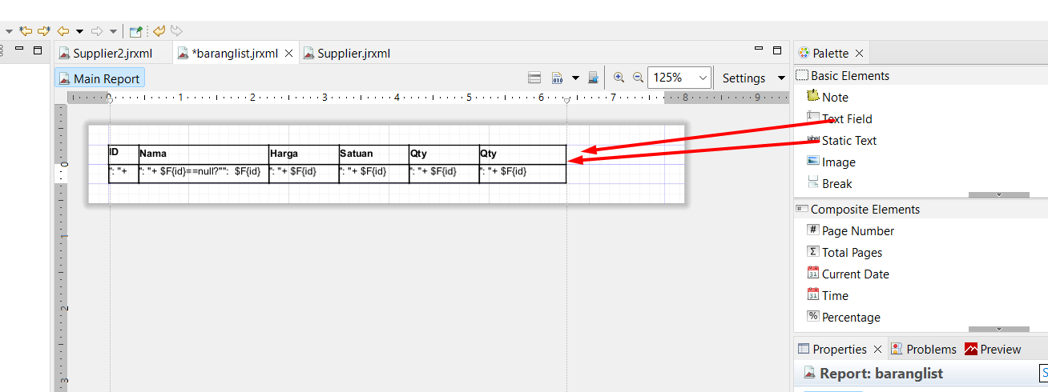

Isi valuenya sesuai field kolumn tabel anda

Misal

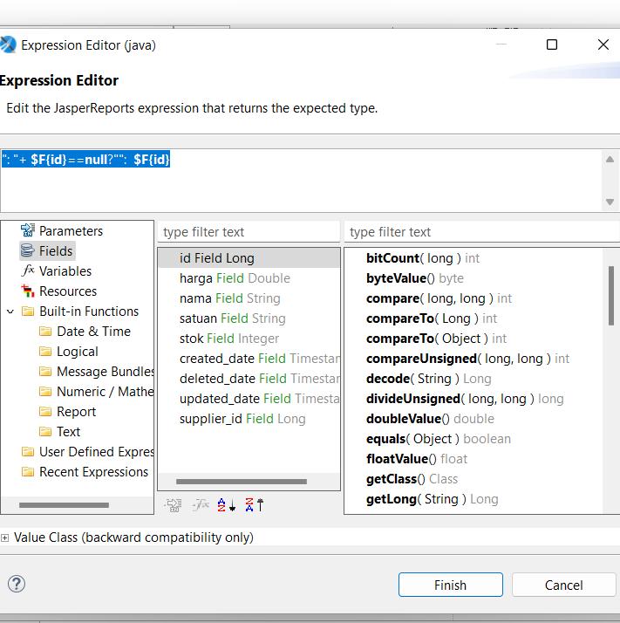

### Output

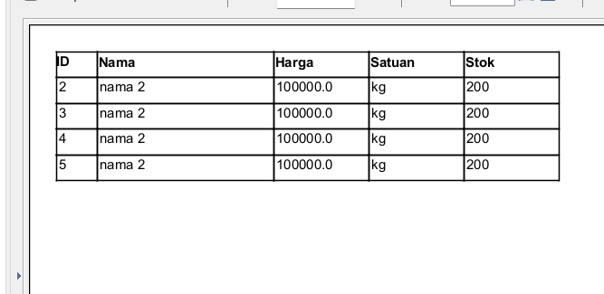

## Mengabungkan header supplier dengan detail barang

### Copy paste supplier.jrxml menjad supplier2.jrxml

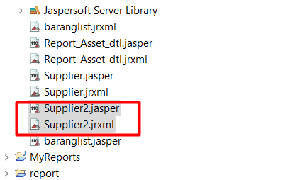

### Tambahkan komponen detail

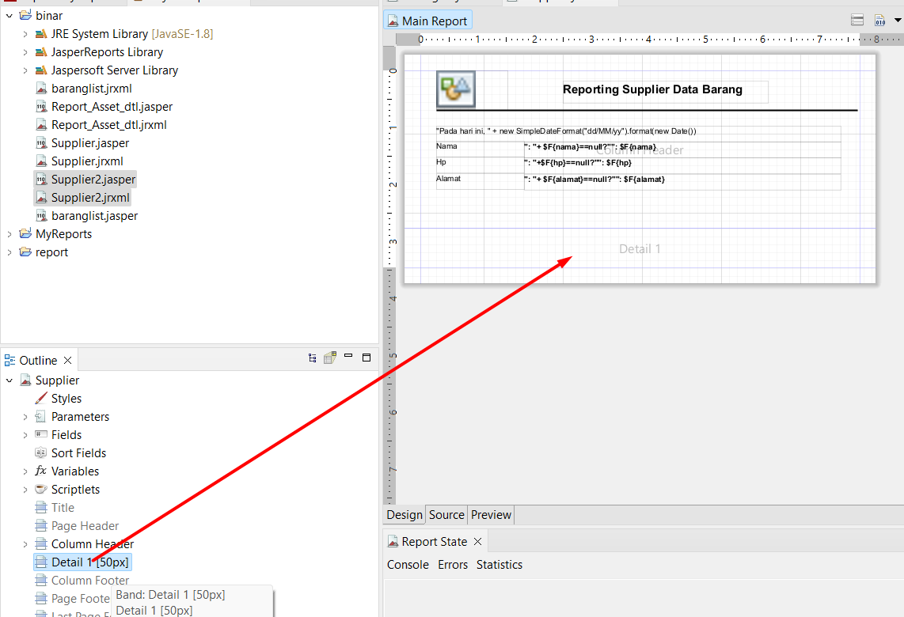

### Tambahkan parameter pathReport untuk url dinamic

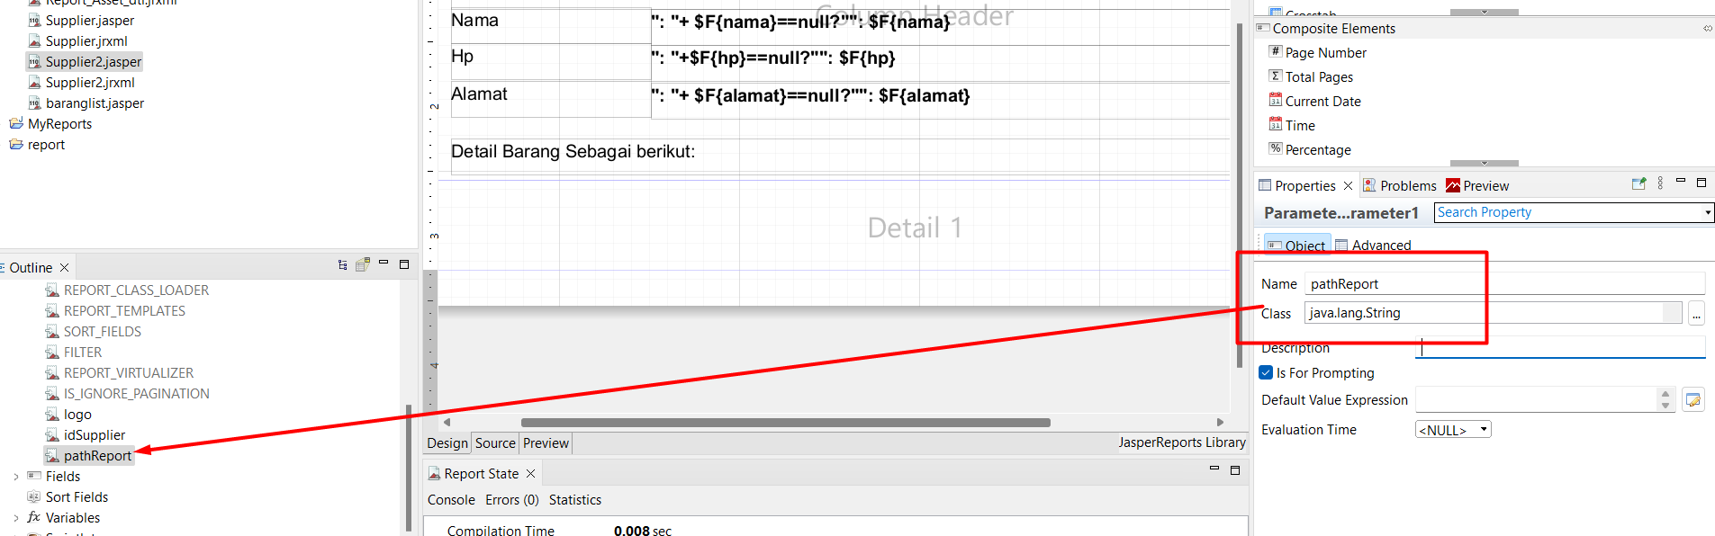

### Tambahkan sub report

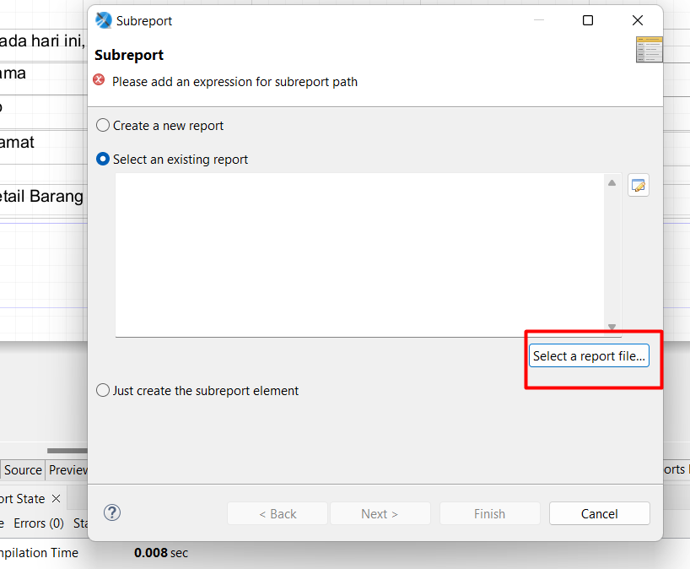

Select a report file

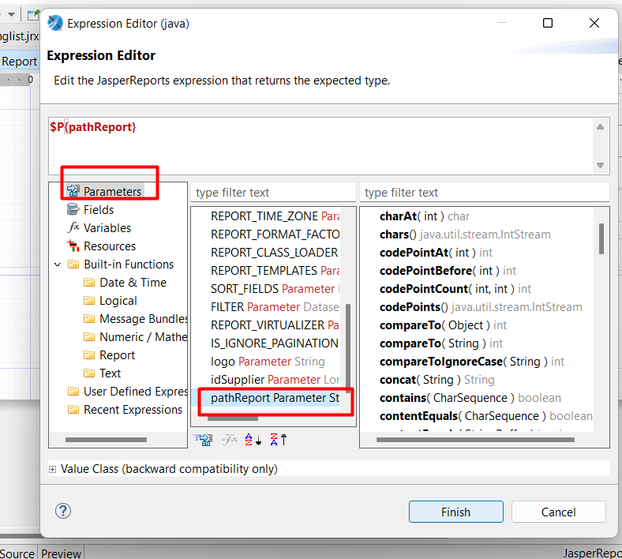

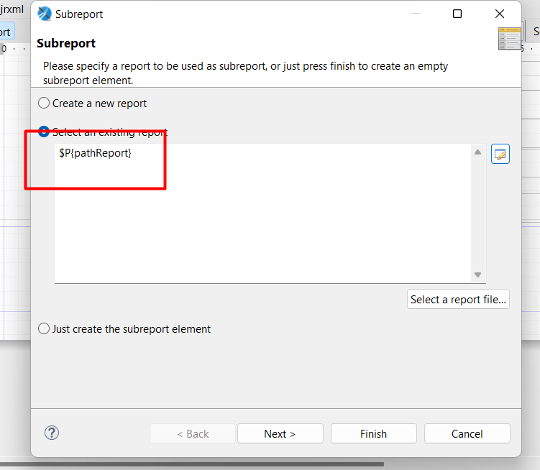

Tambahkan pada sub report : path detail report

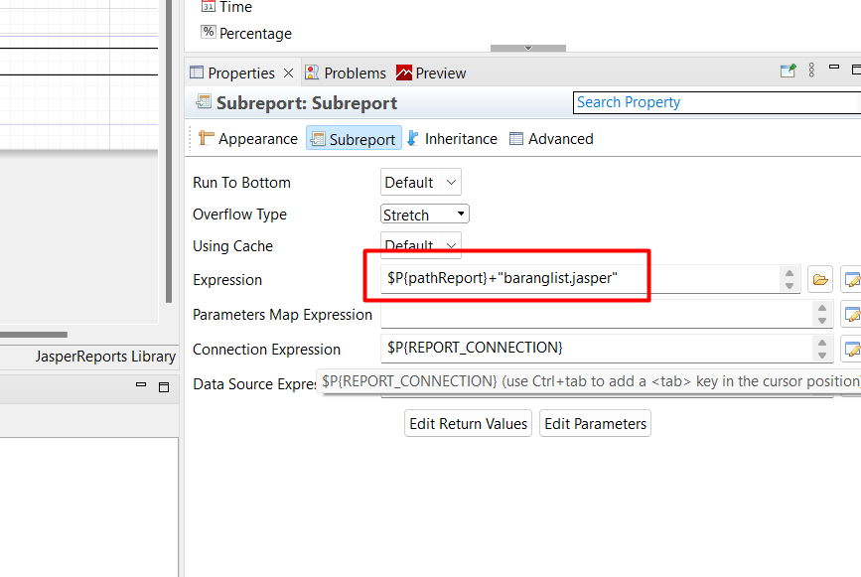

### Output

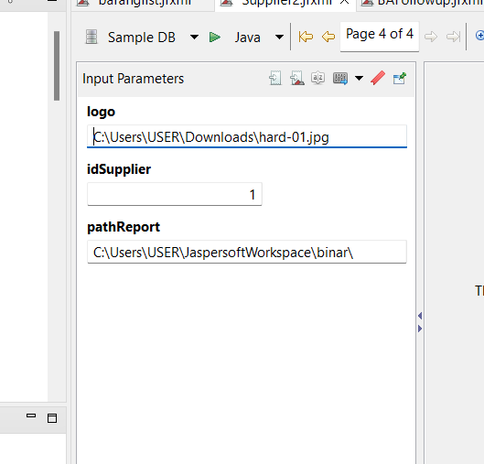

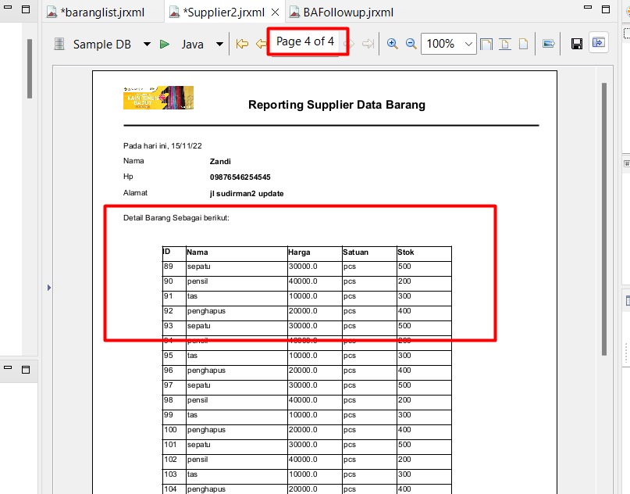

### Wajib dilakukan jika ada perubahan : save permanen

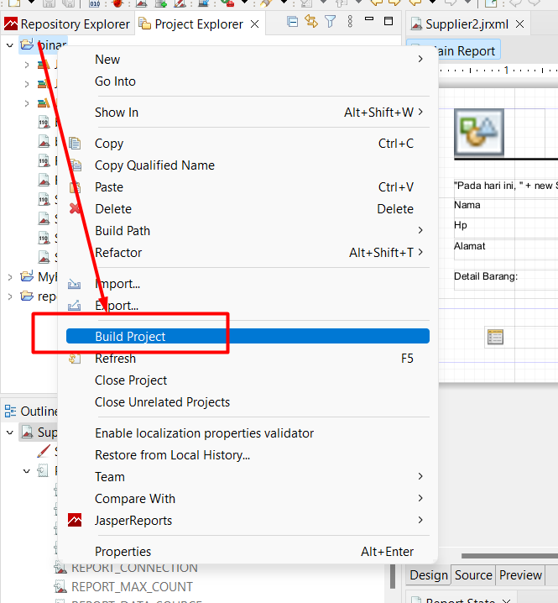

# Jasper report Studi kasus karyawan : Spring Boot

<https://gitlab.com/rikialdi/batch6/-/tree/ch5-sesi5-jasper?ref_type=heads>

## POM

|  |
| --- |
| <!-- jasper--> <dependency>  <groupId>net.sf.jasperreports</groupId>  <artifactId>jasperreports</artifactId>  <version>6.4.0</version> </dependency> <!-- Spring JDBC Support --> <dependency>  <groupId>org.springframework</groupId>  <artifactId>spring-jdbc</artifactId>  <version>5.3.23</version> </dependency> |

## Struktur

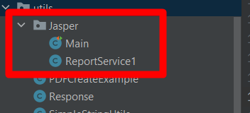

### Main

|  |
| --- |
| package com.aplikasi.karyawan.utils.Jasper;  import net.sf.jasperreports.engine.JRException; import org.junit.Test; import org.junit.runner.RunWith; import org.springframework.beans.factory.annotation.Autowired; import org.springframework.boot.test.context.SpringBootTest; import org.springframework.context.annotation.AnnotationConfigApplicationContext; import org.springframework.test.context.junit4.SpringRunner;  import java.sql.SQLException; import java.util.HashMap; import java.util.Map; @RunWith(SpringRunner.class) @SpringBootTest(webEnvironment = SpringBootTest.WebEnvironment.*RANDOM_PORT*) public class Main { // @Test // public void main( ) { // // AnnotationConfigApplicationContext ctx = new AnnotationConfigApplicationContext(); // ctx.register(JasperRerportsSimpleConfig.class); // ctx.refresh(); // // SimpleReportFiller simpleReportFiller = ctx.getBean(SimpleReportFiller.class); // simpleReportFiller.setReportFileName("./report/Supplier2.jrxml"); // simpleReportFiller.compileReport(); // //// simpleReportFiller.setReportFileName("employeeReport.jrxml"); //// simpleReportFiller.compileReport(); // // Map<String, Object> parameters = new HashMap<>(); // parameters.put("logo", "C:\\Users\\USER\\Downloads\\hard-01.jpg"); // parameters.put("idSupplier", 1); // parameters.put("pathReport", "E:\\binar\\binar synergy batCh 5\\Project\\apps\\report\\"); // // simpleReportFiller.setParameters(parameters); // simpleReportFiller.fillReport(); // // SimpleReportExporter simpleExporter = ctx.getBean(SimpleReportExporter.class); // simpleExporter.setJasperPrint(simpleReportFiller.getJasperPrint()); // // simpleExporter.exportToPdf("employeeReport.pdf", "baeldung"); // simpleExporter.exportToXlsx("employeeReport.xlsx", "Employee Data"); // simpleExporter.exportToCsv("employeeReport.csv"); // simpleExporter.exportToHtml("employeeReport.html"); // // }   @Autowired  public ReportService1 reportService1;   @Test  public void tets() throws SQLException {  Map<String, Object> parameters33 = new HashMap<>(); // parameters33.put("logo", "C:\\Users\\USER\\Downloads\\hard-01.jpg"); // Long inttt = 1L; // parameters33.put("idparam", 1); // parameters33.put("nameparama", "'%a%'"); // parameters33.put("pathReport", "E:\\binar\\binar synergy batCh 5\\Project\\apps\\report\\"); // String pathUrl = "E:\\binar\\binar synergy batCh 5\\Project\\apps\\report\\baranglist.jrxml"; // String pathUrl = "E:\\binar\\binar synergy batCh 5\\Project\\apps\\report\\Supplier2.jrxml";  String pathUrl = "E:\\binar\\Binat Batch 6\\MODUL\\karyawan\\src\\main\\resources\\Blank_A4.jrxml";//bisa dengan gambar, namun tidak bisa load sub report  reportService1.generate_pdf(parameters33,pathUrl);  reportService1.generate_excel(parameters33,pathUrl);  reportService1.generateCSV(parameters33,pathUrl);  } } |

### Reportservice1

|  |
| --- |
| package com.aplikasi.karyawan.utils.Jasper;   import java.io.*; import java.sql.Connection; import java.sql.SQLException; import java.util.HashMap; import java.util.Map; import java.util.logging.Level; import java.util.logging.Logger;  import net.sf.jasperreports.engine.*; import net.sf.jasperreports.engine.design.JasperDesign; import net.sf.jasperreports.engine.export.HtmlExporter; import net.sf.jasperreports.engine.export.JRCsvExporter; import net.sf.jasperreports.engine.export.JRXlsExporterParameter; import net.sf.jasperreports.engine.export.ooxml.JRXlsxExporter; import net.sf.jasperreports.engine.xml.JRXmlLoader; import net.sf.jasperreports.export.SimpleExporterInput; import net.sf.jasperreports.export.SimpleHtmlExporterOutput; import net.sf.jasperreports.export.SimpleWriterExporterOutput; import org.springframework.beans.factory.annotation.Autowired; import org.springframework.context.ApplicationContext; import org.springframework.core.io.Resource; import org.springframework.http.HttpHeaders; import org.springframework.http.HttpStatus; import org.springframework.http.ResponseEntity; import org.springframework.jdbc.core.JdbcTemplate; import org.springframework.jdbc.datasource.DataSourceUtils; import org.springframework.stereotype.Service; import org.springframework.transaction.annotation.Transactional;   import org.springframework.http.HttpEntity; import org.springframework.http.HttpHeaders; import org.springframework.http.HttpMethod; import org.springframework.http.HttpStatus; import org.springframework.http.MediaType; import org.springframework.http.ResponseEntity; import org.springframework.stereotype.Service; import org.springframework.web.client.RestTemplate;  import org.springframework.jdbc.datasource.DriverManagerDataSource;  import javax.sql.DataSource;  @Service public class ReportService1 {  @Autowired  ApplicationContext context;   @Autowired  JdbcTemplate jdbcTemplate;   @Autowired  DataSource dataSource;   RestTemplate restTemplate;   public byte[] generate_pdf(Map<String, Object> parameters, String reportName) {  try {  JasperReport report = JasperCompileManager.*compileReport*(reportName);   JasperPrint jasperPrint = JasperFillManager.*fillReport*(report, parameters,jdbcTemplate.getDataSource().getConnection());   byte[] result = JasperExportManager.*exportReportToPdf*(jasperPrint) ;  OutputStream out = new FileOutputStream("./cdn/out.pdf");  out.write(result);  out.close();  return result;   } catch (Exception e) {  e.printStackTrace();  return null;  }  }   public ResponseEntity generate_excel(Map<String, Object> parameters, String reportName) throws SQLException {  Connection connection = null;  byte[] data = new byte[0];  HttpHeaders httpHeaders = new HttpHeaders();  try {  connection = dataSource.getConnection();  httpHeaders.set( HttpHeaders.*CONTENT_DISPOSITION*, "attachment; filename=" + reportName + ".xlsx" );   JasperReport report = JasperCompileManager.*compileReport*(reportName);   // Fill the report  JasperPrint jasperPrint = JasperFillManager.*fillReport*(report, parameters,jdbcTemplate.getDataSource().getConnection());   JRXlsxExporter exporter = new JRXlsxExporter();   ByteArrayOutputStream byteArrayOutputStream=new ByteArrayOutputStream();  exporter.setParameter(JRExporterParameter.*JASPER_PRINT*, jasperPrint);  exporter.setParameter(JRExporterParameter.*OUTPUT_STREAM*, byteArrayOutputStream);  exporter.setParameter(JRXlsExporterParameter.*IS_ONE_PAGE_PER_SHEET*, Boolean.*TRUE*);  exporter.setParameter(JRXlsExporterParameter.*IS_WHITE_PAGE_BACKGROUND*, Boolean.*FALSE*);  exporter.setParameter(JRXlsExporterParameter.*IS_REMOVE_EMPTY_SPACE_BETWEEN_ROWS*, Boolean.*TRUE*);  exporter.exportReport();  data = byteArrayOutputStream.toByteArray();  OutputStream out = new FileOutputStream("./cdn/out.xlsx");  out.write(data);  out.close();  } catch (Exception e) {  e.printStackTrace();  return null;  } finally {  if(connection != null) {  connection.close();  connection = null;  }  }  return new ResponseEntity(data, httpHeaders, HttpStatus.*OK* );  }   public ResponseEntity generateCSV(Map<String, Object> parameters, String reportName) throws SQLException {  Connection connection = null;  byte[] data = new byte[0];  HttpHeaders httpHeaders = new HttpHeaders();  try {  connection = dataSource.getConnection();  httpHeaders.set( HttpHeaders.*CONTENT_DISPOSITION*, "attachment; filename=" + reportName + ".csv" );   JasperReport report = JasperCompileManager.*compileReport*(reportName);   // Fill the report  JasperPrint jasperPrint = JasperFillManager.*fillReport*(report, parameters,jdbcTemplate.getDataSource().getConnection());   JRXlsxExporter exporter = new JRXlsxExporter();   ByteArrayOutputStream byteArrayOutputStream=new ByteArrayOutputStream();  exporter.setParameter(JRExporterParameter.*JASPER_PRINT*, jasperPrint);  exporter.setParameter(JRExporterParameter.*OUTPUT_STREAM*, byteArrayOutputStream);  exporter.setParameter(JRXlsExporterParameter.*IS_ONE_PAGE_PER_SHEET*, Boolean.*TRUE*);  exporter.setParameter(JRXlsExporterParameter.*IS_WHITE_PAGE_BACKGROUND*, Boolean.*FALSE*);  exporter.setParameter(JRXlsExporterParameter.*IS_REMOVE_EMPTY_SPACE_BETWEEN_ROWS*, Boolean.*TRUE*);  exporter.exportReport();  data = byteArrayOutputStream.toByteArray();  OutputStream out = new FileOutputStream("./cdn/out.csv");  out.write(data);  out.close();  } catch (Exception e) {  e.printStackTrace();  return null;  } finally {  if(connection != null) {  connection.close();  connection = null;  }  }  return new ResponseEntity(data, httpHeaders, HttpStatus.*OK* );  } } |

## Jasper report

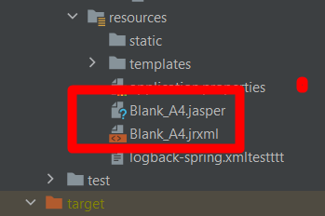

## Output

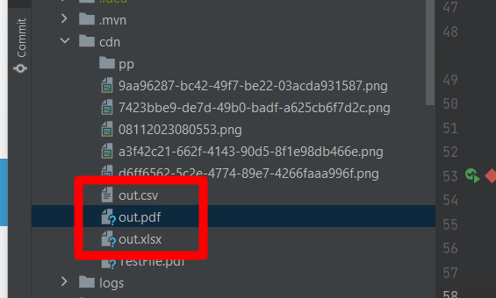

# Itext PDF

## POM

|  |
| --- |
| <!-- https://mvnrepository.com/artifact/com.itextpdf/itextpdf --> <dependency>  <groupId>com.itextpdf</groupId>  <artifactId>itextpdf</artifactId>  <version>5.5.13.3</version> </dependency> <dependency>  <groupId>com.itextpdf</groupId>  <artifactId>kernel</artifactId>  <version>7.0.2</version>  </dependency>    <dependency>  <groupId>com.itextpdf</groupId>  <artifactId>io</artifactId>  <version>7.0.2</version>  </dependency>    <dependency>  <groupId>com.itextpdf</groupId>  <artifactId>layout</artifactId>  <version>7.0.2</version>  </dependency>    <dependency>  <groupId>com.itextpdf</groupId>  <artifactId>forms</artifactId>  <version>7.0.2</version>  </dependency>    <dependency>  <groupId>com.itextpdf</groupId>  <artifactId>pdfa</artifactId>  <version>7.0.2</version>  </dependency>    <dependency>  <groupId>com.itextpdf</groupId>  <artifactId>sign</artifactId>  <version>7.0.2</version>  </dependency>    <dependency>  <groupId>com.itextpdf</groupId>  <artifactId>barcodes</artifactId>  <version>7.0.2</version>  </dependency>    <dependency>  <groupId>com.itextpdf</groupId>  <artifactId>font-asian</artifactId>  <version>7.0.2</version>  </dependency>    <dependency>  <groupId>com.itextpdf</groupId>  <artifactId>hyph</artifactId>  <version>7.0.2</version>  </dependency> |

## Example itext

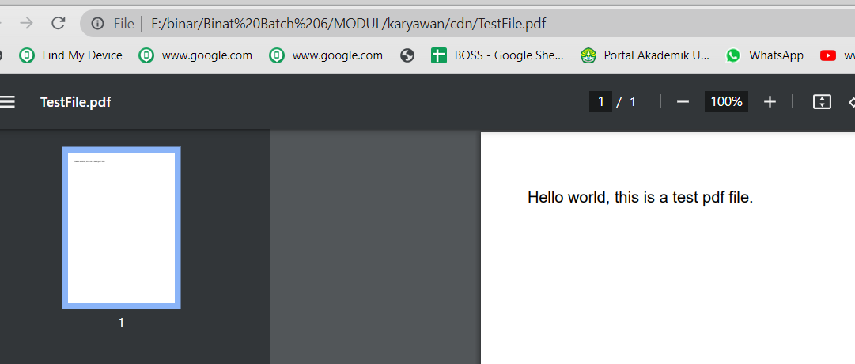

|  |
| --- |
| package com.aplikasi.karyawan.utils.itext;  import java.io.File; import java.io.FileOutputStream; import java.io.OutputStream; import com.itextpdf.text.Document; import com.itextpdf.text.Paragraph; import com.itextpdf.text.pdf.PdfWriter;  */**  * This class is used to create a pdf file using iText jar.  \** ***@author*** *w3spoint  */* public class PDFCreateExample {  public static void main(String args[]){  try {  //Create Document instance.  Document document = new Document();   //Create OutputStream instance.  OutputStream outputStream =  new FileOutputStream(new File("./cdn/TestFile.pdf"));   //Create PDFWriter instance.  PdfWriter.*getInstance*(document, outputStream);   //Open the document.  document.open();   //Add content to the document.  document.add(new Paragraph("Hello world, " +  "this is a test pdf file."));   //Close document and outputStream.  document.close();  outputStream.close();   System.*out*.println("Pdf created successfully.");  } catch (Exception e) {  e.printStackTrace();  }  } } |

## with report tabel

Refer : <https://www.tutorialspoint.com/itext/itext_adding_table.htm>

|  |
| --- |
|  |

# Membuat File Zip

File diambil dari reporting jasper generate file

## branch

171122-file-zip

https://gitlab.com/rikialdi/binar5-spring.git

## struktur project

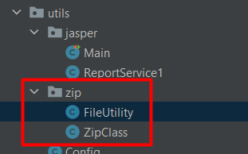

## Fileutility

|  |
| --- |
| package com.binar5.apps.utils.zip;   import java.io.File; import java.io.FileOutputStream; import java.io.FilenameFilter; import java.io.IOException; import java.io.InputStream;  import org.apache.logging.log4j.util.Strings; import org.apache.tomcat.util.http.fileupload.IOUtils;  import lombok.extern.slf4j.Slf4j;  @Slf4j public class FileUtility {   private final static String *EXTENTION_FILE* = ".";   public static File commonFindFileOld(String path, String referenceNumber) {  File f = new File(path);  File[] matchingFiles = f.listFiles(new FilenameFilter() {  public boolean accept(File dir, String name) {  return name.contains(referenceNumber);  }  });   return matchingFiles != null && matchingFiles.length > 0 ? matchingFiles[0] : null;  }   public static File commonFindFile(String path, String referenceNumber) {  File file = null;  try {  int lastIndexOf = referenceNumber.lastIndexOf(".");  path = path.endsWith("/") ? path : (path + File.*separator*);  if (lastIndexOf == -1) {  String[] typeFileList = { "jpg", "jpeg", "png", "pdf", "xls", "xlsx", "JPG", "JPEG", "PNG", "PDF", "XLS", "XLSX" };  for (String typeFile : typeFileList) {  file = new File(path + referenceNumber + *EXTENTION_FILE* + typeFile);  if (file.exists()) {  return file;  }  }  } else {  file = new File(path + referenceNumber);  if (file.exists()) {  return file;  }  }  } catch (Exception e) {  *log*.error("cannot get file ", e);  }  return null;  }   public static File streamTemporaryFile(InputStream in, String refNumber) throws IOException {  final File tempFile = File.*createTempFile*(refNumber, ".html");  tempFile.deleteOnExit();  try (FileOutputStream out = new FileOutputStream(tempFile)) {  IOUtils.*copy*(in, out);  }  return tempFile;  }   public static String getFileExtension(File file) {  String name = file.getAbsolutePath();  int lastIndexOf = name.lastIndexOf(".");  if (lastIndexOf == -1) {  return "";  }  return name.substring(lastIndexOf).replace(".", "");  }   public static String getFileName(File file) {  String name = file.getName();  int pos = name.lastIndexOf(".");  if (pos > 0) {  name = name.substring(0, pos);  }  return name;  }   public static String removeSpace(String text) {  if (text == null) {  return Strings.*EMPTY*;  }   return text.replace(" ", "");  }   } |

## zipClass

|  |
| --- |
| package com.binar5.apps.utils.zip;  import com.fasterxml.jackson.databind.ObjectMapper; import org.apache.tomcat.util.http.fileupload.IOUtils; import org.springframework.web.bind.annotation.GetMapping; import org.springframework.web.bind.annotation.RestController;  import javax.servlet.http.HttpServletResponse; import java.io.*; import java.util.HashMap; import java.util.Map; import java.util.zip.ZipEntry; import java.util.zip.ZipOutputStream;  @RestController public class ZipClass {  @GetMapping(value = "/report/download/zip", produces = "application/zip")  public void zipFiles(HttpServletResponse response) throws IOException {   // setting headers  response.setStatus(HttpServletResponse.*SC_OK*);  // akan mendownload file dengan nama "filename.zip"  response.addHeader("Content-Disposition", "attachment; filename=" + "filenameDownload" + ".zip");   // 1.otomatis dwonload ke client  ZipOutputStream zipOutputStream = new ZipOutputStream(response.getOutputStream());  // 2.tulis ke direkctori  FileOutputStream fos = new FileOutputStream("./cdn/out2.zip");  ZipOutputStream zipOutputStreamLocalSave = new ZipOutputStream(fos); // String prefix = "Temp_";  String path = "./cdn/";  String fileName = "out.csv";// file yang diambil : diharcode  String fileName2 = "out.pdf";// file yang diambil : diharcode  String fileName3 = "out.xlsx";// file yang diambil : diharcode  String fileName5 = "hard-01.jpg";// file yang diambil : diharcode  String fileName6 = "out.docx";// file yang diambil : diharcode  String name = "zipexport";  File ktp = FileUtility.*commonFindFile*(path, fileName);  File npwp = FileUtility.*commonFindFile*(path, fileName2);  File customer = FileUtility.*commonFindFile*(path,fileName3);  File signature = FileUtility.*commonFindFile*(path, fileName5);  File boKtp = FileUtility.*commonFindFile*(path, fileName6);  File boNpwp = FileUtility.*commonFindFile*(path, fileName);   Map res = new HashMap<>();  String jsonResult = new ObjectMapper().writeValueAsString(res);  StringBuilder htmlStringBuilder = new StringBuilder();  htmlStringBuilder.append("<!DOCTYPE html><html> <head> <title> Onboarding</title> </head>");  htmlStringBuilder.append("<body><h1 style=\"color:black;\"> Data Onboarding </h1>");  htmlStringBuilder.append("<pre id=\"dwibd\" style= \"color:black; font-size: 12px;\"></pre>");  htmlStringBuilder.append("<script> var el_down = document.getElementById(\"dwibd\"); var obj = " + jsonResult + ";");  htmlStringBuilder.append("el_down.innerHTML = JSON.stringify(obj, undefined, 4);");  htmlStringBuilder.append("</script> </body> </html>");   InputStream inputStream = new ByteArrayInputStream(htmlStringBuilder.toString().getBytes(("UTF8")));  File json = FileUtility.*streamTemporaryFile*(inputStream, name);  String[] listType = { "ktp", "npwp", "customer", "signature", "BOKtp", "BONpwp", "jsonData" };  File[] file = { ktp, npwp, customer, signature, boKtp, boNpwp, json };   for (int i = 0; i < file.length; i++) {  if (null != file[i]) {  zipOutputStream.putNextEntry(new ZipEntry(listType[i] + "_" + file[i].getName()));  zipOutputStreamLocalSave.putNextEntry(new ZipEntry(listType[i] + "_" + file[i].getName()));   FileInputStream fileInputStream = new FileInputStream(file[i]);  FileInputStream fileInputStream2 = new FileInputStream(file[i]);  IOUtils.*copy*(fileInputStream2, zipOutputStreamLocalSave);  IOUtils.*copy*(fileInputStream, zipOutputStream);   ;  fileInputStream.close();   zipOutputStream.closeEntry();  zipOutputStreamLocalSave.closeEntry();   }  }   // membuat file zip pada local direktori  zipOutputStreamLocalSave.close();  zipOutputStream.close();  }  /*  list  map  set  */ } |

## Output dilocal

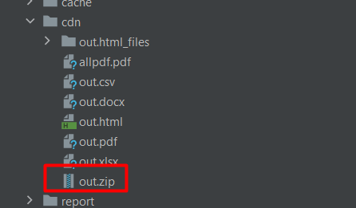

## Output rest API

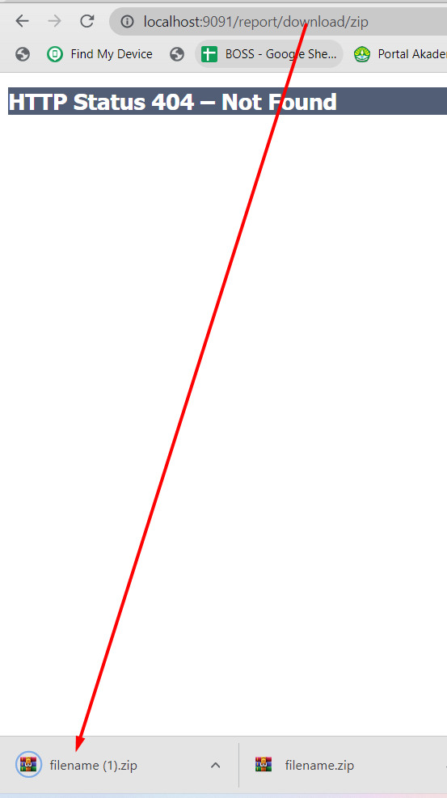

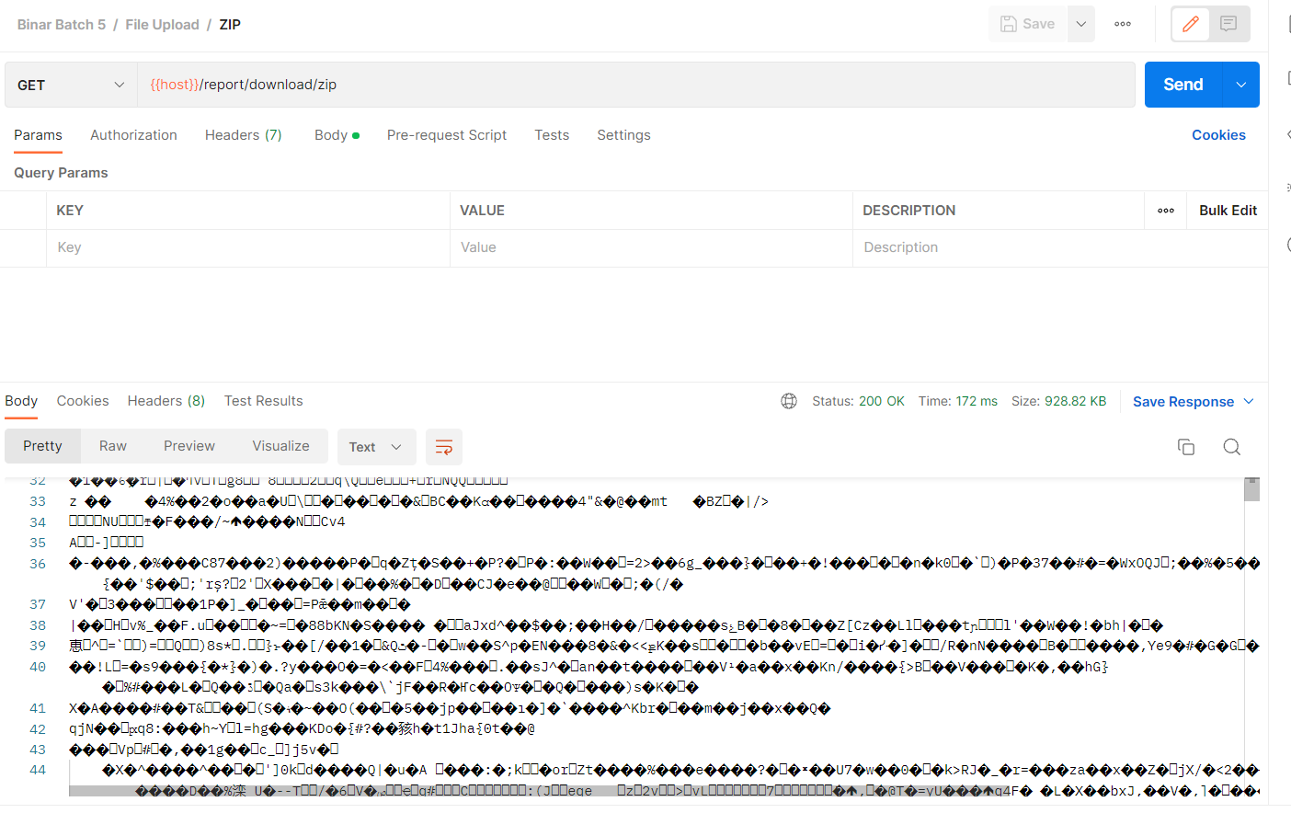

# Index pada JPA

<https://www.baeldung.com/jpa-indexes>

## Penerapan pada Class java

|  |
| --- |
| @Table(name = "barang", indexes = {@Index(name = "idx_barang_nama", columnList="nama")}) |

## Penerapan pada SQL

|  |
| --- |
| CREATE INDEX index_name  ON table_name(column_name);  Contoh  CREATE INDEX idx_barang_nama  ON barang(nama); |

# Merubah CamelCase to SnakeCase

|  |
| --- |
| Pom.xml  <dependencies> <!-- Dependencies lainnya --> <dependency> <groupId>org.springframework.boot</groupId> <artifactId>spring-boot-configuration-processor</artifactId> <optional>true</optional> </dependency> </dependencies>  Application properties   # CamelCase  examplePropertyName=NilaiProperti   # Snake_case  example_property_name=NilaiProperti  Paenerapan : @Value("${example_property_name}") private String examplePropertyName; |

# Referensi

[**https://glints.com/id/lowongan/crud-adalah/#.YTFxXo4zbIU**](https://glints.com/id/lowongan/crud-adalah/#.YTFxXo4zbIU)

[**https://www.sinaungoding.com/operasi-crud-menggunakan-spring-boot-jdbc/**](https://www.sinaungoding.com/operasi-crud-menggunakan-spring-boot-jdbc/)

[**https://blog.ichromanrd.me/2019/11/20/java-persistence-api-1.html**](https://blog.ichromanrd.me/2019/11/20/java-persistence-api-1.html)

[**https://www.baeldung.com/spring-data-jpa-pagination-sorting**](https://www.baeldung.com/spring-data-jpa-pagination-sorting)

**https://www.baeldung.com/swagger-2-documentation-for-spring-rest-api**

[**https://id.linkedin.com/pulse/membuat-rest-api-dengan-springboot-swagger-dan-deni-gunawan**](https://id.linkedin.com/pulse/membuat-rest-api-dengan-springboot-swagger-dan-deni-gunawan)

[**https://simplesolution.dev/spring-boot-rest-api-openapi-swagger-ui-springdoc-openapi/**](https://simplesolution.dev/spring-boot-rest-api-openapi-swagger-ui-springdoc-openapi/)

https://appkey.id/pembuatan-aplikasi/mobile-programming/framework-spring-boot/

<https://www.codepolitan.com/spring-boot-pengenalan-588da0c4bedd1>

<https://blog.xsis.academy/berkenalan-dengan-spring-boot/>

<https://medium.com/easyread/membuat-project-spring-boot-baru-62d3b8e52b49>

<https://leonardusdani.wordpress.com/2016/11/14/tutorial-belajar-spring-framework-part-ii-dependency-injection-dan-spring-inversion-of-control-container/>

<https://medium.com/the-legend/spring-ioc-54306410a4ed>

<https://subrutin.com/tutorial-spring-framework-2-inversion-of-control-vs-dependency-injection/>

<http://imamfarisi.com/dependency-injection-dan-beans-di-spring-core/>

<https://www.tutorialspoint.com/spring_boot/spring_boot_logging.htm>

<https://medium.com/codelabs-unikom/microservices-apaan-tuh-b9f5d56e8848>

https://github.com/tedydarmawan/SpringBoot

<https://medium.com/@satya.syahputra/mengenal-spring-dependency-injection-framework-bahasa-indonesia-3c3b9487a59e>

https://www.baeldung.com/jpa-indexes